1. Upper Hill Performance on Mobile
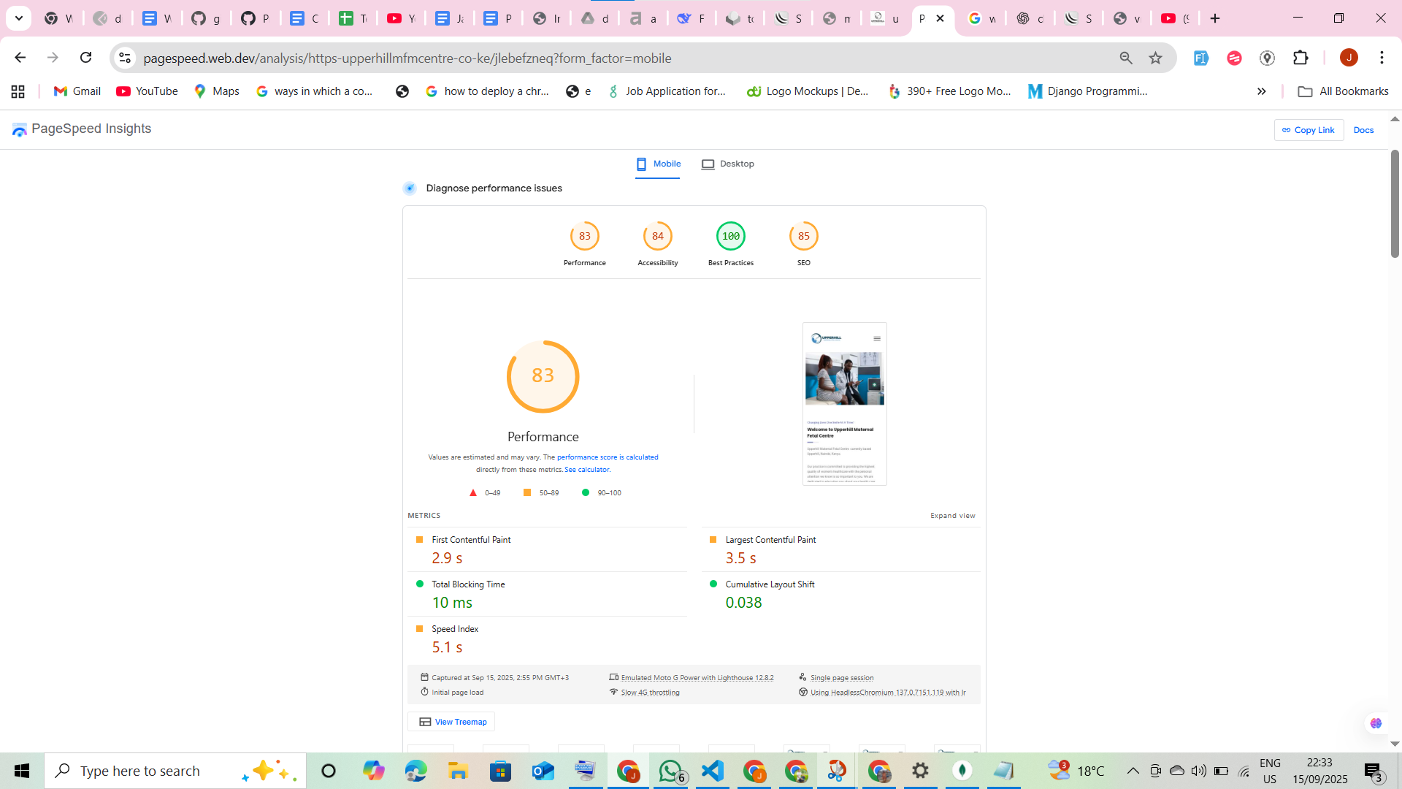

UpperHill’s website performs fairly well on mobile with an overall performance score of 83/100. Strengths include excellent responsiveness (TBT), layout stability (CLS), and adherence to best practices. However, there are improvement opportunities in loading speed (FCP & LCP), accessibility, and SEO crawlability. Addressing these will enhance user experience, inclusivity, and search engine visibility.

a. Performance (83/100)

Core Web Vitals (Mobile)

- FCP (2.9s): Near poor threshold → slightly slow.
- LCP (3.5s): Moderately slow → improvement needed.
- Speed Index (5.1s): Acceptable but not ideal.
- TBT (10ms): Excellent → very responsive.
- CLS (0.038): Excellent → stable layout.

Key Recommendations

- Optimize images/videos (WebP/AVIF).
- Reduce render-blocking resources (defer/async CSS/JS).
- Enable caching & CDN for faster delivery.
- Preload critical resources (fonts, hero images).
- Apply lazy loading for below-the-fold content.
- Minify CSS/JS/HTML.
- Prioritize above-the-fold content.

b. Accessibility (84/100)

Issues Detected

- Buttons and links missing accessible names.
- Insufficient contrast between text and backgrounds.
- Headings not in sequential order.
- Manual checks needed for ARIA roles, tab order, and custom controls.

Strengths:

- Alt text present on images.
- Valid document title & language attribute.
- Large touch targets and skip links supported.
- Correct ARIA usage with no deprecated roles.

Key Recommendations

- Add descriptive labels to buttons and links.
- Improve text/background contrast ratios.
- Structure headings in correct order (H1 → H2 → H3).
- Conduct manual accessibility tests for ARIA roles and tab navigation.

c. Best Practices (100/100)

The site adheres strongly to modern development standards with no critical issues detected.

Key Recommendations:

- Maintain secure coding practices.
- Keep libraries and dependencies updated.
- Regularly perform security and performance audits.

d. SEO (85/100)

Issues Detected

- 1 link without descriptive text.
- Some links are uncrawlable, preventing indexing.
- Manual checks recommended for structured data, sitemap, and robots.txt.

Strengths

- Valid title and meta description.
- Mobile-friendly with proper viewport settings.
- Robots.txt configured.
- Tap targets optimized for mobile.

Key Recommendations:

- Ensure all links use descriptive anchor text.
- Fix uncrawlable links (avoid JS-only navigation).
- Implement structured data (schema.org).
- Audit sitemap & robots.txt to confirm index coverage.
- Monitor Google Search Console for indexing errors.

2. Performance on desktop
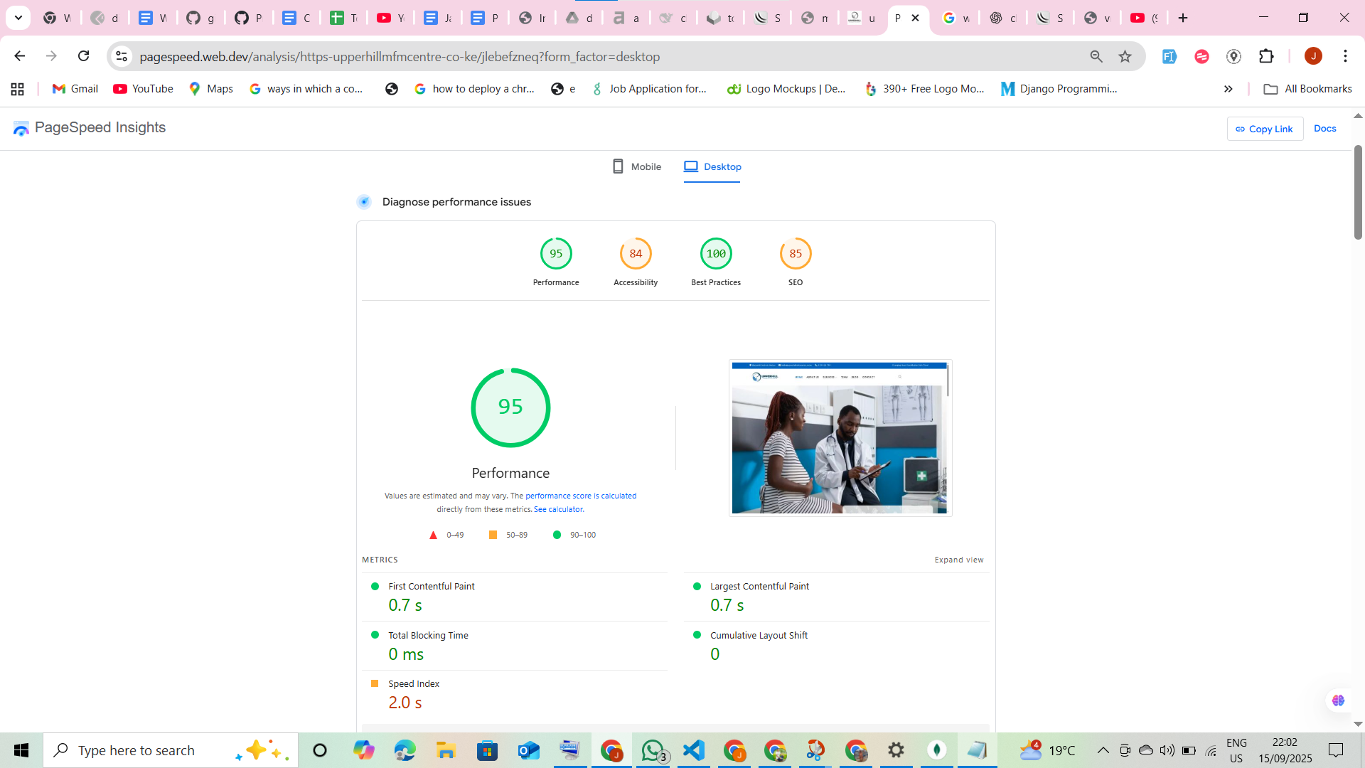
The Upperhill MFM Centre website demonstrates strong overall desktop performance, achieving a Performance Score of 95/100 and a Best Practices score of 100/100. The site loads very quickly, with a First Contentful Paint (FCP) and Largest Contentful Paint (LCP) both under 1 second, ensuring an excellent user experience.
However, there are notable areas for improvement in Accessibility (84/100) and SEO (85/100). Addressing these issues will enhance usability, compliance, and search visibility.

Performance Details
- First Contentful Paint (FCP): 0.7s – Excellent visual feedback for users.
- Largest Contentful Paint (LCP): 0.7s – Excellent; meets Core Web Vitals requirements.
- Total Blocking Time (TBT): 0ms – Perfect responsiveness, no JS execution delays.
- Speed Index: 2.0s – Good, though can be slightly optimized for even faster visual completion.
- Cumulative Layout Shift (CLS): 0 – Perfect; no unexpected layout shifts.

Issues To be Resolved
- Server Response & Latency - Reduce document request latency (potential savings ~1.02s), Consider implementing a CDN or optimizing server-side processing.
- Render-Blocking Resources- Defer or async non-critical CSS/JS to save ~620ms, Inline critical CSS for above-the-fold content.
- Font Optimization - Use font-display: swap to avoid invisible text and save ~500ms.
- Browser Caching - Set efficient cache lifetimes for static resources (estimated savings: 413 KiB).
- Image Optimization - Convert images to next-gen formats (WebP/AVIF) and compress to save ~57 KiB.
- Code Optimization - Minify and remove unused CSS/JS (estimated savings: 317 KiB).

Accessibility Review
- Contrast Issues: Background and text color combinations do not meet WCAG standards.
- Form Elements: Missing label associations for form inputs.
- Links: Some links lack descriptive text, impacting screen reader usability.
- Heading Structure: Headings not following logical hierarchy (H1 → H2 → H3).

SEO Recommendations
- Ensure all pages have descriptive meta titles and descriptions.
- Use meaningful, keyword-rich anchor text for internal links.
- Validate structured data for rich results (if applicable).

