# Quality control of BIOP/LNMC Cellpose model

## Version Control

|  |  |  |  |  |
| --- | --- | --- | --- | --- |
| Version | Author | Description | Validation | Date |
| 0.1 | JP | First version |  | 20220804 |
| 0.2 | JP | Added pictures, conclusion and remarks |  | 20220825 |
| 0.3 | JP | Add information about images used |  | 20221006 |

## About This document

This report aims to present and provide quality control for results of a cell detection model (“V2”) for Instance segmentation. Results were computed in Jupyter Notebook and benchmarked on 6 annotated slices of sagittal cuts of juvenile mouse brains. The benchmark for quality control is “cyto2”, a [Cellpose pre-trained model](https://cellpose.readthedocs.io/en/latest/models.html?highlight=cyto2#cytoplasm-2-0-model-cyto2). Code is authored by Olivier Burri from BIOP at EPFL.

# Dataset and model

All tasks were performed in square sections of the brainslice images with the following IDs: 404, 406, 512, 563. Masks of the models being evaluated are stored in "Z:\2021_LayerBoundariesRefinement\LBR_Algorithm\Cellpose\QC Notebook-JOAO\QC".

# Methodology

Three model parameters are compared between ‘cyto2’ and ‘V2’, as advised in arXiv:2206.01653:

* **Dice Similarity Coefficient** (DSC) : an overlap based metric (measures overlap between ground truth, annotations, and learned structure). This metric is greatly influenced by the cell size distribution but indifferent to shape. As the DSC approaches 1, the annotation converges to ground truth. Recommended for segmentation problems. A visual representation of the DSC metric is shown in Figure 1.

Rajouter information de quand la metrique est bonne, schémas,

* **Mask Intersection over** **Union** (IoU) : another overlap based metric. There are multiple different IoU metrics (Mask IoU, Boundary IoU and Intersection over Reference).   
  As the IoU approaches 1, the annotation converges to ground truth. Advantages and disadvantages of each metric are list in E.4 (page 54) of [1] . visual representation of the IoU metric is shown in Figure 1.

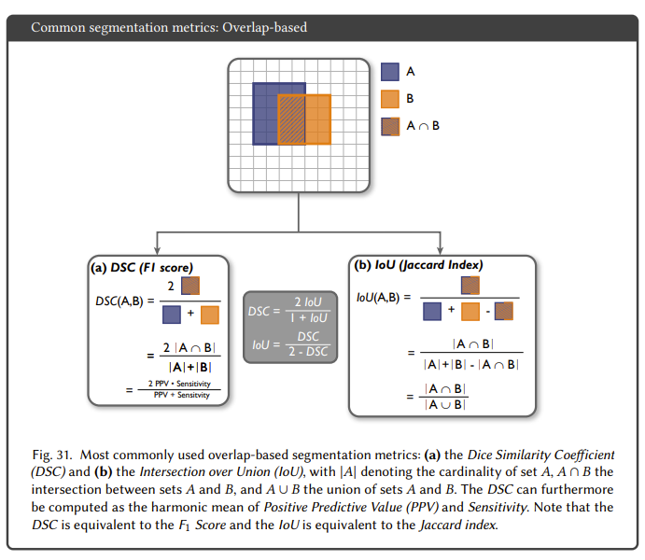

Figure 1. DSC and IoU representation reproduced from [1]

* **Panoptic quality** (PQ) : a counting metric (based on the count of identified structures). As the metric approaches 1, false negatives and false positives tend to 0 and true positives approach ground truth. This metric evaluates both segmentation (like IoU and DSC) and detection (analysis of false and true positives/negatives).
* **Accuracy :** Metric common used in classification tasks to quantify how much a model is correct (with respect to ground truth) : $Accuracy= \frac{True positives}{True positives+False positives+False negatives}$

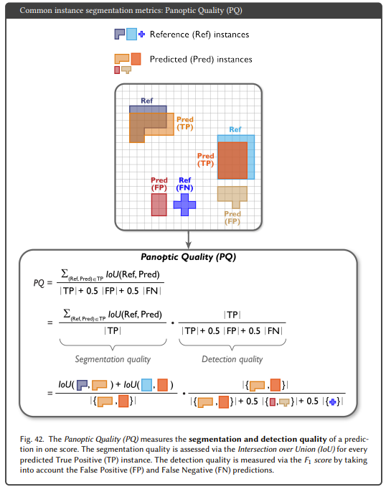Figure 2. PQ representation reproduced from [1]

Unpaired Welch T-tests[1] are applied to) results from ‘cyto2’ and ‘V2’ mean predictions (n=6) using scipy.stats module default configurations. Results are plotted and p-values are reported with asterisk convention (e.g. ‘ * ’ corresponds to p-value <= 0.1, ‘ *** ‘ corresponds to p-value <= 0.001).

## Results

DSC: (p-value = 3.21e-5)

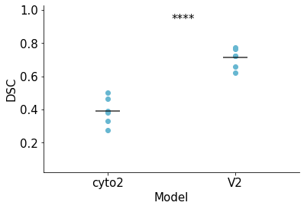Remarks:

cyto2: 0.2677 ± 0.06167

V2: 0.5513 ± 0.04523

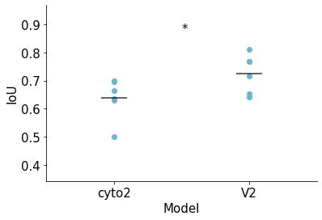

IoU: (p-value =0.059)

Remarks:

cyto2: 0.6383 ± 0.0677

V2: 0.726 ± 0.06262

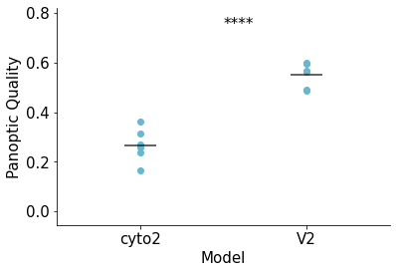PQ : (p-value =1.47e-5)

Remarks :

cyto2 : 0.3908 ± 0.07681

V2 : 0.7119 ± 0.05417

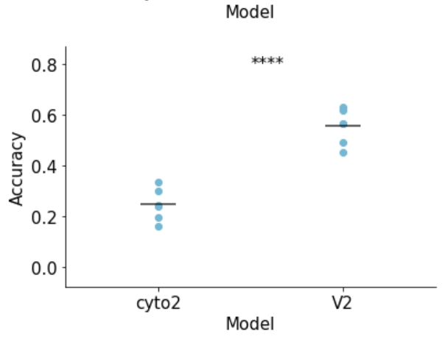

Accuracy: (p-value = 1.36e-05)

Remarks:

cyto2 : 0.2457 ± 0.05961

V2 : 0.5554 ± 0.06426

## Conclusion

We observe a significant improvement in DSC and PQ metrics for the V2 classifier in comparison to cyto2. IoU improvement is below a threshold of p = 0.05 and cannot be considered statistically significant. A possible explanation for the generalized increase in all metrics can be an improvement in the segmentation task, as V2 seems to be less biased to annotating bigger cells than cyto2. Nevertheless, statistical analysis with (n = 5) is at the low end limit of applicability and analysis with more samples would be preferred.

## Bibliography / Reference Paper

[1] Maier-Hein, L., Reinke, A., Christodoulou, E., Glocker, B., Godau, P., Isensee, F., Kleesiek, J., Kozubek, M., Reyes, M., Riegler, M., Wiesenfarth, M., Baumgartner, M., Eisenmann, M., Heckmann-Nötzel, D., Kavur, A., Rädsch, T., Tizabi, M., Acion, L., Antonelli, M., Arbel, T., Bakas, S., Bankhead, P., Benis, A., Cardoso, M., Cheplygina, V., Cimini, B., Collins, G., Farahani, K., Ginneken, B., Hashimoto, D., Hoffman, M., Huisman, M., Jannin, P., Kahn, C., Karargyris, A., Karthikesalingam, A., Kenngott, H., Kopp-Schneider, A., Kreshuk, A., Kurc, T., Landman, B., Litjens, G., Madani, A., Maier-Hein, K., Martel, A., Mattson, P., Meĳering, E., Menze, B., Moher, D., Moons, K., Müller, H., Nickel, F., Nichyporuk, B., Petersen, J., Rajpoot, N., Rieke, N., Saez-Rodriguez, J., Gutiérrez, C., Shetty, S., Smeden, M., Sudre, C., Summers, R., Taha, A., Tsaftaris, S., Van Calster, B., Varoquaux, G., & Jäger, P.. (2022). Metrics reloaded: Pitfalls and recommendations for image analysis validation.

<https://doi.org/10.48550/arXiv.2206.01653>

## 

1. Unpaired Welch tests assume that the means being compared are normally distributed (asymptotically true) and that the variances are not equal (but also normally distributed)