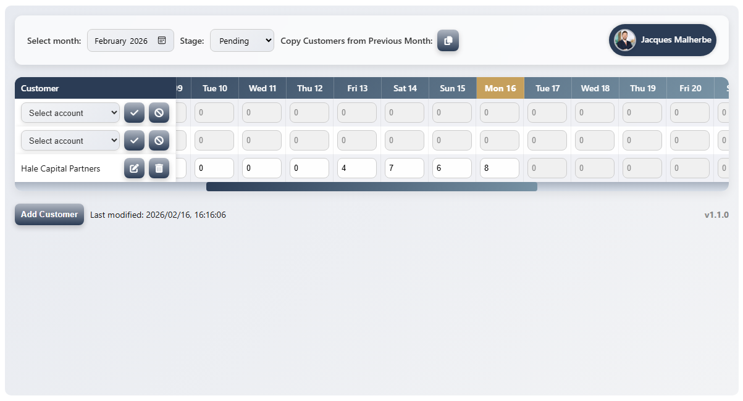
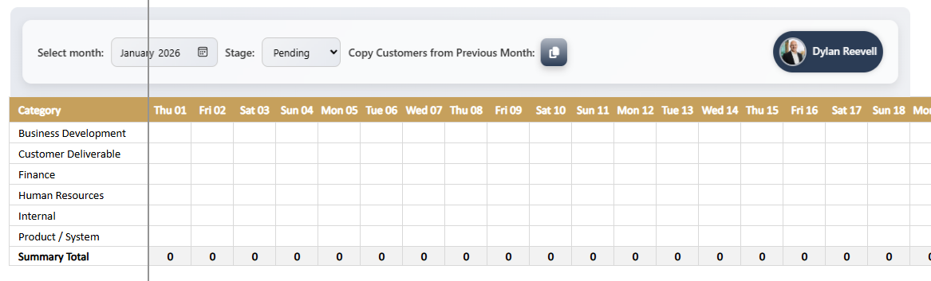
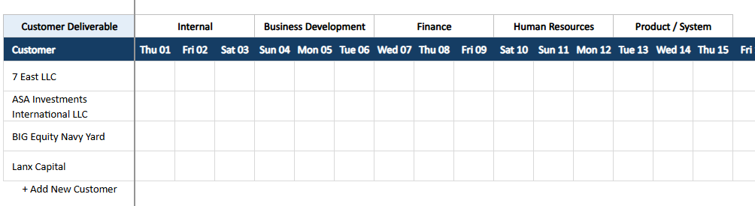
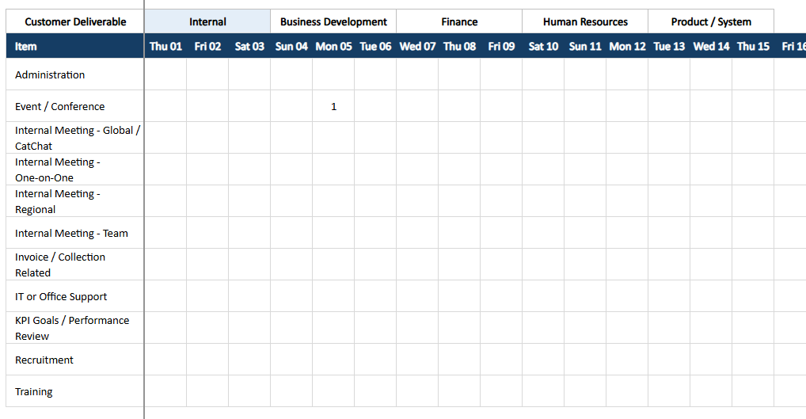
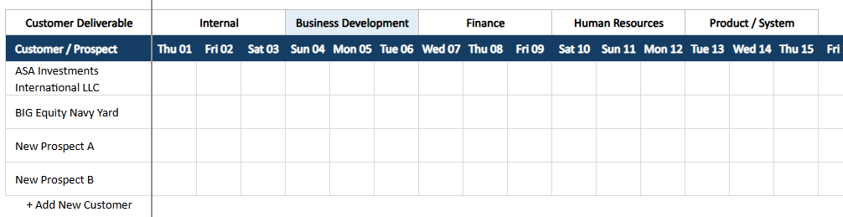
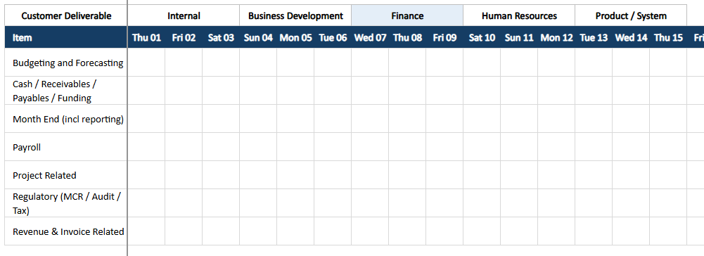
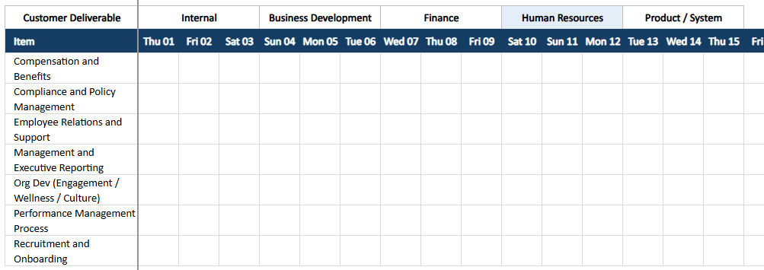
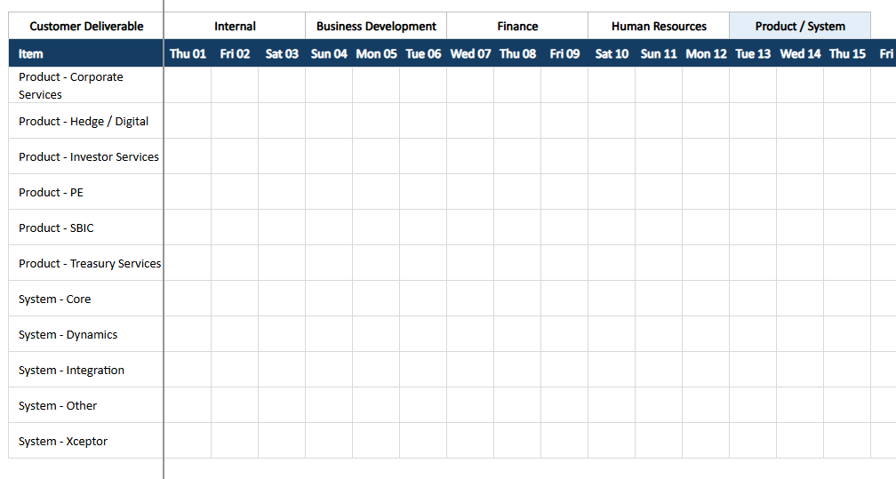

📋 AI PROMPT — “Time Keeper – Phase 2 App (TypeScript + CSS)”
Goal\ Create a new Phase 2 version of a browser-based time sheet application in TypeScript (no framework; DOM API only) with a companion CSS file. The app must preserve the existing visual theme of Phase 1 (Segoe UI / Roboto; glassmorphism toolbar; blue header gradient) and introduce a gold color #c6a05c for the Summary Dashboard. The result must be two fully working, well-commented files:
- timesheet-phase2.ts
- timesheet-phase2.css

1) Functional Scope
Phase 2 purpose\ In addition to customer work (Phase 1), users must capture time for non-customer categories. The UI shows tabs for all categories; Customer Deliverable is the default tab on load.
Categories/Tabs (always visible, selectable):
- Customer Deliverable (default)
- Business Development
- Internal
- Finance
- Human Resources
- Product / System
Sub-category sources
- Internal, Finance, Human Resources, Product / System: static, configurable lists defined in a new config object (see §3).
- Customer Deliverable, Business Development: dynamic from existing API (reuse listAccounts—customer rows use Accounts, and Business Development uses Prospects also sourced from Accounts). Keep Phase 1 behaviors for Add Customer, Edit, Delete, and Copy Previous Month on these two categories only.
Month & Stage (page-level)
- Select month control filters data for the entire page (not per team or category).
- Stage dropdown (Pending / Submitted / Finalised) behaves exactly like Phase 1:
  - Pending: editing enabled; Add/Edit/Delete/Copy enabled (but only for Customer Deliverable + Business Development).
  - Submitted/Finalised: all editing disabled and inputs read-only; buttons disabled.
  - Stage change updates all rows (batch update API call), as in Phase 1.
Summary Dashboard (read-only, computed on the client, not saved)
- Daily totals across all categories for every day in the month.
- Monthly totals per category.
- Overall monthly total.
- Ability to expand/collapse categories within the Summary. Collapsed by default. Expanding shows per-category sub-category totals.
- Summary must stay horizontally aligned with the day columns of the entry grid; when the grid scrolls horizontally, Summary scrolls in sync.
Entry grid
- For the selected tab, render sub-categories (or customers/prospects) as rows; days of month as columns.
- Inputs: numeric, step 0.25, min 0, max 24; future dates disabled, today and past enabled (unless stage blocks edits).
- Auto-save (debounced) on blur/Enter (reuse Phase 1 logic: queue, debounce 500ms, batch to API).
- Only create/save a DB row if the user captured > 0 hours on that row.
- Total per row updates live; Summary recalculates live from in-memory state, independent of save state.
Copy from Previous Month
- Only for Customer Deliverable and Business Development.
- Imports rows from previous month (no duplicate accounts in the current month), clears hours, sets meta & stage to Pending, and performs batch create.
Error Handling & Loaders
- Reuse Phase 1 loader overlay and error overlay patterns (glassmorphism overlay inside .ts-app).
- Respect popup blocked message if MSAL popup fails (Phase 1 already does this).

2) Integration & Reuse from Phase 1
Authentication & APIs
- Reuse the following patterns from Phase 1 exactly (assume they exist globally or re-implement within the file if absent):
  - loadMsalFromCdn(), getMsalApp(), ensureTokenForFunction()
  - API provider abstraction with these endpoints (adjusted names allowed but same behavior):
    - listAccounts(year, month) → returns array of accounts/prospects.
    - listTimesheets(year, month) → returns existing saved time rows for the current user for the month.
    - saveTimesheet(record) → create/update single row.
    - createTimesheets(records) → batch create.
    - updateTimesheets(records) → batch update (used for stage changes).
    - deleteTimeKeepEntry(id) and deleteTimeKeepEntries(ids).
Data Compatibility
- Keep Phase 1 TimesheetRecord shape and helpers (dayKey(d), sumHours(record)), but add fields as needed for category and subCategory metadata.
Entry ID & Stage Map
- Reuse the Phase 1 stage map (Pending=596610000, Submitted=596610001, Finalised=596610002) and timeSheetEntryId pattern (YearMonth_CatNumber_UserInitial.Lastname) where applicable.

3) New Config for Static Sub-categories
Create and export a strongly-typed config object and interface:
export type StaticConfigCategory = "Internal" | "Finance" | "Human Resources" | "Product / System";

export interface Phase2StaticCategoryConfig {
internal: string[];
finance: string[];
humanResources: string[];
productSystem: string[];
}

export const phase2StaticCategoryConfig: Phase2StaticCategoryConfig = {
internal: [
"Administration",
"Event / Conference",
"Internal Meeting - Global / Catchup",
"Internal Meeting - One-on-One",
"Internal Meeting - Regional",
"Internal Meeting - Team",
"Invoice / Collection Related",
"IT / Office Support",
"KPI Goals / Performance Review",
"Recruitment",
"Training"
],
finance: [
"Budgeting and Forecasting",
"Cash / Receivables / Payables / Funding",
"Month End (incl reporting)",
"Payroll",
"Project Related",
"Regulatory (MCR / Audit / Tax)",
"Revenue & Invoice Related"
],
humanResources: [
"Recruitment",
"HR Admin",
"Performance Management",
"Interviews"
],
productSystem: [
"System Support",
"Product Enhancements",
"Architecture Review",
"Tech Stack Governance"
]
};
``
Use this config to render sub-category rows for those four categories. Do not hit the API for them.

4) TypeScript: Architecture & Contracts
File: timesheet-phase2.ts
- Namespaces/Classes
  - TimeSheetStageMap (reuse numbers above).
  - CategoryName union type:
type CategoryName =
| "Customer Deliverable"
| "Business Development"
| "Internal"
| "Finance"
| "Human Resources"
| "Product / System";
  - TimesheetRowModel:
interface TimesheetRowModel {
timeSheetId: string | null;
timeSheetEntryId: string | null;
yearMonth: string; // "YYYY-MM"
category: CategoryName;
subCategory: string; // for static cats or account/prospect display name
accountId?: string | null; // for Customer Deliverable / Business Development
userId: string;
timeSheetStage: number; // from map
totalHours: number;
timeSheetStartDate: string; // ISO start of month (UTC)
timeSheetEndDate: string; // ISO end of month (UTC)
// day01..day31 numbers
[k: day${string}]: number | string | null | undefined;
}
  - SummaryModel:
interface SummaryModel {
dailyTotals: number[]; // length = daysInMonth
categoryTotals: Record<CategoryName, number>;
overall: number;
expandedCategories: Set<CategoryName>;
}
  - ApiProvider (reuse Phase 1 method signatures; just instantiate inside this file; uses ensureTokenForFunction() for auth header).
  - TimesheetAppV2 main class with:
    - State: year, month, daysInMonth, selectedTab: CategoryName, rows: TimesheetRowModel[], accountsCache, summary: SummaryModel, stageText (string), ui: { toolbar, tabBar, summary, header, body, scrollWrap }.
    - Methods:
      - mount(container: HTMLDivElement): Promise<void>
      - buildShell() (toolbar, tab bar, summary panel, grid with synchronized header/body scroll)
      - renderTabs(), renderSummary(), renderHeader(), renderBody()
      - syncScroll() (header/body & summary scroll)
      - loadData() (calls listTimesheets, listAccounts as needed, builds row models for each tab)
      - applyStageToUi() (enable/disable buttons & inputs)
      - addCustomerRow(), editCustomerRow(), deleteCustomerRow(), copyFromPreviousMonth()
      - scheduleSave(row: TimesheetRowModel, updateFn?: () => void) (debounced 500 ms)
      - saveRow(row: TimesheetRowModel)
      - recalcRowAndSummary(row: TimesheetRowModel)
      - computeSummaryFromRows(): SummaryModel
      - setMonth(year: number, month: number)
      - setStage(stageText: "Pending"|"Submitted"|"Finalised")
      - setTab(category: CategoryName)
    - Enforce rule: do not POST/PUT a row unless at least one dayXX > 0.
- Initialization
  - Export initTimesheetPhase2(container: HTMLDivElement): Promise<TimesheetAppV2>.
  - Auto-init if an element with id="app" exists on DOMContentLoaded.
- Behaviors to Match
  - Inputs disabled if: no account/sub-category picked, future day, or Stage is Submitted/Finalised.
  - Add/Edit/Delete/Copy buttons exist only on Customer Deliverable & Business Development rows; hidden/disabled otherwise.
  - Tabs: switch preserves month and stage; reloads appropriate row set.
- Accessibility
  - All interactive elements have aria-label and keyboard handlers.
  - Loader and error overlays mirror Phase 1 (role=“status”, aria-live="polite").
- Comments & Readability
  - Provide top-of-file docstring.
  - JSDoc comments for all public methods.
  - Explain any non-obvious logic (e.g., stage gating, summary sync).

5) CSS: Theme & Layout
File: timesheet-phase2.css
- Base: keep Phase 1 look & feel (rounded corners, blue gradient headers, light backgrounds, focused shadows). Use the ts- class prefix consistently.
- New Summary Dashboard (Gold)
  - Root container: .ts-summary with background: #c6a05c, white text.
  - Rounded (12px), inner padding, subtle shadow, uses same font and scale as toolbar.
  - Inside:
    - .ts-summary-header (title, expand/collapse all).
    - .ts-summary-grid (flex/row or CSS grid) with columns aligned to day columns.
    - .ts-summary-category rows (collapsed by default; expand shows .ts-summary-subcat rows).
  - Provide scrollbar styles matching Phase 1 for horizontal scroll.
- Tabs
  - .ts-tabs, .ts-tab (active state styled with the blue gradient; non-active subdued).
- Grid
  - Keep .ts-grid, .ts-grid-header-row, .ts-row, .ts-cell, .ts-hour-input, .ts-today.
  - Ensure the header and body scrollbars remain in sync with the summary’s horizontal scrollbar (shared scroll container or JS sync).
- Buttons & Icons
  - .ts-btn palette same as Phase 1; danger states preserved.
  - Disabled states visually consistent with Phase 1.
- Overlays
  - Reuse loader #ts-loader and error overlay #ts-error-overlay styles.
Add comments to the CSS sections for quick navigation.

6) Performance & Quality
- Debounce saves to 500 ms; batch creates/updates where appropriate.
- Avoid layout thrashing (batch DOM updates; use fragments).
- Handle months with 28–31 days.
- Respect prefers-reduced-motion for spinners.
- Strict TypeScript, noImplicitAny: true.

7) Acceptance Criteria (Definition of Done)
- App shows all tabs, Customer Deliverable default.
- Changing tab updates the body grid rows accordingly.
- Static categories render from config; dynamic categories render from listAccounts().
- Summary shows daily totals, per-category totals, and overall total; expands/collapses; scrolls in sync with grid.
- Stage and Month act at page level; stage gating & button enablement mirror Phase 1 behavior.
- Add/Edit/Delete/Copy only visible/active for Customer Deliverable & Business Development.
- Only rows with > 0 hours are saved/updated in DB.
- Inputs accept 0–24 in 0.25 increments; future days disabled.
- Loader & error overlays behave the same as Phase 1.
- Output consists of exactly two files with complete code:
  - timesheet-phase2.ts (≈ 700–1200 lines, fully commented)
  - timesheet-phase2.css (complete styles for tabs, summary, grid, overlays)

8) Output Format
- Return two distinct code blocks, each labeled with its file name comment header:
  - // FILE: timesheet-phase2.ts
  - /* FILE: timesheet-phase2.css */
- Each block must contain the entire file content, ready to save as-is.

End of Prompt

APIs
/** API-based data provider implementation */
class ApiProvider implements DataProvider {
async listAccounts(_year: number, _month: number): Promise<Account[]> {
let url = _isDev ? "http://localhost:7071/api/getaccounts" : "https://cat-dev-pa-dataverse-b6fmgzfgd4f9fkfd.canadacentral-01.azurewebsites.net/api/getaccountswithaadauth"
const response = await fetch(url, {
method: "GET",
headers: {
"Content-Type": "application/json",
"Authorization": `Bearer ${await ensureTokenForFunction()}`
},
});
if (!response.ok) throw new Error("Failed to fetch accounts");
return await response.json();
}

async listTimesheets(year: number, month: number): Promise<TimesheetRecord[]> {
let url = _isDev ? "http://localhost:7071/api/gettimekeepentries" : "https://cat-dev-pa-dataverse-b6fmgzfgd4f9fkfd.canadacentral-01.azurewebsites.net/api/gettimekeepentrieswithaadauth"
const response = await fetch(url, {
method: "POST",
headers: {
"Content-Type": "application/json",
"Authorization": `Bearer ${await ensureTokenForFunction()}`
},
body: JSON.stringify({ userId: _currentUser?.userId, yearMonth: `${year}-${String(month).padStart(2, "0")}` }),
});
if (!response.ok) throw new Error("Failed to fetch timesheets");
return await response.json();
}

async saveTimesheet(record: TimesheetRecord): Promise<TimesheetRecord> {
const url = record.timeSheetId
? _isDev ? "http://localhost:7071/api/updatetimekeepentry" : "https://cat-dev-pa-dataverse-b6fmgzfgd4f9fkfd.canadacentral-01.azurewebsites.net/api/updatetimekeepentrywithaadauth"
: _isDev ? "http://localhost:7071/api/createtimekeepentry" : "https://cat-dev-pa-dataverse-b6fmgzfgd4f9fkfd.canadacentral-01.azurewebsites.net/api/createtimekeepentrywithaadauth";
const response = await fetch(url, {
method: "POST",
headers: {
"Content-Type": "application/json",
"Authorization": `Bearer ${await ensureTokenForFunction()}`
},
body: JSON.stringify(record),
});
if (!response.ok) throw new Error("Failed to save timesheet");
return await response.json();
}

async updateTimesheets(records: TimesheetRecord[]): Promise<TimesheetRecord[]> {
let url = _isDev ? "http://localhost:7071/api/updatetimekeepentries" : "https://cat-dev-pa-dataverse-b6fmgzfgd4f9fkfd.canadacentral-01.azurewebsites.net/api/updatetimekeepentrieswithaadauth"
const response = await fetch(url, {
method: "POST",
headers: {
"Content-Type": "application/json",
"Authorization": `Bearer ${await ensureTokenForFunction()}`
},
body: JSON.stringify(records),
});
if (!response.ok) throw new Error("Failed to save timesheet");
return await response.json();
}

async createTimesheets(records: TimesheetRecord[]): Promise<TimesheetRecord[]> {
let url = _isDev ? "http://localhost:7071/api/createtimekeepentries" : "https://cat-dev-pa-dataverse-b6fmgzfgd4f9fkfd.canadacentral-01.azurewebsites.net/api/createtimekeepentrieswithaadauth";
const response = await fetch(url, {
method: "POST",
headers: {
"Content-Type": "application/json",
"Authorization": `Bearer ${await ensureTokenForFunction()}`
},
body: JSON.stringify(records),
});
if (!response.ok) throw new Error("Failed to save timesheet");
return await response.json();
}

async deleteTimeKeepEntry(timeSheetId: Guid): Promise<void> {
let url = _isDev ? "http://localhost:7071/api/deletetimekeepentry" : "https://cat-dev-pa-dataverse-b6fmgzfgd4f9fkfd.canadacentral-01.azurewebsites.net/api/deletetimekeepentrywithaadauth";
const response = await fetch(url, {
method: "DELETE",
headers: {
"Content-Type": "application/json",
"Authorization": `Bearer ${await ensureTokenForFunction()}`
},
body: JSON.stringify({ timeSheetId }),
});
if (!response.ok) throw new Error("Failed to delete timesheet entry");
}

async deleteTimeKeepEntries(timeSheetIds: Guid[]): Promise<void> {
let url = _isDev ? "http://localhost:7071/api/deletetimekeepentries" : "https://cat-dev-pa-dataverse-b6fmgzfgd4f9fkfd.canadacentral-01.azurewebsites.net/api/deletetimekeepentrieswithaadauth";
const response = await fetch(url, {
method: "DELETE",
headers: {
"Content-Type": "application/json",
"Authorization": `Bearer ${await ensureTokenForFunction()}`
},
body: JSON.stringify({ timeSheetIds }),
});
if (!response.ok) throw new Error("Failed to delete timesheet entries");
}

async getUser(): Promise<User> {
let url = _isDev ? "http://localhost:7071/api/getuser" : "https://cat-dev-pa-dataverse-b6fmgzfgd4f9fkfd.canadacentral-01.azurewebsites.net/api/getuserwithaadauth";
const response = await fetch(url, {
method: "POST",
headers: {
"Content-Type": "application/json",
"Authorization": `Bearer ${await ensureTokenForFunction()}`
},
body: JSON.stringify({ emailAddress: _UserEmail }),
});
if (!response.ok) throw new Error("Failed to fetch user");
const user: User = await response.json();
_currentUser = user;
return user;
}
}

