
FIRS – AgroParisTech - Géodata Paris

Data analysis and storytelling- Evaluation
Part I
Last name :
First name :
For multiple choice questions, cross false answers
Multiple choice questions can have several good answers.
For each question, selecting all good answers gives all the points, selecting a part of good answers gives a part of the points, selecting no answer gives no points, selecting wrong answers deducts points.
Q1 : I have data on tree mortality and exposure to certain pests, by measurement plot. Which approach should I choose to visually demonstrate a correlation between these two variables?
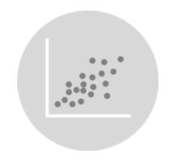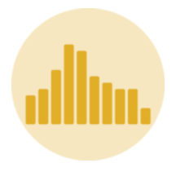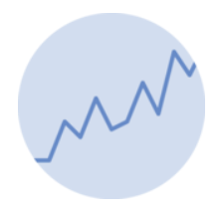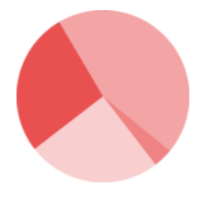
Q2 : I need to represent the proportion of different tree species in the Vosges massif. Which approach should I use?

Q3 : I would like to visualize the change in wood volume among all oak species over a 40-year period (with one data item per year), while also showing the proportion of wood volume related to each specific oak species. Which approach should I use?
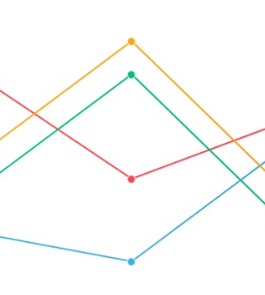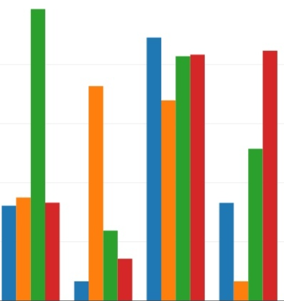
Q4: I would like to map the growth in wood volume by region—ranging from “-3%” to “2%”—using a color scale. Which scale should I use?
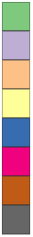

Q5 : I need to represent the wood volume for several regions on a map. What is the best way to do this?
- Using proportionnal sized symbols
- Using a color scale
- Using hatching
- Using different symbol shapes
- Using 3D by extruding 2D polygons
Q6 : You need to compare beech tree mortality rate between 2005 and 2022 across different regions. Which approache should you use?
- An animated map.
- Two maps.
- An histogram.
- One map representing change rate.
Q7 : You need to compare beech tree mortality rate between 2005 and 2022, regardless of the region. Which approaches should you use?
- An animated map.
- Two maps.
- An histogram.
- One map representing change rate.
Q8 : List and define four tactics for improving the storytelling around a visualization.

Q9 : The following curve shows the trend in wood volume for beech trees along the years. This value is estimated with a margin of ±10%. How can you represent this uncertainty?
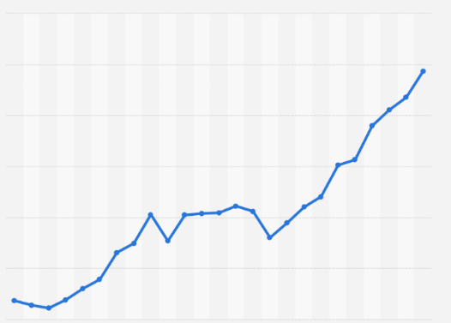
Non-contractual image
Q10 : The following map shows an estimation of the number of beech trees affected by plagues for a specific year. How can you represent data uncertainty for expert users who need to assess how a value can be trusted?
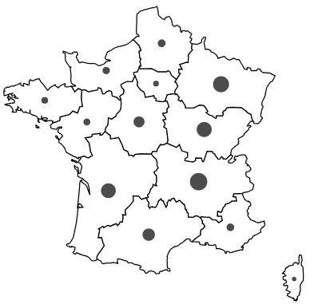
Non-contractual image

Q11 : Following question Q10, how can you represent data in order to indicate to non-experts when they can trust, or not, the represented values?

Q12 : These four maps represent wood volume. Which one is the more suited to represent this data? Explain why.
