Homework 2

Jacqui Cole

5/21/23

# Data Visualisation - Exploration

Now that you’ve demonstrated your software is setup, and you have the basics of data manipulation, the goal of this assignment is to practice transforming, visualising, and exploring data.

# Mass shootings in the US

In July 2012, in the aftermath of a mass shooting in a movie theater in Aurora, Colorado, [Mother Jones](https://www.motherjones.com/politics/2012/07/mass-shootings-map/) published a report on mass shootings in the United States since 1982. Importantly, they provided the underlying data set as [an open-source database](https://www.motherjones.com/politics/2012/12/mass-shootings-mother-jones-full-data/) for anyone interested in studying and understanding this criminal behavior.

## Obtain the data

Rows: 125  
Columns: 14  
$ case <chr> "Oxford High School shooting", "San Jose VTA shoo…  
$ year <dbl> 2021, 2021, 2021, 2021, 2021, 2021, 2020, 2020, 2…  
$ month <chr> "Nov", "May", "Apr", "Mar", "Mar", "Mar", "Mar", …  
$ day <dbl> 30, 26, 15, 31, 22, 16, 16, 26, 10, 6, 31, 4, 3, …  
$ location <chr> "Oxford, Michigan", "San Jose, California", "Indi…  
$ summary <chr> "Ethan Crumbley, a 15-year-old student at Oxford …  
$ fatalities <dbl> 4, 9, 8, 4, 10, 8, 4, 5, 4, 3, 7, 9, 22, 3, 12, 5…  
$ injured <dbl> 7, 0, 7, 1, 0, 1, 0, 0, 3, 8, 25, 27, 26, 12, 4, …  
$ total_victims <dbl> 11, 9, 15, 5, 10, 9, 4, 5, 7, 11, 32, 36, 48, 15,…  
$ location_type <chr> "School", "Workplace", "Workplace", "Workplace", …  
$ male <lgl> TRUE, TRUE, TRUE, TRUE, TRUE, TRUE, TRUE, TRUE, T…  
$ age_of_shooter <dbl> 15, 57, 19, NA, 21, 21, 31, 51, NA, NA, 36, 24, 2…  
$ race <chr> NA, NA, "White", NA, NA, "White", NA, "Black", "B…  
$ prior_mental_illness <chr> NA, "Yes", "Yes", NA, "Yes", NA, NA, NA, NA, NA, …

| column(variable) | description |
| --- | --- |
| case | short name of incident |
| year, month, day | year, month, day in which the shooting occurred |
| location | city and state where the shooting occcurred |
| summary | brief description of the incident |
| fatalities | Number of fatalities in the incident, excluding the shooter |
| injured | Number of injured, non-fatal victims in the incident, excluding the shooter |
| total_victims | number of total victims in the incident, excluding the shooter |
| location_type | generic location in which the shooting took place |
| male | logical value, indicating whether the shooter was male |
| age_of_shooter | age of the shooter when the incident occured |
| race | race of the shooter |
| prior_mental_illness | did the shooter show evidence of mental illness prior to the incident? |

## Explore the data

### Specific questions

* Generate a data frame that summarizes the number of mass shootings per year.

#creating a dataframe of the frequency (n) of mass shootings per year and saving it as msperyear.  
df_msperyear <- mass_shootings %>%  
count(year)

* Generate a bar chart that identifies the number of mass shooters associated with each race category. The bars should be sorted from highest to lowest and each bar should show its number.

#Read in data and filter out entries for race that are not applicable (NA)  
mass_shootings %>%  
 filter(!is.na(race)) %>%  
#Produce a frequency metric, n, for the number of times a mass shooter is of a specific race  
 count(race) %>%  
#Plot the result, ordering the race from highest to lowest frequency of occurrence.  
ggplot(mapping = aes(reorder(race, -n, sum),n)) + geom_col() +labs(title = "Relationship between Mass Shooters and Race", subtitle = "Frequency of mass shootings in the US by shooter's race", x = "Race of shooter", y = "Frequency")

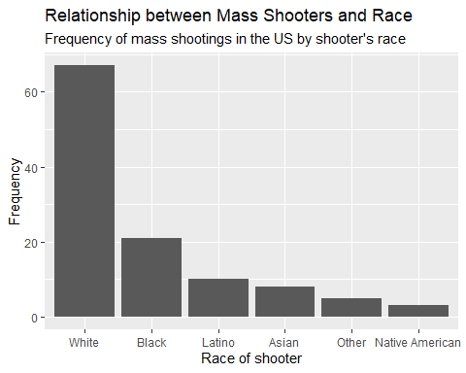

* Generate a boxplot visualizing the number of total victims, by type of location.

# I produce a boxplot to visualise the number of total victims of mass shootings in the US by type of location. The code and plot are given below.  
 ggplot(data = mass_shootings, mapping = aes(location_type,total_victims)) + geom_boxplot() + labs(x = "Location Type", y = "Total number of victims", title = "Victim Numbers by Mass-Shooting Location", subtitle = "Variation in victim count with mass-shooting location type")

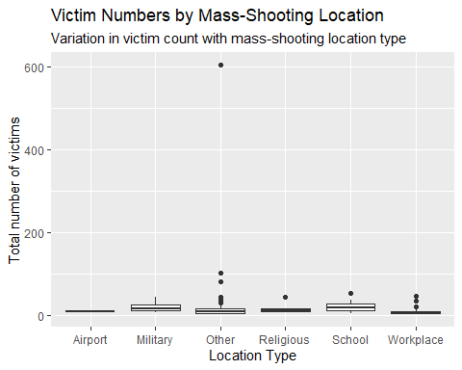

* Redraw the same plot, but remove the Las Vegas Strip massacre from the dataset.

#I note that there is a extreme data outlier in the location_type 'other' category and that its particularly high total number of victims skews the presentation of the plot. There are also two other much larger data points in other. In order that the rest of the data show up in good proportioning, I identify these three data points in order to consider removing them and then replot the trend:  
 mass_shootings %>%  
 count(total_victims) %>%  
 arrange(desc(total_victims))

# A tibble: 38 × 2  
 total_victims n  
 <dbl> <int>  
 1 604 1  
 2 102 1  
 3 82 1  
 4 55 1  
 5 48 1  
 6 46 1  
 7 44 2  
 8 41 1  
 9 37 1  
10 36 1  
# ℹ 28 more rows

#This produces a table where the three highest values can be easily identified. I first filter out the largest data outlier and replot the trend:  
   
 mass_shootings %>%  
 filter(total_victims != 604) %>%  
 ggplot(mapping = aes(location_type,total_victims)) + geom_boxplot() + labs(x = "Location Type", y = "Total number of victims", title = "Victim Numbers by Mass-Shooting Location", subtitle = "Variation in victim count with mass-shooting location type", caption = "*'Other' data with 604 victims from the Las Vegas Strip massacre are not shown")

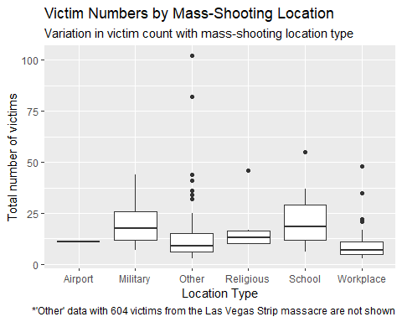

#I then filter out the other two large 'Other' data outliers and then replot the trend in order to obtain even better data proportioning of the results:  
 mass_shootings %>%  
 filter(total_victims != 604) %>%  
 filter(total_victims != 102) %>%  
 filter(total_victims != 82) %>%  
 ggplot(mapping = aes(location_type,total_victims)) + geom_boxplot() + labs(x = "Location Type", y = "Total number of victims", title = "Victim Numbers by Mass-Shooting Location", subtitle = "Variation in victim count with mass-shooting location type", caption = "*Three 'Other' data, with 604, 102 and 82 victims, are not shown, for clarity.")

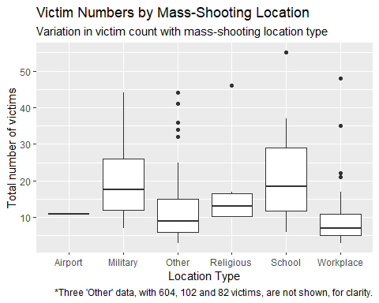

### More open-ended questions

Address the following questions. Generate appropriate figures/tables to support your conclusions.

* How many white males with prior signs of mental illness initiated a mass shooting after 2000?

# There are 125 entries of mass shootings in this database. I filter these down to those that occurred after 2000, where the shooter is white and had shown signs of prior mental illness. This produces a tibble of 23 entries.  
  
mass_shootings %>%  
 filter(year > 2000, race == "White", prior_mental_illness == "Yes")

# A tibble: 23 × 14  
 case year month day location summary fatalities injured total_victims  
 <chr> <dbl> <chr> <dbl> <chr> <chr> <dbl> <dbl> <dbl>  
 1 FedEx wa… 2021 Apr 15 Indiana… "Brand… 8 7 15  
 2 Odessa-M… 2019 Aug 31 Odessa,… "Seth … 7 25 32  
 3 SunTrust… 2019 Jan 23 Sebring… "Zephe… 5 0 5  
 4 Waffle H… 2018 Apr 22 Nashvil… "Travi… 4 4 8  
 5 Marjory … 2018 Feb 14 Parklan… "Nikol… 17 17 34  
 6 Texas Fi… 2017 Nov 5 Sutherl… "Devin… 26 20 46  
 7 Rural Oh… 2017 May 12 Kirkers… "Thoma… 3 0 3  
 8 Isla Vis… 2014 May 23 Santa B… "Ellio… 6 13 19  
 9 Santa Mo… 2013 Jun 7 Santa M… "John … 6 3 9  
10 Sandy Ho… 2012 Dec 14 Newtown… "Adam … 27 2 29  
# ℹ 13 more rows  
# ℹ 5 more variables: location_type <chr>, male <lgl>, age_of_shooter <dbl>,  
# race <chr>, prior_mental_illness <chr>

#i.e. There are 23 white males with prior signs of mental illness initiated a mass shooting after 2000.

* Which month of the year has the most mass shootings? Generate a bar chart sorted in chronological (natural) order (Jan-Feb-Mar- etc) to provide evidence of your answer.

mass_shootings %>%  
 count(month) %>%  
 ggplot(mapping = aes(x = month, y = n)) + geom_col() + scale_x_discrete(limits = month.abb) + labs(title = "When are mass shootings more common?", subtitle = "No. of mass shootings n versus their monthly occurrence")

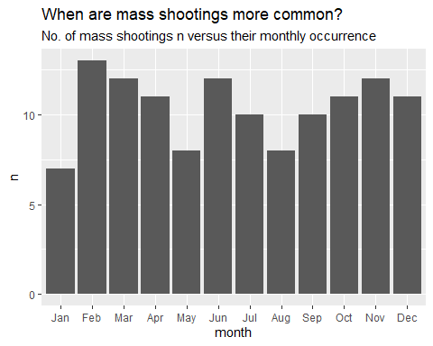

#This bar plot reveals that mass shootings in the US most commonly occur during the month of February. I now produce a data fram that shows the explicit number that occur per month (revealing that this is 13 in February):  
  
monthlyvariation <- mass_shootings %>%  
 count(month) %>%  
 arrange(desc(n))   
monthlyvariation

# A tibble: 12 × 2  
 month n  
 <chr> <int>  
 1 Feb 13  
 2 Jun 12  
 3 Mar 12  
 4 Nov 12  
 5 Apr 11  
 6 Dec 11  
 7 Oct 11  
 8 Jul 10  
 9 Sep 10  
10 Aug 8  
11 May 8  
12 Jan 7

* How does the distribution of mass shooting fatalities differ between White and Black shooters? What about White and Latino shooters?

mass_shootings %>%  
 filter (!is.na(race)) %>%  
 count(fatalities,race) %>%  
 group_by(fatalities,n,race) %>%  
 ggplot() + (aes(x = fatalities, y = n)) + geom_col() + facet_wrap(vars(race)) + labs(title = "How Shooter's Race Affects their Killing Tally?", subtitle = "Frequency distribution of fatalities per shooter's race", x = "Number of fatalities", y = "Frequency")

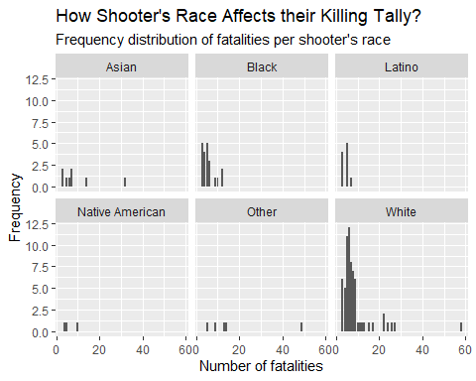

#This set of plots reveal that white, black and Latino shooters track a similar killing distribution profile. There are many fewer cases of black and Latino shooters, but the max point in the distribution appears to be similar between all three cases while the distribution for white shooters seems to have a longer tail at the upper boundary; this suggests that a small proportion of white shooters may shoot many more than those from another race (although it is difficult to make any concrete conclusions as the sample is small). We can calculate the mean to assist although these values not surprisingly vary because of the small samples involved (so we cannot regard these as representative except for the overall mean and the mean for white shooters - which are similar):  
  
#Determining the overall mean (= 8)  
  
mass_shootings %>%  
 filter(!is.na(fatalities)) %>%  
 summarise(meanfat = mean(fatalities))

# A tibble: 1 × 1  
 meanfat  
 <dbl>  
1 8

#Determining the mean for white shooters (= 8.8)  
  
mass_shootings %>%  
 filter(!is.na(fatalities)) %>%  
 filter(race == "White") %>%  
 summarise(meanfat = mean(fatalities))

# A tibble: 1 × 1  
 meanfat  
 <dbl>  
1 8.78

#Determining the mean for black shooters (= 5.6)  
mass_shootings %>%  
 filter(!is.na(fatalities)) %>%  
 filter(race == "Black") %>%  
 summarise(meanfat = mean(fatalities))

# A tibble: 1 × 1  
 meanfat  
 <dbl>  
1 5.57

#Determining the mean for latino shooters (= 4.4)  
mass_shootings %>%  
 filter(!is.na(fatalities)) %>%  
 filter(race == "Latino") %>%  
 summarise(meanfat = mean(fatalities))

# A tibble: 1 × 1  
 meanfat  
 <dbl>  
1 4.4

### Very open-ended

* Are mass shootings with shooters suffering from mental illness different from mass shootings with no signs of mental illness in the shooter?

mass_shootings %>%  
 filter (!is.na(prior_mental_illness)) %>%  
 group_by(total_victims,prior_mental_illness) %>%  
 ggplot(mapping = aes(total_victims)) + geom_bar() + facet_wrap(vars(prior_mental_illness))

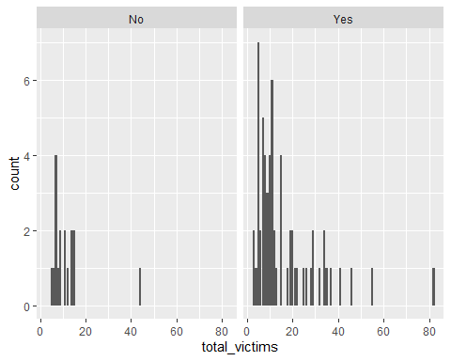

# This plot shows that there are many more shooters who have a priori known signs of mental illness than there are otherwise. The max number of victims that they affect is the same in each case. There is a greater tail of more victims in the case where a mental illness is known in the shooter prior to the shooting.

Assess the relationship between mental illness and total victims, mental illness and location type, and the intersection of all three variables.

#I then explore the relative distribution of total victims versus fatalities in shootings and see if there is a difference between those who are killed or injured as a function of whether or not the shooter showed any prior signs of mental illness. I plot the total victims (green) versus fatalities (dark blue) on each of the two faceted plots that partitions those showing prior signs of mental illness ("Yes") and those that did not. The code and graph are below. The results show that the relative proportions of fatalities and injured victims are similar irrespective of the mental state of the shooter.  
  
mass_shootings %>%  
 filter (!is.na(prior_mental_illness)) %>%  
 group_by(total_victims,fatalities,prior_mental_illness) %>%  
 ggplot(mapping = aes(x = total_victims, y = fatalities, fill = fatalities)) + geom_bar(stat="identity", colour = "green") + facet_wrap(vars(prior_mental_illness))

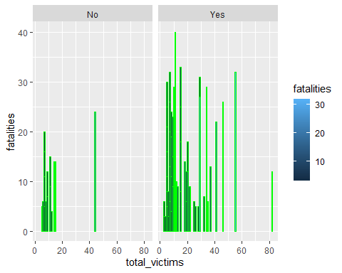

#I now explore possible correlation between mental health and location type using similar code and visualisation:  
  
mass_shootings %>%  
 filter (!is.na(prior_mental_illness)) %>%  
 group_by(location_type,prior_mental_illness) %>%  
 ggplot(mapping = aes(location_type)) + geom_bar() + facet_wrap(vars(prior_mental_illness)) + theme(axis.text = element_text(size=5))

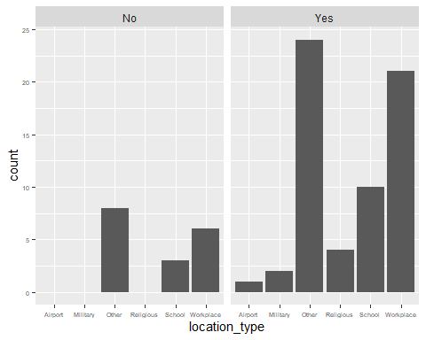

#This plot shows that the school, workplace or other location types are shooting venues with the same proportion, while only shooters with prior signs of mental illness appear to target religious, military and airport locations.  
  
#I then explore possible correlation between the three variables: prior_mental_illness, location_type and total_victims:  
  
mass_shootings %>%  
 filter (!is.na(prior_mental_illness)) %>%  
 group_by(total_victims,location_type,prior_mental_illness) %>%  
 ggplot(mapping = aes(x = total_victims)) + geom_histogram() + facet_grid(rows = vars(location_type), cols = vars(prior_mental_illness)) + theme(axis.text = element_text(size=5),strip.text.y = element_text (size = 4),plot.subtitle = element_text(size=5)) + labs(x = "Number of Total Victims", y = "Frequency", title = "Shooter's Mental State Controls Venue & Victims", subtitle = "Correlating Shooter's Prior Mental Illness (Yes/No) with Shooter's Choice of Location and the Number of Victims Incurred")

`stat_bin()` using `bins = 30`. Pick better value with `binwidth`.

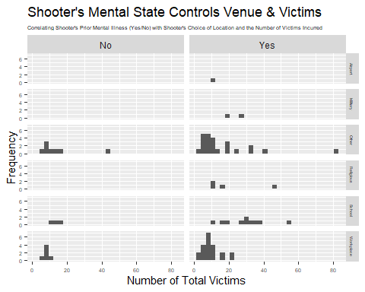

#These results show that the Workplace and 'Other' are the worst types of locations for mass shootings that result in the greatest number of victims. The maximum number of victims in each case lies in the same bin of 8-10 in these histograms, irrespective of the mental state of the shooter, or the location type. Schools are the next most frequent type of location for a mass shooting in the US, with fewer victims overall but a much wider statistical variation of the number of victims for a given shooting than any other location type except for Other. One might interpret this in terms of US school staff being briefed in what to do in a mass shooting but the number of victims varying a lot because of the more unpredictable actions of a child when placed in the path of a shooter. However, we cannot make this interpretation with too much conviction as we don't have any corroboratory evidence beyond these distributions. There are few instances of shootings at religious, military and airport locations and those that exist occur exclusively when the shooter has shown prior signs of mental illness.

Make sure to provide a couple of sentences of written interpretation of your tables/figures. Graphs and tables alone will not be sufficient to answer this question.

# Exploring credit card fraud

We will be using a dataset with credit card transactions containing legitimate and fraud transactions. Fraud is typically well below 1% of all transactions, so a naive model that predicts that all transactions are legitimate and not fraudulent would have an accuracy of well over 99%– pretty good, no? (well, not quite as we will see later in the course)

You can read more on credit card fraud on [Credit Card Fraud Detection Using Weighted Support Vector Machine](https://www.scirp.org/journal/paperinformation.aspx?paperid=105944)

The dataset we will use consists of credit card transactions and it includes information about each transaction including customer details, the merchant and category of purchase, and whether or not the transaction was a fraud.

## Obtain the data

The dataset is too large to be hosted on Canvas or Github, so please download it from dropbox https://www.dropbox.com/sh/q1yk8mmnbbrzavl/AAAxzRtIhag9Nc_hODafGV2ka?dl=0 and save it in your dsb repo, under the data folder

The data dictionary is as follows

| column(variable) | description |
| --- | --- |
| trans_date_trans_time | Transaction DateTime |
| trans_year | Transaction year |
| category | category of merchant |
| amt | amount of transaction |
| city | City of card holder |
| state | State of card holder |
| lat | Latitude location of purchase |
| long | Longitude location of purchase |
| city_pop | card holder’s city population |
| job | job of card holder |
| dob | date of birth of card holder |
| merch_lat | Latitude Location of Merchant |
| merch_long | Longitude Location of Merchant |
| is_fraud | Whether Transaction is Fraud (1) or Not (0) |

* In this dataset, how likely are fraudulent transactions? Generate a table that summarizes the number and frequency of fraudulent transactions per year.
* How much money (in US$ terms) are fraudulent transactions costing the company? Generate a table that summarizes the total amount of legitimate and fraudulent transactions per year and calculate the % of fraudulent transactions, in US$ terms.
* Generate a histogram that shows the distribution of amounts charged to credit card, both for legitimate and fraudulent accounts. Also, for both types of transactions, calculate some quick summary statistics.
* What types of purchases are most likely to be instances of fraud? Consider category of merchants and produce a bar chart that shows % of total fraudulent transactions sorted in order.
* When is fraud more prevalent? Which days, months, hours? To create new variables to help you in your analysis, we use the lubridate package and the following code

mutate(  
 date_only = lubridate::date(trans_date_trans_time),  
 month_name = lubridate::month(trans_date_trans_time, label=TRUE),  
 hour = lubridate::hour(trans_date_trans_time),  
 weekday = lubridate::wday(trans_date_trans_time, label = TRUE)  
 )

* Are older customers significantly more likely to be victims of credit card fraud? To calculate a customer’s age, we use the lubridate package and the following code

mutate(  
 age = interval(dob, trans_date_trans_time) / years(1),  
 )

* Is fraud related to distance? The distance between a card holder’s home and the location of the transaction can be a feature that is related to fraud. To calculate distance, we need the latidue/longitude of card holders’s home and the latitude/longitude of the transaction, and we will use the [Haversine formula](https://en.wikipedia.org/wiki/Haversine_formula) to calculate distance. I adapted code to [calculate distance between two points on earth](https://www.geeksforgeeks.org/program-distance-two-points-earth/amp/) which you can find below

# distance between card holder's home and transaction  
# code adapted from https://www.geeksforgeeks.org/program-distance-two-points-earth/amp/  
  
  
#fraud <- fraud %>%  
 # mutate(  
   
 # convert latitude/longitude to radians  
 # lat1_radians = lat / 57.29577951,  
 # lat2_radians = merch_lat / 57.29577951,  
 #long1_radians = long / 57.29577951,  
 #long2_radians = merch_long / 57.29577951,  
   
 # calculate distance in miles  
 #distance_miles = 3963.0 * acos((sin(lat1_radians) * sin(lat2_radians)) + cos(lat1_radians) * cos(lat2_radians) * cos(long2_radians - long1_radians)),  
  
 # calculate distance in km  
 #distance_km = 6377.830272 * acos((sin(lat1_radians) * sin(lat2_radians)) + cos(lat1_radians) * cos(lat2_radians) * cos(long2_radians - long1_radians))  
  
 #)

Plot a boxplot or a violin plot that looks at the relationship of distance and is_fraud. Does distance seem to be a useful feature in explaining fraud?

# Exploring sources of electricity production, CO2 emissions, and GDP per capita.

There are many sources of data on how countries generate their electricity and their CO2 emissions. I would like you to create three graphs:

## 1. A stacked area chart that shows how your own country generated its electricity since 2000.

You will use

geom_area(colour="grey90", alpha = 0.5, position = "fill")

## 2. A scatter plot that looks at how CO2 per capita and GDP per capita are related

## 3. A scatter plot that looks at how electricity usage (kWh) per capita/day GDP per capita are related

We will get energy data from the Our World in Data website, and CO2 and GDP per capita emissions from the World Bank, using the wbstatspackage.

# Download electricity data  
#url <- "https://nyc3.digitaloceanspaces.com/owid-public/data/energy/owid-energy-data.csv"  
  
#energy <- read_csv(url) %>%   
 # filter(year >= 1990) %>%   
# drop_na(iso_code) %>%   
 # select(1:3,  
# biofuel = biofuel_electricity,  
# coal = coal_electricity,  
# gas = gas_electricity,  
# hydro = hydro_electricity,  
# nuclear = nuclear_electricity,  
# oil = oil_electricity,  
# other_renewable = other_renewable_exc_biofuel_electricity,  
# solar = solar_electricity,  
# wind = wind_electricity,   
# electricity_demand,  
# electricity_generation,  
# net_elec_imports, # Net electricity imports, measured in terawatt-hours  
# energy_per_capita, # Primary energy consumption per capita, measured in kilowatt-hours Calculated by Our World in Data based on BP Statistical Review of World Energy and EIA International Energy Data  
# energy_per_gdp, # Energy consumption per unit of GDP. This is measured in kilowatt-hours per 2011 international-$.  
# per_capita_electricity, # Electricity generation per capita, measured in kilowatt-hours  
 # )   
  
# Download data for C02 emissions per capita https://data.worldbank.org/indicator/EN.ATM.CO2E.PC  
#co2_percap <- wb_data(country = "countries_only",   
# indicator = "EN.ATM.CO2E.PC",   
# start_date = 1990,   
# end_date = 2022,  
# return_wide=FALSE) %>%   
# filter(!is.na(value)) %>%   
 #drop unwanted variables  
# select(-c(unit, obs_status, footnote, last_updated)) %>%   
# rename(year = date,  
# co2percap = value)  
  
  
# Download data for GDP per capita https://data.worldbank.org/indicator/NY.GDP.PCAP.PP.KD  
#gdp_percap <- wb_data(country = "countries_only",   
# indicator = "NY.GDP.PCAP.PP.KD",   
# start_date = 1990,   
# end_date = 2022,  
## return_wide=FALSE) %>%   
# filter(!is.na(value)) %>%   
 #drop unwanted variables  
# select(-c(unit, obs_status, footnote, last_updated#)) %>%   
# rename(year = date,  
# GDPpercap = value)

Specific questions:

1. How would you turn energy to long, tidy format?
2. You may need to join these data frames
   * Use left_join from dplyr to [join the tables](http://r4ds.had.co.nz/relational-data.html)
   * To complete the merge, you need a unique *key* to match observations between the data frames. Country names may not be consistent among the three dataframes, so please use the 3-digit ISO code for each country
   * An aside: There is a great package called [countrycode](https://github.com/vincentarelbundock/countrycode) that helps solve the problem of inconsistent country names (Is it UK? United Kingdon? Great Britain?). countrycode() takes as an input a country’s name in a specific format and outputs it using whatever format you specify.
3. Write a function that takes as input any country’s name and returns all three graphs. You can use the patchwork package to arrange the three graphs as shown below

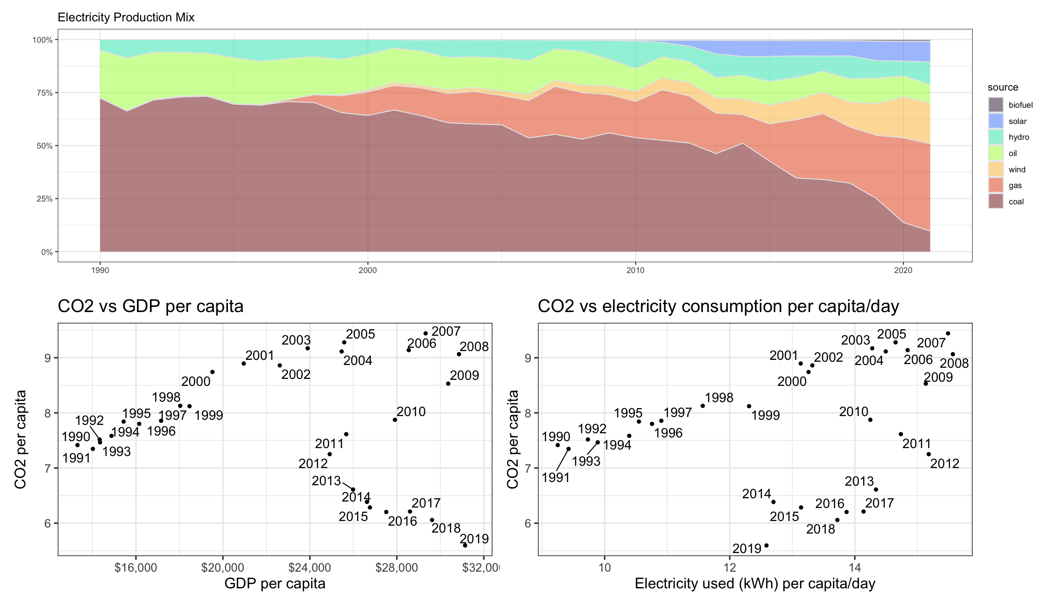

# Deliverables

There is a lot of explanatory text, comments, etc. You do not need these, so delete them and produce a stand-alone document that you could share with someone. Knit the edited and completed Quarto Markdown (qmd) file as a Word document (use the “Render” button at the top of the script editor window) and upload it to Canvas. You must be commiting and pushing tour changes to your own Github repo as you go along.

# Details

* Who did you collaborate with: TYPE NAMES HERE
* Approximately how much time did you spend on this problem set: ANSWER HERE
* What, if anything, gave you the most trouble: ANSWER HERE

**Please seek out help when you need it,** and remember the [15-minute rule](https://mam2022.netlify.app/syllabus/#the-15-minute-rule). You know enough R (and have enough examples of code from class and your readings) to be able to do this. If you get stuck, ask for help from others, post a question on Slack– and remember that I am here to help too!

As a true test to yourself, do you understand the code you submitted and are you able to explain it to someone else?

# Rubric

13/13: Problem set is 100% completed. Every question was attempted and answered, and most answers are correct. Code is well-documented (both self-documented and with additional comments as necessary). Used tidyverse, instead of base R. Graphs and tables are properly labelled. Analysis is clear and easy to follow, either because graphs are labeled clearly or you’ve written additional text to describe how you interpret the output. Multiple Github commits. Work is exceptional. I will not assign these often.

8/13: Problem set is 60–80% complete and most answers are correct. This is the expected level of performance. Solid effort. Hits all the elements. No clear mistakes. Easy to follow (both the code and the output). A few Github commits.

5/13: Problem set is less than 60% complete and/or most answers are incorrect. This indicates that you need to improve next time. I will hopefully not assign these often. Displays minimal effort. Doesn’t complete all components. Code is poorly written and not documented. Uses the same type of plot for each graph, or doesn’t use plots appropriate for the variables being analyzed. No Github commits.