# Tepache

BY [JUNE XIE](https://www.delish.com/author/221969/june-xie/)PUBLISHED: MAY 4, 2022

APPROVED BY THE [DELISH TEST KITCHEN](https://www.delish.com/about/a60636180/tested-approved-delish-kitchen-process/)

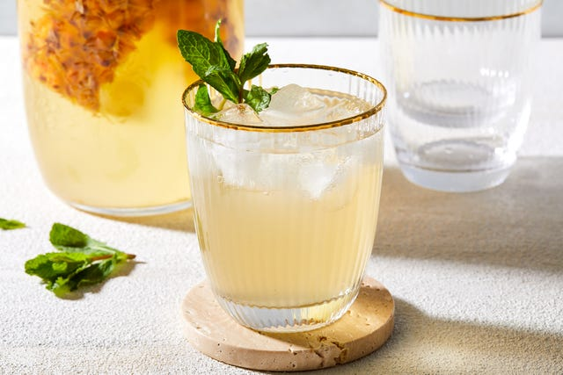

YIELDS:**8** c.

PREP TIME: **10** mins

TOTAL TIME: **10** mins

You can follow this step-by-step to [**cut your pineapple**](https://www.delish.com/kitchen-tools/kitchen-secrets/a20654260/how-to-cut-a-pineapple/) to yield juicy pieces of fruit, but what happens to all that trimmed waste? When it comes to repurposing inedible pineapple skin and the fibrous core, you can add sugar and water to those by-products and make tepache.

A fermented drink originating in Mexico, tepache is usually made with an unrefined brown sugar called piloncillo. You can also substitute granulated sugar, so long as you use real cane sugar and not sugar substitutes. Sugar is necessary in this case to help feed the microorganisms on the pineapple peel; for this reason, it is recommended that you use organic pineapples whenever possible, to eliminate the presence of pesticides and allow for the presence of healthier natural yeast.

Much like making [**kombucha**](https://www.delish.com/cooking/recipe-ideas/a26297879/how-to-make-kombucha-recipe/), you need time and patience for making tepache. The process to turn the pineapple skin into an effervescent drink is usually 5 days, depending on conditions like your water composition, ambient temperature, and how much natural yeast was on your pineapple to begin with. Buy an organic pineapple if it’s available, then wash thoroughly with just water—no soap!—to preserve some of the wild yeast on the skin. Start with a clean, sterilized jar to ensure a successful fermentation and give your mixture a gentle shake or stir a few times every day to help everything get along together. A formation of white scum or film on top is normal. Mold will look like fuzzy greenish-white growths at the surface level.

Tepache, depending on how far the fermentation goes, can be slightly alcoholic. There is a first ferment in the jar at room temperature, then a second ferment that takes place in the fridge. Be sure to “burp” your bottles a couple of times a day or keep your lid loosely tightened to prevent an explosive pop from the gas build-up!

To enjoy, add sweetener or fruit juice or [**strawberry lemonade**](https://www.delish.com/cooking/recipe-ideas/a32714263/easy-strawberry-lemonade-recipe/) until your desired level of fruitiness is achieved. Traditionally, it is served with cinnamon and sometimes beer for a spiked experience. Rum or white wine can also produce a fun tepache cocktail: serve chilled or over ice, with [**simple syrup**](https://www.delish.com/cooking/recipe-ideas/a44964783/simple-syrup-recipe/) or a sprig of bruised mint.

Once you've made a batch, drop us a comment and let us know how you enjoyed it!

## Ingredients

**1** ripe pineapple (preferably organic), washed and dried

* **3/4** **cup** organic cane sugar
* **8** **cups** water
* Mint leaves, for serving

Servings | Prep Time | Total Time