My part seems to be saved in
C:\Users\Ich\Documents\Fritzing\parts\user

in file with following extension: fzp

The index of my part is located in
C:\Users\Ich\Documents\Fritzing\bins\my_parts.fzb

my_parts.fzb is a simple xml file containing the list of my parts

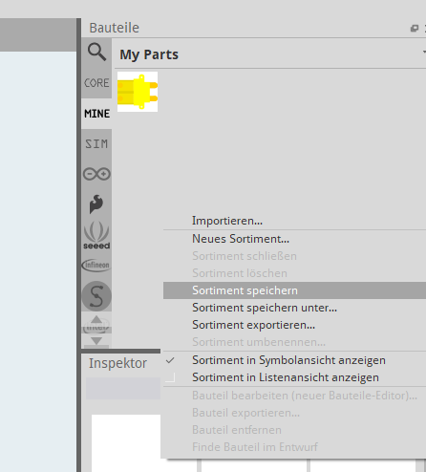
it is update when we saved the part collection

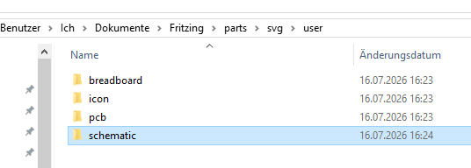
The fzp file is also a xml file that define where the svg can be found.
Svg are loaded from
When the user open a zipped part like
XT30PW-M.fzpz
typically used as model for own custom part. As soon as the archive parted is open,

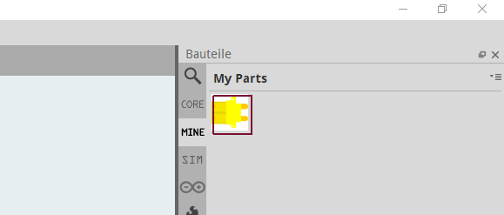
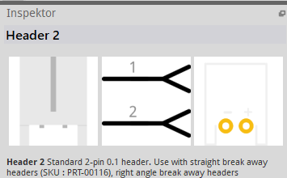
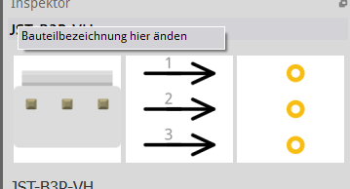
the fzp file and svgs are created in their specific folders
archived that has been opened in Fritzing
Example of female header
Example of male header
Note from (Fritzing's Graphic Standards)
D:\Fujitsu_Lifebook_2026\77_Joy-it_Buckboost01_Fritzing\Input\FontsAndTemplates
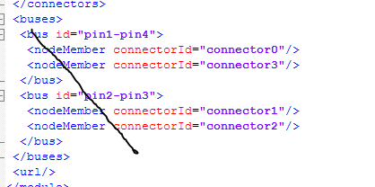
install the OCR A font (right click , and install in system)
The Text must use OCR A font but must be converted to Path and the SVG must be saved as plan-SVG (not inkscape SVG)
Arrow must be draw as path (do not use arrow end).
The xml in *.fzp may contains a bus tag that connect pin internally together. This connection could have been necessary for the base part, but those internal connection maybe unnecessary for the derived part.

