**Abstract-**

**Keywords-** Local government – proof of concept – asset information capture – LoRaWAN Internet of things – budgeting- climate data

INTRODUCTION

The City of Melville has an issue. Heat affects everyone. Choices need to be made. These choices affect budget. Vast material options. Science and research to decision making. Disruptive technology. Internet of things. arming local government. GIS data. Thermal imagery. Cost of Thermal imagery, time taken to get data.Scalability

BODY

Interest in heat dissipation rates for different materials. Tin, astro turf vs established grass, red brick, concrete

Outcomes

Other uses: analysis of tree planting arrangements, water sensors

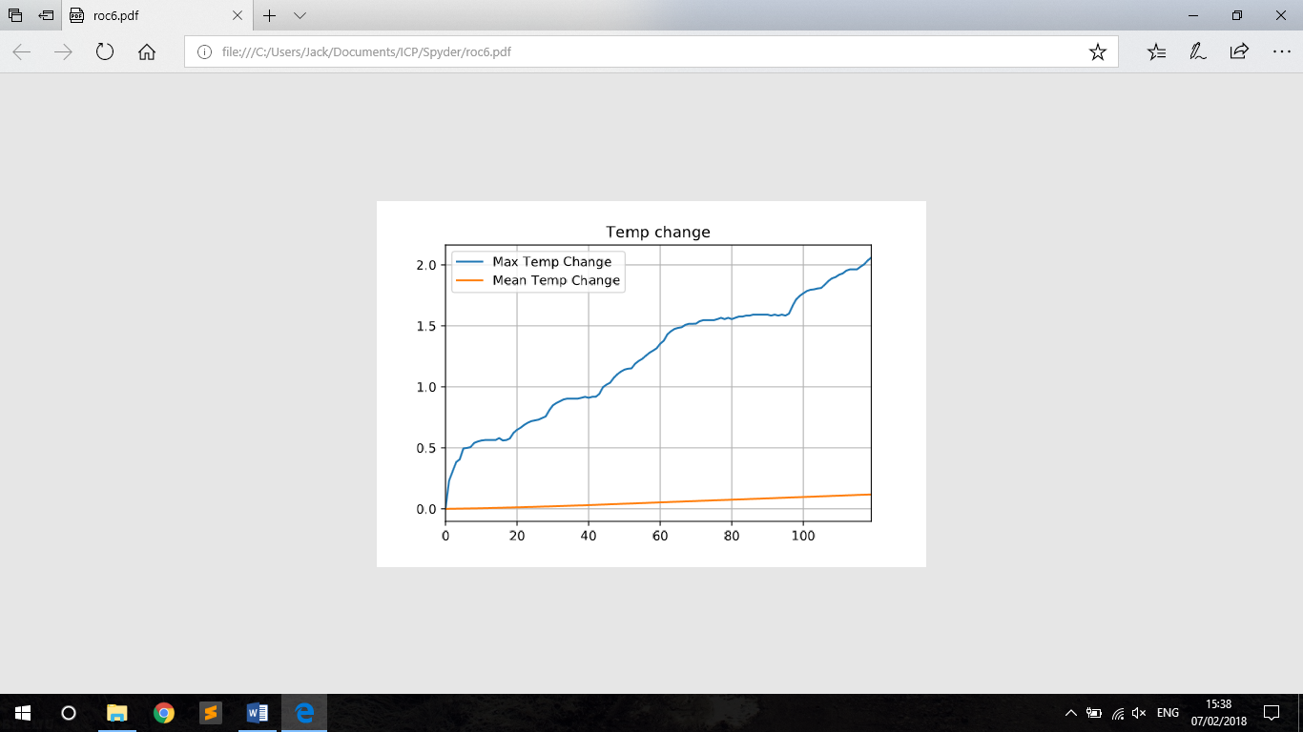

Figure - Max Temp change per minute

Pipeline: graphical overview of system, temporal period analysis, battery times

The Technology: Temp sensors, Arduino, set and forget vs reuse and short cycle deployment

Cost: setup, maintenance, studies, labour, 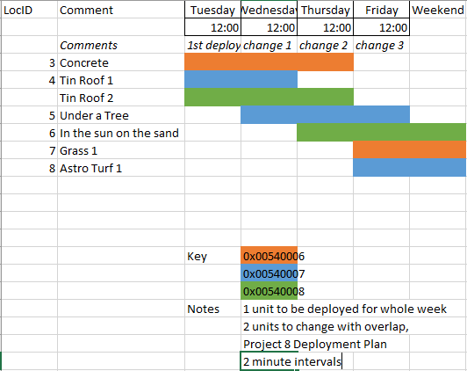

Key issues - sensor accuracy, confirmation bias, Network coverage, theft, battery degradation and fires, third party vs in-house, temperature max outs

RECOMMENDATIONS

do it

CONCLUSION

Local government asset management and planning through utilization of LoRaWAn enabled sensors can be ustilized for case studies on localised temperature readings with realtime feedback