Jacob Harrington

Professor Koenig

CSCI-360

7 October 2021

Project 1 - Part 1

**Problem 1**

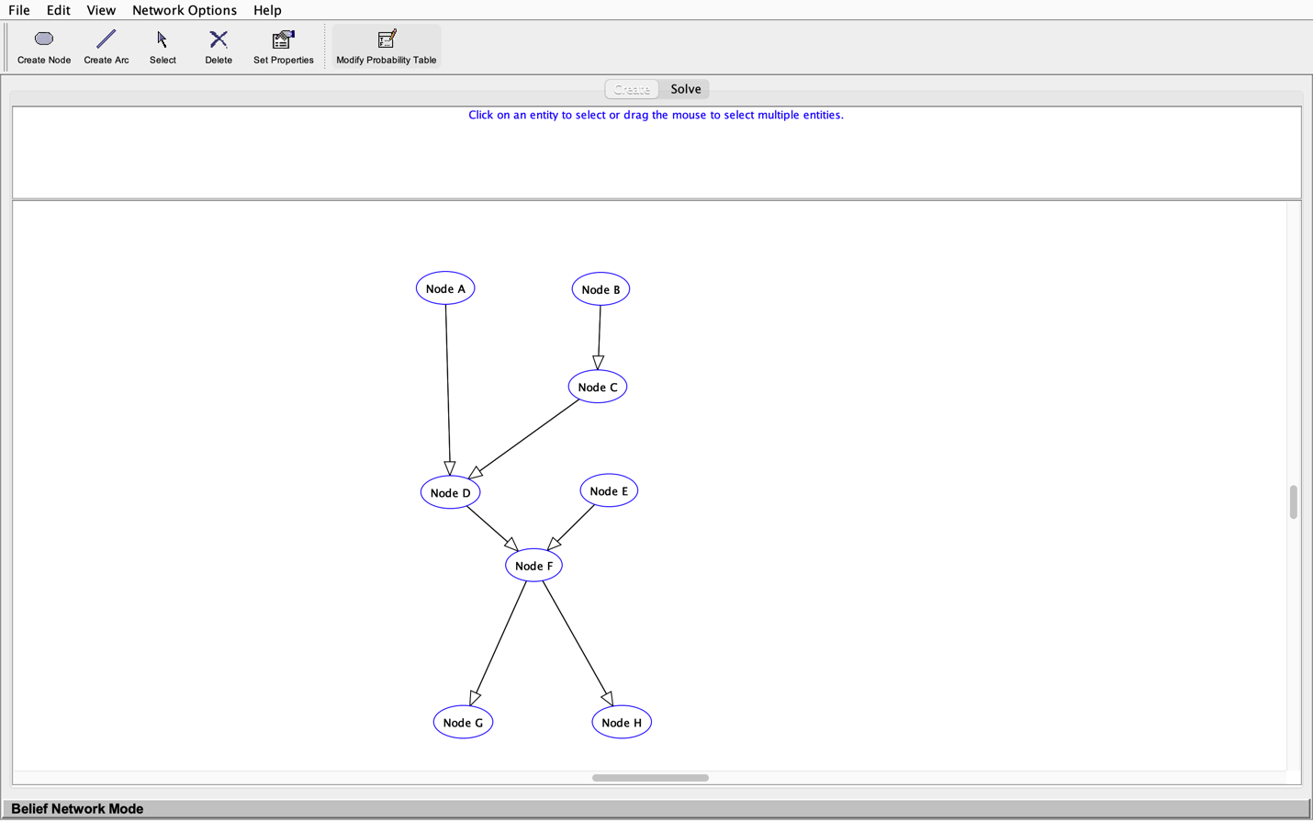

**Problem 2**  
1) Query Result for Variable Node F:

* P (Node F = T) = 0.11662
* P (Node F = F) = 0.883388

2) Toggle Monitoring initial distribution

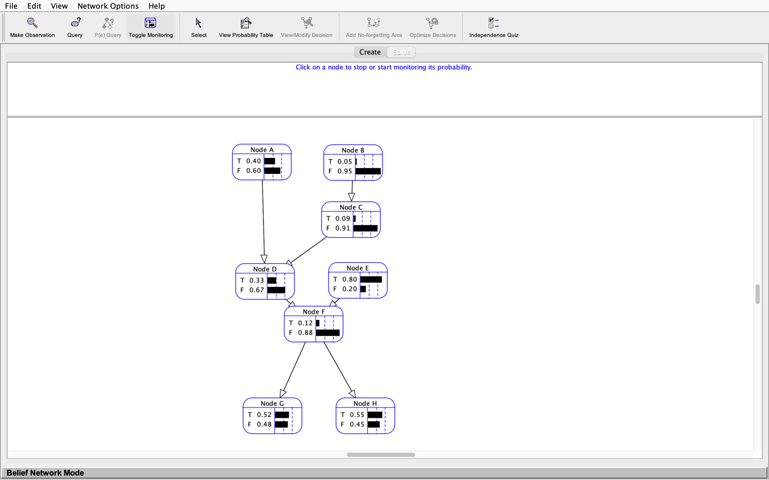

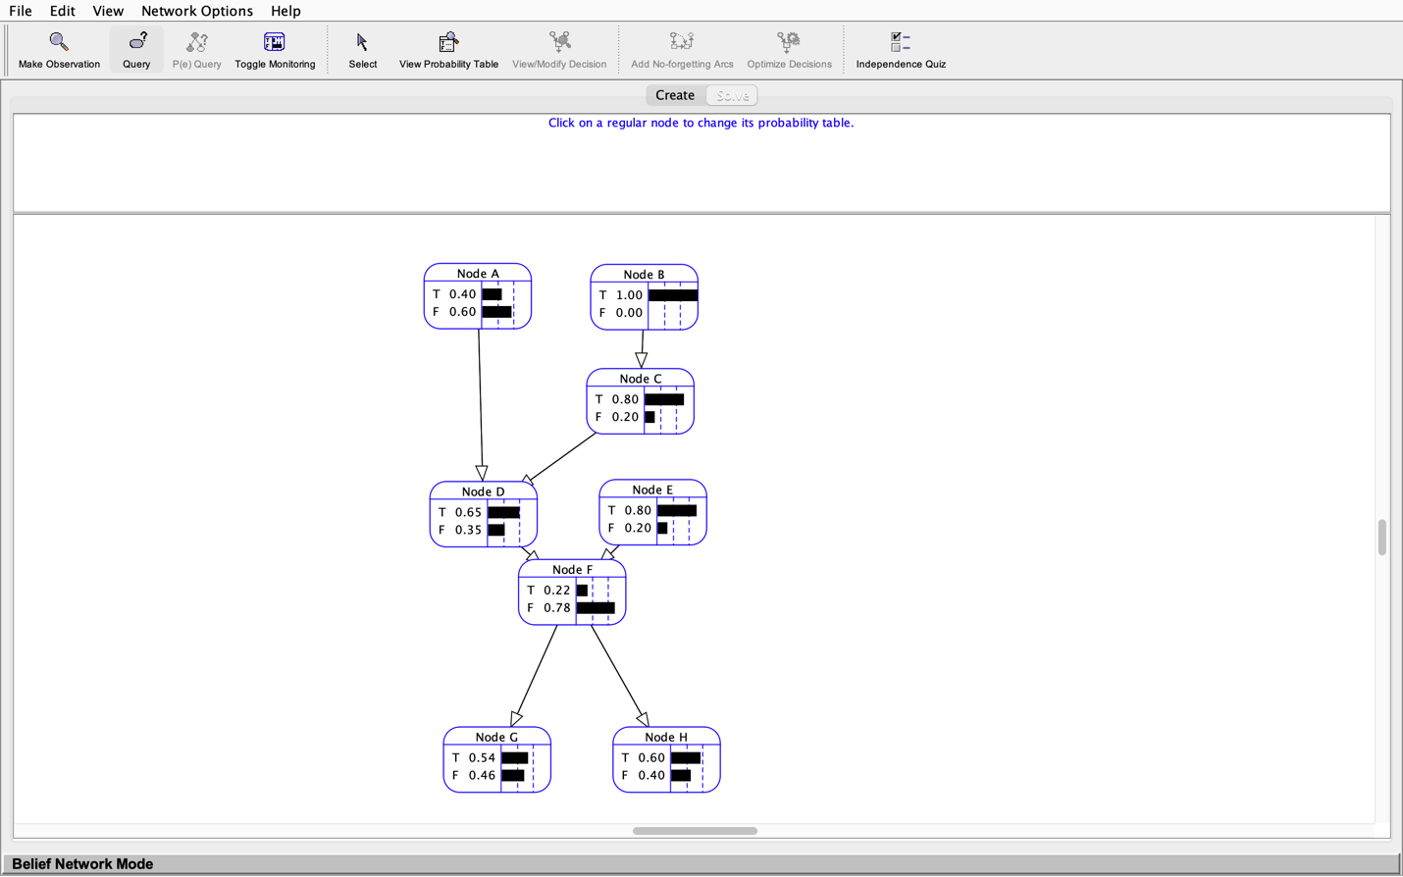3) Change in F, given B is True:

Here, the probability of F increases provided we know the subject is B, a frontline healthcare worker. This occurs as a result of inheritance/conditional dependence. In our Bayesian network, the probability of F relates to both nodes D and E. Continuing up the chain of related nodes, it is clear that D depends on (A and) C which depend on B. Ergo, if B is true, C is more likely to be so, which pools into D, and, ultimately, F. Further evidence of this is apparent when contrasting the two images above; the first is the initial probability distribution and the latter has been tweaked such that B is always true.

**Problem 3**

1) Is random propositional variable G conditionally independent of random propositional variable H given random propositional variable F? Please explain the result or provide a mathematical proof.

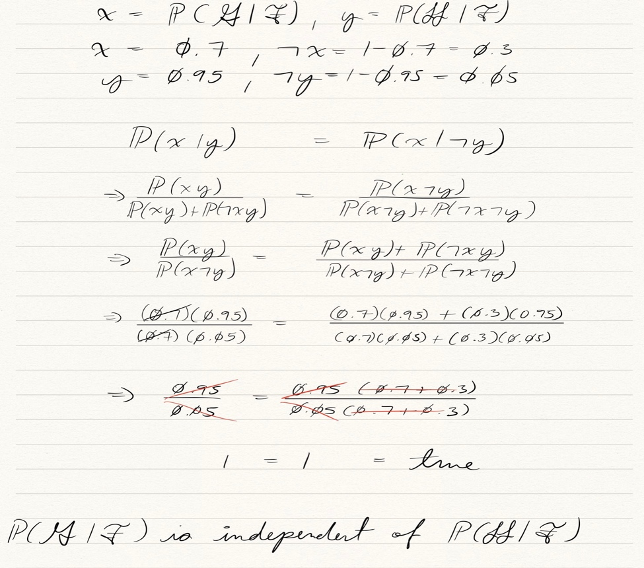 - True

// Change of variables

// If holds, x is independent from y

// Conversion to alternate form

// Simplification

// Always true, thereby, x is independent from y.

2) Is random propositional variable D conditionally independent of random propositional variable E given random propositional variable F? Please explain the result or provide a mathematical proof.

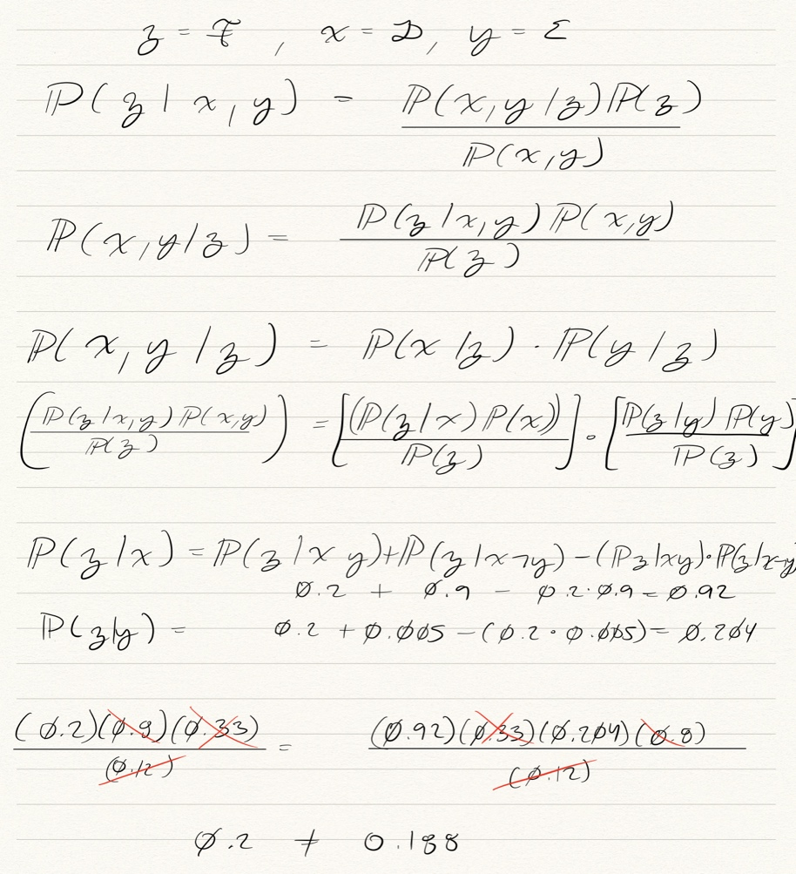 - False

// Converting to alternate form

// If holds, D & E are conditionally  
independent given F

// Converting to alternate forms

// Computations

Z given x = (z|xy) OR (z|x!y)

Z given y = (z|xy) OR (z|!xy)

// Does not hold, thereby, D & E are conditionally dependent given F.