Jacob Harrington

Professor Koenig

CSCI-360

7 October 2021

Project 1 - Part 3

Provided there were no ties involved in the initial four splits, I chose each split based whichever component reflected the highest information gain.

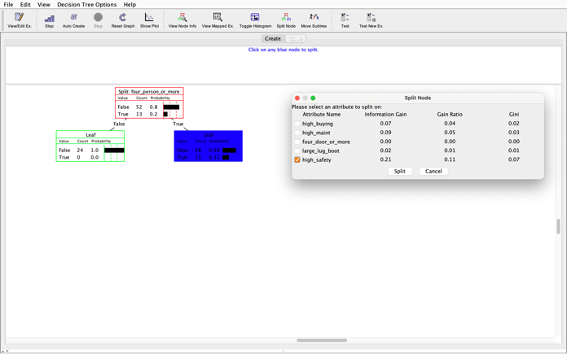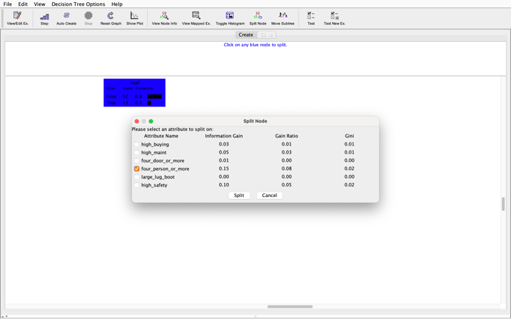

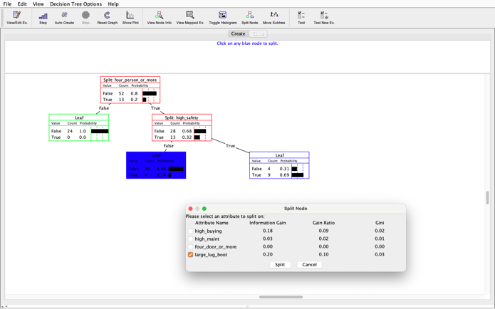

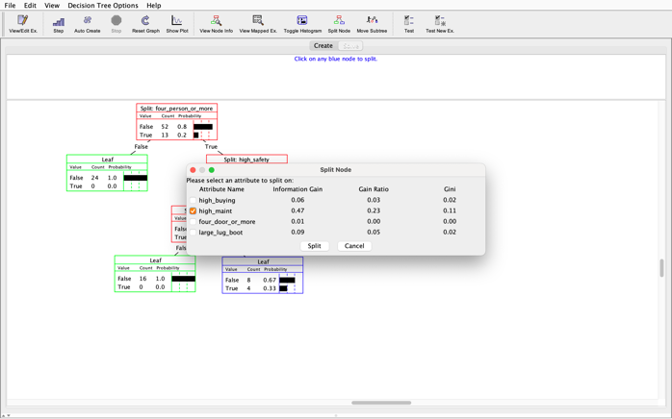

Below is the final tree followed by the test tool results:

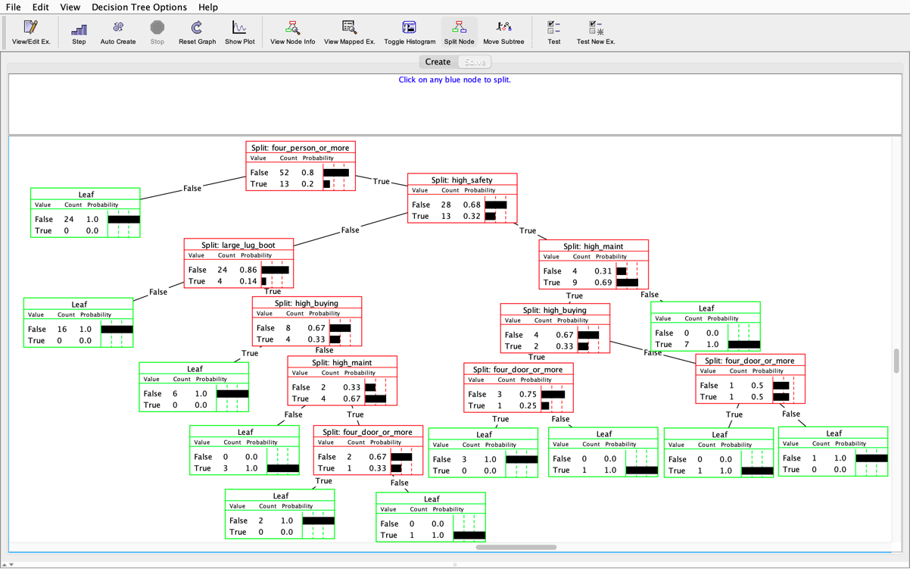

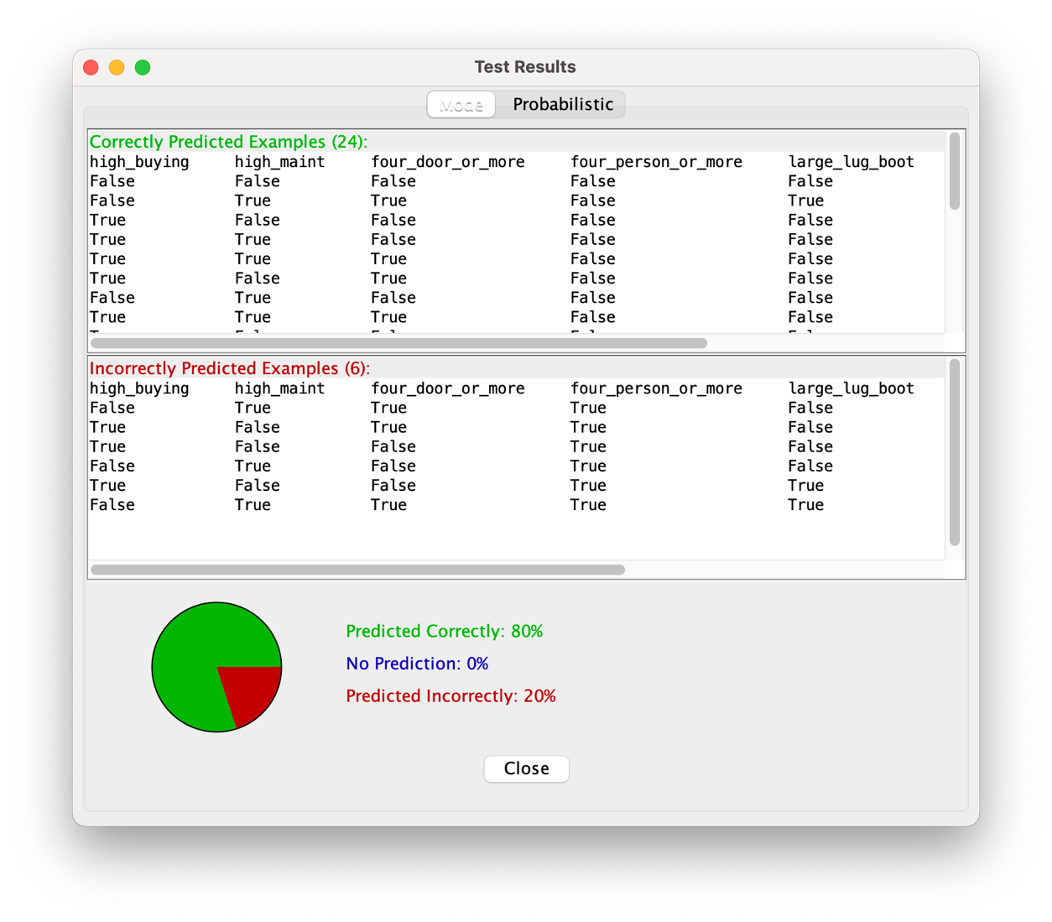

Decision tree from auto-create:

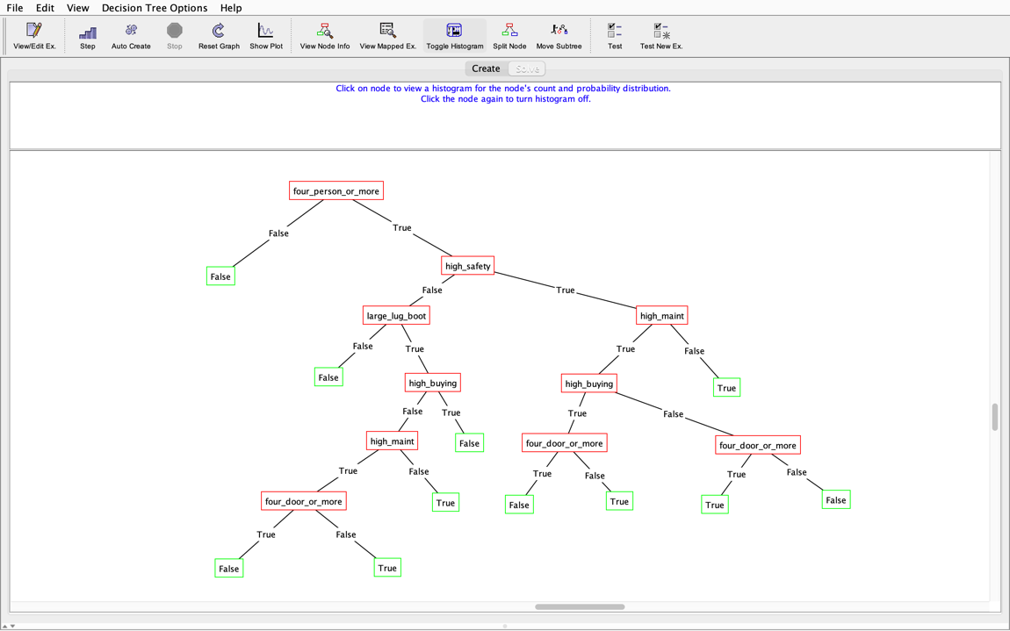

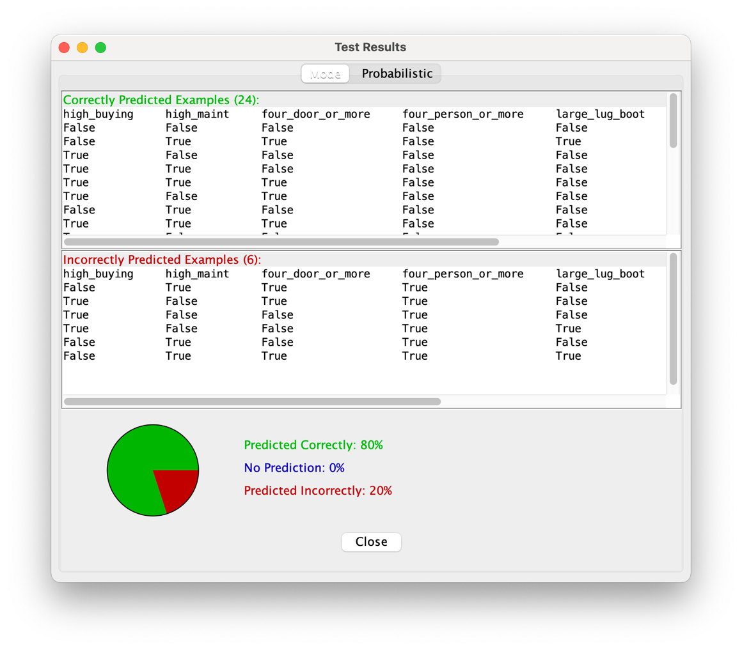

Correctly predicted example: trace decision to derive correct prediction

Four person or more: true => high safety: false => large lugboot: false => decision of false.