Documentation

\*\* This project for everybody who wants to share with information about his daily life or about lessons, about everything. Everybody able to use this application, because this project's interface structure is simple.

\*\* Everybody can able to use this application

\*\* first page is login page if the user has already entered, if not register page.

\*\* then the user may go to the home page in hme page we have the profile,list of users,posts,post categories

\*\* This project contains ->

php laravel library

voyager library

controllers:

HomeController to home page

MessageController to define online users

ProfileController to profile

models:

Message

PostCategory

PostCategoryPivot

Profile

User

\*\* Connected with mysql database

\*\* In middleware folder we have help.php file that takes our names first letters and connects them

\*\* This project has email sending feature -> reset password

\*\* Project has an admin

\*\* Project saves the token in the localStorage

<< Admin >>

\* can delete users

\* can update post categories delete insert

\* can delete user posts

<<Database>>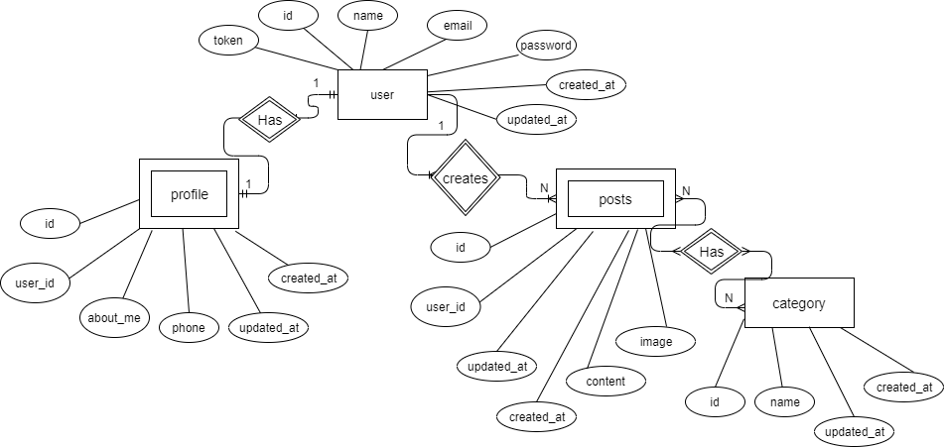

\* has 4 tables

\* user strong entity main table

\* user has profile, profile is weak entity. if user underfined there will not be the profile.

\* posts weak entity because user creates the posts

\* post categories is strong entity, it is not depends on some tables. defines categories of posts, user able to choose it , filter it