Digital Systems Lab — Project Report

4-Digit Password Lock (Hardware-Based)

1. Team Members
# | Name | CRN
1 | Salam Nayel | 202601007
2 | Karim Daw | 202602278
3 | Jad Khaddaj | 202600853

2. Project Description
For this lab work, our group made an entirely hardware-based 4-Digit Password Lock. It consists of ICs and other circuits and is spread out in three breadboards.
How the lock works:
This lock will work if the user presses the four buttons in the following sequential order: 1 → 3 → 5 → 7. On pressing each correct button, the flip-flop will memorize the sequence and move on to the next stage. Also, the digit will be displayed on the 7-segment screen for the user's information. But the lock will only open if all the four digits are entered correctly.
Security feature — the wrong button reset:
There are 10 buttons in total and they are marked 0 to 9. Out of these, four buttons (1, 3, 5, 7) are the correct buttons and pressing them will move on to the next step. But the other six buttons (0, 2, 4, 6, 8, 9) are the wrong buttons. And pressing any one of them anywhere in the middle of the code will reset the whole process. The memories of all the flip-flops will clear up, all the seven segment screens will turn off and then lock starts again.
Status indicators:
- A Red LED is on by default whenever the lock is in a locked state.
- The moment the final correct digit (7) is entered, the Red LED turns off and a Green LED lights up, signaling that the lock is open.

3. Components Used
Component | Quantity / Value | Role in the Circuit
Breadboard | 3 | Main assembly platform for all components
4×AA Battery Pack | 1 | Power source for the entire circuit
Tactile Pushbuttons | 10 | User input (4 correct + 6 decoy/reset buttons)
Resistors | 21 | Pull-down resistors for each pushbutton
74HC74 Dual D-Type Flip-Flop | 2 | Sequential memory — stores each correct button press
7-Segment Decoder | 4 | Decodes binary input and drives the 7-segment displays; hardwired to show 1, 3, 5, and 7
74HC32 Quad OR Gate | 2 | Groups the 6 wrong-button signals into a single error signal
74HC04 Hex NOT Gate | 1 | Inverts the error signal to drive the CLR (clear) pins of the flip-flops
7-Segment Display | 4 | Displays the digits as correct buttons are pressed
Red LED | 1 | Stays on while the lock is in the locked state
Green LED | 1 | Turns on when the full correct code is entered

4. CircuitVerse Diagram & Truth Table
Circuit Diagram:
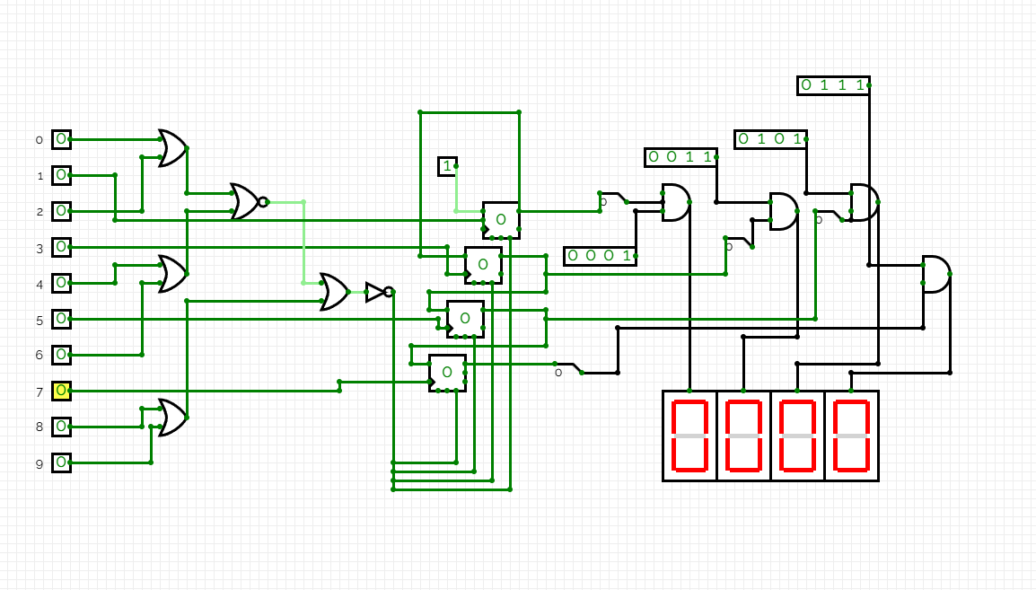

Truth Table:
The table below maps the system's input states to its outputs. Fill in the logic values (0 or 1) based on your circuit behavior.
State | Button Pressed | B1 Correct (1) | B2 Correct (3) | B3 Correct (5) | B4 Correct (7) | Wrong Button | Memory Cleared | Green LED | Red LED
Idle / Reset | — | 0 | 0 | 0 | 0 | 0 | — | 0 | 1
After pressing 1 | 1 | 1 | 0 | 0 | 0 | 0 | 0 | 0 | 1
After pressing 3 | 3 | 1 | 1 | 0 | 0 | 0 | 0 | 0 | 1
After pressing 5 | 5 | 1 | 1 | 1 | 0 | 0 | 0 | 0 | 1
After pressing 7 | 7 | 1 | 1 | 1 | 1 | 0 | 0 | 1 | 0
Wrong button at any stage | 0/2/4/6/8/9 | X | X | X | X | 1 | 1 | 0 | 1

5. Steps Taken

Phase 1 — Building and Testing One Digit
We started by setting up the power rails across all three breadboards and making sure voltage was stable before adding any ICs. The first real step was wiring a single 74HC74 flip-flop connected to the button for digit 1. The output of the flip-flop was then fed into a CD4511 BCD-to-7-segment decoder, which we hardwired with fixed input combinations so it would always display the number "1" when activated.

Phase 2 — Making the Numbers Go in Order
With one digit working, we replicated the same flip-flop and decoder setup three more times — one for each of the remaining correct digits: 3, 5, and 7. The key part of this phase was creating the sequential dependency. We did this by connecting the Q output of the first flip-flop (for digit 1) directly into the clock or enable input of the next flip-flop (for digit 3). This means pressing button 3 does absolutely nothing unless button 1 has already been successfully pressed and its flip-flop is set.
We chained all four stages in the same way, so:
- Button 3 only registers if digit 1 was already entered.
- Button 5 only registers if digits 1 and 3 were already entered.
- Button 7 only registers if digits 1, 3, and 5 were already entered.
After wiring all four stages, we tested each step manually to confirm the sequence was locked in properly.

Phase 3 — Adding the Status Lights
Once the sequential logic was solid, we added the two LED status indicators. The Green LED was connected to the Q output of the final (4th) flip-flop — the one controlled by button 7. When that flip-flop gets set, its output goes HIGH, and the Green LED lights up to signal the lock is open.
The Red LED was wired to be on by default at power-up, staying lit as long as the circuit is in its normal locked state. We connected it so that it automatically turns off when the Green LED turns on, ensuring only one indicator is active at a time. We tested both LEDs individually and confirmed the switching behavior was clean.

Phase 4 — Wiring the Wrong Buttons (The Security Loop)
This was the most involved part of the build. We placed the six decoy buttons (0, 2, 4, 6, 8, 9) on the board and wired each one to an input of a 74HC32 OR gate. Since the 74HC32 has four 2-input OR gates, we grouped the six wrong-button signals across multiple gates, feeding them together so that any single wrong button press produces a HIGH signal at the OR gate output.
That combined error signal was then routed through a 74HC04 NOT gate, which inverted it. The inverted signal was connected directly to the CLR (clear) pins of all four 74HC74 flip-flops simultaneously. This is the reset mechanism: when a wrong button is pressed, the OR gate goes HIGH, the NOT gate flips it LOW, and a LOW on the CLR pin of a 74HC74 immediately clears its memory — snapping all displays back to blank and returning the lock to its initial state.
We tested the reset loop thoroughly by intentionally pressing wrong buttons at various stages of the code to confirm the wipe was instant and complete.
placed the six decoy buttons (0, 2, 4, 6, 8, 9) on the board and wired each one to an input of a 74HC32 OR gate. Since the 74HC32 has four 2-input OR gates, we grouped the six wrong-button signals across multiple gates, feeding them together so that any single wrong button press produces a HIGH signal at the OR gate output.
That combined error signal was then routed through a 74HC04 NOT gate, which inverted it. The inverted signal was connected directly to the CLR (clear) pins of all four 74HC74 flip-flops simultaneously. This is the reset mechanism: when a wrong button is pressed, the OR gate goes HIGH, the NOT gate flips it LOW, and a LOW on the CLR pin of a 74HC74 immediately clears its memory — snapping all displays back to blank and returning the lock to its initial state.
We tested the reset loop thoroughly by intentionally pressing wrong buttons at various stages of the code to confirm the wipe was instant and complete.

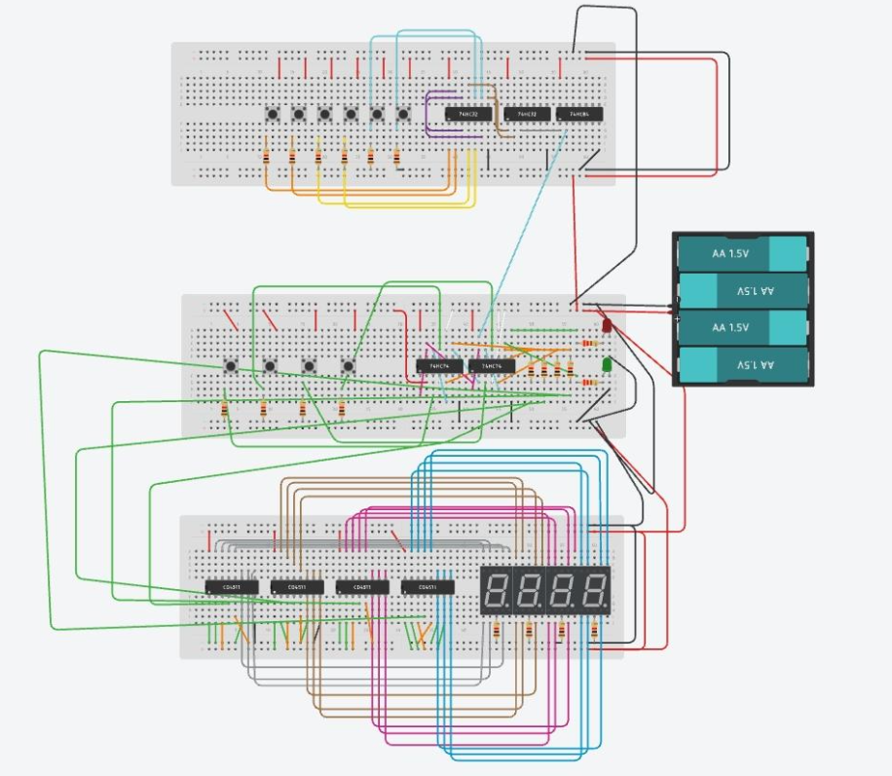
6. Tinkercad Connections

