ISQS-7339: Homework 3 — Solutions

Problem 1 (Monte Carlo Simulation: Travel Time)
a) Here is the simulation setup and results for the total time T = X + Y + Z using 100,000 random observations.
Key result: Estimated mean(T) = 60.296 seconds; SD(T) = 8.097 seconds.
Interpretation: The mean is the expected total time to locate a part, and the standard deviation shows how much the total time typically varies from trip to trip.
Code used to generate the simulation and histogram:
import numpy as np
import matplotlib.pyplot as plt
np.random.seed(123)
n = 100_000
# X ~ Uniform(25, 50)
X = np.random.uniform(25, 50, n)
# Y ~ Triangular(min=10, mode=15, max=25)
Y = np.random.triangular(10, 15, 25, n)
# Z ~ Truncated Normal (lower bound=2, mean=6, sd=2)
mu, sd, lower = 6, 2, 2
Z = np.empty(n)
filled = 0
while filled < n:
batch = int((n-filled)*1.2) + 1000
s = np.random.normal(mu, sd, batch)
s = s[s >= lower]
take = min(len(s), n-filled)
Z[filled:filled+take] = s[:take]
filled += take
T = X + Y + Z
print(T.mean(), T.std(ddof=1))
plt.hist(T, bins=60)
plt.xlabel("Total time (seconds)")
plt.ylabel("Frequency")
plt.title("Total time to locate a part")
plt.show()
Histogram (Total Time):
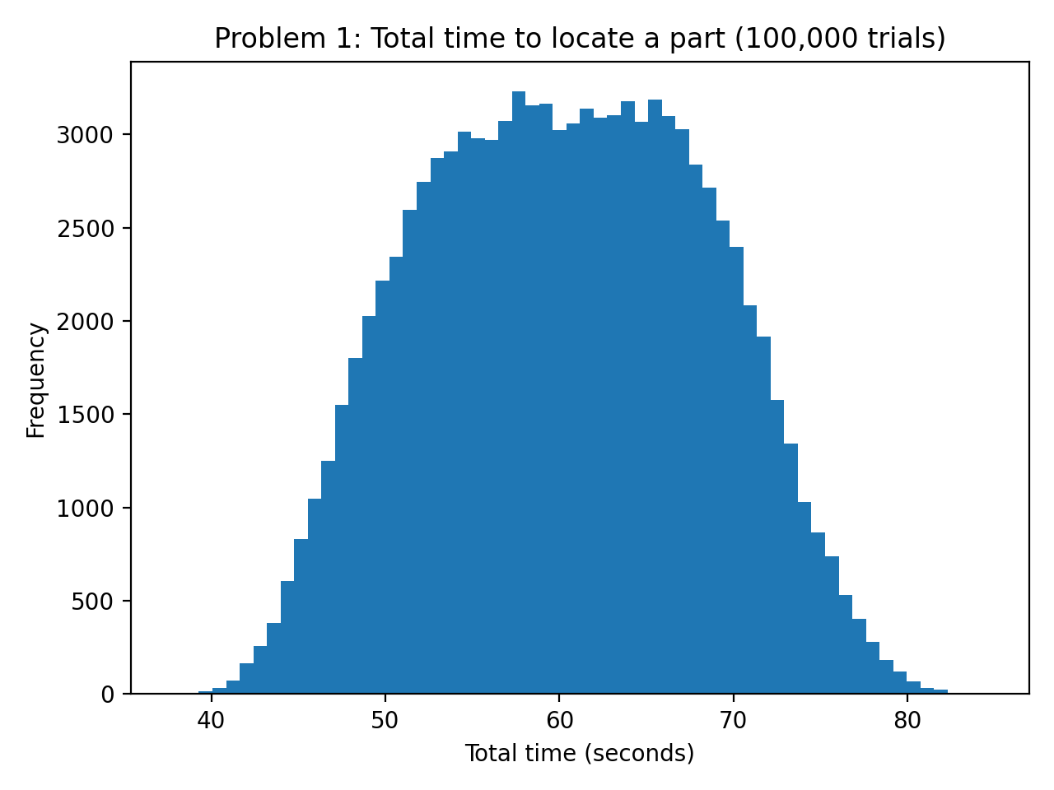
b) Here is the estimated probability that the total time exceeds 70 seconds.
Key result: P(T > 70) = 0.1295.
Interpretation: This is the fraction of simulated trials where the total time was longer than 70 seconds. The vertical line at 70 on the histogram shows the cutoff visually.
Code used for the probability estimate and vertical line:
prob_gt_70 = (T > 70).mean()
print(prob_gt_70)
plt.hist(T, bins=60)
plt.axvline(70)
plt.title("P(T>70) shown with a vertical line at 70")
plt.xlabel("Total time (seconds)")
plt.ylabel("Frequency")
plt.show()
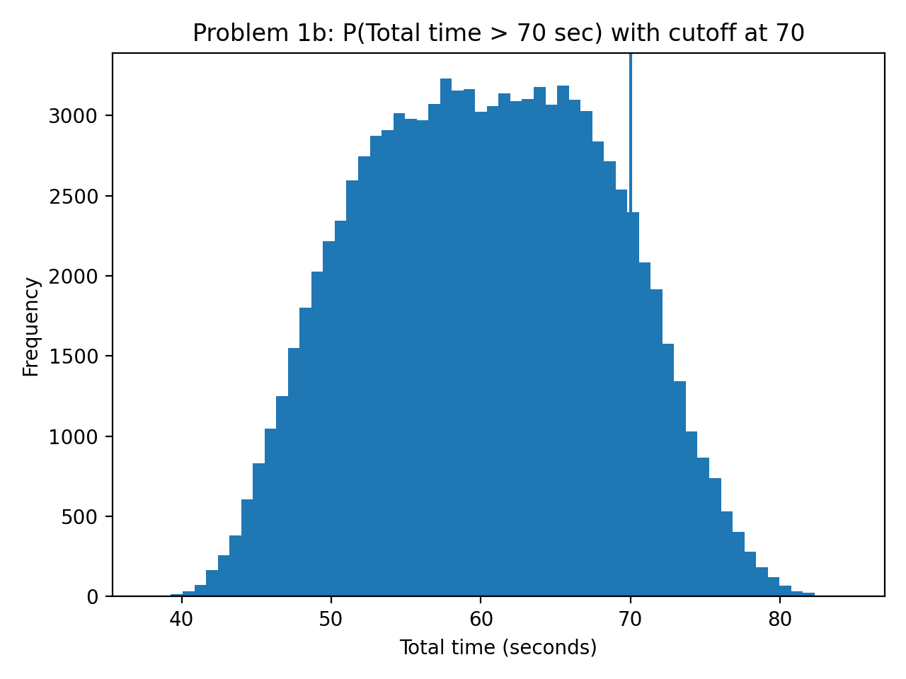

Problem 2 (LCG: Linear Congruential Generator)
a) Here are the first three pseudorandom numbers computed manually for m=200, a=17, c=1, R0=5.
Manual work:
R0 = 5
R1 = (17*5 + 1) mod 200 = 86
U1 = 86 / 200 = 0.43
R2 = (17*86 + 1) mod 200 = 1463 mod 200 = 63
U2 = 63 / 200 = 0.315
R3 = (17*63 + 1) mod 200 = 1072 mod 200 = 72
U3 = 72 / 200 = 0.36
Key result: U1 = 0.43, U2 = 0.315, U3 = 0.36.
b) Here is R code to compute the first 20 pseudorandom numbers from the same LCG.
# R code (LCG)
m <- 200
a <- 17
c <- 1
R0 <- 5
R <- numeric(20)
U <- numeric(20)
r <- R0
for (i in 1:20) {
r <- (a*r + c) %% m
R[i] <- r
U[i] <- r / m
}
data.frame(i=1:20, R=R, U=U)

Problem 3 (Monte Carlo Simulation: Drug NPV)
a) Here is the Monte Carlo model (100,000 trials) to estimate the 5-year NPV (in millions of dollars).
Key result: Mean NPV = 200.715 million; SD NPV = 247.975 million.
Interpretation: A higher mean NPV indicates the project is attractive on average. The standard deviation measures risk/uncertainty in NPV driven by the uncertain inputs (costs, market size, initial market share).
Code used to compute NPV and histogram:
import numpy as np
import matplotlib.pyplot as plt
np.random.seed(123)
n = 100_000
# Uncertain inputs
RD = np.random.triangular(500, 750, 850, n) # R&D cost (millions)
CT = np.random.uniform(135, 170, n) # Clinical trials cost (millions)
market0 = np.random.normal(2_200_000, 250_000, n) # Market size
share1 = np.random.uniform(0.05, 0.10, n) # Year 1 market share
# Constants
discount = 0.08
growth_market = 0.05
growth_share = 0.10
margin_monthly = 150 - 50 # $100
npv = -(RD + CT) # millions
for t in range(1, 6):
market_t = market0 * (1 + growth_market)**(t-1)
share_t = share1 * (1 + growth_share)**(t-1)
cf_dollars = market_t * share_t * 12 * margin_monthly
cf_millions = cf_dollars / 1e6
npv += cf_millions / (1 + discount)**t
print(npv.mean(), npv.std(ddof=1))
plt.hist(npv, bins=60)
plt.title("NPV over 5 years")
plt.xlabel("NPV (millions of $)")
plt.ylabel("Frequency")
plt.show()
Histogram (NPV):
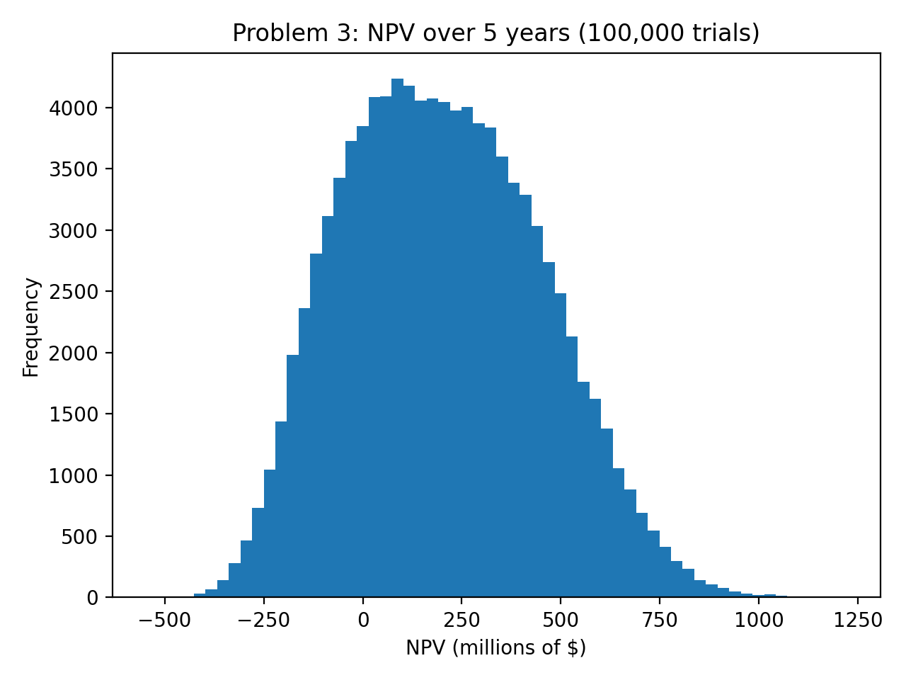
b) Here is the probability of negative NPV and a histogram with a vertical line at 0.
Key result: P(NPV < 0) = 0.2359.
Interpretation: This is the estimated chance the project loses money in present-value terms over 5 years. The vertical line at 0 separates positive (right side) vs negative (left side) outcomes.
Code used for probability of negative NPV and vertical line:
prob_neg = (npv < 0).mean()
print(prob_neg)
plt.hist(npv, bins=60)
plt.axvline(0)
plt.title("Probability of negative NPV (line at 0)")
plt.xlabel("NPV (millions of $)")
plt.ylabel("Frequency")
plt.show()
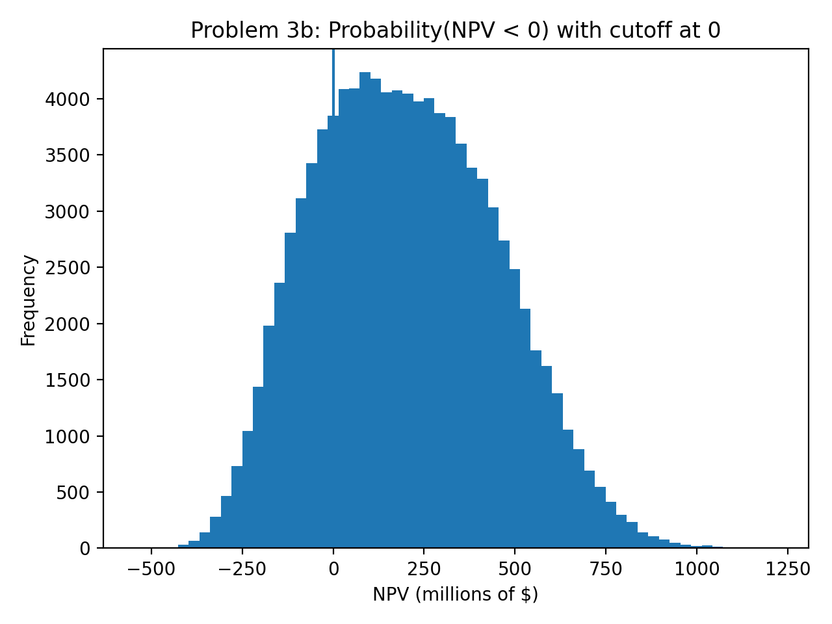

Problem 4 (Newsvendor + Monte Carlo Simulation)
a) Here is the Newsvendor critical fractile approach for Poisson demand with mean 40/day.
Key result: Cu = 6, Co = 2, Critical fractile = 0.750, Optimal Q* ≈ 44 units/day.
Interpretation: Ordering Q* balances the cost of under-ordering (lost margin) vs over-ordering (salvage loss). With a critical fractile of 0.75, we choose the 75th percentile of demand.
Code (R) for Q* (preferred, direct quantile):
# R code for Q* using Poisson quantile
C <- 12; R <- 18; S <- 10
Cu <- R - C
Co <- C - S
crit <- Cu / (Cu + Co)
Q_star <- qpois(crit, lambda = 40)
Q_star
b) Monte Carlo visualization of expected profit vs Q, plus profit distribution at Q*:
Key plot: expected profit should peak around Q*; the histogram shows variability in daily profit due to random demand.
Code used for the Monte Carlo plots:
import numpy as np
import matplotlib.pyplot as plt
from scipy.stats import poisson
np.random.seed(123)
n = 200_000
lam = 40
C, Rprice, S = 12, 18, 10
Cu = Rprice - C
Co = C - S
crit = Cu/(Cu+Co)
Q_star = int(poisson.ppf(crit, lam))
D = np.random.poisson(lam, n)
Qs = np.arange(Q_star-20, Q_star+21)
exp_profit = []
for Q in Qs:
sold = np.minimum(D, Q)
leftover = Q - sold
profit = sold*Rprice + leftover*S - Q*C
exp_profit.append(profit.mean())
plt.plot(Qs, exp_profit)
plt.xlabel("Order quantity Q")
plt.ylabel("Expected profit ($)")
plt.title("Expected profit vs Q")
plt.show()
# Profit distribution at Q*
Q = Q_star
sold = np.minimum(D, Q)
leftover = Q - sold
profit_star = sold*Rprice + leftover*S - Q*C
plt.hist(profit_star, bins=60)
plt.title(f"Profit distribution at Q={Q_star}")
plt.xlabel("Daily profit ($)")
plt.ylabel("Frequency")
plt.show()
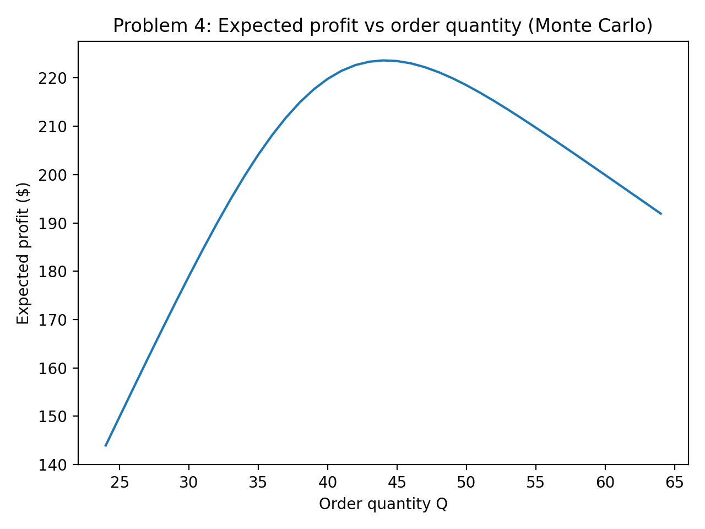
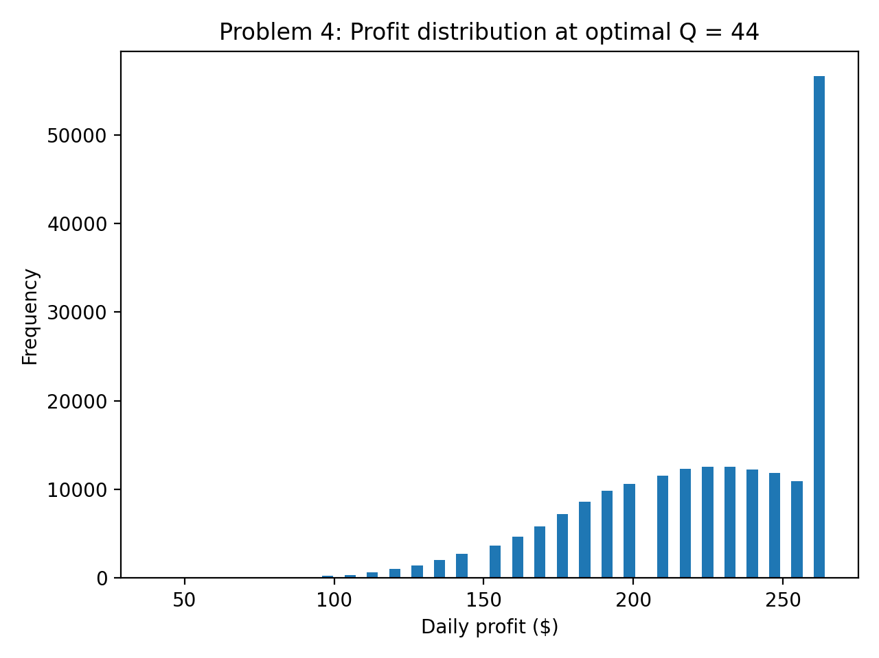
Conclusion statement: The optimal purchase quantity is the Poisson 75th-percentile demand (because critical fractile = 0.75). The Monte Carlo plot confirms the expected profit is maximized around that quantity.

