SO4
Jada Malone
2026-02-16

PROBLEM 1: Wind Turbine Input Analysis + Simulation

—- 1(a) FailCount (Discrete): Poisson vs Negative Binomial —-
mean_fail <- mean(fail)
var_fail <- var(fail)
cat("\nFailCount mean =", mean_fail, "\n")
##
## FailCount mean = 2.93
cat("FailCount variance =", var_fail, "\n")
## FailCount variance = 2.849347
lambda_hat <- mean_fail
cat("Poisson lambda_hat =", lambda_hat, "\n")
## Poisson lambda_hat = 2.93
# Fit Negative Binomial (MASS)
if (!requireNamespace("MASS", quietly=TRUE)) install.packages("MASS")
library(MASS)
nb_fit <- fitdistr(fail, "Negative Binomial")
cat("\nNegative Binomial fit:\n")
##
## Negative Binomial fit:
print(nb_fit)
## size mu
## 100.0016552 2.9300078
## (158.5297901) ( 0.1227979)
if (!requireNamespace("fitdistrplus", quietly=TRUE)) install.packages("fitdistrplus")
library(fitdistrplus)
## Warning: package 'fitdistrplus' was built under R version 4.5.2
## Loading required package: survival
cat("\nHistograms for input analysis...\n")
##
## Histograms for input analysis...
hist(repair, breaks=20, probability=TRUE, main="Histogram: rapair.time", xlab="rapair.time")
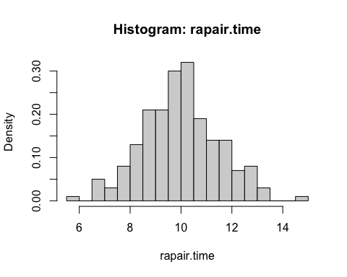
hist(drive, breaks=20, probability=TRUE, main="Histogram: drive.time", xlab="drive.time")
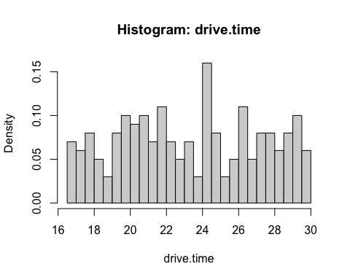
# Fit RepairTime distributions
fit_repair_norm <- fitdist(repair, "norm")
fit_repair_logn <- fitdist(repair, "lnorm")
fit_repair_gamma <- fitdist(repair, "gamma")
fit_repair_weib <- fitdist(repair, "weibull")
# Fit DriveTime distributions
fit_drive_norm <- fitdist(drive, "norm")
fit_drive_logn <- fitdist(drive, "lnorm")
fit_drive_gamma <- fitdist(drive, "gamma")
fit_drive_weib <- fitdist(drive, "weibull")
# AIC comparison tables
repair_AIC <- data.frame(
Distribution = c("Normal","Lognormal","Gamma","Weibull"),
AIC = c(fit_repair_norm$aic, fit_repair_logn$aic, fit_repair_gamma$aic, fit_repair_weib$aic)
)
drive_AIC <- data.frame(
Distribution = c("Normal","Lognormal","Gamma","Weibull"),
AIC = c(fit_drive_norm$aic, fit_drive_logn$aic, fit_drive_gamma$aic, fit_drive_weib$aic)
)
cat("\nRepairTime AIC Comparison:\n")
##
## RepairTime AIC Comparison:
print(repair_AIC)
## Distribution AIC
## 1 Normal 735.9362
## 2 Lognormal 740.0863
## 3 Gamma 737.0708
## 4 Weibull 749.8674
cat("\nDriveTime AIC Comparison:\n")
##
## DriveTime AIC Comparison:
print(drive_AIC)
## Distribution AIC
## 1 Normal 1109.259
## 2 Lognormal 1111.471
## 3 Gamma 1109.578
## 4 Weibull 1110.756
# Select best continuous models (lowest AIC)
best_repair_name <- repair_AIC$Distribution[which.min(repair_AIC$AIC)]
best_drive_name <- drive_AIC$Distribution[which.min(drive_AIC$AIC)]
cat("\nBest RepairTime model:", best_repair_name, "\n")
##
## Best RepairTime model: Normal
cat("Best DriveTime model:", best_drive_name, "\n")
## Best DriveTime model: Normal

—- 1(b) Simulation of income —-
N <- 20000
# Decide FailCount model: use NegBin if overdispersed
use_negbin <- (var_fail > mean_fail * 1.2)
if (use_negbin) {
size_hat <- nb_fit$estimate["size"]
mu_hat <- nb_fit$estimate["mu"]
fail_sim <- rnbinom(N, size=size_hat, mu=mu_hat)
cat("\nFailCount model used: Negative Binomial\n")
cat("size =", size_hat, "mu =", mu_hat, "\n")
} else {
fail_sim <- rpois(N, lambda=lambda_hat)
cat("\nFailCount model used: Poisson\n")
cat("lambda =", lambda_hat, "\n")
}
##
## FailCount model used: Poisson
## lambda = 2.93
# Simulate RepairTime using chosen best model
if (best_repair_name == "Normal") {
repair_sim <- rnorm(N, mean=fit_repair_norm$estimate["mean"], sd=fit_repair_norm$estimate["sd"])
} else if (best_repair_name == "Lognormal") {
repair_sim <- rlnorm(N, meanlog=fit_repair_logn$estimate["meanlog"], sdlog=fit_repair_logn$estimate["sdlog"])
} else if (best_repair_name == "Gamma") {
repair_sim <- rgamma(N, shape=fit_repair_gamma$estimate["shape"], rate=fit_repair_gamma$estimate["rate"])
} else {
repair_sim <- rweibull(N, shape=fit_repair_weib$estimate["shape"], scale=fit_repair_weib$estimate["scale"])
}
# Simulate DriveTime using chosen best model
if (best_drive_name == "Normal") {
drive_sim <- rnorm(N, mean=fit_drive_norm$estimate["mean"], sd=fit_drive_norm$estimate["sd"])
} else if (best_drive_name == "Lognormal") {
drive_sim <- rlnorm(N, meanlog=fit_drive_logn$estimate["meanlog"], sdlog=fit_drive_logn$estimate["sdlog"])
} else if (best_drive_name == "Gamma") {
drive_sim <- rgamma(N, shape=fit_drive_gamma$estimate["shape"], rate=fit_drive_gamma$estimate["rate"])
} else {
drive_sim <- rweibull(N, shape=fit_drive_weib$estimate["shape"], scale=fit_drive_weib$estimate["scale"])
}
# Income formula
income_sim <- 2 * (repair_sim + drive_sim) * fail_sim
# Report stats + 95% CI for mean
mean_income <- mean(income_sim)
sd_income <- sd(income_sim)
CI_income <- mean_income + c(-1, 1) * 1.96 * sd_income / sqrt(N)
cat("\n--- Problem 1(b) Results ---\n")
##
## --- Problem 1(b) Results ---
cat("Mean income =", mean_income, "\n")
## Mean income = 194.5038
cat("SD income =", sd_income, "\n")
## SD income = 116.4425
cat("95% CI for mean income =", CI_income[1], "to", CI_income[2], "\n")
## 95% CI for mean income = 192.89 to 196.1176
hist(income_sim, breaks=30, main="Simulated Yearly Income per Turbine", xlab="Income ($)")
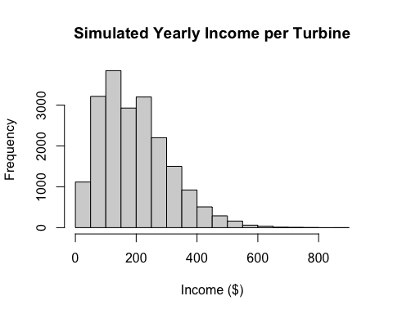

PROBLEM 2: Bootstrap median + 95% CI (Prestige dataset)
if (!requireNamespace("car", quietly=TRUE)) install.packages("car")
library(car)
## Warning: package 'car' was built under R version 4.5.2
## Loading required package: carData
data("Prestige")
income <- Prestige$income
income <- income[!is.na(income)]
B <- 20000
n <- length(income)
boot_medians <- numeric(B)
for (b in 1:B) {
boot_medians[b] <- median(sample(income, size=n, replace=TRUE))
}
median_hat <- median(income)
CI_median <- quantile(boot_medians, probs=c(0.025, 0.975))
cat("\n--- Problem 2 Results ---\n")
##
## --- Problem 2 Results ---
cat("Sample median =", median_hat, "\n")
## Sample median = 5930.5
cat("95% Bootstrap CI for median:\n")
## 95% Bootstrap CI for median:
print(CI_median)
## 2.5% 97.5%
## 5134.0 6750.5
hist(boot_medians, breaks=30,
main="Bootstrap Distribution of Median (Prestige$income)",
xlab="Bootstrapped median")
abline(v=median_hat, lwd=2)
abline(v=CI_median[1], lty=2, lwd=2)
abline(v=CI_median[2], lty=2, lwd=2)
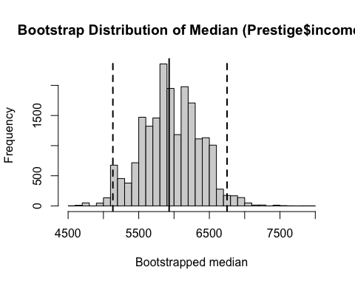

PROBLEM 3: Newsvendor resampling simulation
news <- read.csv("newsVendorData(1).csv")
cat("\nNewsvendor columns:\n")
##
## Newsvendor columns:
print(colnames(news))
## [1] "demand"
cat("\nFirst 5 rows:\n")
##
## First 5 rows:
print(head(news))
## demand
## 1 27
## 2 45
## 3 37
## 4 58
## 5 38
## 6 45
demand <- news$demand
C <- 12
R <- 18
S <- 10
profit_fn <- function(Q, D) {
sold <- pmin(Q, D)
leftover <- pmax(Q - D, 0)
R*sold + S*leftover - C*Q
}
Q_grid <- seq(min(demand), max(demand), by=1)
B <- 20000
avg_profit <- numeric(length(Q_grid))
for (i in seq_along(Q_grid)) {
Q <- Q_grid[i]
D_sim <- sample(demand, size=B, replace=TRUE)
avg_profit[i] <- mean(profit_fn(Q, D_sim))
}
Q_star <- Q_grid[which.max(avg_profit)]
cat("\nOptimal purchase quantity Q* =", Q_star, "\n")
##
## Optimal purchase quantity Q* = 45
plot(Q_grid, avg_profit, type="l",
main="Expected Profit vs Order Quantity (Resampling Simulation)",
xlab="Order Quantity Q", ylab="Mean Profit")
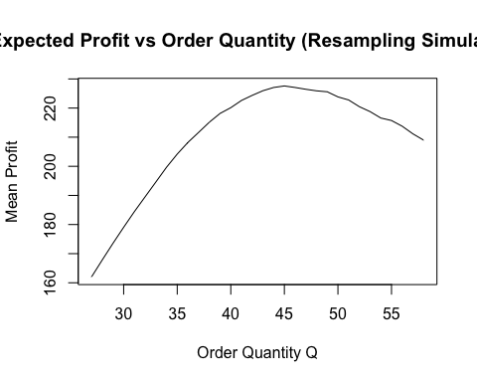
# Profit distribution at optimal Q*
D_star <- sample(demand, size=B, replace=TRUE)
profit_star <- profit_fn(Q_star, D_star)
CI_profit <- quantile(profit_star, probs=c(0.025, 0.975))
cat("\n--- Problem 3 Results ---\n")
##
## --- Problem 3 Results ---
cat("Mean profit at Q* =", mean(profit_star), "\n")
## Mean profit at Q* = 227.7392
cat("95% CI for profit at Q*:\n")
## 95% CI for profit at Q*:
print(CI_profit)
## 2.5% 97.5%
## 134 270
hist(profit_star, breaks=30,
main=paste("Profit Distribution at Optimal Q* =", Q_star),
xlab="Profit")
