Problem 1
import simpy
import numpy as np
import matplotlib.pyplot as plt

SIM_TIME = 360
N_REPS = 50

def run_replications(sim_fn, n_reps=50, seed=123):
results = []
for i in range(n_reps):
rng = np.random.default_rng(seed + i) # independent seed per rep
results.append(sim_fn(rng=rng, rep=i))
return results
def tri_service(rng):
return rng.triangular(5, 10, 20)

def interarrival_p1(rng):
return rng.exponential(14)

def sim_p1_single_queue(rng, rep):
env = simpy.Environment()
ops = simpy.Resource(env, capacity=2)
waits = []

def call():
arrival = env.now
with ops.request() as req:
yield req
waits.append(env.now - arrival)
yield env.timeout(tri_service(rng))

def generator():
while True:
yield env.timeout(interarrival_p1(rng))
env.process(call())

env.process(generator())
env.run(until=SIM_TIME)
return float(np.mean(waits)) if len(waits) else np.nan

def sim_p1_separate_random(rng, rep):
env = simpy.Environment()
op1 = simpy.Resource(env, capacity=1)
op2 = simpy.Resource(env, capacity=1)
waits = []

def call():
arrival = env.now
chosen = op1 if rng.random() < 0.5 else op2
with chosen.request() as req:
yield req
waits.append(env.now - arrival)
yield env.timeout(tri_service(rng))

def generator():
while True:
yield env.timeout(interarrival_p1(rng))
env.process(call())

env.process(generator())
env.run(until=SIM_TIME)
return float(np.mean(waits)) if len(waits) else np.nan

# run
res_a = run_replications(sim_p1_single_queue, N_REPS)
res_b = run_replications(sim_p1_separate_random, N_REPS)

# plots
plt.figure()
plt.hist([v for v in res_a if np.isfinite(v)], bins=12)
plt.title("P1(a) Avg waiting time (single queue)")
plt.xlabel("minutes"); plt.ylabel("count")
plt.show()

plt.figure()
plt.hist([v for v in res_b if np.isfinite(v)], bins=12)
plt.title("P1(b) Avg waiting time (separate random queues)")
plt.xlabel("minutes"); plt.ylabel("count")
plt.show()

print("Mean A:", np.nanmean(res_a))
print("Mean B:", np.nanmean(res_b))
print("Difference (B-A):", np.nanmean(res_b) - np.nanmean(res_a))
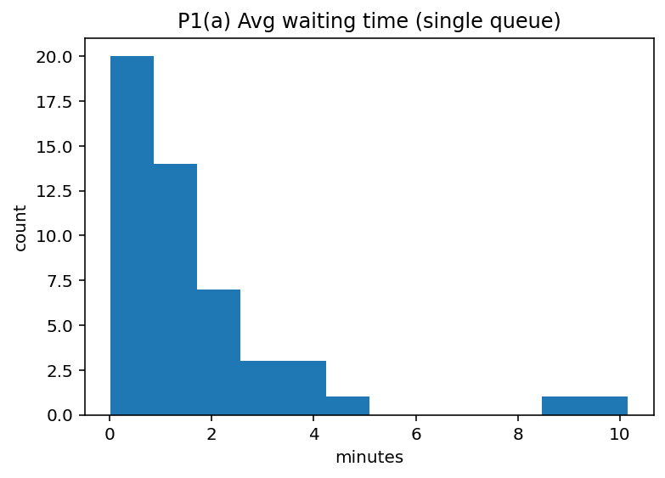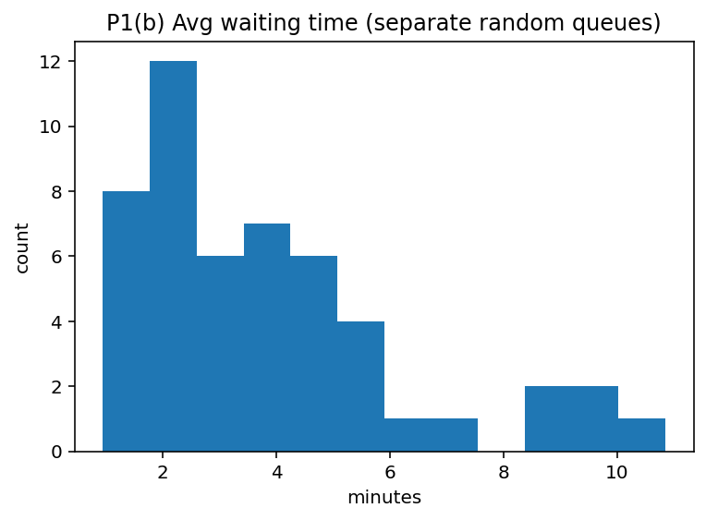
Answers
Mean A: 1.723327603528461
Mean B: 3.8267348132991525
Difference (B-A): 2.1034072097706913
*This means that you reserve a quicker response when there is two operators each having their own queue.

Problem 2
SIM_TIME_P2 = 360
def ci95(x):
x = np.array([v for v in x if np.isfinite(v)]) # remove NaN/Inf
n = len(x)
mean = np.mean(x)
std = np.std(x, ddof=1)
half_width = 1.96 * std / np.sqrt(n)
return mean, (mean - half_width, mean + half_width)

def interarrival_p2(rng):
return rng.exponential(5)

def service_op12(rng):
return rng.uniform(5, 20)

def service_op3(rng):
# if you want to avoid negatives: max(0, rng.normal(15,3))
return max(0.0, rng.normal(15, 3))

def sim_p2(rng, rep):
env = simpy.Environment()
op = [simpy.Resource(env, capacity=1) for _ in range(3)]

waits = [[], [], []]
busy = [0.0, 0.0, 0.0] # accumulate service time actually performed

def call():
arrival = env.now
k = rng.integers(0, 3) # 0,1,2 random routing
with op[k].request() as req:
yield req
waits[k].append(env.now - arrival)
st = service_op3(rng) if k == 2 else service_op12(rng)
busy[k] += st
yield env.timeout(st)

def generator():
while True:
yield env.timeout(interarrival_p2(rng))
env.process(call())

env.process(generator())
env.run(until=SIM_TIME_P2)

util = [b / SIM_TIME_P2 for b in busy]
avg_wait = [float(np.mean(w)) if len(w) else np.nan for w in waits]
return util, avg_wait

# replications
utils = []
avg_waits = []
for i in range(N_REPS):
u, w = sim_p2(np.random.default_rng(1000+i), i) # independent seeds per rep
utils.append(u)
avg_waits.append(w)

utils = np.array(utils) # shape (reps, 3)
avg_waits = np.array(avg_waits)

# Utilization plots
plt.figure()
plt.plot(utils[:,0]); plt.title("P2 Utilization Op1"); plt.ylim(0,1); plt.show()
plt.figure()
plt.plot(utils[:,1]); plt.title("P2 Utilization Op2"); plt.ylim(0,1); plt.show()
plt.figure()
plt.plot(utils[:,2]); plt.title("P2 Utilization Op3"); plt.ylim(0,1); plt.show()

# Waiting time per operator
for k in range(3):
m = np.nanmean(avg_waits[:,k])
ci = ci95(avg_waits[:,k])
print(f"Op{k+1} mean wait={m:.3f}, CI95={ci[1]}")
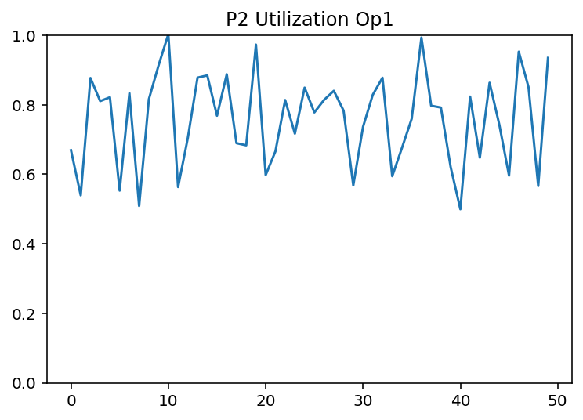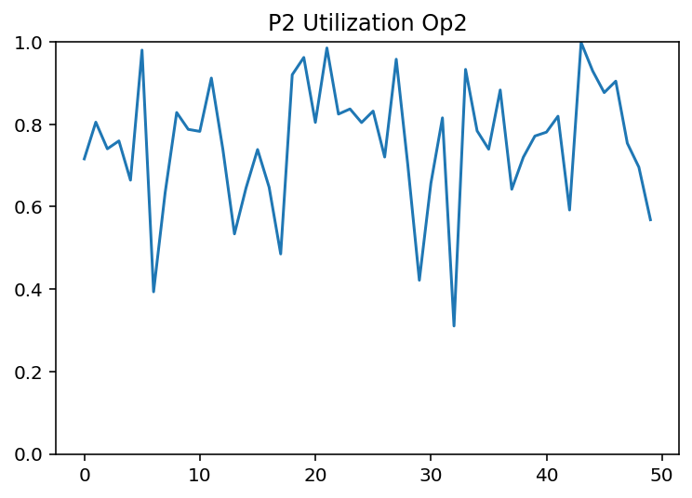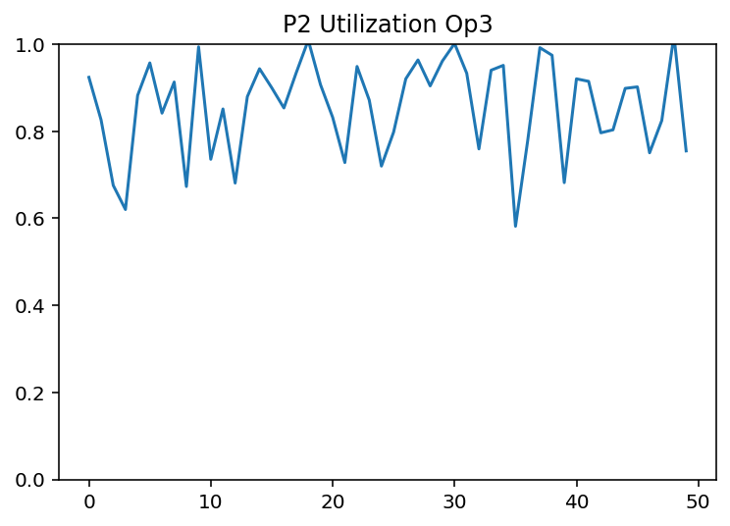
Answers
Op1 mean wait=14.743, CI95=11.401042894637971 , 18.084287948351996
Op2 mean wait=15.845, CI95= 12.637095314956884, 19.05368375636907
Op3 mean wait=25.983, CI95= 21.643941331378617, 30.32134723040483
* Operators 1 and 2 exhibit similar average waiting times because they share identical service time distributions and receive calls with equal probability. Their confidence intervals overlap, indicating no meaningful difference between them. Operator 3, however, has a significantly higher average waiting time. This is due to her longer average service time (Normal with mean 15 minutes versus 12.5 minutes for Operators 1 and 2). The utilization plot confirms that Operator 3 operates closer to full capacity, creating longer queues and increased waiting times. The simulation demonstrates how even modest increases in service time can substantially increase waiting time, especially as utilization approaches 1. Operator 3 becomes the system bottleneck.

Problem 3
import simpy
import numpy as np
import matplotlib.pyplot as plt
from scipy.stats import truncnorm

SIM_TIME_P3 = 2000
N_REPS = 50

def truncnorm_interarrival(rng, low=0.5, mean=4.0, sd=2.0):
a = (low - mean) / sd
return truncnorm.rvs(a=a, b=np.inf, loc=mean, scale=sd, random_state=rng)

def pos_normal(rng, mean, sd):
return max(0.0, rng.normal(mean, sd))

def sim_p3_one_rep(seed=123):
rng = np.random.default_rng(seed)
env = simpy.Environment()

m1 = simpy.Resource(env, capacity=1)
m2 = simpy.Resource(env, capacity=1)
op1 = simpy.Resource(env, capacity=1)
op2 = simpy.Resource(env, capacity=1)

# --- tracking ---
flow_t = {1: [], 2: []}
wait_t = {1: [], 2: []} # waiting for machine (queue delay)
busy_m = {1: 0.0, 2: 0.0} # service time accumulation (machine busy)
busy_op = {1: 0.0, 2: 0.0}# setup time accumulation (operator busy)
count = {1: 0, 2: 0}

def part():
part_type = 1 if rng.random() < 0.60 else 2
arrival = env.now
count[part_type] += 1

if part_type == 1:
# --- waiting for Machine 1 ---
t0 = env.now
with m1.request() as reqm:
yield reqm
wait_t[1].append(env.now - t0)

# setup using Operator 1 (required)
with op1.request() as reqo:
yield reqo
setup = 1.0
busy_op[1] += setup
yield env.timeout(setup)

# service on Machine 1
service = pos_normal(rng, 4.5, 1.0)
busy_m[1] += service
yield env.timeout(service)

else:
# --- waiting for Machine 2 ---
t0 = env.now
with m2.request() as reqm:
yield reqm
wait_t[2].append(env.now - t0)

# setup using Operator 2 (required)
with op2.request() as reqo:
yield reqo
setup = 1.5
busy_op[2] += setup
yield env.timeout(setup)

# service on Machine 2
service = pos_normal(rng, 7.5, 1.5)
busy_m[2] += service
yield env.timeout(service)

depart = env.now
flow_t[part_type].append(depart - arrival)

def generator():
while True:
yield env.timeout(truncnorm_interarrival(rng))
env.process(part())

env.process(generator())
env.run(until=SIM_TIME_P3)

# utilization estimates
util = {
"m1": busy_m[1] / SIM_TIME_P3,
"m2": busy_m[2] / SIM_TIME_P3,
"op1": busy_op[1] / SIM_TIME_P3,
"op2": busy_op[2] / SIM_TIME_P3
}

# average metrics
avg_flow = {k: (np.mean(flow_t[k]) if flow_t[k] else np.nan) for k in [1,2]}
avg_wait = {k: (np.mean(wait_t[k]) if wait_t[k] else np.nan) for k in [1,2]}

return util, avg_flow, avg_wait

# --- Run replications ---
utils = []
flows1, flows2 = [], []
waits1, waits2 = [], []

for r in range(N_REPS):
util, avg_flow, avg_wait = sim_p3_one_rep(seed=1000+r)
utils.append(util)
flows1.append(avg_flow[1]); flows2.append(avg_flow[2])
waits1.append(avg_wait[1]); waits2.append(avg_wait[2])

# --- Plots required for (a) ---
plt.figure(); plt.plot([u["m1"] for u in utils]); plt.title("P3 Utilization: Machine 1"); plt.ylim(0,1); plt.show()
plt.figure(); plt.plot([u["m2"] for u in utils]); plt.title("P3 Utilization: Machine 2"); plt.ylim(0,1); plt.show()
plt.figure(); plt.plot(flows1); plt.title("P3 Avg Flow Time: Type 1"); plt.show()
plt.figure(); plt.plot(flows2); plt.title("P3 Avg Flow Time: Type 2"); plt.show()
plt.figure(); plt.plot(waits1); plt.title("P3 Avg Waiting Time (machine queue): Type 1"); plt.show()
plt.figure(); plt.plot(waits2); plt.title("P3 Avg Waiting Time (machine queue): Type 2"); plt.show()

# --- Report for (b) ---
print("P3 Avg total flow time Type 1:", np.nanmean(flows1))
print("P3 Avg total flow time Type 2:", np.nanmean(flows2))
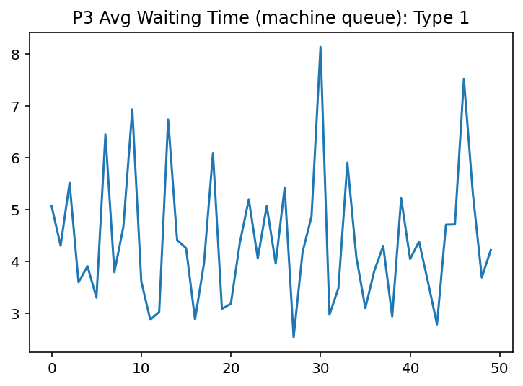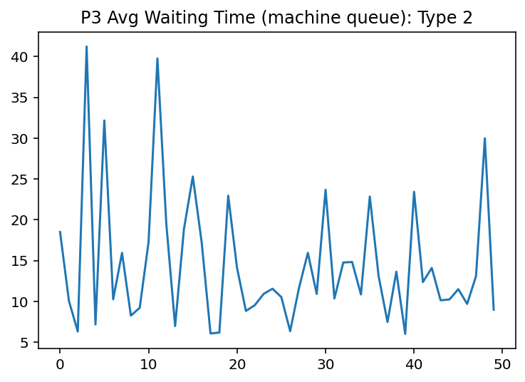
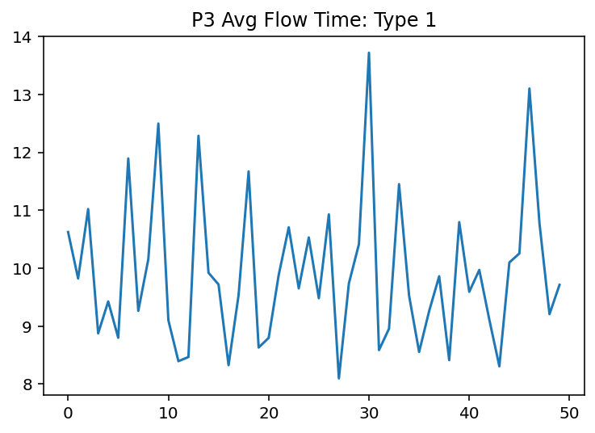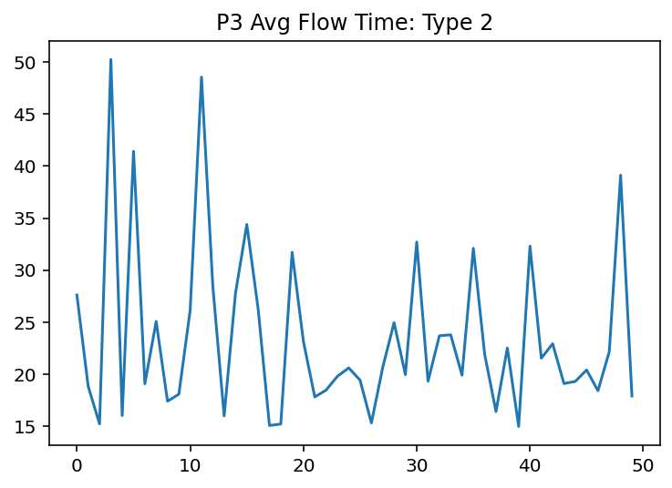
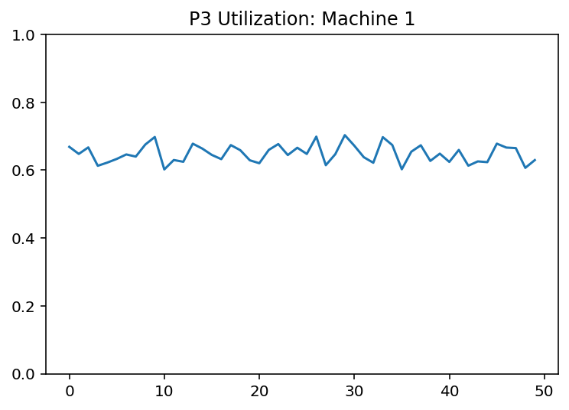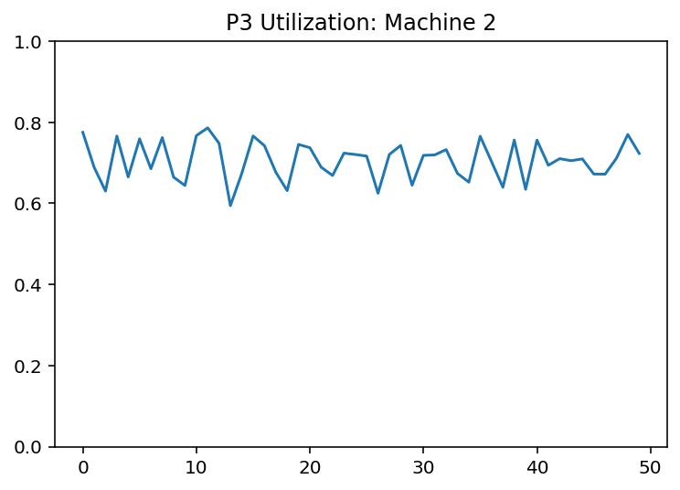
Answers
P3 Avg total flow time Type 1: 9.918655785931582
P3 Avg total flow time Type 2: 23.580037984394618
* The results show that Type 2 parts have a higher average flow time and waiting time compared to Type 1 parts. This is expected because Type 2 parts require a longer setup time (1.5 minutes vs. 1 minute) and have a longer average service time (7.5 minutes vs. 4.5 minutes), which increases machine utilization and queue congestion. The utilization plots indicate that the machine processing Type 2 parts operates closer to capacity, making it the primary bottleneck in the system.

Problem 4
import simpy
import numpy as np
import matplotlib.pyplot as plt
from scipy.stats import gamma

SIM_TIME_P4 = 480
N_REPS = 50

def interarrival_p4(rng): return rng.exponential(6)
def triage_time(rng): return rng.triangular(3, 5, 10)
def doc_high(rng): return max(0.0, rng.normal(40, 5))
def doc_low(rng): return gamma.rvs(a=15, scale=1.0, random_state=rng) # rate=1 => scale=1
def patience_low(rng): return rng.uniform(15, 25)

def sim_p4_one_rep(seed=123):
rng = np.random.default_rng(seed)
env = simpy.Environment()

nurse = simpy.Resource(env, capacity=1)
doctors = simpy.Resource(env, capacity=3)

flow_high, flow_low = [], []
low_balk = 0
low_total = 0
low_renege = 0 # extra (not asked, but useful insight)

def patient():
nonlocal low_balk, low_total, low_renege

arrival = env.now
is_high = (rng.random() < 0.25)

# Balking check BEFORE triage (based on doctor queue)
if len(doctors.queue) > 10:
if not is_high:
low_balk += 1
low_total += 1
return

# Triage (nurse)
with nurse.request() as reqn:
yield reqn
yield env.timeout(triage_time(rng))

# After triage: request doctor with reneging for LOW
reqd = doctors.request()
if is_high:
# High: wait as long as needed (no reneging stated)
yield reqd
else:
# Low: renege if waiting exceeds patience
low_total += 1
pat = patience_low(rng)

# Race: either doctor request succeeds or patience timeout fires
result = yield reqd | env.timeout(pat)

if reqd not in result:
# Timed out => reneged (left)
doctors.release(reqd) if False else None # don't release; never acquired
low_renege += 1
return
# else: got the doctor, continue

# Service
st = doc_high(rng) if is_high else doc_low(rng)
yield env.timeout(st)
doctors.release(reqd)

depart = env.now
flow = depart - arrival
if is_high:
flow_high.append(flow)
else:
flow_low.append(flow)

def generator():
while True:
yield env.timeout(interarrival_p4(rng))
env.process(patient())

env.process(generator())
env.run(until=SIM_TIME_P4)

return {
"flow_high_mean": np.mean(flow_high) if flow_high else np.nan,
"flow_low_mean": np.mean(flow_low) if flow_low else np.nan,
"p_low_balk": (low_balk / low_total) if low_total else np.nan,
"p_low_renege": (low_renege / low_total) if low_total else np.nan
}

# --- Run replications ---
out = [sim_p4_one_rep(seed=5000+r) for r in range(N_REPS)]
flow_high = [d["flow_high_mean"] for d in out]
flow_low = [d["flow_low_mean"] for d in out]
p_balk = [d["p_low_balk"] for d in out]
p_ren = [d["p_low_renege"] for d in out]

# --- Report ---
print("P4 mean flow time HIGH:", np.nanmean(flow_high))
print("P4 mean flow time LOW :", np.nanmean(flow_low))
print("P4 Prob LOW balk :", np.nanmean(p_balk))
print("P4 Prob LOW renege (extra insight):", np.nanmean(p_ren))

# --- Simple plots ---
plt.figure(); plt.plot(flow_high); plt.title("P4 Avg flow time HIGH (per rep)"); plt.show()
plt.figure(); plt.plot(flow_low); plt.title("P4 Avg flow time LOW (per rep)"); plt.show()
plt.figure(); plt.plot(p_balk); plt.title("P4 Prob LOW balk (per rep)"); plt.ylim(0,1); plt.show()
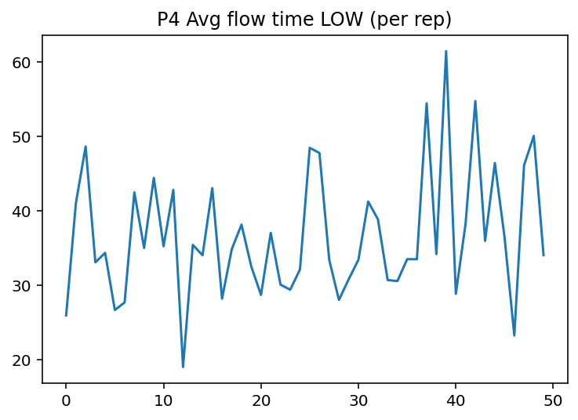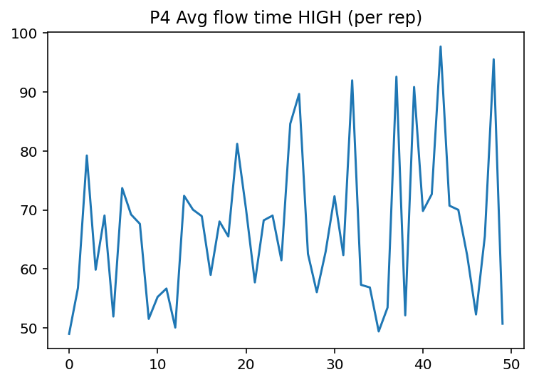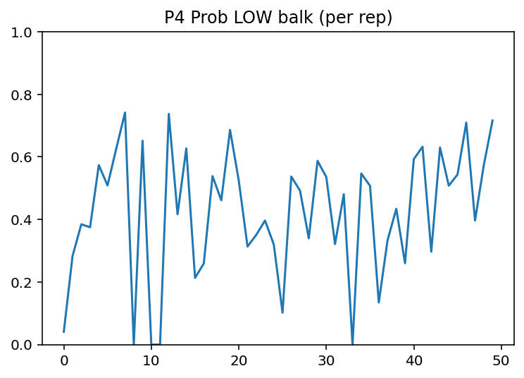
Answers
P4 mean flow time HIGH: 66.87080334901334
P4 mean flow time LOW : 36.723352041207534
P4 Prob LOW balk : 0.4248752575369934
P4 Prob LOW renege (extra insight): 0.23150717406689

