Finding 3 – Time Series Analysis : Month offense counts by offense types
Grouped 2024 offense records by OFNS_DESC and OCC_MONTH to analyze monthly offense trends for the top five offense categories. The time series line chart shows that offense patterns varied by month and offense type. Petit larceny was consistently the highest offense category and peaked in July with 9,580 cases. Harassment peaked earlier in May with 7,745 cases, while assault-related offenses peaked in June with 6,015 cases. Criminal mischief and grand larceny also peaked in July. Overall, several major offenses were highest during late spring and summer, then declined noticeably by December.
Variables/Inputs : OFNS_DESC, OCC_MONTH, OCC_YEAR
Model : Monthly time series trend analysis of offense counts grouped by offense type.
Finding statement : Most top offense types peak in late spring or summer.
Limitation : This analysis only uses one year of data, so it cannot prove long-term seasonal patterns.

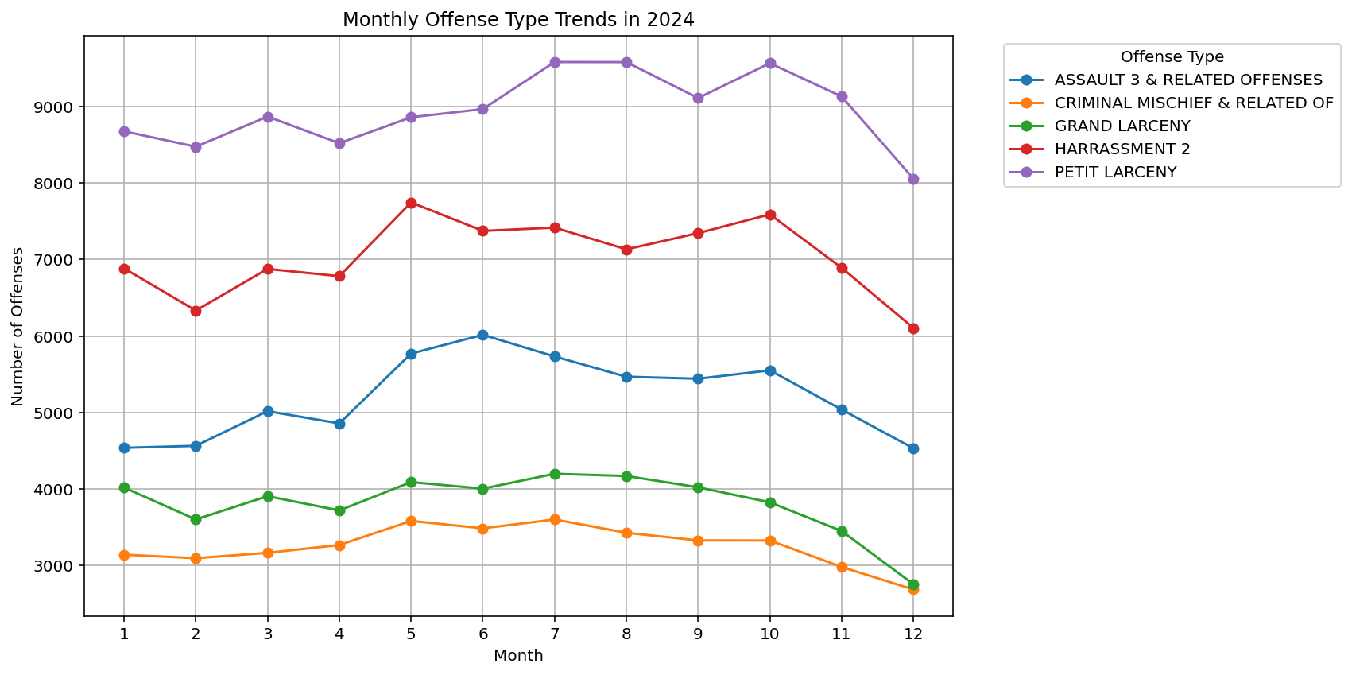

Peak Month and Count by Offense Type:
Peak Month Peak Count
OFNS_DESC
ASSAULT 3 & RELATED OFFENSES 6 6015
CRIMINAL MISCHIEF & RELATED OF 7 3602
GRAND LARCENY 7 4199
HARRASSMENT 2 5 7745
PETIT LARCENY 7 9580
Readable Peak Summary:
Peak Month Peak Count Peak Month Name
OFNS_DESC
ASSAULT 3 & RELATED OFFENSES 6 6015 June
CRIMINAL MISCHIEF & RELATED OF 7 3602 July
GRAND LARCENY 7 4199 July
HARRASSMENT 2 5 7745 May
PETIT LARCENY 7 9580 July

