Homework2
Jada Malone
2025-06-19

Problem 1

a. Expected value and standard deviation (Binomial)
n <- 75
p <- 0.45
expected_value <- n * p
std_dev <- sqrt(n * p * (1 - p))
expected_value
## [1] 33.75
std_dev
## [1] 4.308422
Explanation:
The expected value is 33.75 cured patients, and the standard deviation is approximately 4.31.

b. Probability distribution of all values (numerical and graphical)
x_vals <- 0:n
prob_vals <- dbinom(x_vals, size = n, prob = p)
head(data.frame(Cured = x_vals, Probability = prob_vals), 10)
## Cured Probability
## 1 0 3.366679e-20
## 2 1 2.065917e-18
## 3 2 6.254093e-17
## 4 3 1.245133e-15
## 5 4 1.833741e-14
## 6 5 2.130474e-13
## 7 6 2.033634e-12
## 8 7 1.640113e-11
## 9 8 1.140624e-10
## 10 9 6.947437e-10
barplot(prob_vals, names.arg = x_vals,
main = "Binomial Distribution", xlab = "Cured Patients",
ylab = "Probability", border = NA)
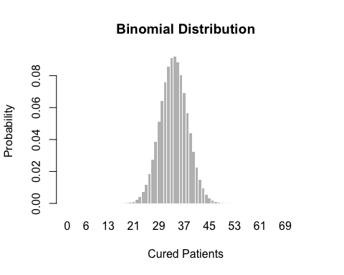
Explanation:
The distribution shows the likelihood of different cure counts, based on binomial probabilities.

c. Probability of ≤ 30% effectiveness
cutoff <- floor(0.30 * n)
p_leq_30 <- pbinom(cutoff, size = n, prob = p)
p_leq_30
## [1] 0.003988792
Explanation:
There is a ~4% chance the cure rate appears to be 30% or lower, even if it’s truly 45%.

d. Simulating 10,000 trials
set.seed(123)
sim_trials <- rbinom(10000, n, p)
mean(sim_trials)
## [1] 33.722
sd(sim_trials)
## [1] 4.309893
hist(sim_trials, breaks = 30, main = "10,000 Simulated Trials",
xlab = "Number of Cured Patients")
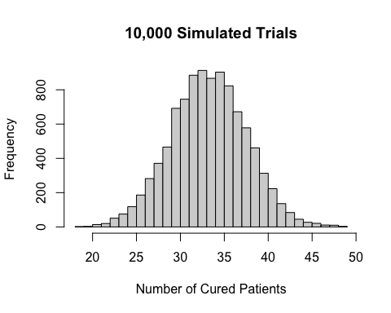

Problem 2

a. Expected value and standard deviation (Poisson)
lambda <- 600
expected_value_pois <- lambda
std_dev_pois <- sqrt(lambda)
expected_value_pois
## [1] 600
std_dev_pois
## [1] 24.4949
Explanation:
For Poisson, both expected value and variance are λ. Here, mean is 600 and SD is ~24.49.

b. Distribution and grouped probabilities
x_vals <- 500:700
probs <- dpois(x_vals, lambda)
plot(x_vals, probs, type = "h", main = "Poisson Distribution",
xlab = "Number of Patrons", ylab = "Probability")
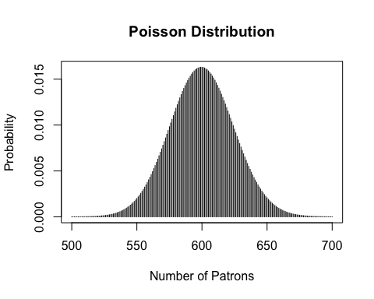
group_probs <- sapply(seq(500, 700, by = 100), function(start) {
sum(dpois(start:(start + 99), lambda))
})
names(group_probs) <- c("500–599", "600–699", "700–799")
group_probs
## 500–599 600–699 700–799
## 4.945588e-01 5.053920e-01 3.692287e-05

