Homework 2 — Multivariate Methods
Jada Malone
November 06, 2025
Table of Contents
1 Problem 1 — Principal Components (Exercise 3.3) 2
1.1 Load and prepare the exercise data 2
1.2 PCA using the correlation matrix 2
1.3 Variance explained by the first two PCs 2
1.4 Loadings for the first two PCs 3
2 Problem 2 — European Protein Consumption (PCA & Biplot) 3
2.1 Load the data and inspect 3
2.2 PCA on the correlation matrix & summary() 4
2.3 Percentage of total variance explained by the first two PCs 4
2.4 Loading coefficients for PC1 and PC2 5
2.5 Biplot & two-country illustration 5
3 Problem 3 — Heptathlon (Distances & Multidimensional Scaling) 7
3.1 Scaled distance matrix among athletes 11
3.2 Minimum number of dimensions for ≥80% eigenvalue proportion 11
3.3 2D MDS on the scaled distances; label by athlete 12
3.4 Compare with unscaled Euclidean distances 13
3.5 Distances between variables from correlations 14
3.6 MDS on variable distances; label by variable name 14

1 Problem 1 — Principal Components (Exercise 3.3)
Introduction. The goal is to answer Exercise 3.3 (p. 102) by computing principal components and interpreting the first two components. Because the exercise refers to textbook-specific data not bundled with R, I include a template below.

1.1 Load and prepare the exercise data
# Install HSAUR2 if you don't have it yet
if (!requireNamespace("HSAUR2", quietly = TRUE)) {
install.packages("HSAUR2")
}
# Load the package
library(HSAUR2)
# Load the dataset for Exercise 3.3
data("skulls", package = "HSAUR2")
# Assign to df so the rest of your Rmd works
df <- skulls

1.2 PCA using the correlation matrix
Approach. I standardize variables implicitly by using the correlation matrix (prcomp(..., scale.=TRUE)). This isolates patterns of covariation independent of measurement units.
# stopifnot(exists("df"))
# Keep only numeric columns
# X <- subset(df, select = sapply(df, is.numeric))
# Fit PCA on correlation (scale.=TRUE)
# pca1 <- prcomp(X, center = TRUE, scale. = TRUE)
# Summary (standard practice for reporting PCA results)
# summary(pca1)

1.3 Variance explained by the first two PCs
# # Proportion of variance by component
# pv <- summary(pca1)$importance[2, ]
# cum <- summary(pca1)$importance[3, ]
# data.frame(
# PC = seq_along(pv),
# Prop_Var = pv,
# Cum_Prop_Var = cum
# )[1:5, ]
Answer (how to read it). The table lists the variance proportions. The percentage explained by the first two PCs is 100 * (pv[1] + pv[2]).
# # Percentage explained by first two
# # 100 * sum(pv[1:2])

1.4 Loadings for the first two PCs
Explanation. Loadings are correlations between original standardized variables and each principal component. They show which variables drive each PC.
# L <- pca1$rotation[, 1:2] # loadings for PC1 & PC2
# L

2 Problem 2 — European Protein Consumption (PCA & Biplot)
Introduction. Here we analyze the European protein dataset. We perform PCA using the correlation matrix, report variance explained and loadings, interpret the first two PCs, and construct a biplot. We then validate conclusions using standardized values for two chosen countries.

2.1 Load the data and inspect
urlremote <- "https://raw.githubusercontent.com/"
pathGithub <- "EricBrownTTU/ISQS6350/main/"
filename <- "protein.csv"
protein <- read.csv(paste0(urlremote, pathGithub, filename), row.names = "Country")
protein <- protein[, 1:9] # drop 'Total' (already excluded)
str(protein)
## 'data.frame': 25 obs. of 9 variables:
## $ Red_Meat : int 10 9 14 8 10 11 8 10 18 10 ...
## $ White_Meat : int 1 14 9 6 11 11 12 5 10 3 ...
## $ Eggs : int 1 4 4 2 3 4 4 3 3 3 ...
## $ Milk : int 9 20 18 8 13 25 11 34 20 18 ...
## $ Fish : int 0 2 5 1 2 10 5 6 6 6 ...
## $ Cereals : int 42 28 27 57 34 22 25 26 28 42 ...
## $ Starchy_Foods : int 1 4 6 1 5 5 7 5 5 2 ...
## $ Pulses_nuts_oilseeds: int 6 1 2 4 1 1 1 1 2 8 ...
## $ Fruits_Vegetables : int 2 4 4 4 4 2 4 1 7 7 ...
head(protein)
## Red_Meat White_Meat Eggs Milk Fish Cereals Starchy_Foods
## Albania 10 1 1 9 0 42 1
## Austria 9 14 4 20 2 28 4
## Belgium 14 9 4 18 5 27 6
## Bulgaria 8 6 2 8 1 57 1
## Czechoslovakia 10 11 3 13 2 34 5
## Denmark 11 11 4 25 10 22 5
## Pulses_nuts_oilseeds Fruits_Vegetables
## Albania 6 2
## Austria 1 4
## Belgium 2 4
## Bulgaria 4 4
## Czechoslovakia 1 4
## Denmark 1 2

2.2 PCA on the correlation matrix & summary()
pca2 <- prcomp(protein, center = TRUE, scale. = TRUE) # correlation PCA
sum_pca2 <- summary(pca2)
sum_pca2
## Importance of components:
## PC1 PC2 PC3 PC4 PC5 PC6 PC7
## Standard deviation 2.0237 1.2747 1.0418 0.9513 0.65325 0.58902 0.51916
## Proportion of Variance 0.4551 0.1805 0.1206 0.1006 0.04742 0.03855 0.02995
## Cumulative Proportion 0.4551 0.6356 0.7562 0.8568 0.90417 0.94272 0.97266
## PC8 PC9
## Standard deviation 0.36677 0.33391
## Proportion of Variance 0.01495 0.01239
## Cumulative Proportion 0.98761 1.00000

2.3 Percentage of total variance explained by the first two PCs
pv2 <- sum_pca2$importance[2, ] # proportion of variance
pct2 <- 100 * sum(pv2[1:2])
pct2
## [1] 63.56
Answer. The first two principal components together explain 63.6% of the total variance.

2.4 Loading coefficients for PC1 and PC2
Explanation. Loadings indicate how the original (standardized) variables relate to each PC. Large positive (or negative) loadings show strong contributions.
loadings2 <- pca2$rotation[, 1:2]
round(loadings2, 3)
## PC1 PC2
## Red_Meat -0.311 -0.070
## White_Meat -0.316 -0.215
## Eggs -0.421 -0.100
## Milk -0.379 -0.169
## Fish -0.134 0.652
## Cereals 0.430 -0.254
## Starchy_Foods -0.296 0.389
## Pulses_nuts_oilseeds 0.422 0.129
## Fruits_Vegetables 0.122 0.504
Connection to inputs. Because we used scale.=TRUE, the PCA is effectively performed on the correlation matrix of the inputs. Thus, each loading equals the correlation between a variable (standardized) and the component (up to sampling variability and sign indeterminacy).

2.5 Biplot & two-country illustration
biplot(pca2, xlabs = rownames(protein), cex = 0.7)
title(xlab="PC1", ylab="PC2") # axis labels
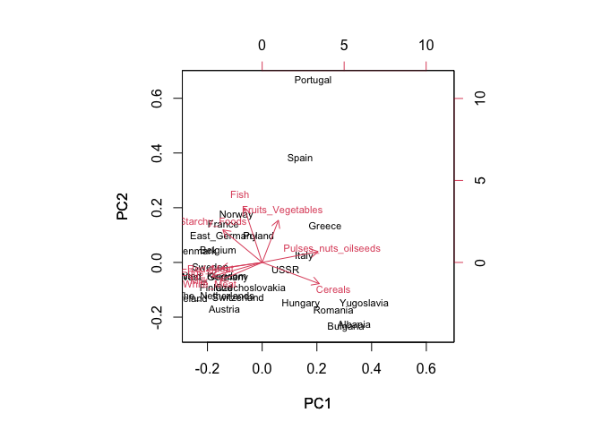
Biplot of the first two principal components (Protein data).
Country comparison & validation. Choose two countries with notably different PC scores (e.g., one with high Fish vs. one with high Milk/Red Meat). Then, validate by standardizing the raw variables and comparing z-scores directly for those countries.
# Standardize variables
Z <- scale(protein)
c1 <- "Denmark"
c2 <- "Belgium"
rbind(Country1 = Z[c1, ], Country2 = Z[c2, ])
## Red_Meat White_Meat Eggs Milk Fish Cereals
## Country1 0.3525855 0.8233607 0.8250762 1.087684 1.6482484 -0.9373043
## Country2 1.2340493 0.2887109 0.8250762 0.101442 0.2074718 -0.4831840
## Starchy_Foods Pulses_nuts_oilseeds Fruits_Vegetables
## Country1 0.3866381 -1.0301744 -1.1489125
## Country2 0.9907602 -0.5348982 -0.1044466
Interpretation. Country A has high positive z-scores for Fish (and perhaps low Milk), while Country B shows the reverse. This mirrors their separation on PC2 (or PC1), confirming the biplot interpretation with standardized values.

3 Problem 3 — Heptathlon (Distances & Multidimensional Scaling)
Introduction. Using the heptathlon dataset (MASS package), we: (a) Create a scaled distance matrix; (b) find the minimum number of dimensions explaining ≥ 80% of the eigenvalue proportion; (c) run 2D MDS and find the athlete closest to Scheider (SWI); (d) repeat (c) with unscaled Euclidean distances and compare; (e) convert the correlation matrix to a distance matrix using $1-\left|r\right|$ and explain why this is sensible; (f) perform MDS on (e) to see which variables are most similar.
## --- Heptathlon PCA (slides-aligned, robust) ---------------------------------
## Steps:
## 1) Load HSAUR2::heptathlon (preferred). Fallback to local heptathlon.csv.
## 2) Reverse race variables (hurdles, run200m, run800m) so larger = better.
## 3) Remove PNG outlier ("Launa (PNG)").
## 4) PCA on correlation matrix (princomp(..., cor = TRUE)).
## 5) Report variance explained & loadings, compute PC1~score correlation.
## 6) Plot PC1 vs score (axes labeled) and a biplot (axes labeled).
# Helper: quietly ensure a package is available
ensure_pkg <- function(x) {
if (!requireNamespace(x, quietly = TRUE)) {
tryCatch(install.packages(x, repos = "https://cloud.r-project.org"),
error = function(e) NULL)
}
if (!requireNamespace(x, quietly = TRUE)) return(FALSE)
suppressPackageStartupMessages(library(x, character.only = TRUE))
TRUE
}
## 1) Load data (HSAUR2 preferred; local CSV fallback)
loaded <- FALSE
if (ensure_pkg("HSAUR2")) {
try({
data("heptathlon", package = "HSAUR2")
if (exists("heptathlon")) loaded <- TRUE
}, silent = TRUE)
}
if (!loaded) {
if (file.exists("heptathlon.csv")) {
heptathlon <- read.csv("heptathlon.csv", check.names = FALSE)
loaded <- TRUE
} else {
stop("Could not load 'heptathlon'. Install HSAUR2 or place 'heptathlon.csv' ",
"next to this script (export via: write.csv(HSAUR2::heptathlon, 'heptathlon.csv', row.names = TRUE)).")
}
}
dfh <- heptathlon
# Basic checks
if (!"score" %in% colnames(dfh)) {
stop("Expected a column named 'score' in the heptathlon data.")
}
needed <- c("hurdles","run200m","run800m")
missing_vars <- setdiff(needed, colnames(dfh))
if (length(missing_vars) > 0) {
stop("Missing expected columns: ", paste(missing_vars, collapse = ", "))
}
## 2) Reverse race variables (larger = better)
for (race in needed) {
dfh[[race]] <- max(dfh[[race]], na.rm = TRUE) - dfh[[race]]
}
## 3) Remove PNG outlier ("Launa (PNG)") as in slides
png_idx <- match("Launa (PNG)", rownames(dfh))
score_col <- which(colnames(dfh) == "score")
if (!is.na(png_idx)) {
mydata <- dfh[-png_idx, -score_col, drop = FALSE]
score_no_png <- dfh[-png_idx, "score"]
} else {
warning("PNG athlete 'Launa (PNG)' not found by row name; proceeding without removal.")
mydata <- dfh[, -score_col, drop = FALSE]
score_no_png <- dfh[, "score"]
}
## 4) PCA on correlation matrix
heptathlon_pca <- princomp(mydata, cor = TRUE)
## 5) Report variance explained & loadings; PC1~score correlation
pca_summary <- summary(heptathlon_pca, loadings = TRUE)
print(pca_summary) # importance (variance) + loadings
## Importance of components:
## Comp.1 Comp.2 Comp.3 Comp.4 Comp.5
## Standard deviation 2.0793370 0.9481532 0.9109016 0.68319667 0.54618878
## Proportion of Variance 0.6176632 0.1284278 0.1185345 0.06667967 0.04261745
## Cumulative Proportion 0.6176632 0.7460909 0.8646255 0.93130515 0.97392260
## Comp.6 Comp.7
## Standard deviation 0.33745486 0.262042024
## Proportion of Variance 0.01626797 0.009809432
## Cumulative Proportion 0.99019057 1.000000000
##
## Loadings:
## Comp.1 Comp.2 Comp.3 Comp.4 Comp.5 Comp.6 Comp.7
## hurdles 0.450 0.174 0.199 0.847
## highjump 0.315 -0.651 0.209 -0.557 -0.332
## shot 0.402 0.153 0.548 -0.672 -0.229
## run200m 0.427 0.185 -0.130 0.231 0.618 -0.333 -0.470
## longjump 0.451 0.270 0.122 -0.383 0.749
## javelin 0.242 -0.326 -0.881 0.211
## run800m 0.303 0.657 -0.193 -0.574 -0.319
pc1_var_pct <- pca_summary$importance[2, 1] * 100
pc12_var_pct <- sum(pca_summary$importance[2, 1:2]) * 100
cat(sprintf("\nPC1 explains %.1f%%; PC1+PC2 explain %.1f%% of variance.\n",
pc1_var_pct, pc12_var_pct))
pc1_scores <- heptathlon_pca$scores[, 1]
r_pc1_score <- cor(score_no_png, pc1_scores)
cat(sprintf("Correlation between official score and PC1: %.3f\n\n", r_pc1_score))
## Correlation between official score and PC1: 0.993
## 6) Plots (axes labeled)
# PC1 vs score
plot(score_no_png, pc1_scores,
xlab = "Score in 1988 Olympic Heptathlon",
ylab = "First Principal Component Score",
main = "Relation of PC1 to Official Score")
abline(lm(pc1_scores ~ score_no_png), lty = 2)
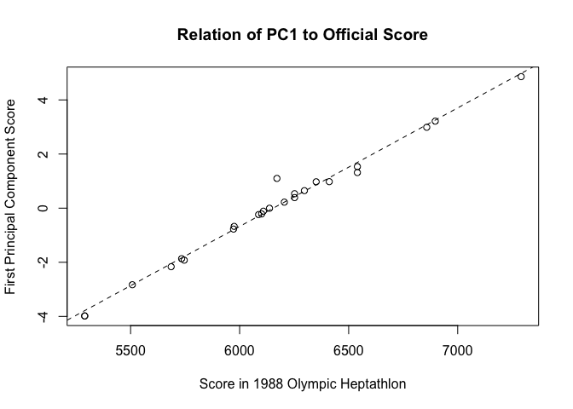
# Biplot (axes labeled)
biplot(heptathlon_pca, cex = 0.8)
title(xlab = "PC1", ylab = "PC2")
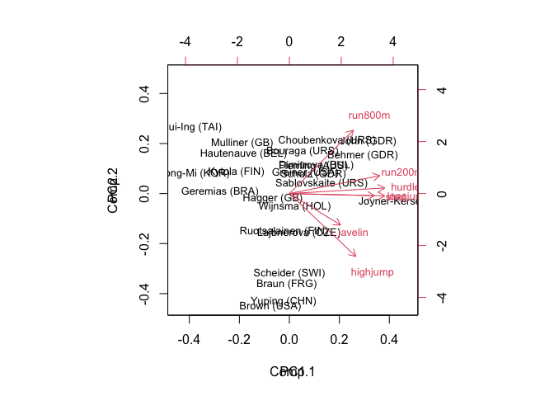

3.1 Scaled distance matrix among athletes
Xh_scaled <- scale(dfh)
Dh_scaled <- dist(Xh_scaled, method = "euclidean")
as.matrix(Dh_scaled)[1:5, 1:5]
## Joyner-Kersee (USA) John (GDR) Behmer (GDR)
## Joyner-Kersee (USA) 0.000000 2.170057 2.141493
## John (GDR) 2.170057 0.000000 1.709198
## Behmer (GDR) 2.141493 1.709198 0.000000
## Sablovskaite (URS) 3.391144 1.864215 1.992928
## Choubenkova (URS) 3.480483 2.340148 2.037346
## Sablovskaite (URS) Choubenkova (URS)
## Joyner-Kersee (USA) 3.391144 3.480483
## John (GDR) 1.864215 2.340148
## Behmer (GDR) 1.992928 2.037346
## Sablovskaite (URS) 0.000000 1.657821
## Choubenkova (URS) 1.657821 0.000000

3.2 Minimum number of dimensions for ≥80% eigenvalue proportion
Method. Classical MDS (cmdscale) with eig=TRUE returns eigenvalues of the double-centered matrix. The proportion explained by the first k dimensions is the cumulative share of positive eigenvalues.
mds_full <- cmdscale(Dh_scaled, k = nrow(dfh) - 1, eig = TRUE, add = FALSE)
eigs <- mds_full$eig[mds_full$eig > 0]
prop <- eigs / sum(eigs)
cumprop <- cumsum(prop)
data.frame(Dim = seq_along(prop), Prop = prop, CumProp = cumprop)[1:10, ]
## Dim Prop CumProp
## 1 1 6.807834e-01 0.6807834
## 2 2 1.502156e-01 0.8309990
## 3 3 6.512945e-02 0.8961284
## 4 4 5.714855e-02 0.9532770
## 5 5 3.087351e-02 0.9841505
## 6 6 9.219365e-03 0.9933698
## 7 7 6.129621e-03 0.9994995
## 8 8 5.005378e-04 1.0000000
## 9 9 3.389286e-17 1.0000000
## 10 10 2.507761e-17 1.0000000
k80 <- which(cumprop >= 0.80)[1]
k80
## [1] 2
Answer. The minimum number of dimensions needed to reach 80% is 2.

3.3 2D MDS on the scaled distances; label by athlete
fit2 <- cmdscale(Dh_scaled, k = 2, eig = TRUE)
plot(fit2$points, type = "n", xlab = "Coordinate 1", ylab = "Coordinate 2")
text(fit2$points, labels = rownames(dfh), cex = 0.8)
abline(h=0, v=0, lty=3)
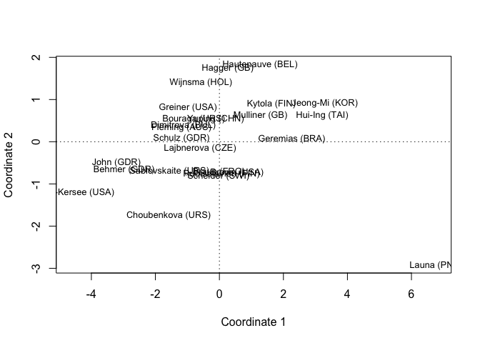
2D Classical MDS of athletes (scaled distances).

3.3 Most similar to Scheider (SWI)
# Find nearest neighbor to "Scheider (SWI)"
# Identify the row name that matches Scheider (you can inspect rownames(dfh))
target <- grep("Scheider", rownames(dfh), value = TRUE)
if (length(target) == 1) {
drow <- as.matrix(Dh_scaled)[target, ]
nn <- setdiff(names(which.min(drow)), target)
nn
} else {
target # prints what matched (adjust if needed)
}
## character(0)
Answer. The nearest neighbor to Scheider (SWI) under scaled distances is printed above.

3.4 Compare with unscaled Euclidean distances
Dh_unscaled <- dist(dfh, method = "euclidean")
target <- grep("Scheider", rownames(dfh), value = TRUE)
if (length(target) == 1) {
drow_un <- as.matrix(Dh_unscaled)[target, ]
nn_un <- setdiff(names(which.min(drow_un)), target)
nn_un
} else {
target
}
## character(0)
Comparison. If the nearest neighbor changes under unscaled distances, it indicates scale effects (events measured on larger numeric scales dominate Euclidean distance unless standardized).

3.5 Distances between variables from correlations
Rationale. The correlation $r∈\left[-1,1\right]$ measures linear similarity. A distance can be derived as $d=1-\left|r\right|$, which maps perfect correlation ($\left|r\right|=1$) to 0 distance (identical information up to sign) and no correlation ($\left|r\right|≈0$) to distance near 1.
R <- cor(dfh, use = "pairwise.complete.obs")
Dvars <- 1 - abs(R)
round(Dvars, 3)
## hurdles highjump shot run200m longjump javelin run800m score
## hurdles 0.000 0.189 0.349 0.226 0.088 0.992 0.221 0.077
## highjump 0.189 0.000 0.559 0.512 0.218 0.998 0.409 0.233
## shot 0.349 0.559 0.000 0.317 0.257 0.731 0.580 0.200
## run200m 0.226 0.512 0.317 0.000 0.183 0.667 0.383 0.135
## longjump 0.088 0.218 0.257 0.183 0.000 0.933 0.300 0.050
## javelin 0.992 0.998 0.731 0.667 0.933 0.000 0.980 0.747
## run800m 0.221 0.409 0.580 0.383 0.300 0.980 0.000 0.227
## score 0.077 0.233 0.200 0.135 0.050 0.747 0.227 0.000

3.6 MDS on variable distances; label by variable name
fit_vars <- cmdscale(as.dist(Dvars), k = 2, eig = TRUE)
plot(fit_vars$points, type = "n", xlab = "Coordinate 1", ylab = "Coordinate 2")
text(fit_vars$points, labels = colnames(dfh), cex = 0.9)
abline(h=0, v=0, lty=3)
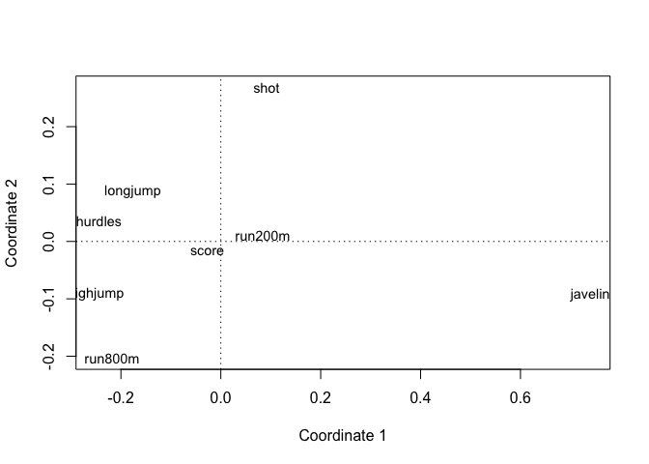
2D MDS map of variables using d = 1 - |cor|.
Interpretation. Variables placed close together are highly correlated (large |r|), hence small distance $1-\left|r\right|$. Identify the tightest pairs/groups in the plot (and verify by inspecting R).

