Homework 3
Jada Malone
2025-12-03

Problem 1 – Factor Analysis
r <- matrix(c(
1.00,0.44,0.41,0.29,0.33,0.25,
0.44,1.00,0.35,0.35,0.32,0.33,
0.41,0.35,1.00,0.16,0.19,0.18,
0.29,0.35,0.16,1.00,0.59,0.47,
0.33,0.32,0.19,0.59,1.00,0.46,
0.25,0.33,0.18,0.47,0.46,1.00
), nrow=6, byrow=TRUE)
colnames(r) <- rownames(r) <- c("French","English","History","Arithmetic","Algebra","Geometry")
set.seed(123)
efa2 <- factanal(covmat=r, factors=2)
efa2
##
## Call:
## factanal(factors = 2, covmat = r)
##
## Uniquenesses:
## French English History Arithmetic Algebra Geometry
## 0.508 0.595 0.644 0.377 0.440 0.628
##
## Loadings:
## Factor1 Factor2
## French 0.233 0.661
## English 0.319 0.551
## History 0.591
## Arithmetic 0.770 0.172
## Algebra 0.715 0.220
## Geometry 0.570 0.215
##
## Factor1 Factor2
## SS loadings 1.593 1.215
## Proportion Var 0.265 0.202
## Cumulative Var 0.265 0.468
##
## The degrees of freedom for the model is 4 and the fit was 0.0101
efa3 <- factanal(covmat=r, factors=3)
efa3
##
## Call:
## factanal(factors = 3, covmat = r)
##
## Uniquenesses:
## French English History Arithmetic Algebra Geometry
## 0.448 0.497 0.679 0.411 0.376 0.611
##
## Loadings:
## Factor1 Factor2 Factor3
## French 0.229 0.706
## English 0.295 0.538 0.355
## History 0.554
## Arithmetic 0.741 0.169 0.109
## Algebra 0.756 0.222
## Geometry 0.567 0.185 0.183
##
## Factor1 Factor2 Factor3
## SS loadings 1.588 1.207 0.181
## Proportion Var 0.265 0.201 0.030
## Cumulative Var 0.265 0.466 0.496
##
## The degrees of freedom for the model is 0 and the fit was 0.001
efa2_norot <- factanal(covmat=r, factors=2, rotation="none")
efa2_norot
##
## Call:
## factanal(factors = 2, covmat = r, rotation = "none")
##
## Uniquenesses:
## French English History Arithmetic Algebra Geometry
## 0.508 0.595 0.644 0.377 0.440 0.628
##
## Loadings:
## Factor1 Factor2
## French 0.558 0.425
## English 0.569 0.286
## History 0.392 0.450
## Arithmetic 0.738 -0.279
## Algebra 0.718 -0.209
## Geometry 0.595 -0.133
##
## Factor1 Factor2
## SS loadings 2.204 0.603
## Proportion Var 0.367 0.101
## Cumulative Var 0.367 0.468
##
## The degrees of freedom for the model is 4 and the fit was 0.0101

Problem 2 – Gene Clustering
genes <- read.csv(
"https://raw.githubusercontent.com/EricBrownTTU/ISQS6350/main/geneexpression.csv",
header=FALSE
)
sample_cor <- cor(t(genes))
dist_cor <- as.dist(1 - sample_cor)
hc_avg <- hclust(dist_cor, method="average")
plot(hc_avg)
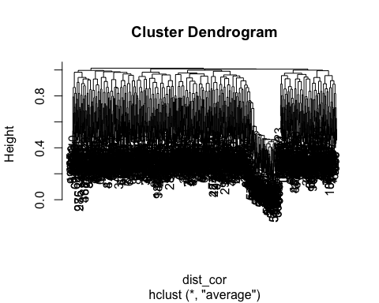
clusters_avg <- cutree(hc_avg, k=2)
group <- ifelse(1:nrow(genes) <= 20, "Healthy", "Diseased")
table(group, clusters_avg)
## clusters_avg
## group 1 2
## Diseased 238 742
## Healthy 4 16
hc_comp <- hclust(dist_cor, method="complete")
plot(hc_comp)
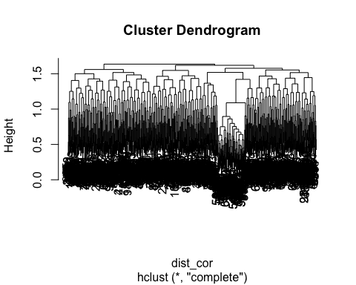
clusters_comp <- cutree(hc_comp, 2)
table(group, clusters_comp)
## clusters_comp
## group 1 2
## Diseased 331 649
## Healthy 5 15
hc_single <- hclust(dist_cor, method="single")
plot(hc_single)
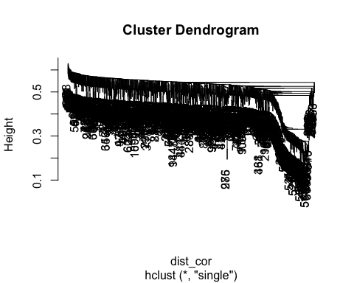
clusters_single <- cutree(hc_single, 2)
table(group, clusters_single)
## clusters_single
## group 1 2
## Diseased 979 1
## Healthy 20 0
mean_diff <- apply(genes, 2, function(g){
abs(mean(g[group=="Healthy"]) - mean(g[group=="Diseased"]))
})
top_genes <- order(mean_diff, decreasing=TRUE)[1:10]
top_genes
## [1] 29 22 40 30 37 26 33 25 36 28
mean_diff[top_genes]
## V29 V22 V40 V30 V37 V26 V33 V25
## 1.0807549 1.0188408 0.9822137 0.9771575 0.9192654 0.9087575 0.8617634 0.8340118
## V36 V28
## 0.8299118 0.8273652

Problem 3 – Protein Data Clustering
urlremote <- "https://raw.githubusercontent.com/"
pathGithub <- "EricBrownTTU/ISQS6350/main/"
filename <- "protein.csv"
protein <- read.csv(paste0(urlremote, pathGithub, filename), row.names="Country")
protein <- protein[,1:9]
protein_scaled <- scale(protein)
set.seed(123)
max_k <- 10
wss <- sapply(1:max_k, function(k){
kmeans(protein_scaled, centers=k, nstart=25)$tot.withinss
})
plot(1:max_k, wss, type="b")
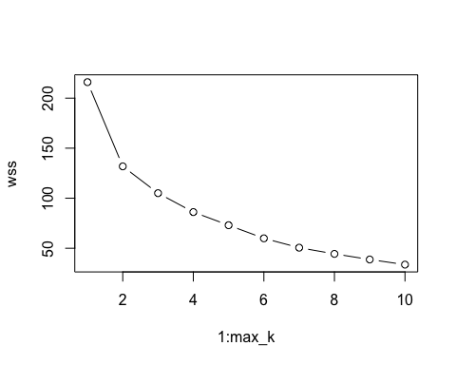
k_opt <- 3
km_protein <- kmeans(protein_scaled, centers=k_opt, nstart=25)
protein$Cluster <- factor(km_protein$cluster)
split(rownames(protein), protein$Cluster)
## $`1`
## [1] "Austria" "Belgium" "Czechoslovakia" "Denmark"
## [5] "East_Germany" "Finland" "France" "Ireland"
## [9] "The_Netherlands" "Norway" "Poland" "Sweden"
## [13] "Switzerland" "United_Kingdom" "West_Germany"
##
## $`2`
## [1] "Albania" "Bulgaria" "Greece" "Hungary" "Italy"
## [6] "Romania" "USSR" "Yugoslavia"
##
## $`3`
## [1] "Portugal" "Spain"
cluster_means <- aggregate(protein,
by=list(Cluster=protein$Cluster),
FUN=mean)
## Warning in mean.default(X[[i]], ...): argument is not numeric or logical:
## returning NA
## Warning in mean.default(X[[i]], ...): argument is not numeric or logical:
## returning NA
## Warning in mean.default(X[[i]], ...): argument is not numeric or logical:
## returning NA
cluster_means
## Cluster Red_Meat White_Meat Eggs Milk Fish Cereals Starchy_Foods
## 1 1 11.400 9.866667 3.733333 21.400 4.733333 25.6 5.00
## 2 2 7.625 5.375000 2.125000 12.125 1.875000 46.0 2.75
## 3 3 6.500 3.500000 2.000000 7.000 10.500000 28.0 6.00
## Pulses_nuts_oilseeds Fruits_Vegetables Cluster
## 1 1.666667 3.800 NA
## 2 5.125000 4.125 NA
## 3 5.500000 7.500 NA
mc_protein <- Mclust(protein_scaled)
summary(mc_protein)
## ----------------------------------------------------
## Gaussian finite mixture model fitted by EM algorithm
## ----------------------------------------------------
##
## Mclust VII (spherical, varying volume) model with 3 components:
##
## log-likelihood n df BIC ICL
## -252.7025 25 32 -608.409 -608.9585
##
## Clustering table:
## 1 2 3
## 10 3 12
plot(mc_protein, what="classification")
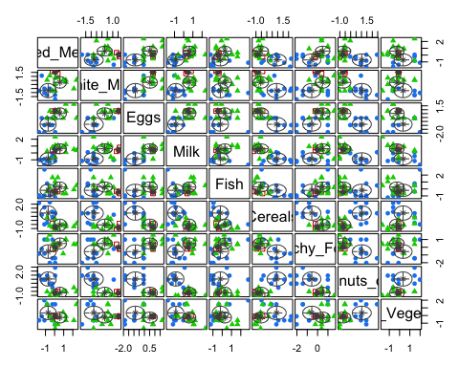
protein$MC_Cluster <- mc_protein$classification
split(rownames(protein), protein$MC_Cluster)
## $`1`
## [1] "Albania" "Bulgaria" "Greece" "Hungary" "Italy"
## [6] "Portugal" "Romania" "Spain" "USSR" "Yugoslavia"
##
## $`2`
## [1] "Austria" "The_Netherlands" "West_Germany"
##
## $`3`
## [1] "Belgium" "Czechoslovakia" "Denmark" "East_Germany"
## [5] "Finland" "France" "Ireland" "Norway"
## [9] "Poland" "Sweden" "Switzerland" "United_Kingdom"
plot(mc_protein, what="uncertainty", dimens=c(1,9))
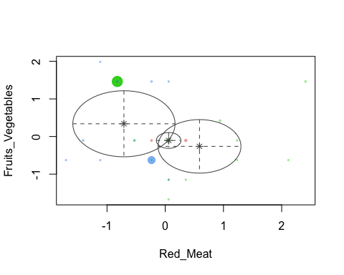

Problem 4 – Association Rules
courses <- read.csv(
"https://raw.githubusercontent.com/EricBrownTTU/ISQS6350/main/Coursetopics.csv",
header=TRUE
)
courses_trans <- as(as.matrix(courses), "transactions")
rules <- apriori(courses_trans,
parameter=list(supp=0.10, conf=0.50, minlen=2))
## Apriori
##
## Parameter specification:
## confidence minval smax arem aval originalSupport maxtime support minlen
## 0.5 0.1 1 none FALSE TRUE 5 0.1 2
## maxlen target ext
## 10 rules TRUE
##
## Algorithmic control:
## filter tree heap memopt load sort verbose
## 0.1 TRUE TRUE FALSE TRUE 2 TRUE
##
## Absolute minimum support count: 36
##
## set item appearances ...[0 item(s)] done [0.00s].
## set transactions ...[8 item(s), 365 transaction(s)] done [0.00s].
## sorting and recoding items ... [8 item(s)] done [0.00s].
## creating transaction tree ... done [0.00s].
## checking subsets of size 1 2 done [0.00s].
## writing ... [0 rule(s)] done [0.00s].
## creating S4 object ... done [0.00s].
length(rules)
## [1] 0
summary(rules)
## set of 0 rules
rules_sorted <- sort(rules, by="lift", decreasing=TRUE)
inspect(head(rules_sorted, 1))
lhs_intro_reg <- subset(rules_sorted,
lhs %pin% "Intro" & lhs %pin% "Regression")
inspect(lhs_intro_reg)

