LALI Jewelry Inc
LALI Jewelry Inc:
- Goal: Build brand awareness
- Feature: ONE piece from their gemstone collections (you pick it in step 2)
- Target Audience: Anyone celebrating special occasions (birthday, anniversary, graduation, etc.)
- Message: Affordable luxury
- Desired Action: Visit retail website to shop for online exclusives
- Tone: Sophisticated
- Format: Website graphic
- Colors: Deep royal purple

Directions (FOLLOW ALL DIRECTIONS IF YOU ARE DOING LALI JEWELS):
- Read About the Business & Explore the Site: https://www.lalijewelry.com/?page=history
- Visit LALI Jewels Catalog and select a jewelry product: https://www.lalijewelry.com/?page=jewelry
(ex 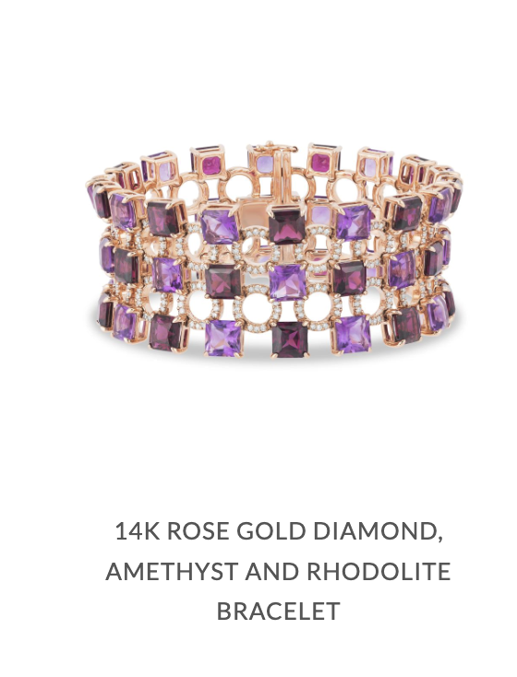)
- Complete the Business Review Article and Ad Guide

MyTeenGig
MyTeenGig:
- Goal: Build brand awareness for ONE side of MyTeenGig. Pick one:
  - Teen side: get teens ages 14–19 to create a free account and find local gigs and volunteer opportunities
  - Business side: get homeowners and businesses to post jobs and volunteer opportunities for local teens
- Feature: A platform designed specifically to connect teens ages 14–19 with local opportunities
- Target Audience: Match the side you picked.
  - Teen side: Teens ages 14–19 looking to earn money, gain experience, build skills, or volunteer (parents looking for good jobs for their teens can be a second audience)
  - Business side: Homeowners and businesses looking for help
- Message:
  - Teen side: There are opportunities right in your community that MyTeenGig can help you find in one place
  - Business side: Local teens available to homeowners and businesses needing help
- Desired Action:
  - Teen side: Visit MyTeenGig.com, create a free teen account, build a profile, and explore available gigs, business opportunities, and volunteer opportunities
  - Business side: Visit MyTeenGig.com, create a free homeowner/business account, and post opportunities for local teens
- Tone: Friendly, energetic, positive, and trustworthy. Appeal to teens without feeling childish.
- Format: Pick ONE: social post, story/vertical post, flyer, poster, or website graphic
- Colors: MyTeenGig’s existing logo and brand colors. Photos or illustrations of diverse teens participating in gigs are encouraged.

Directions (FOLLOW ALL DIRECTIONS IF YOU ARE DOING MyTeenGig):
- Explore MyTeenGig and read the About Page: https://myteengig.com/#about
- Select One Gig Type: https://myteengig.com/#gig-types
(ex. 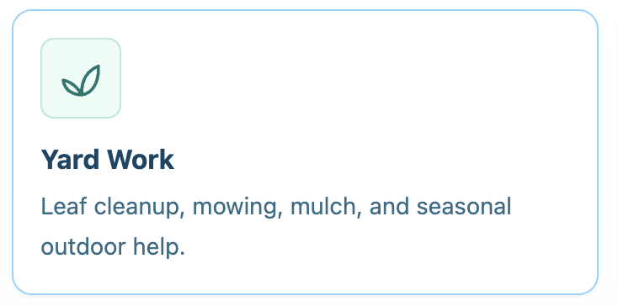
- Complete the Business Review Article and Ad Guide

Double Happiness Creations
Double Happiness Creations:
- Goal: Build brand awareness by showing off ONE design they made
- Feature: ONE project from their portfolio (event & gala branding, design, print production, or creative support)
- Target Audience: Organizations planning an event or gala that needs polished branding, mainly hospitals and nonprofits. Museums are a new audience they want to reach.
- Message: Deep appreciation for detail, narrative, and the tactile experience of print
- Desired Action: Email or call Double Happiness Creations to start working together
- Tone: Sophisticated and carefully designed. Your ad should look like their work.
- Format: Pick ONE: Instagram post or Instagram reel
- Colors: Red as the main accent; take the other colors from the design you picked

Directions (FOLLOW ALL DIRECTIONS IF YOU ARE DOING DOUBLE HAPPINESS CREATIONS):
- Read About the Business & Explore the site: https://doublehappinesscreations.com/about-us
- Select a design: https://doublehappinesscreations.com/work
(ex. )
- Complete the Business Review Article and Ad Guide

Fountain of Kindness
Fountain of Kindness:
- Goal: Get donations by showing donors exactly where their money goes
- Feature: ONE of their current projects (this is the “where your donation goes” story)
- Target Audience: Donors, especially Great Neck and Long Island community members who want to help families nearby
- Message: “You ask, we deliver.” Every dollar becomes an act of kindness.
- Desired Action: Donate at fountainofkindness.org/donate
- Tone: Warm, hopeful, and personal. Show the kindness, not the hardship, and never show a real family’s face or name.
- Format: Pick ONE: social media post or short video. You design it yourself; you do not need an Instagram account.
- Colors: No set colors. Match the look of their website.

Directions (FOLLOW ALL DIRECTIONS IF YOU ARE DOING FOUNTAIN OF KINDNESS):
- Read About the Business & Explore the Site: https://www.fountainofkindness.org/about-us
- Select ONE current project. Your ad shows a donor where their money goes for that one project: https://www.fountainofkindness.org/current-projects
- Complete the Business Review Article and Ad Guide

