JADA MANIKANTA

**Place:** Srikakulam, Andhra Pradesh

**Phone:** +919618598647

**Mail id:** manikantajada16@gmail.com

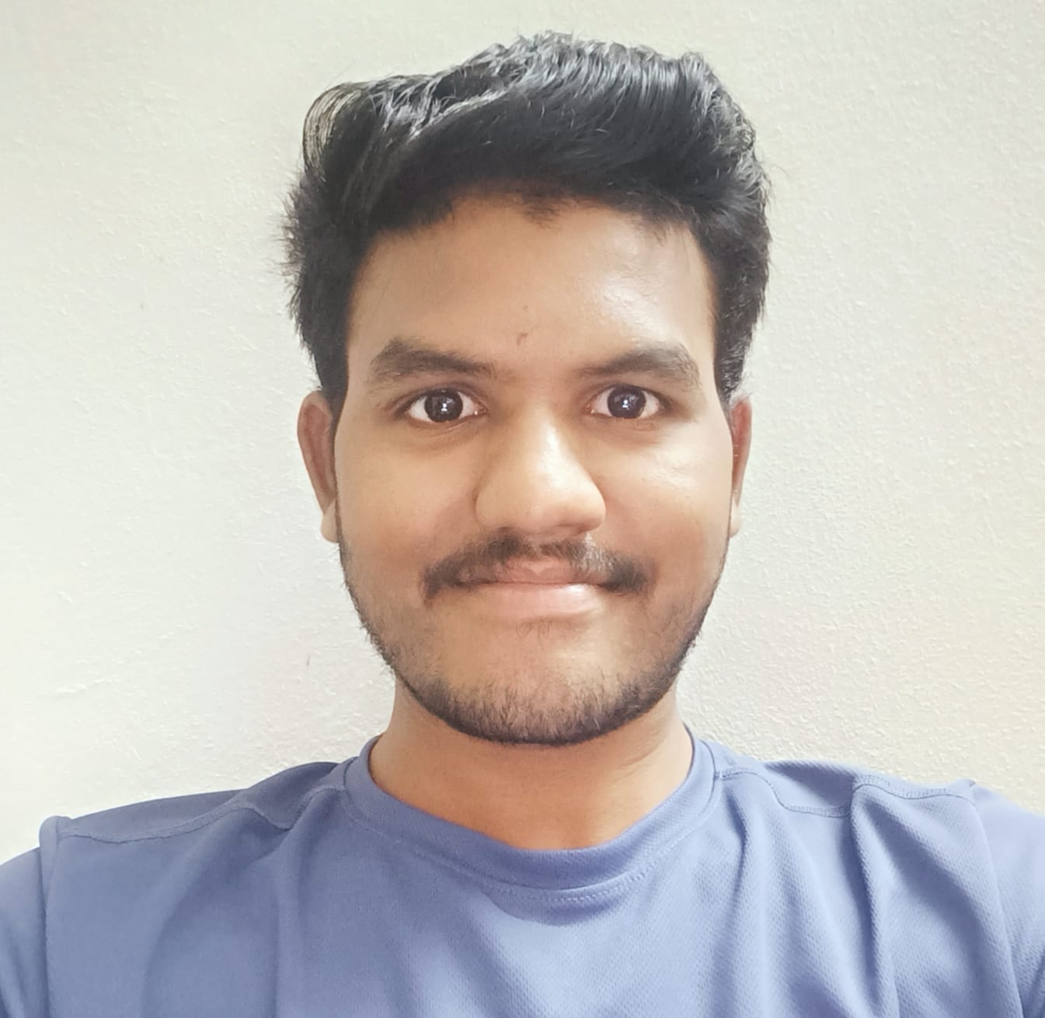

**Education**

|  |  |  |  |
| --- | --- | --- | --- |
| **Year** | **Degree/Certificate** | **Institute** | **CGPA** |
| 2019 - 2023 | B.Tech (Mechanical) | Raghu Engineering College | 8.55 |
| 2017-2019 | Intermediate (XII) | Sri Chaitanya junior College | 9.73 |
| 2017 | SSC (X) | Bhashyam public school | 9.7 |

# Projects

[**Portfolio Website**](https://jadamanikanta.github.io/RESUME/) **|** [**GitHub**](https://github.com/jadamanikanta/RESUME)

* **Tech:** HTML5, CSS3
* Personal Portfolio is a static website built using **HTML5 and CSS3.**
* It consists of the all the details of the person like skills, academics, contact details, social media platform. etc.

**Remaining Projects**

* Smart cane for blind people using Arduino.

**Languages**

# English, Hindi, Telugu

# Career Objective

To assist a stable and thriving company in achieving its mission and goals by being able to continuously learn and improve the necessary skills and knowledge needed to help push both the company and myself forward into success.

**Certifications**

Manual testing internship

# Technical Skills

**Languages:** C, Basics of python.

**Web Development:** HTML5, CSS3

**Software testing:** manual testing

**Personality Traits**

* Adaptable to new and challenging environments.
* Ability to work under peer pressure.
* I possess a strong passion for continuous learning, enabling me to quickly grasp and absorb new information.
* Self-Motivated and open to new challenges.