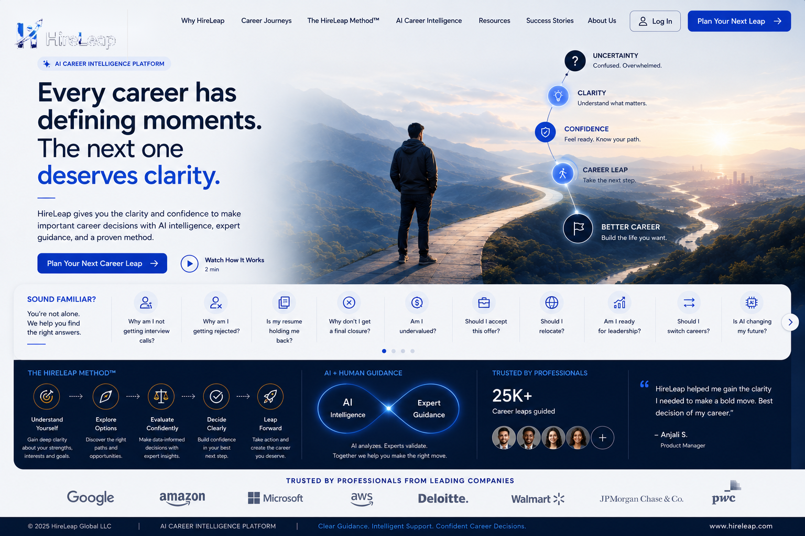

HireLeap Experience Blueprint™
  - Product Design System, Component Library & Screen Specifications
MASTER DEVELOPER EDITION | VERSION 1.0
Single source of truth for product, UI/UX, engineering, QA, content and launch.
Prepared for HireLeap Global LLC
July 2026
STATUS Approved implementation baseline. Exact content, prices, videos, legal copy and credentials remain configurable dependencies.

Document control & authority
How this blueprint governs implementation.

Document identity
Owner: HireLeap Global LLC. Classification: Confidential - Developer Use. Authority: approved HireLeap experience designs, founder decisions, website requirements and functional specification.

Precedence rules
- Latest written requirement in this document overrides earlier mock-up text.
- Approved screenshots control composition and visual intent.
- Pending assets must be configurable placeholders, not an invitation to redesign.
- All deviations require written HireLeap approval.

How teams use it
- Product: scope and priority decisions.
- Design: visual and responsive implementation.
- Engineering: component, behavior and integration requirements.
- QA: acceptance criteria and release gates.
- Content/marketing: approved language, claims and brand voice.
LOCKED DECISION Developer implementation must preserve intent, not merely reproduce desktop pixels.

Acceptance criteria
- A new team member can begin estimation without founder explanation.
- Every open dependency is visible and configurable.

Contents - Books I & II
Condensed navigation for this master document.
- Book I - Foundation
- 1. Product purpose and north star
- 2. Vision, mission and promise
- 3. Audience and career journeys
- 4. Product philosophy
- 5. Core and experience principles
- 6. Positioning and success
- 7. The HireLeap Standard
- Book II - Design System & Brand Standards
- 8. Brand identity and governance
- 9. Voice, copy and terminology
- 10. Logo system
- 11. Typography
- 12. Color and gradients
- 13. Layout, grid and spacing
- 14. Imagery, illustration and iconography
- 15. Motion and accessibility
READING RULE Books I-II establish the rules. Book III defines reusable building blocks. Book IV defines each page and must be read together with its approved screenshot.

Contents - Books III & IV
Condensed navigation for this master document.
- Book III - Component Library
- 16. Navigation and footer
- 17. Buttons, links and CTAs
- 18. Cards and content modules
- 19. Forms and validation
- 20. Video, sliders and accordions
- 21. Pricing, testimonials and metrics
- 22. States, feedback and system pages
- Book IV - Screen Specifications
- 23. Homepage
- 24. Why We Exist
- 25. Career Journeys
- 26. The HireLeap Method™
- 27. Career Intelligence
- 28. Career Hub / Resources
- 29. Success Stories
- 30. Career Investment
- 31. About Us / Why We Believe
- 32. Plan Your Next Leap
- 33. Legal, 404 and future login
- 34. Analytics, SEO, QA and handover
READING RULE Books I-II establish the rules. Book III defines reusable building blocks. Book IV defines each page and must be read together with its approved screenshot.

BOOK I

FOUNDATION
Why HireLeap exists and how every decision is evaluated.
NORTH STAR Every interaction should leave the user more informed, more confident and closer to a meaningful career decision.

1. Product purpose & executive summary
HireLeap is a premium career decision platform, not a conventional service brochure.

Purpose
Guide people from uncertainty to clarity using expert guidance, intelligent technology and structured execution.

Website role
- Immersive narrative experience.
- Trust-building platform.
- Career journey discovery tool.
- Consultation lead-generation system.
- Foundation for future product experiences.

Version 1.0 scope
- Public website and approved experience pages.
- Reusable global components and responsive behavior.
- Lead capture, WhatsApp, video and optional scheduling.
- SEO, analytics, accessibility, security and performance foundations.
LOCKED DECISION No page may reduce HireLeap to resume writing, staffing or job placement.

Acceptance criteria
- The first viewport explains what HireLeap is.
- Every page offers a coherent next step.

2. Vision, mission & brand promise
The enduring statements that guide strategy and execution.

Vision
To become the world’s most trusted career decision platform, empowering professionals to navigate every stage of their careers with confidence, clarity and purpose.

Mission
Help professionals make better career decisions through expert guidance, intelligent technology and structured execution.

Brand promise
Better Decisions. Better Careers.

Practical meaning
- Better Decisions: clearer options, informed trade-offs, personalized strategy and confident action.
- Better Careers: sustainable progress, readiness, alignment and long-term growth - not guaranteed employment.
LOCKED DECISION The brand promise replaces the legacy descriptor “AI Career Intelligence Platform” across all customer-facing experiences.

Acceptance criteria
- No legacy descriptor remains.
- Claims are supportable and do not imply guaranteed results.

3. Audience & career situations
The product recognizes the user’s situation before presenting solutions.

Primary audiences
- Students and early-career professionals.
- Professionals seeking growth or leadership progression.
- Career changers.
- Global career professionals, including OPT, STEM OPT, CPT, H-4 EAD and H-1B users.
- Returning professionals.
- Professionals rebuilding after layoffs or setbacks.
- Entrepreneurial professionals creating a new future.

Seven approved journey labels
- I’m Starting
- I’m Growing
- I’m Changing
- I’m Building a Global Career
- I’m Returning
- I’m Rebuilding
- I’m Creating My Future

Design implication
Users should be able to recognize themselves without first understanding HireLeap’s service catalogue.
LOCKED DECISION Journey language is user-centered and remains consistent throughout navigation, forms and content.

Acceptance criteria
- All seven journeys are available as configurable form values.
- Journey cards use inclusive, non-judgmental language.

4. Product philosophy
Careers are shaped by decisions; technology should strengthen human expertise.

People before technology
AI accelerates research, personalization and preparation. Human experts retain judgment, empathy and accountability.

Guidance before automation
Explain context and trade-offs before asking the user to act.

Trust before conversion
Provide useful clarity before presenting commercial commitment.

Long-term value
Optimize for durable career progress, not quick transactional wins.

Structured execution
Move from understanding to strategy, preparation, positioning and action.
LOCKED DECISION AI is an enabling capability, not the hero of the brand.

Acceptance criteria
- Technology is always connected to a user outcome.
- No autonomous or guaranteed-career claims appear.

5. Core principles
Non-negotiable decision rules for every team.

Principles
- People Before Technology
- Guidance Before Automation
- Confidence Through Clarity
- Simplicity Is a Feature
- Trust Before Conversion
- Consistency Builds Confidence
- Every Interaction Creates Momentum
- Premium Without Pretension

Application
When principles conflict, prioritize user trust, accessibility and clarity over visual novelty or short-term conversion.

Review questions
- Does this reduce uncertainty?
- Is the next action obvious?
- Can the user understand it without explanation?
- Does it respect the user’s time and situation?
LOCKED DECISION New patterns require a proven user need, not aesthetic preference.

Acceptance criteria
- Every feature review references at least one core principle.
- Dead ends and misleading urgency are absent.

6. Experience principles
The emotional outcomes HireLeap intentionally creates.

Users should feel
- Understood
- Informed
- Confident
- Supported
- Hopeful
- Prepared
- Respected
- Motivated

Design behaviors
- Use calm hierarchy and plain language.
- Acknowledge uncertainty without amplifying fear.
- Show progress and next steps.
- Avoid judgmental labels and forced urgency.
- Provide recovery paths when errors occur.

Measurement signals
Qualitative feedback, consultation quality, task completion and reduced confusion are as important as clicks.
LOCKED DECISION Every screen must improve the user’s state, even when no conversion occurs.

Acceptance criteria
- Error messages remain respectful.
- Users can identify where they are and what happens next.

7. Product positioning
HireLeap occupies the career decision platform category.

HireLeap is
- Premium career decision platform.
- Structured guidance partner.
- Technology-enabled human service.
- Long-term career companion.

HireLeap is not
- Recruitment or staffing agency.
- Job board.
- Resume-only business.
- Freelance coaching marketplace.
- AI chatbot replacing experts.
- Employment guarantee service.

Messaging hierarchy
- Career decisions and clarity.
- Human expertise + intelligent technology.
- Structured methodology.
- Preparation, positioning and execution.
- Career services as supporting capabilities.
LOCKED DECISION Features may resemble career services, but the category and narrative remain decision-led.

Acceptance criteria
- Homepage and metadata consistently describe HireLeap as a career decision platform.

8. Definition of success
Success balances customer value, product quality, business health and team alignment.

Customer success
- Greater clarity and confidence.
- Relevant preparation and informed action.
- A respectful experience independent of purchase.

Product success
- High task completion.
- Coherent journey navigation.
- Qualified consultation enquiries.
- Strong accessibility, reliability and performance.

Business success
- Trust, referrals and sustainable growth.
- Maintainable platform and reusable content.

Team success
- Shared decisions.
- Less redesign caused by ambiguity.
- Measured continuous improvement.
LOCKED DECISION Numerical KPI targets live in analytics plans; this chapter defines what must never be optimized away.

Acceptance criteria
- Conversion improvements do not reduce trust or accessibility.

9. The HireLeap Standard
The release gate for every page, feature, campaign and workflow.

Mandatory questions
- Does it help someone make a better decision?
- Does it reduce uncertainty?
- Does it build trust?
- Is it simple and accessible?
- Is it consistent with the brand promise?
- Is it respectful of time and privacy?
- Can it scale without loss of quality?
- Would HireLeap proudly showcase it?

Decision rule
Any “no” requires refinement, explicit exception approval or removal.

Ownership
Founders own positioning and locked brand decisions. Product/design own interpretation. Engineering owns reliable execution. QA owns evidence.
LOCKED DECISION The HireLeap Standard is the final authority when a visual preference conflicts with user trust or usability.

Acceptance criteria
- Release checklist documents compliance or an approved exception.

BOOK II

DESIGN SYSTEM & BRAND STANDARDS
How HireLeap looks, speaks, moves and feels.
DESIGN INTENT Calm confidence. Premium through clarity. Human expertise strengthened by intelligent technology.

10. Brand identity & governance
The brand is a shared product system, not a marketing decoration.

Brand essence
HireLeap helps people make better career decisions with confidence.

Attributes
- Intelligent
- Human
- Trustworthy
- Structured
- Premium
- Optimistic
- Calm
- Modern
- Approachable

Governance
- Founder approval: name, promise, logo, primary palette, typography, positioning and core language.
- Product/design approval: components, page patterns, responsive adaptations and motion.
- Content approval: claims, pricing, testimonials, employer references and legal language.

Environmental branding
The approved H icon may appear naturally on mugs, notebooks, laptop stickers or boards within imagery; it must not look pasted on.
LOCKED DECISION Brand consistency takes precedence over individual campaign styling.

Acceptance criteria
- Only approved brand assets are used.
- Unverified claims are hidden or clearly marked for configuration.

11. Brand voice & tone
HireLeap communicates like an experienced career partner: clear, warm and confident.

Voice characteristics
- Calm, never pressuring.
- Intelligent, never jargon-heavy.
- Human, never robotic.
- Optimistic, never unrealistic.
- Professional, never cold.

Writing rules
- Use complete sentences and sentence case.
- Explain before asking.
- Use “you” respectfully and directly.
- Prefer specific outcomes over buzzwords.
- Keep headings concise and body copy scannable.

Avoid
- “Get hired fast,” “guaranteed job,” “revolutionary AI,” or unsupported #1 claims.
- Fear-based countdowns, excessive exclamation marks and aggressive urgency.
LOCKED DECISION “Plan Your Next Leap” is the principal conversion language; “Submit” is the approved form button label.

Acceptance criteria
- Copy reinforces decisions, clarity and preparation.
- No employment guarantee language appears.

12. Approved terminology & microcopy
Consistent language prevents the product from drifting into generic career-services messaging.

Approved
- Career decision platform
- Expert guidance
- Intelligent technology
- Structured execution
- AI Powered Expert Guidance
- Plan Your Next Leap
- Start Your Career Journey
- Let’s Have a Conversation
- Career Investment
- Career Momentum™ Membership

Avoid or retire
- AI Career Intelligence Platform
- Services as primary navigation label
- Get Started when a more meaningful CTA exists
- AI-powered guidance without “expert” where specified
- Customer guarantee language

Core exact wording
- Homepage hero: “Every career has defining moments. The next one deserves clarity.”
- Career Intelligence closing: “One day you’ll celebrate the opportunity. We’ll celebrate the journey that helped you earn it. That’s the HireLeap difference.”
- Footer: “Every remarkable career begins with one better decision.”
LOCKED DECISION Locked copy is reproduced exactly unless founders approve a revision.

Acceptance criteria
- Exact wording passes content QA.

13. Logo system
The H-arrow symbol communicates growth, movement and career momentum.

Approved assets
- Primary horizontal logo with brand promise.
- Compact horizontal wordmark.
- H icon.
- App icon / favicon.
- Single-color versions supplied by HireLeap.

Usage
- Full logo on desktop header and formal documents where legible.
- Compact mark or H icon at constrained mobile sizes.
- SVG preferred for web; transparent PNG fallback.
- Maintain clear space approximately equal to the height of the H stem.

Never
- Redraw, stretch, rotate, recolor, outline, shadow or crop.
- Use low-resolution screenshot logos in production.
- Place over busy images without a contrast treatment.
LOCKED DECISION Logo master assets are locked; implementations may resize but may not reinterpret.

Acceptance criteria
- Logo remains legible at all breakpoints.
- Favicon and social-share assets use approved marks.

14. Typography system
Typography creates editorial emotion while preserving UI clarity.

Families
- DM Serif Display: hero headlines, major page titles, editorial quotes and selected emotional statements.
- Inter: navigation, buttons, UI, body, forms, cards, labels, tables and footer.

Desktop scale
- Hero 60-72 px; H1 52-60; H2 40-48; H3 30-32; H4 22-24; body large 18; body 16; small 14.

Mobile scale
- Hero 36-42 px; H1 32-36; H2 28-32; H3 24-28; body 16; small 14.

Rules
- Body line-height 1.5-1.7.
- Headings 1.1-1.3.
- Readable line length 60-75 characters.
- Left-align long text; center only short hero/CTA copy.
- Use fluid clamp() values where practical.
LOCKED DECISION Only DM Serif Display and Inter are approved for the digital experience.

Acceptance criteria
- No clipped text at 200% zoom.
- Fallback fonts preserve hierarchy.

15. Typography implementation tokens
A practical baseline for frontend implementation.

Suggested CSS tokens
- --font-display: “DM Serif Display”, Georgia, serif;
- --font-ui: Inter, Arial, sans-serif;
- --text-hero: clamp(2.25rem, 5vw, 4.5rem);
- --text-h1: clamp(2rem, 4vw, 3.75rem);
- --text-h2: clamp(1.75rem, 3vw, 3rem);
- --text-body: 1rem;
- --leading-body: 1.6;

Font loading
- Self-host or use an approved provider.
- Preload only critical weights.
- Use font-display: swap.
- Avoid loading unused weights/styles.

Editorial underline
Implement as a reusable SVG/CSS decorative component beneath selected words; it is not the browser text-decoration underline.
LOCKED DECISION Typography tokens are centralized and not redefined page by page.

Acceptance criteria
- No layout shift caused by uncontrolled font loading.

16. Color system
Colors have assigned roles and must not be used interchangeably.

Core tokens
- Primary Blue #2563EB - primary actions and selected accents.
- Primary Purple #7C3AED - intelligence cues and secondary accents.
- Deep Navy #081224 - dark sections, footer and premium contrast.
- Background #F8FAFC - light alternating sections.
- Primary Text #0F172A.
- Secondary Text #64748B.
- Border #E2E8F0.
- White #FFFFFF.

Semantic
- Success #16A34A
- Warning #F59E0B
- Error #DC2626
- Information #0EA5E9

Rules
- White-first interface.
- Purple complements; it does not dominate every section.
- Status colors communicate states only.
- Color alone never carries meaning.
LOCKED DECISION No new brand color is introduced without design governance approval.

Acceptance criteria
- Text and controls meet WCAG AA contrast.

17. Gradients & dark sections
Gradients create controlled emphasis, not decoration everywhere.

Approved direction
Blue-to-purple gradients may be used in selected hero accents, Career Intelligence, premium CTA surfaces and illustrations.

Dark sections
Deep Navy supports the footer, Career Intelligence and high-impact trust/quote bands. Maintain readable white or light-gray copy.

Avoid
- Gradient body text.
- Multiple competing gradients on one viewport.
- Neon saturation.
- Dark sections that contain dense long-form copy.

Implementation
Store gradients as tokens; use overlays to preserve photographic contrast.
LOCKED DECISION White remains the primary canvas; dark and gradient surfaces are intentional moments.

Acceptance criteria
- All dark sections pass contrast and reduced-transparency checks.

18. Layout & grid system
The layout balances editorial storytelling with predictable structure.

Desktop
- 12-column grid.
- Maximum content width 1280 px.
- Outer gutters 64-96 px depending on viewport.
- Use asymmetric editorial compositions where approved.

Tablet
- 8-column or simplified 12-column grid.
- Gutters 32-48 px.
- Two-column content may stack or become horizontal touch modules.

Mobile
- Single-column flow.
- Gutters 20-24 px.
- No scaled-down desktop compositions.
- Full-width cards remain inside safe page padding.

Reading width
Long-form copy should generally remain within 640-760 px.
LOCKED DECISION Responsive design preserves narrative hierarchy, not exact desktop geometry.

Acceptance criteria
- No horizontal page overflow.
- Aligned elements share container edges.

19. Spacing & vertical rhythm
An 8-point system keeps screens calm and implementation consistent.

Core scale
- 4, 8, 12, 16, 24, 32, 40, 48, 64, 80, 96, 120 px.

Typical usage
- Button inset: 12-16 vertical, 20-28 horizontal.
- Card padding: 24-32 desktop; 20-24 mobile.
- Form field gap: 16-20.
- Section spacing: 80-120 desktop; 56-80 tablet; 48-64 mobile.
- Hero top/bottom: 96-144 desktop; 64-96 mobile.

Rule
Do not reduce spacing simply to fit more content. Remove or prioritize content instead.
LOCKED DECISION Spacing must use centralized tokens and avoid one-off values except for documented visual alignment.

Acceptance criteria
- Repeated components have identical spacing.

20. Buttons, focus & interactive styling
Interactive elements must be obvious, consistent and calm.

Primary button
Solid Primary Blue or approved blue-purple treatment; white label; medium/semi-bold Inter; clear hover, active, disabled and focus states.

Secondary button
White/transparent surface with visible border or text-and-icon treatment.

Focus
Use a high-contrast 2-3 px focus ring with offset; do not remove outlines without replacement.

Touch
Minimum target approximately 44 x 44 CSS px.

Labels
Use specific actions: Plan Your Next Leap, Explore How It Works, See How We Prepare, Let’s Talk, Submit.
LOCKED DECISION Each viewport should present one visually dominant primary action.

Acceptance criteria
- Keyboard focus is visible.
- Disabled states are not conveyed by opacity alone.

21. Iconography & illustration
Visual symbols simplify meaning and support the HireLeap narrative.

Icons
- Use one coherent outline family.
- Consistent 1.5-2 px stroke.
- Rounded joins and calm geometry.
- Sizes generally 16, 20, 24, 32 and 48 px.
- Pair ambiguous icons with text labels.

Illustrations
- Editorial, structured and career-relevant.
- Use brand colors selectively.
- Avoid cartoonish mascots and generic futuristic AI brains.

Custom H use
The H icon may anchor journey maps, method diagrams and Career Intelligence systems.
LOCKED DECISION Icons and illustrations explain; they do not decorate empty space.

Acceptance criteria
- All meaningful icons have accessible names or adjacent labels.

22. Photography & AI-generated imagery
Imagery should feel authentic, thoughtful and quietly aspirational.

Direction
- Natural light or controlled warm professional lighting.
- Realistic workspaces, interviews, coaching and reflection.
- Expressions that show focus, optimism or thoughtful uncertainty.
- Diverse ages, backgrounds, career stages and abilities.
- Premium but lived-in environments.

Composition
- Preserve negative space for copy.
- Set clear focal points for responsive crops.
- Use shallow depth only when it supports focus.

Avoid
- Handshakes, fake boardroom smiles, implausible holograms, excessive blue lighting, visible competitor branding and stereotypical roles.

AI generation
Images must be reviewed for anatomy, text errors, bias, realism and brand consistency before use.
LOCKED DECISION Approved page imagery should remain as designed unless a production-quality replacement is approved.

Acceptance criteria
- Every image has descriptive alt text or is marked decorative.

23. Motion system
Motion clarifies state and progression without delaying content.

Durations
- Hover 150-200 ms.
- Buttons/cards 200-300 ms.
- Hero reveal 400-600 ms.
- Modal/page overlay 250-400 ms.

Approved uses
- Sequential method reveal.
- Subtle fade/translate on section entry.
- Logo marquee.
- Card hover elevation.
- Accordion expansion.
- Form success transition.

Rules
- No autoplay with sound.
- No scroll-jacking.
- Pause marquee on hover/focus.
- Respect prefers-reduced-motion.
- Keep content accessible before animation completes.
LOCKED DECISION Motion is a communication layer, never a barrier.

Acceptance criteria
- Reduced-motion mode removes nonessential movement.

24. Accessibility & inclusive design
Accessibility is a release requirement, not a later enhancement.

Baseline
Target WCAG 2.2 AA where feasible; minimum accepted baseline is WCAG AA.

Requirements
- Semantic headings and landmarks.
- Keyboard operability.
- Visible focus.
- Accessible names and labels.
- Contrast-compliant text and controls.
- Captions/transcripts for videos where available.
- Form errors linked to fields.
- 200% text zoom without loss.
- Reduced-motion support.
- Responsive touch targets.

Inclusive language
Avoid assumptions about age, immigration status, disability, family situation or career path. Optional sensitive fields include “Prefer not to say.”
LOCKED DECISION No launch exception may make the core consultation journey inaccessible.

Acceptance criteria
- Automated and manual accessibility checks are recorded.

BOOK III

COMPONENT LIBRARY
Reusable building blocks and interaction contracts.
IMPLEMENTATION RULE Pages assemble approved components. Do not create page-specific variants when an existing component can satisfy the requirement.

25. Global header & desktop navigation
A consistent orientation and conversion system across all pages.

Structure
- Left: approved HireLeap logo linking to homepage.
- Center/right: primary navigation.
- Utility: future Login may remain hidden until available.
- Right: Plan Your Next Leap primary CTA.

Behavior
- Sticky after initial scroll on desktop/tablet.
- Active page state visible and accessible.
- Header height remains stable to avoid layout shift.
- Dropdowns, if needed, open by click and keyboard - not hover only.

Approved destinations
- Why We Exist
- Career Journeys
- The HireLeap Method™
- Career Intelligence
- Career Hub / Resources
- Success Stories
- Career Investment
- About Us / Why We Believe
- Plan Your Next Leap
LOCKED DECISION Page naming and CTA prominence remain constant, even if items move into an overflow menu.

Acceptance criteria
- Logo, active state and primary CTA remain visible at common desktop widths.

26. Mobile navigation
The mobile menu is intentionally designed for touch and assistive technology.

Trigger
Visible menu button with accessible name and expanded state.

Panel behavior
- Focus moves into menu and is contained while open.
- Escape and close button dismiss it.
- Selecting an item closes it.
- Background scrolling is controlled.
- Primary CTA remains prominent.

Layout
Single-column list with generous 44 px minimum targets; nested items use accessible disclosure controls.

Performance
Do not load a second navigation implementation with conflicting links.
LOCKED DECISION Mobile navigation must never be a squeezed desktop header.

Acceptance criteria
- Keyboard and screen-reader testing passes.

27. Footer & pre-footer CTA
The footer closes the narrative and supplies navigation, trust and legal access.

Homepage
Includes large “Ready for your next leap?” pre-footer CTA, followed by the full footer.

Internal pages
Remove the large pre-footer CTA unless explicitly approved; use the reusable compact footer.

Columns
- HireLeap
- Company
- Resources
- Legal

Required content
- Social icons.
- Configured contact information.
- Privacy, Terms, Cookie Policy and Disclaimer.
- Trust ribbon.
- “Every remarkable career begins with one better decision.”
- “Better Decisions. Better Careers.” and HireLeap Global LLC.
LOCKED DECISION Footer architecture is shared; homepage pre-footer behavior is the approved exception.

Acceptance criteria
- All legal and social links are functional.

28. CTA routing contract
Calls to action lead users through a coherent decision journey.

Primary conversion
- Plan Your Next Leap, Start Your Career Journey and equivalent page-end primary CTAs route to /plan-your-next-leap.
- After navigation, focus/scroll to the “Let’s Have a Conversation” first-name field.

Exploration
- Explore Your Journey and journey-card arrows -> The HireLeap Method™.
- Explore How It Works -> introductory video.
- See How We Prepare -> preparation video.
- Let’s Talk -> configured WhatsApp link.

Anchor behavior
Smooth scroll, destination not hidden by sticky header, and keyboard focus moved appropriately.
LOCKED DECISION CTA destinations are centrally configured and tested site-wide.

Acceptance criteria
- No primary CTA ends at a dead page or generic contact route.

29. Buttons & text links
Buttons express hierarchy; links support navigation and details.

Variants
- Primary
- Secondary
- Tertiary/text
- Icon button
- Destructive only for authenticated future products

States
- Default
- Hover
- Focus
- Active
- Loading
- Disabled

Rules
- One dominant CTA per section.
- Button labels use verbs and outcomes.
- Arrow icons indicate forward navigation, not decoration.
- External links disclose new-window behavior where appropriate.

Loading
Prevent duplicate submission; retain label context with progress indicator.
LOCKED DECISION Button visual style is determined by action priority, not arbitrary color preference.

Acceptance criteria
- Every button state is implemented.

30. Editorial underline component
A recognizable brand gesture for selected emotional words.

Use
Words such as clarity, moments, decisions, you, journey and future where approved in screenshots.

Construction
Reusable SVG or pseudo-element curve aligned beneath the word; responsive to wrapping; treated as decorative.

Avoid
- Plain text underline.
- Multiple underlined phrases in a short paragraph.
- Using the curve on links where it could confuse interaction.

Accessibility
Meaning must remain intact if the decoration is removed.
LOCKED DECISION The curve is a locked editorial accent, not a general text-decoration style.

Acceptance criteria
- Curves render cleanly at mobile and 200% zoom.

31. Hero component family
Heroes establish context, emotion and the next action within the first viewport.

Anatomy
- Eyebrow/section label.
- Editorial headline.
- Short supporting paragraph.
- Primary and optional secondary CTA.
- Approved image or visual system.

Variants
- Light editorial split.
- Dark intelligence hero.
- Image-dominant belief/consultation hero.

Responsive
Image and text may stack; copy remains first in reading order unless the approved narrative requires otherwise.

Content limit
Avoid long service descriptions, dense metrics or more than two initial actions.
LOCKED DECISION Hero purpose is orientation and trust, not complete explanation.

Acceptance criteria
- Hero fits without clipped content at supported widths.

32. Content cards & journey cards
Cards group related decisions and support scanning.

Card anatomy
- Title
- Concise description
- Optional tags/metadata
- Relevant image or icon
- Clear action

Journey cards
Seven approved journey cards; numbers 1-7 are removed; arrows route to The HireLeap Method™.

Responsive
- Desktop list/grid as approved.
- Tablet horizontal track where useful.
- Mobile stacked cards, accordion or accessible swipe carousel.

Interaction
Entire card may be clickable only if semantics and keyboard behavior are correct; otherwise use a clear link/button.
LOCKED DECISION Cards should not contain competing actions or inconsistent heights without purpose.

Acceptance criteria
- Journey titles and routes match the approved list.

33. Horizontal sliders & marquees
Horizontal movement must remain usable beyond a mouse.

Approved uses
- Homepage company logo marquee.
- Why We Exist reality points on constrained widths.
- What Makes HireLeap Different cards.
- Selected resource and testimonial tracks.

Controls
- Touch drag, mouse, keyboard and visible controls/affordance where content is interactive.
- Pause automated marquee on hover/focus.
- Reduced-motion mode presents a static or manually scrollable list.

Edges
Use partial next-card visibility or arrows to signal more content.
LOCKED DECISION Automated movement never prevents users from reading or selecting content.

Acceptance criteria
- All content remains reachable with motion disabled.

34. Method timeline & process steps
Process components explain progression without implying rigidity.

HireLeap Method
Approved five-step framework; reveal sequentially on capable devices.

Conversation process
Explain listening, evaluation, recommendation and partnership without visible numeric section labels where removal is specified.

Semantics
Use ordered-list semantics when order is meaningful even if visible numbers are hidden.

Mobile
Stack vertically with clear connectors; avoid tiny five-column layouts.
LOCKED DECISION Visual numbering may be hidden while semantic order remains available to assistive technology.

Acceptance criteria
- Steps read in correct order across breakpoints.

35. Forms & field controls
Forms should feel like a calm conversation, not an administrative barrier.

Recommended fields
- First Name*
- Last Name*
- Email*
- Phone*
- Current Location*
- Career Journey*
- Current Career Stage*
- Work Authorization / Status (optional)
- Primary Goal*
- Support Timeline*
- Message (optional)
- Consent*

Controls
- Text, email, tel, select, textarea and checkbox.
- Visible labels remain present; placeholders do not replace labels.
- Required status is announced.
- Country code supported for phone.

Layout
Two-column desktop where comfortable; single-column mobile; logical tab order.
LOCKED DECISION Form submit label is “Submit.”

Acceptance criteria
- Labels, autocomplete attributes and error associations are correct.

36. Validation, submission & lead delivery
The user’s information is protected and never silently lost.

Validation
- Client and server validation.
- Specific inline messages.
- Preserve valid input after errors.
- Sanitize and rate-limit server-side.

Submission
- Disable duplicate submission.
- Show loading state.
- Save lead before optional scheduling.
- Show clear success state and recovery guidance on failure.

Delivery
- Notify HireLeap with fields, source page, timestamp and attribution.
- Send branded acknowledgement when configured.
- Capture UTM, referrer and landing page.

Privacy
Consent is required; sensitive optional fields allow Prefer not to say.
LOCKED DECISION Scheduling may follow lead capture but must never be required to save the enquiry.

Acceptance criteria
- Successful and failed submissions are testable in staging.

37. Video modal & media
Video deepens understanding without disrupting the page.

Triggers
- Explore How It Works
- See How We Prepare

Behavior
- Accessible dialog or embedded section.
- Visible controls and close action.
- Focus moves into and returns to trigger.
- Escape closes modal.
- No autoplay with sound.
- Captions/transcript where available.

Configuration
Video provider and URL are editable; use YouTube, Vimeo or approved privacy-conscious provider.

Performance
Load player only on interaction where practical.
LOCKED DECISION Video is supplementary; core meaning remains available in page text.

Acceptance criteria
- Modal works with keyboard and mobile orientation changes.

38. Accordions & FAQs
Accordions reduce density while preserving complete access.

Uses
- Career Investment FAQ.
- Mobile adaptations where approved.
- Resource FAQs.

Behavior
- Button-based headings with aria-expanded and controlled panel IDs.
- Keyboard activation with Enter/Space.
- Focus remains on trigger.
- Multiple-open or single-open behavior is documented per component.

Content
Questions remain concise; answers may include links but not nested interactive complexity.
LOCKED DECISION Accordions are not used to hide essential conversion information.

Acceptance criteria
- Screen readers announce state changes.

39. Pricing & Career Momentum components
Investment is presented as depth of partnership, not candidate worth.

Plans
- Basic
- Elite
- Premium
- Platinum

Card content
- Plan name and positioning.
- Production-approved price.
- Inclusions and limitations.
- Recommended badge where approved.
- Get Started CTA routing to consultation with plan context.

Career Momentum™
Returning-user membership for ongoing marketing/job-application support; provisional reference $200/month, configurable and not final until approved.

Version 1.0
No online payment unless separately approved.
LOCKED DECISION Pricing and inclusions are CMS/configuration data, not hard-coded in multiple pages.

Acceptance criteria
- Disclaimers and provisional values are controlled before production.

40. Metrics, logos & social proof
Proof increases trust only when accurately represented.

Approved revisions
- 25,000+ -> 5,000+ where specified.
- 50+ -> 25+ where specified.
- 10k+ -> 5k+ where specified.
- 95% -> 98% where specified.

Company logos
Communicate professional/alumni background, not endorsement; obtain rights or use approved neutral treatment.

Testimonials
- Consent required.
- May be anonymized.
- Do not fabricate employers, salary, offer or outcome claims.

Configuration
Metrics, quotes and logos must be editable and hideable.
LOCKED DECISION No proof point is published without verification by HireLeap.

Acceptance criteria
- Every metric has a documented owner/source.

41. System feedback & states
Every interaction provides clear, respectful feedback.

States
- Loading
- Empty
- Success
- Warning
- Error
- Offline/network failure
- No search results
- 404

Copy rules
- State what happened.
- Explain what the user can do.
- Preserve progress whenever possible.
- Avoid blame or technical codes.

Visual rules
Pair semantic color with icon and text; announcements use appropriate live regions.

Recovery
Provide retry, edit, back or direct contact route as relevant.
LOCKED DECISION No user action disappears without confirmation or recovery.

Acceptance criteria
- State coverage is included in component QA.

42. CMS & configuration model
The website must evolve without code changes for routine content.

Editable content
- Headings and body copy.
- CTA labels/destinations.
- Images, videos and alt text.
- Metrics and testimonials.
- Pricing, inclusions and FAQs.
- Resource entries and categories.
- Form dropdown values.
- WhatsApp, scheduling and contact details.

Governance
Locked brand copy should be protected or clearly identified. Draft/publish workflow is preferred.

Media
Responsive image derivatives, focal-point control and licensing metadata are recommended.
LOCKED DECISION Configuration flexibility must not expose arbitrary style controls that dilute the design system.

Acceptance criteria
- Content editors can update routine content without deployment.

BOOK IV

SCREEN SPECIFICATIONS
Approved visual intent, page functionality and acceptance criteria.
SCREEN RULE Each screenshot is a visual reference. Written requirements on the following page take precedence over text or numbers visible inside the screenshot.

43. Homepage - approved visual reference
Desktop composition reference supplied with HireLeap website requirements.
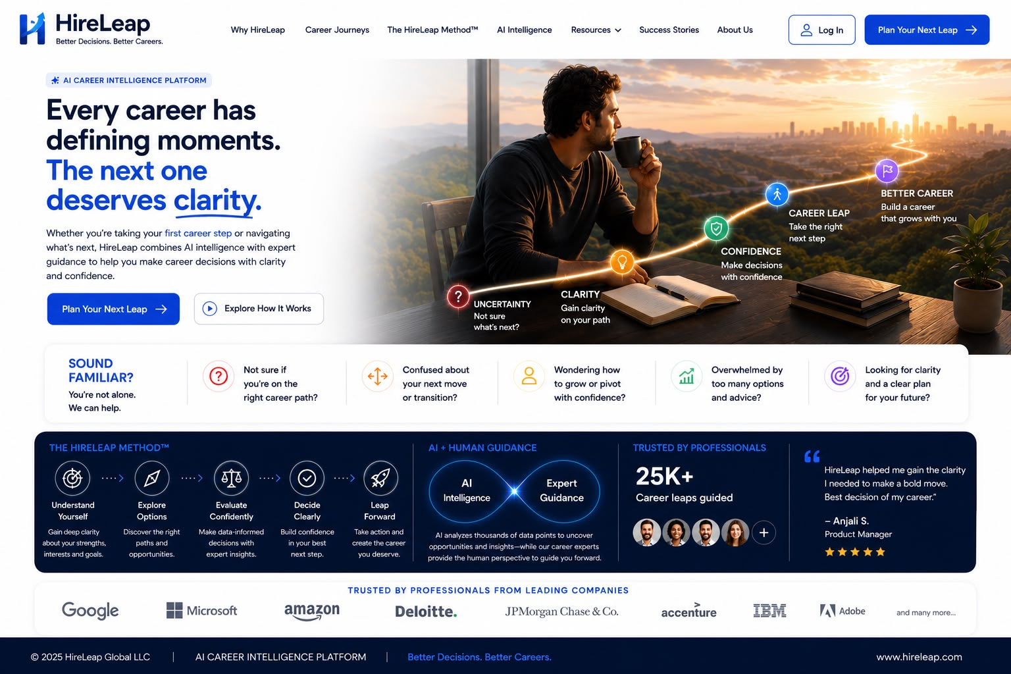
IMPLEMENTATION NOTE Use production assets, approved copy and the written changes in this blueprint. Do not reproduce obsolete numbers, labels or logos visible in the reference image.

44. Homepage - functionality & acceptance
Introduce HireLeap, establish emotional relevance and direct the visitor toward a decision.

Hero
- Remove “AI Career Intelligence Platform.”
- Headline: “Every career has defining moments. The next one deserves clarity.”
- Use approved curved underline beneath clarity.
- Primary CTA -> Plan Your Next Leap form.
- Secondary CTA -> accessible introductory video.

Narrative sections
- Sound Familiar pain-point cards.
- HireLeap Method preview.
- Human + AI/expert guidance framing.
- Professional impact and trust metrics.
- Leading-company logo marquee.

Interactions
- Logo marquee scrolls continuously or left-to-right, pauses on hover/focus and respects reduced motion.
- All major CTAs have configured analytics events.

Responsive
Stack hero intentionally; preserve emotional image crop; pain cards may swipe/stack; marquee remains readable.

SEO
Title and description position HireLeap as a career decision platform. One H1 only.
LOCKED DECISION Homepage alone retains the large pre-footer “Ready for your next leap?” CTA.

Acceptance criteria
- First viewport explains purpose and next action.
- No obsolete descriptor or unverified 25K claim appears.

45. Why We Exist - approved visual reference
Desktop composition reference supplied with HireLeap website requirements.
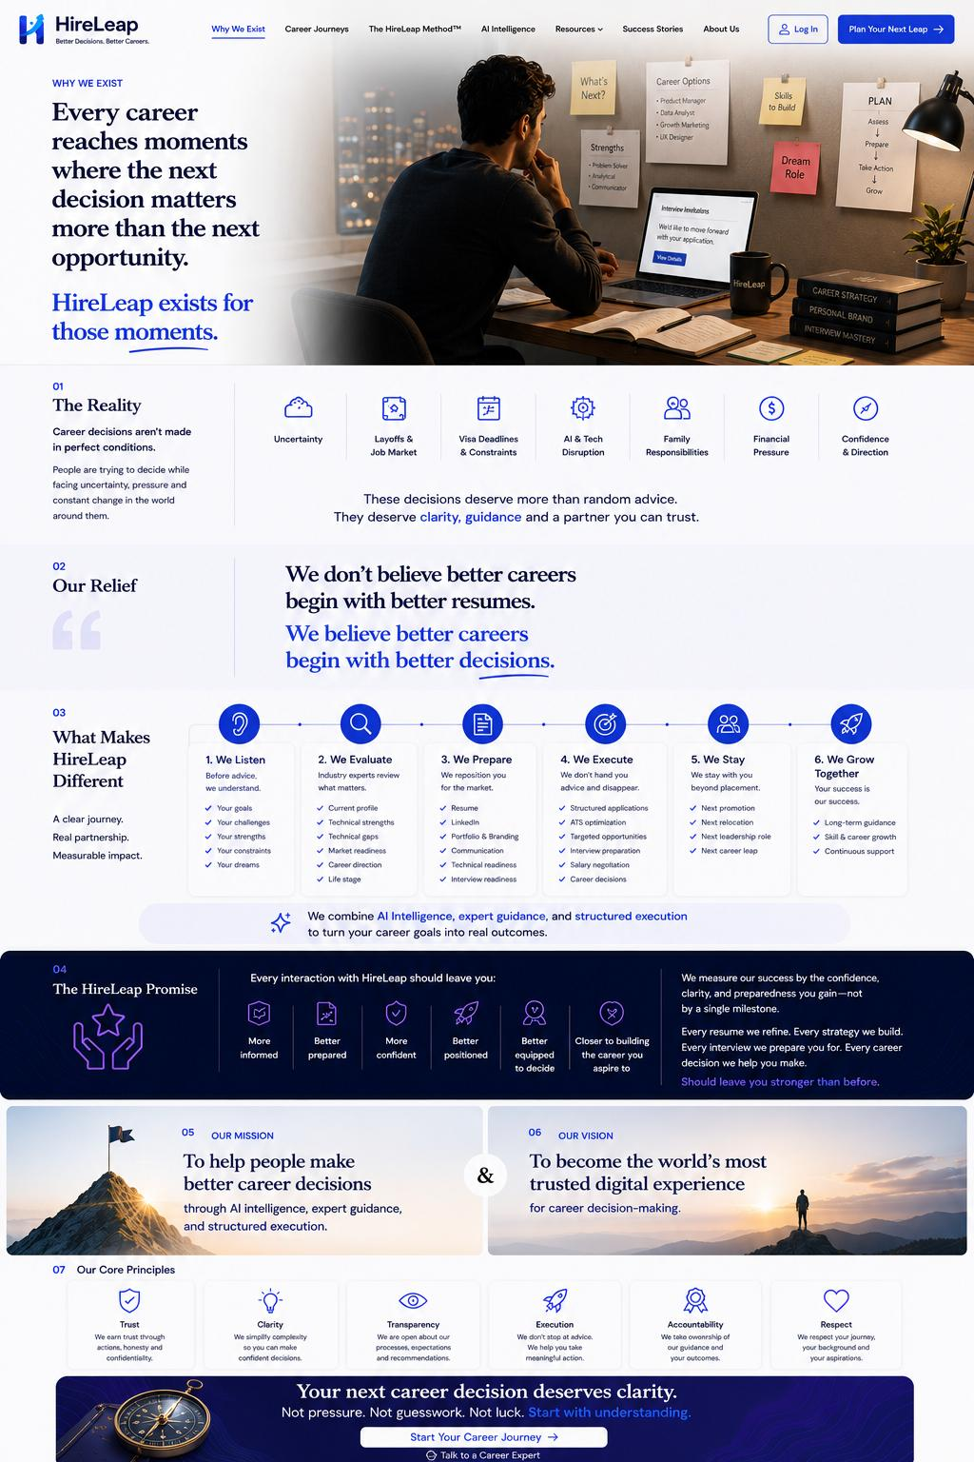
IMPLEMENTATION NOTE Use production assets, approved copy and the written changes in this blueprint. Do not reproduce obsolete numbers, labels or logos visible in the reference image.

46. Why We Exist - functionality & acceptance
Explain the career decision problem, HireLeap belief and differentiation.

Content
- Keep approved hero image and core copy.
- Remove visible section labels 01, 02 and 03.
- Reality points explain uncertainty, layoffs/job market, visa deadlines, AI/tech disruption, family responsibility, financial pressure and confidence/direction.
- Belief: better careers begin with better decisions.
- Differentiate through structured journey, AI intelligence, expert guidance, execution and long-term partnership.

Interactions
- Start Your Career Journey -> Career Journeys when used in the hero context; page-end conversion CTA -> consultation form.
- Reality points and differentiation cards become accessible horizontal tracks on constrained widths.

Brand
- Use curved underlines for approved moments/decisions.
- Integrate HireLeap logo naturally on environmental objects where present.

Responsive
No visible numeric labels; reading order remains hero -> reality -> belief -> differentiation -> promise -> mission/vision -> principles -> CTA.
LOCKED DECISION The page builds belief before it describes services.

Acceptance criteria
- Horizontal tracks support touch and keyboard.
- Image remains faithful to approved design.

47. Career Journeys - approved visual reference
Desktop composition reference supplied with HireLeap website requirements.
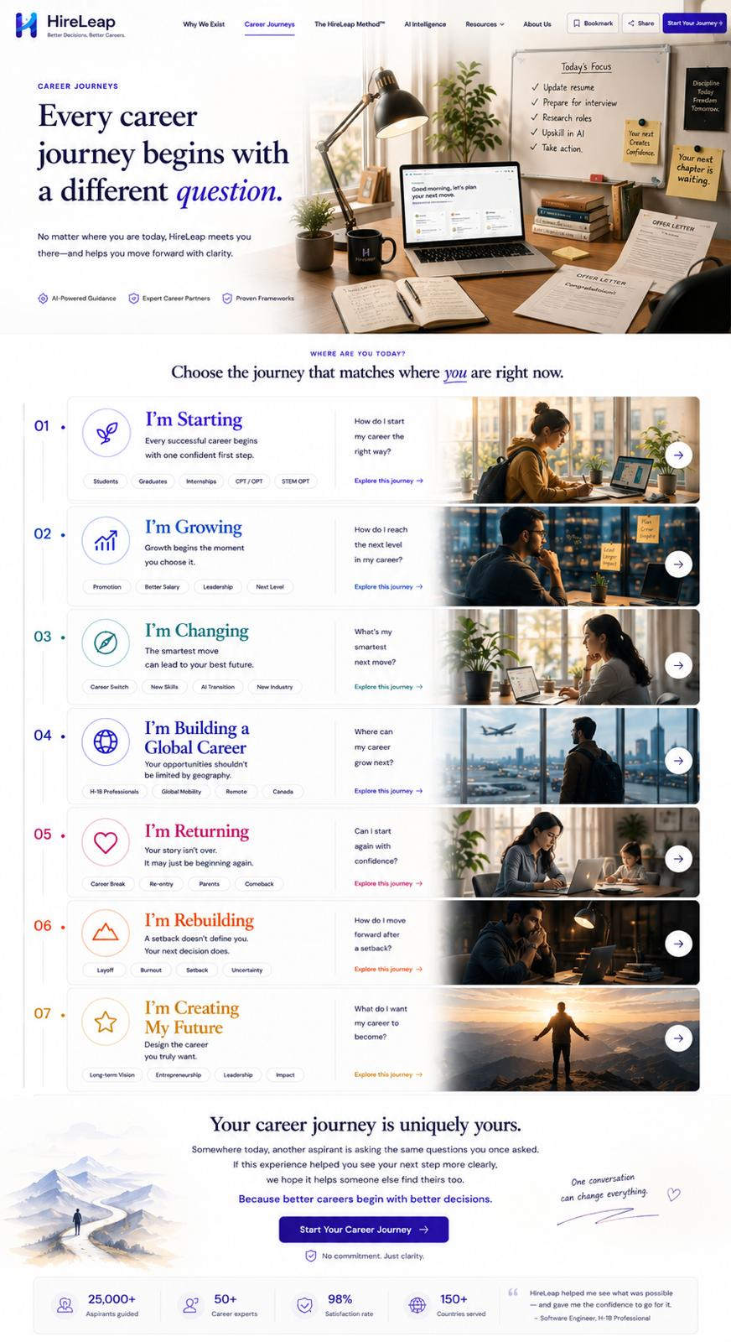
IMPLEMENTATION NOTE Use production assets, approved copy and the written changes in this blueprint. Do not reproduce obsolete numbers, labels or logos visible in the reference image.

48. Career Journeys - functionality & acceptance
Help visitors recognize their present situation and choose the next path.

Hero
“Every career journey begins with a different question.” Use approved curved emphasis under you in the selection prompt.

Journey cards
- Use exactly seven approved titles.
- Remove visible numbers 1-7.
- Replace “AI Powered Guidance” with “AI Powered Expert Guidance.”
- Card arrows and Explore Your Journey -> The HireLeap Method™.

Conversion
Start Your Career Journey -> Plan Your Next Leap form.

Metrics
Replace 25,000+ with 5,000+ and 50+ with 25+ where shown; verify all other claims.

Responsive
Desktop may use the approved tall card list. Mobile uses stacked cards, accordion or accessible swipe experience; never a miniature desktop list.
LOCKED DECISION Journeys are user situations, not product packages.

Acceptance criteria
- Seven labels and destinations match exactly.
- No visible numeric labels remain.

49. The HireLeap Method™ - approved visual reference
Desktop composition reference supplied with HireLeap website requirements.
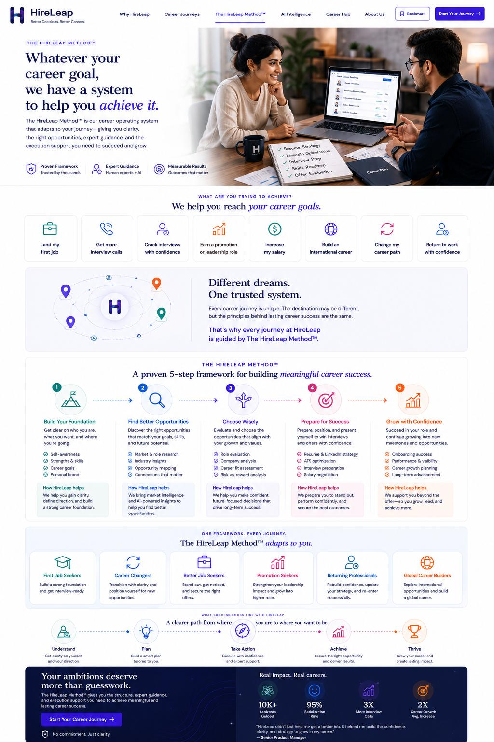
IMPLEMENTATION NOTE Use production assets, approved copy and the written changes in this blueprint. Do not reproduce obsolete numbers, labels or logos visible in the reference image.

50. The HireLeap Method™ - functionality & acceptance
Explain the structured system used to turn career goals into preparation and progress.

Hero
Preserve approved two-person expert-guidance composition and method copy.

Journey system
Place the approved H icon between location pins. Explain that different dreams use one trusted system.

Framework
Use the approved five-step method. Content remains editable, but sequence and purpose are stable.

Outcomes
Present foundation, clarity, readiness, positioning, momentum and confidence as outcomes rather than guarantees.

Metrics
Replace 10k+ with 5k+ and 95% with 98% where specified; verify before publication.

Interactions
Start Your Career Journey -> consultation form. Sequential reveals remain restrained and reduced-motion compatible.

Responsive
Five-step horizontal framework becomes a clear vertical timeline on mobile.
LOCKED DECISION The method is the central bridge between recognizing a journey and starting a consultation.

Acceptance criteria
- Method steps remain in correct order and understandable with animation disabled.

51. Career Intelligence - approved visual reference
Desktop composition reference supplied with HireLeap website requirements.
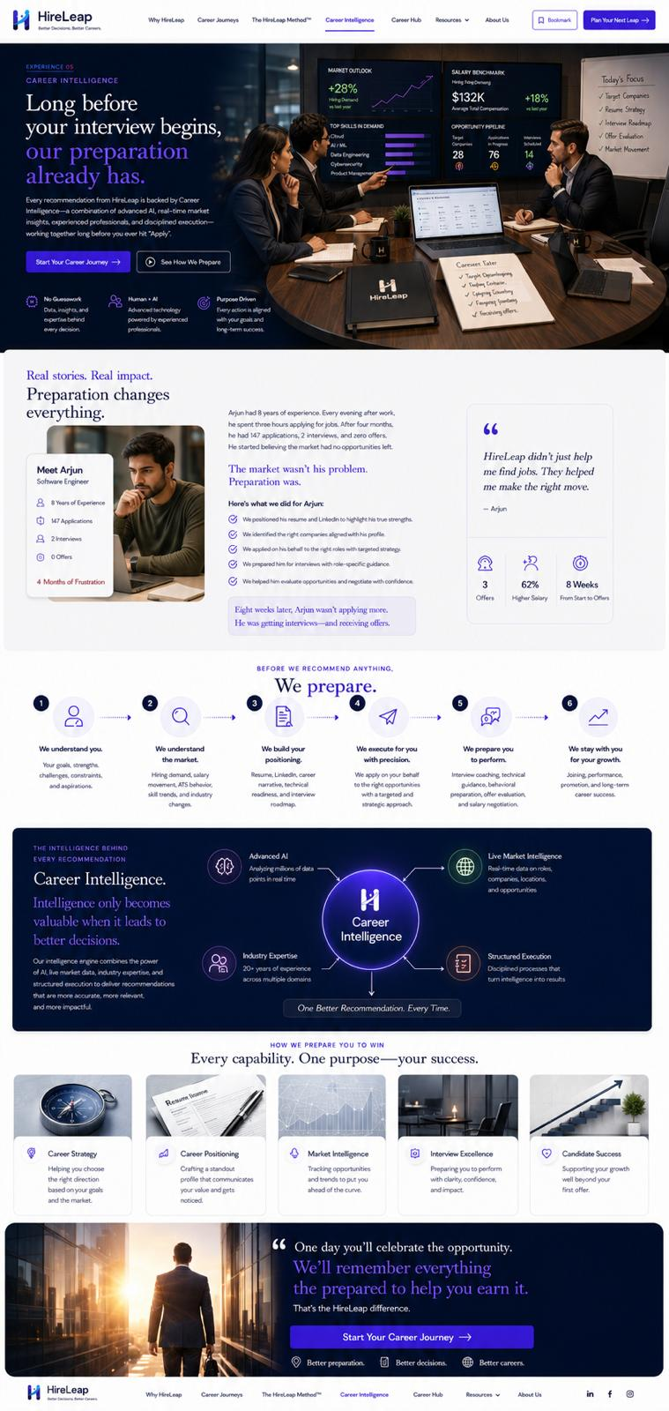
IMPLEMENTATION NOTE Use production assets, approved copy and the written changes in this blueprint. Do not reproduce obsolete numbers, labels or logos visible in the reference image.

52. Career Intelligence - functionality & acceptance
Demonstrate how preparation and intelligence improve readiness before opportunity arrives.

Hero
- Use approved dark intelligence-led composition.
- Start Your Career Journey -> consultation form.
- See How We Prepare -> preparation video.

Content flow
- Real stories / preparation impact.
- “We prepare” process.
- Career Intelligence system visual.
- Capabilities and purpose-driven outcomes.
- Closing emotional quote.

Brand changes
- Use approved H icon in imagery and replace legacy marks.
- Closing quote exactly: “One day you’ll celebrate the opportunity. We’ll celebrate the journey that helped you earn it. That’s the HireLeap difference.”

Responsive
Dark hero content stacks with readable contrast; system diagrams become vertical or horizontally scrollable with clear labels.

Content management
Capabilities and outcomes are editable as services evolve.
LOCKED DECISION Career Intelligence is preparation intelligence supported by experts - not an autonomous AI promise.

Acceptance criteria
- Video is accessible.
- Exact closing quote and approved H mark appear.

53. Career Hub / Resources - screen specification

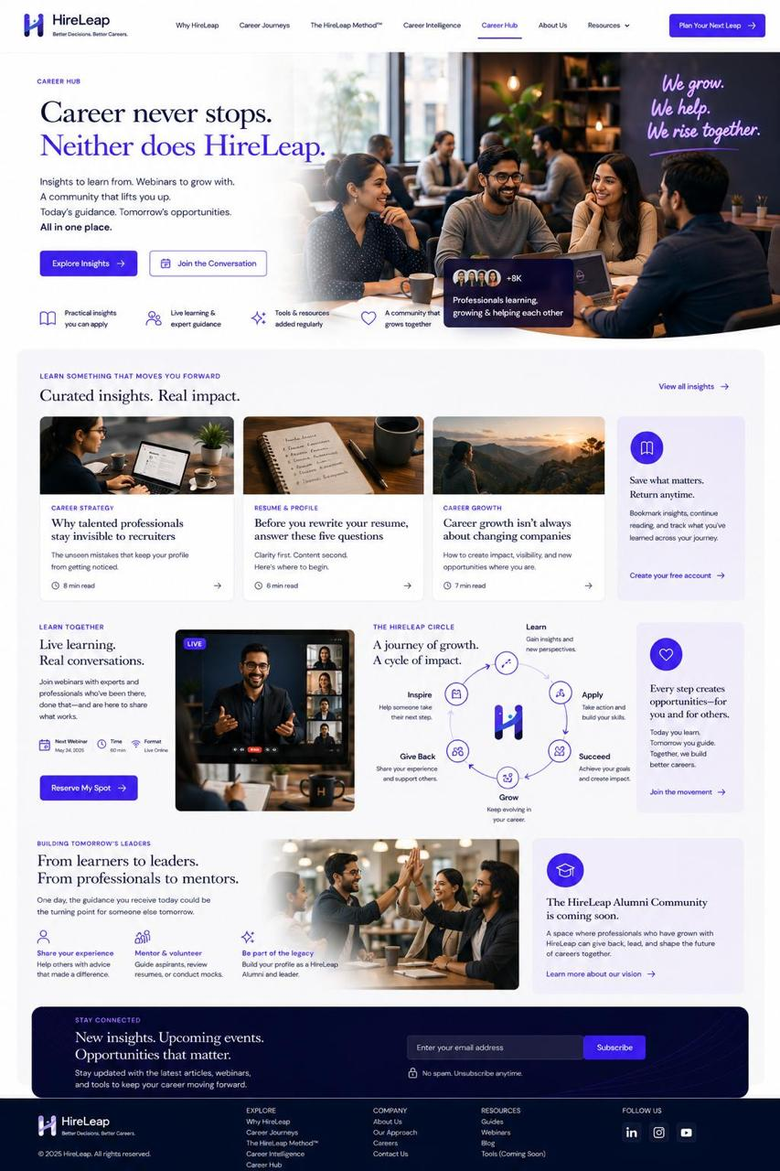
Provide useful content and reinforce expertise through education.

Purpose
Support trust, SEO and ongoing engagement with guides, webinars, articles, templates and FAQs.

Page anatomy
- Editorial hero.
- Featured resource.
- Category filters.
- Resource card grid.
- Webinar/event strip.
- FAQ or newsletter/consultation CTA.

Resource model
- Title, slug, summary, category, image/alt, author, publish/update date, body, SEO title/description, Open Graph image and CTA.

Behavior
- If more than 12 items, provide pagination or Load More.
- Filters update results accessibly and preserve URL state where practical.
- Empty state offers reset and consultation route.

Navigation
Career Hub remains in navigation even if initial volume is small.

Responsive
Filters become scrollable chips or accessible select; cards stack one column on mobile.
LOCKED DECISION Resources educate before they convert; every article should have a relevant next action.

Acceptance criteria
- No empty broken category pages.
- Structured Article/FAQ data is valid where used.

54. Success Stories / Career Transformations

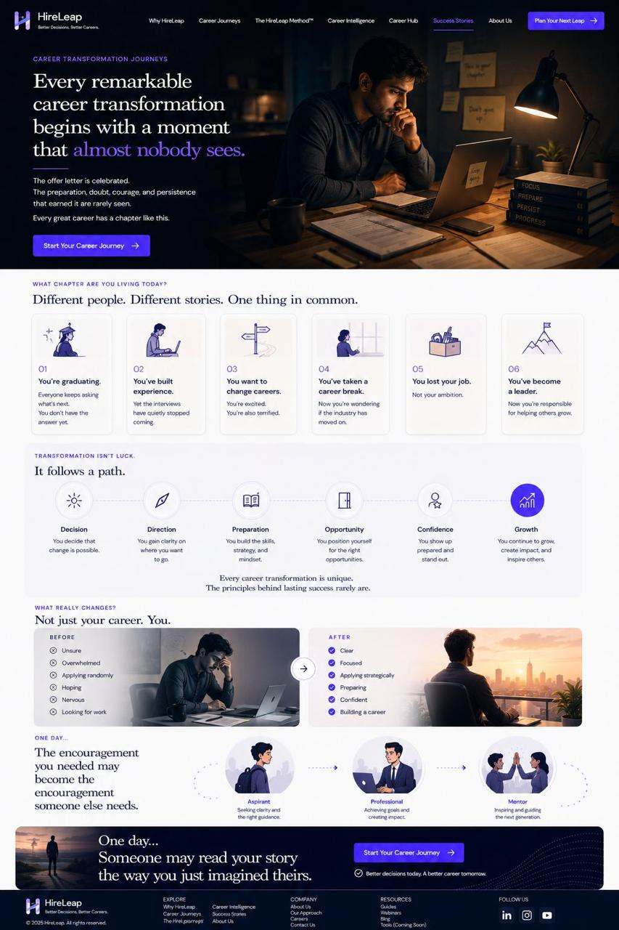
Build credible trust while protecting customer privacy.

Page anatomy
- Hero focused on transformation, not trophies.
- Featured story.
- Filterable quote/story cards.
- Optional video testimonials.
- Outcome themes.
- CTA to start the visitor’s journey.

Story model
- Consent status.
- Display name or anonymized identity.
- Career situation and challenge.
- HireLeap support.
- Verified outcome.
- Quote, image/video and publication approval.

Rules
- No fabricated employer, offer, salary or success claim.
- Clearly distinguish individual results from typical expectations.
- Allow stories to be hidden immediately if consent changes.

Accessibility
Videos have captions/transcripts; quote marks are decorative and not read repetitively.

Responsive
Feature story stacks; filters and cards remain readable without forced equal heights.
LOCKED DECISION Credibility is more important than volume of testimonials.

Acceptance criteria
- Every published story has documented consent and verification.

55. Career Investment - approved visual reference
Desktop composition reference supplied with HireLeap website requirements.
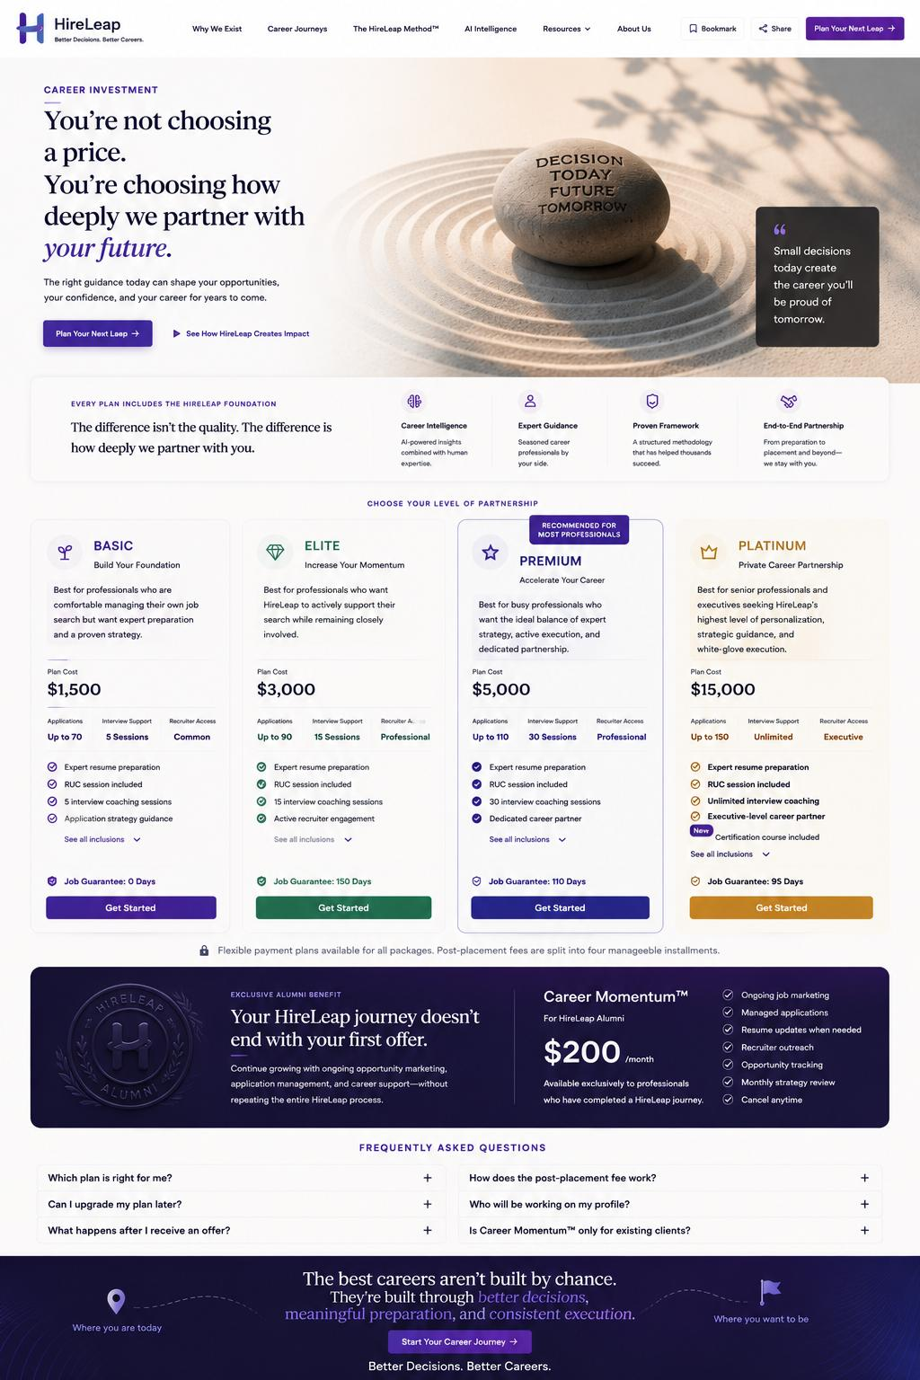
IMPLEMENTATION NOTE Use production assets, approved copy and the written changes in this blueprint. Do not reproduce obsolete numbers, labels or logos visible in the reference image.

56. Career Investment - functionality & acceptance
Explain investment transparently as depth of partnership.

Navigation
Add Career Investment to primary navigation.

Hero
Preserve approved reflection/decision visual and “how deeply we partner” positioning.

Plan cards
- Basic
- Elite
- Premium
- Platinum
- Prices and inclusions are production-approved configuration.
- Get Started -> consultation with selected plan context.

Membership
Career Momentum™ Membership supports returning users needing ongoing marketing and application support. Provisional $200/month must be confirmed.

FAQ
Accessible accordion addressing fit, payment, refund/cancellation and customization.

Version 1.0
No online payment. Consultation precedes commitment unless separately approved.

Responsive
Cards stack or use an accessible comparison pattern; never require horizontal page scrolling to understand plans.
LOCKED DECISION Investment language must never imply that a person’s career level determines their worth.

Acceptance criteria
- All prices, inclusions and disclaimers are editable.
- No provisional price publishes accidentally.

57. About Us / Why We Believe - approved visual reference
Desktop composition reference supplied with HireLeap website requirements.
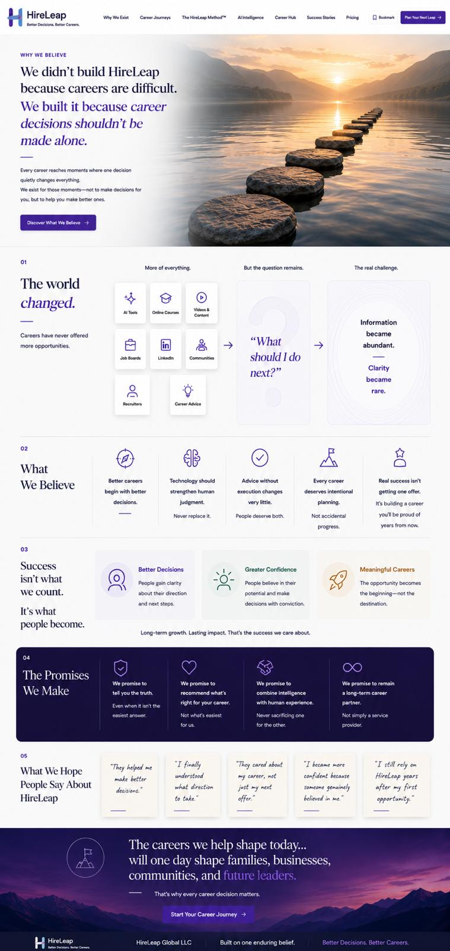
IMPLEMENTATION NOTE Use production assets, approved copy and the written changes in this blueprint. Do not reproduce obsolete numbers, labels or logos visible in the reference image.

58. About Us / Why We Believe - functionality & acceptance
Communicate the founding belief and human commitment behind HireLeap.

Hero
- Keep approved stepping-stones image and belief-led headline.
- Remove “Discover What We Believe” button.

Content
- The world changed.
- What should I do next? uncertainty.
- What We Believe.
- Success is not what we count; it is what people become.
- Promises we make.
- What people say about HireLeap.

Changes
- Remove all visible section numbers.
- Start Your Career Journey -> consultation form.
- Avoid unsupported company history, team scale or outcome claims.

Tone
Human, reflective and founder-led; do not become a generic corporate About page.

Responsive
Preserve story order and readable quote treatment; illustration grids may stack.
LOCKED DECISION This page explains belief and accountability, not a corporate biography.

Acceptance criteria
- No removed button or numeric section labels remain.

59. Plan Your Next Leap - approved visual reference
Desktop composition reference supplied with HireLeap website requirements.
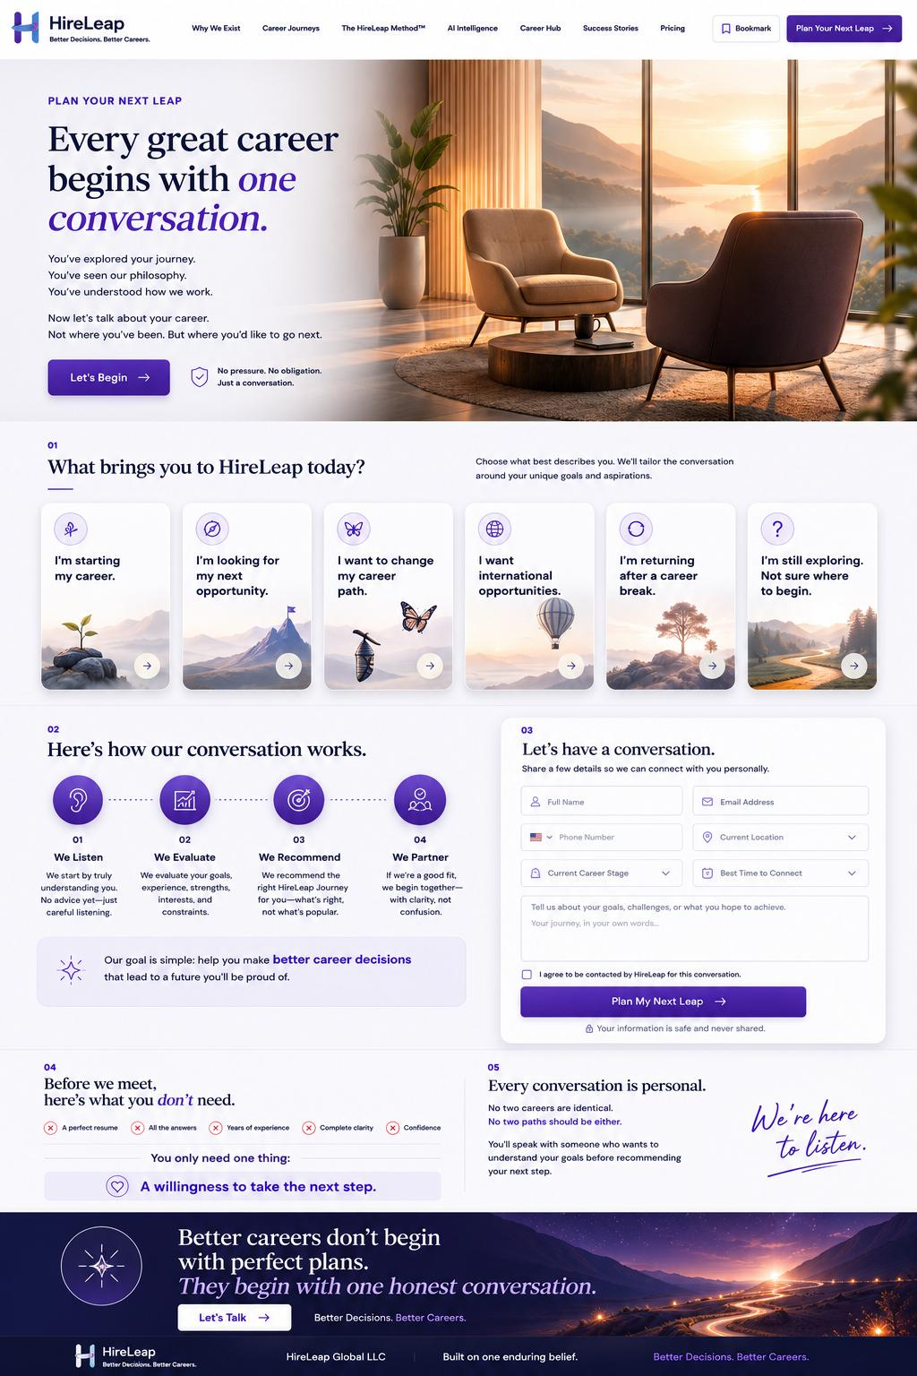
IMPLEMENTATION NOTE Use production assets, approved copy and the written changes in this blueprint. Do not reproduce obsolete numbers, labels or logos visible in the reference image.

60. Plan Your Next Leap - functionality & acceptance
Convert interest into a qualified enquiry through a calm, personal conversation flow.

Hero
- “Every great career begins with one conversation.”
- Let’s Begin scrolls to and focuses the “Let’s Have a Conversation” first-name field.

Journey prompts
Cards under “What brings you to HireLeap today?” scroll to the form and preselect the relevant journey where possible.

Process
Explain how the conversation works. Remove visible numeric labels while retaining semantic sequence.

Form
- Use recommended fields in Book III.
- Button label: Submit.
- Inline validation, spam protection, attribution, success and error handling.

WhatsApp
Let’s Talk opens configured WhatsApp Business link with optional prefilled message.

After submit
Save lead, show thank-you, send notifications and optionally offer Calendly or equivalent scheduling.

Responsive
Single-column form on mobile; CTA scroll offset accounts for sticky header.
LOCKED DECISION The form is a conversation invitation, not an application or eligibility gate.

Acceptance criteria
- All card arrows focus the form correctly.
- Submission is saved before scheduling.

61. Footer - approved visual reference
Desktop composition reference supplied with HireLeap website requirements.
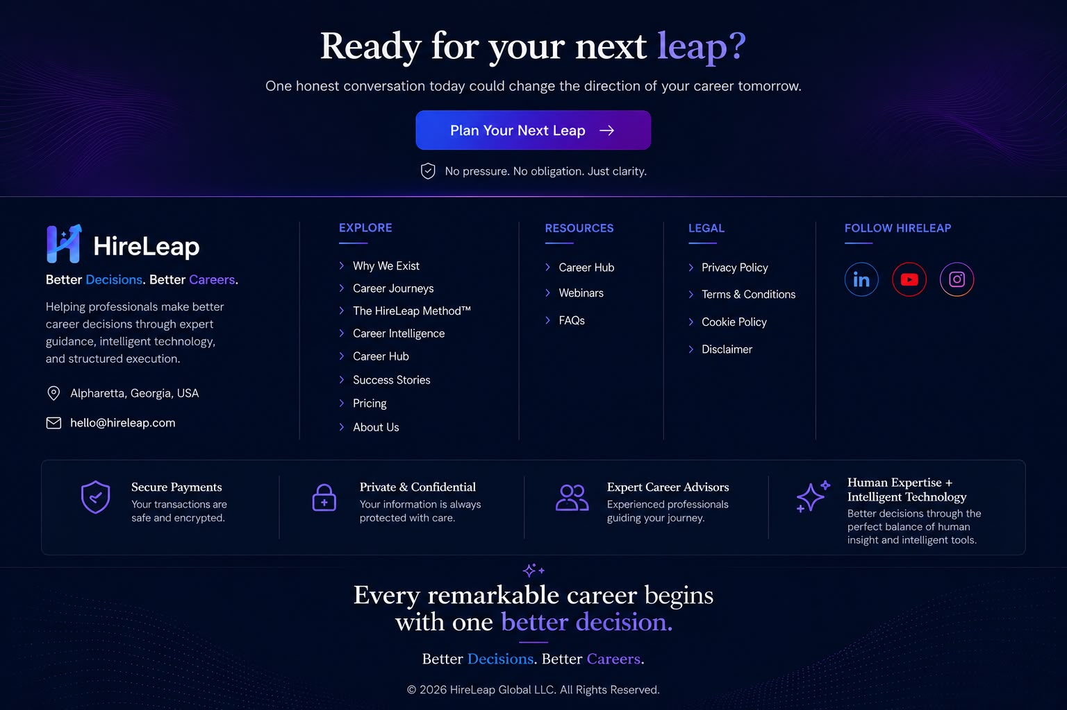
IMPLEMENTATION NOTE Use production assets, approved copy and the written changes in this blueprint. Do not reproduce obsolete numbers, labels or logos visible in the reference image.

62. Footer, legal pages & trust closure
Complete every page with consistent navigation, legitimacy and recovery routes.

Footer implementation
Use the approved compact footer on internal pages; homepage includes the large pre-footer CTA.

Legal pages
- Privacy Policy
- Terms & Conditions
- Cookie Policy
- Disclaimer
Use readable editorial templates, revision date, contact route and stable URLs.

Contact
Display only verified business contact information; WhatsApp and email actions are configurable.

Trust
Do not use badges, ratings, employer logos or certifications without permission/evidence.

Responsive
Columns stack with clear headings; social icons retain accessible names; legal links remain easy to tap.
LOCKED DECISION The footer is part of the product experience, not an afterthought.

Acceptance criteria
- All links and contact actions are tested.

63. 404, empty and future Login experiences
System pages must preserve the HireLeap experience and offer recovery.

404 page
- Clear message without technical blame.
- Links to Homepage, Career Journeys, Career Hub and Plan Your Next Leap.
- Optional search if Career Hub volume justifies it.

Empty states
- Explain why no content appears.
- Offer reset, alternative content or consultation path.

Future Login
Login may remain hidden until an authenticated product exists. Do not launch a decorative or nonfunctional login button.

Security
Authentication, password reset and account flows are future scope and require a separate specification.
LOCKED DECISION No visible navigation link may lead to a placeholder dead end.

Acceptance criteria
- 404 returns correct status and remains index-safe.

64. Information architecture, URLs & metadata
The website should be understandable to users, search engines and analytics.

Recommended URLs
- /why-we-exist
- /career-journeys
- /hireleap-method
- /career-intelligence
- /career-hub
- /success-stories
- /career-investment
- /about
- /plan-your-next-leap

SEO baseline
- Unique title and meta description.
- One H1 and logical heading hierarchy.
- Canonical URLs.
- Open Graph and social image.
- XML sitemap and robots.txt.
- Organization, Website, Breadcrumb, Article and FAQ structured data where appropriate.

Index rules
Staging is noindex. Production indexing is deliberately enabled only after launch QA.

Redirects
Maintain a redirect map for renamed or removed paths.
LOCKED DECISION Clean human-readable URLs are part of the product language.

Acceptance criteria
- No duplicate titles, broken canonicals or accidental staging indexing.

65. Analytics event specification
Measurement should reveal whether the experience creates clarity and momentum.

Core events
- navigation_select
- primary_cta_click
- journey_select
- video_open
- video_complete
- resource_filter
- resource_open
- pricing_plan_select
- faq_expand
- whatsapp_click
- form_start
- form_error
- form_submit_success
- schedule_open

Parameters
- page_path
- component
- cta_label
- journey
- plan
- resource_category
- video_name
- utm_source/medium/campaign
- device class

Tools
GA4 and Microsoft Clarity subject to consent and final approval.

Privacy
Do not transmit free-text form content or sensitive work-authorization values to analytics.

Quality
Events are documented, deduplicated and tested in staging.
LOCKED DECISION Analytics measures behavior; it must not compromise privacy or page performance.

Acceptance criteria
- Form success event fires only after server-confirmed save.

66. Non-functional requirements
The premium experience depends on reliability, security and performance.

Performance
- Target strong Core Web Vitals on representative mobile devices.
- Responsive images, next-gen formats, lazy loading below the fold.
- Minimize third-party scripts and defer video players.
- Prevent layout shift from fonts, images and embeds.

Security
- HTTPS, secure headers, input sanitization, rate limiting and bot protection.
- Secrets stored outside source control.
- Dependencies scanned and updated.

Compatibility
- Current and previous major versions of Chrome, Safari, Edge and Firefox.
- iOS Safari and Android Chrome at minimum.

Reliability
- Graceful submission failure.
- Error monitoring.
- Backup/rollback and deployment ownership.

Maintainability
Reusable components, centralized tokens and clear setup documentation.
LOCKED DECISION Visual fidelity does not justify poor performance or security.

Acceptance criteria
- Performance, security and browser evidence is included at handover.

67. Responsive acceptance matrix
Desktop, tablet and mobile are intentional versions of one experience.

Desktop 1440+
Full editorial layouts, multi-column sections, hover enhancement and persistent header.

Laptop 1024-1439
Compressed desktop with scalable typography and reduced gutters.

Tablet 768-1023
Two-column or stacked hybrid; touch-first; horizontal tracks where appropriate.

Mobile 320-767
Single-column; stacked/accordion/swipe patterns; no miniature desktop scaling.

Universal checks
- No horizontal overflow.
- Touch targets approximately 44 x 44.
- Responsive image crops preserve focal point.
- Sticky header does not obscure anchors.
- Orientation changes do not lose modal/form state.
LOCKED DECISION Every screen is reviewed at representative widths, not only one desktop and one phone.

Acceptance criteria
- Screens pass at 320, 375, 768, 1024 and 1440 px reference widths.

68. QA & release acceptance
Launch requires evidence across content, visual, functional and technical quality.

Functional
- All approved pages reachable.
- CTA routing correct.
- Forms validate, save, notify and confirm.
- Videos, sliders, accordions, menu and WhatsApp work.
- Footer difference between homepage and internal pages is correct.

Visual
- Matches approved composition and written changes.
- No clipping, overlap, distorted imagery, inconsistent spacing or low-resolution assets.
- Typography, curves, colors and logos consistent.

Content
- No legacy descriptor.
- Exact approved quote and labels.
- Metrics, prices, testimonials and logos verified.
- Legal copy approved.

Technical
- Responsive/browser testing.
- Accessibility audit.
- Performance check.
- SEO/structured data validation.
- Analytics and consent verification.
- Security and backup/rollback verification.
LOCKED DECISION No placeholder content or dummy credential reaches production.

Acceptance criteria
- Release checklist is signed by product, engineering and QA owners.

69. Developer deliverables & handover
Implementation is complete only when HireLeap can operate and evolve it.

Required deliverables
- Production-ready responsive website.
- Source repository and setup instructions.
- Environment/configuration template without secrets.
- Asset and licensing inventory.
- CMS/editor access and operating guide.
- Analytics and integration documentation.
- QA evidence.
- Deployment and rollback instructions.
- Administrator credential handover through a secure channel.
- Known limitations and approved backlog.

Ownership
Domains, hosting, analytics, repositories and production accounts should be controlled by HireLeap or explicitly documented.

Documentation
Architecture and component conventions are concise, current and sufficient for a new developer.
LOCKED DECISION “Works on the developer’s machine” is not an accepted handover state.

Acceptance criteria
- A new developer can run, deploy and update content using the handover package.

70. Configuration dependencies & launch decisions
Open items are managed without blocking the core build or creating ambiguity.

Pending inputs
- Final production logo variants and favicon.
- Introduction and preparation videos.
- Verified metrics and company logo permissions.
- Production pricing and package inclusions.
- Career Momentum final terms.
- WhatsApp number and prefilled message.
- Calendly/scheduling link.
- Notification recipients and email provider.
- Legal documents and consent language.
- Analytics IDs and consent configuration.

Developer treatment
Use centralized configuration and clearly marked staging values. Never hard-code provisional values across multiple templates.

Launch gate
Each dependency has an owner, status and production decision before go-live.
LOCKED DECISION Pending content is a configuration dependency, not redesign permission.

Acceptance criteria
- No provisional value remains unreviewed in production.

71. Final implementation checklist
A concise build checklist for the delivery team.

Brand
- Approved logo and H icon.
- Brand promise replaces legacy descriptor.
- DM Serif Display + Inter only.
- Official color tokens.
- Curved editorial underlines.

Experience
- Approved navigation.
- Responsive intentional layouts.
- Primary CTA routing.
- Accessible videos/sliders/accordions.
- Correct homepage/internal footer behavior.

Conversion
- Consultation form fields and validation.
- Lead save, notifications and acknowledgement.
- WhatsApp and optional scheduling.
- Attribution capture without sensitive analytics.

Quality
- WCAG AA.
- Core Web Vitals focus.
- SEO and structured data.
- Browser/device testing.
- Security, error monitoring and rollback.

Content
- Exact locked wording.
- Verified metrics/pricing/testimonials/logos.
- No unsupported guarantees.
LOCKED DECISION This checklist summarizes but does not replace the detailed requirements.

Acceptance criteria
- All items have pass/fail evidence or an approved exception.

72. Design decision register
Locked decisions that future teams should not reverse casually.

DDR-001
Position HireLeap as a Career Decision Platform.

DDR-002
Brand promise: Better Decisions. Better Careers.

DDR-003
Human expertise remains central; AI strengthens guidance.

DDR-004
DM Serif Display + Inter typography system.

DDR-005
White-first interface with blue, purple and deep navy.

DDR-006
Single dominant primary CTA: Plan Your Next Leap.

DDR-007
Mobile is intentionally redesigned, not scaled down.

DDR-008
Homepage retains large pre-footer CTA; internal pages do not.

DDR-009
No online payment in Version 1.0 without approval.

DDR-010
Metrics, pricing, testimonials and company logos require verification.
LOCKED DECISION Locked decisions may change only through documented founder/product governance.

Acceptance criteria
- Any exception records reason, owner, date and affected scope.

73. Asset register
Production uses approved high-resolution and legally cleared assets.

Required brand assets
- Primary horizontal logo with promise - SVG/PNG.
- Compact horizontal logo - SVG/PNG.
- H icon and app icon - SVG/PNG/favicon.
- Editorial underline SVG.

Page assets
- Approved desktop mock-ups for each experience.
- Responsive crops or focal-point definitions.
- Introduction and Career Intelligence videos.
- Company logo marquee assets.
- Journey, method, intelligence, pricing, about and consultation imagery.

Content assets
- Pricing/inclusion data.
- Verified metrics.
- Testimonials with consent.
- Resource content and Open Graph images.
- Legal documents.

Asset rules
Use descriptive filenames, alt text, source/license and version. Production must not use screenshots as logos or low-resolution references as final imagery.
LOCKED DECISION Every production asset has an owner and usage right.

Acceptance criteria
- Broken, missing and oversized assets are absent from release.

Build with clarity.
Every remarkable career begins with one better decision.
Better Decisions. Better Careers.
FINAL AUTHORITY This master document is the implementation baseline for HireLeap Version 1.0. Where an approved screenshot and written requirement differ, the latest written requirement in this document takes precedence.

