Writing an Academic Paper Using Overleaf
Overleaf is an online editor designed for students, researchers, and academics to create professional-quality papers. This guide is intended for beginners with little or no prior experience using Overleaf. It explains step-by-step on starting a new project, using templates, and compiling your work into a polished PDF document. By following these instructions, beginners of Overleaf can efficiently create academic papers, collaborate with co-authors, and manage references in a structured and professional format.

Gather Your Materials
The following materials are essential:
- A computer, tablet, or smartphone with internet access
- A web browser
- An active Overleaf account (free or paid)
Note: Make sure your internet connection is stable. Overleaf requires an online connection to save and compile your work.

Opening an Account
Open a web browser on your computer, tablet, or smartphone.
- Go to https://www.overleaf.com/register.
- Choose a registration method:
  - Click “Sign up with Google” to register using your Google account, or
  - Click “Sign up with ORCID” to register using your ORCID account, or
  - Enter your email address and password manually, or
  - If your organization supports Single Sign-On (SSO), click “Log in with SSO.”
Note: Use your institutional account if your school provides premium Overleaf features but also link a personal email. Institutional logins may be deactivated when you graduate, so a personal email ensures you can keep access to your account.
After registering, a pop-up appears asking for a verification code.
- Check your email inbox for a six-digit verification code sent by Overleaf.
- Enter the six-digit code into the pop-up and click “Continue” to finish your setup.
Note: If you don’t receive the code, click “Resend Confirmation Code” to request a new one.
Overleaf asks for your first and last name. This is visible to the people you collaborate with.
- Enter your information and then click “Continue.”
- Select your experience level with LaTeX.
- Choose whether you would like to receive emails about feature updates from Overleaf by checking the box next to “I’d like emails about feature updates, offers, and user feedback opportunities.”
Note: Your preferences for email updates can be changed later in your Overleaf account settings.
- Select where you work or study.
  - If none of the options apply, select “Other.”
  - Under Organization Name, enter your full name.
  - Under Job Title, enter your current role or title.
- Click “Go to Overleaf.” Your account is verified and ready to use.

Creating and Managing Projects
- Click “Create a New Project.”
A sidebar appears with the following options:
  - Blank Project – starts a new document from scratch.
  - Example Project – opens a sample LaTeX project with pre-written code.
  - Upload Project – imports a .zip file or .tex file from your device.
  - Import from GitHub – connects to your GitHub account to import a repository.
- Select the option that best fits your needs.
- Enter a name for your project in the text box provided.
- Click “Create.”
Your new project is now open in the Overleaf workspace.

Adding and Editing Content

Typing Text in LaTeX
- Open your Overleaf project and click on the main .tex file in the file list (usually named main.tex or sample.tex). Add your text in this file.
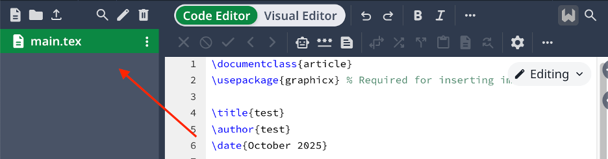
Note: Click the Recompile button at the top of the screen to see your changes in the PDF preview.

Organizing Sections and Subsections
- Use LaTeX commands to structure your document:
  - \section{Title} – creates a main section
  - \subsection{Title} – creates a subsection
  - \subsubsection{your Title} – creates a further division
Each section or subsection automatically appears in the PDF preview and helps organize your content.

Using Formatting Commands
- Apply formatting to your text using LaTeX commands:
  - \textbf{bold text} – makes text bold
  - \textit{italic text} – makes text italic
  - \underline{underline text} – underlines text
- Organize points using lists:
  - \begin{itemize} your text \end{itemize} – creates a bullet list
  - \begin{enumerate} your text \end{enumerate} – creates a numbered list
Note: LaTeX formatting commands must be typed exactly as shown, including the braces {}.

Creating a .bib File for References
- Click the “New File” icon in your project’s file list.
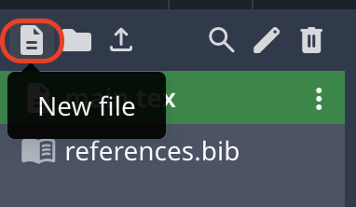
- Name the file using a .bib extension (for example, references.bib).
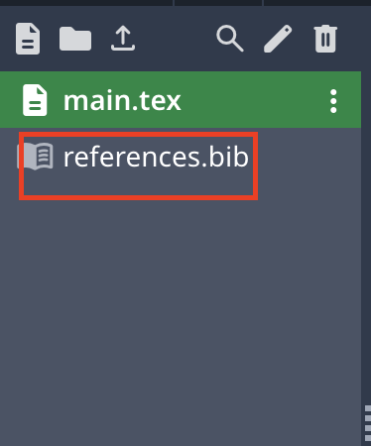
- Click “Create” to add the file to your project.

Adding Citations
- 1. Open your .bib file in your Overleaf project.
If you do not have a .bib File, follow the instructions in “Creating a .bib File for References.”
- Add your references using the information from the source you want to cite (author, title, journal, year, etc.). Use the following format:
@article{citekey,
author = {Author Name},
title = {Title of the Article},
journal = {Journal Name},
year = {Year},
}
Tip: Make the citekey short, meaningful, and easy to remember, e.g., smith2020 for an article by Smith published in 2020.

Adding Inline Citations
- Ensure your .bib file with all references is added to your project.
- Place the cursor in your main .tex file where you want the citation to appear.
- Insert a citation using the \cite{citekey} command:
  - Replace citekey with the unique key you assigned to the reference in your .bib file.
  - Example: This method was first described in \cite{smith2020}.
- Compile your document to see the in-text citation appear in the PDF
Note: Each citation must match a key in your .bib file, or Overleaf will show an error.
Your text now contains properly formatted inline references that link to your bibliography.

Adding the Bibliography
- Add the bibliography at the end of your document using these commands:
\bibliographystyle{plain}
\bibliography{yourbibfilename}
Note: Replace yourbibfilename with the name of your .bib file, without the .bib extension.
Your document will now display a formatted bibliography with all cited references.

Compiling, Reviewing, and Sharing Your Paper

Compiling Your PDF and Checking for Errors
- Click the Recompile button at the top of your Overleaf project.
- Wait for Overleaf to compile your LaTeX code into a PDF.
- Check the PDF preview on the right-hand side for formatting, text, and section structure.
- Review the log panel at the bottom of the editor if errors appear to identify issues.
- Correct any syntax or formatting errors in your .tex file and recompile.

Downloading the Final PDF
- Click the “Download PDF” button at the top of the PDF preview panel to save a copy to your device once your PDF is error-free.
Note: Always double-check your PDF to ensure all sections, citations, and figures are correctly formatted.
You now have a fully compiled, error-free PDF of your paper ready for use.

