**Name : jadav savan**

**Roll No : 31**

**PRN : 2017095900001955**

**Sub : Python Programming ☺**

**Sem : 7th**

**Branch : Computer Engineering**

**______________________________________________________________________________**

File_name = format.py

{***This file is only for good view and I use this file in all the Practical for good Lock*** }

class Line_maker:  
 lent = 0  
 print_str = **''** def __init__(self):  
 pass  
 def string_Line(self,string):  
 if(type(string) == type(**""**)):  
 self.lent = len(string)  
 self.print_str += **"| "** self.print_str += string  
 if(len(self.print_str) < 70):  
 rang =70-len(self.print_str)  
 for i in range(rang+1):  
 self.print_str += **" "** else:  
 self.print_str += **"|"** print(self.print_str)  
 self.print_str = **''** def start_Line(self):  
 self.print_str += **"+"** for i in range(70):  
 self.print_str += **"-"** else:  
 self.print_str += **"+"** print(self.print_str)  
 self.print_str = **''**

**Practical 1 :**

**(a) develop a program to add two numbers**

from format import *  
  
obj = Line_maker()  
obj.start_Line()  
  
obj.string_Line(string=**" Fast program "**)  
  
obj.start_Line()  
  
obj.string_Line(string=**"Enter First Number : "**)  
print(**"| "**,end=**""**)  
a=int(input())  
obj.string_Line(string=**"Enter Second Number : "**)  
print(**"| "**,end=**""**)  
b=int(input())  
obj.string_Line(string=**"The Adition of two numbers is :"**+str(a+b))  
obj.start_Line()

**output:** 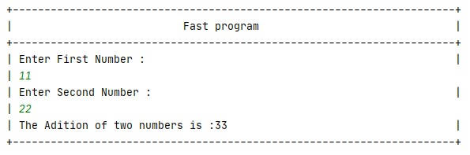

**(b) Write a program to check if the number is Odd or Even. Take input from use**

from format import *  
  
obj = Line_maker()  
obj.start_Line()  
  
obj.string_Line(string=**"Enter number to check it is odd or even."**)  
print(**"| "**,end=**""**)  
number = int(input())  
if number%2 == 0:  
 obj.string_Line(string=**"Number is Even."**)  
else:  
 obj.string_Line(string=**"Number is Odd."**)  
  
obj.start_Line()

**output:**

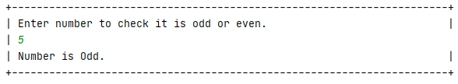

**(c) write a program to find given nunber is armstrong or not.**

from format import *  
  
obj = Line_maker()  
obj.start_Line()  
  
obj.string_Line(string=**"Enter number to check it is Armstrong or not"**)  
print(**"| "**,end=**""**)  
no = int(input())  
t = no  
sum = 0  
while t > 0:  
 i = t % 10  
 sum = sum + i**3  
 t = t//10  
if no == sum:  
 obj.string_Line(string=**"Number is Armstrong"**)  
else:  
 obj.string_Line(string=**"Number is not Armstrong"**)  
obj.start_Line()

**output:**

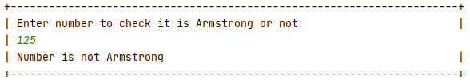

**(d) Write a python program to compute GCD of two numbers**

from format import *  
  
obj = Line_maker()  
obj.start_Line()  
  
obj.string_Line(string=**"Enter First Number : "**)  
print(**"| "**,end=**""**)  
a = int(input())  
  
obj.string_Line(string=**"Enter Second Number : "**)  
print(**"| "**,end=**""**)  
b = int(input())  
i = 1  
gcd = 0  
while i <= a and i<=b:  
 if a % i == 0 and b % i == 0:  
 gcd = i  
 i+=1  
obj.string_Line(string=**"The GCD is "**+str(gcd))  
obj.start_Line()

**output:**

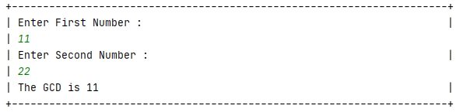

**(e) To Find all prime numbers between give range**

from format import *  
  
obj = Line_maker()  
obj.start_Line()  
  
obj.string_Line(string=**"PRIME NUMBERS BETWEEN TWO RANGE"**)  
obj.string_Line(string=**"Enter lower number: "**)  
print(**"| "**,end=**""**)  
no1 = int(input())  
  
obj.string_Line(string=**"Enter upper number: "**)  
print(**"| "**,end=**""**)  
no2 = int(input())  
  
for number in range(no1, no2 + 1):  
  
 if number > 1:  
 for i in range(2, number):  
 if (number % i) == 0:  
 break  
 else:  
  
 obj.string_Line(string=str(number))  
obj.start_Line()

**output:**

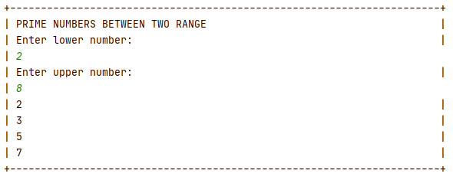

**(f) To print ‘n terms of Fibonacci series using iteration.**

from format import *  
  
obj = Line_maker()  
obj.start_Line()  
  
  
obj.string_Line(string=**"Enter Number Upto Which You Want TO Get Fibonacci Series : "**)  
print(**"| "**,end=**""**)  
n = int(input())  
n1 = 0  
n2 = 1  
n3 = 0  
for i in range(n):  
 obj.string_Line(string=str(n2))  
 n3 = n1 + n2  
 n1 = n2  
 n2 = n3  
obj.start_Line()

**output:**

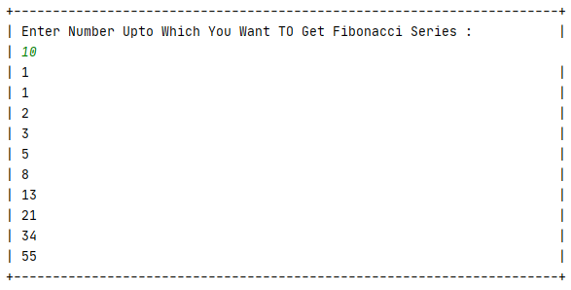

**(g)Write a program to print following pattern:**

**A**

**B C**

**D E F**

**G H I J**

**K L M N O**

aasci = 65

for i in range(6):

for j in range(i):

print(chr(aasci),end=" ")

aasci += 1

print("\n")

**output:**

