**Name : jadav savan**

**Roll No : 31**

**PRN : 2017095900001955**

**Sub : Python Programming ☺**

**Sem : 7th**

**Branch : Computer Engineering**

**Practical 2**

**(a) Develop a python program to split and join the string**

**Solution :**

**file name = Practical_2.py**

from format import *  
  
  
obj.start_Line()  
  
obj.string_Line(string=**" ** Develop a python program to split and join the string ** "**)  
obj.start_Line()  
obj.string_Line(string=**"Enter a string : "**)  
print(**"| "**,end=**""**)  
str1 = input(**""**)  
  
obj.string_Line(string=**"Splitting of the string"**)  
strList = str1.split(**" "**)  
str3 = **"The splitted strings are : "**+str(strList)  
obj.string_Line(string=str3)  
obj.string_Line(string=**"Joining the strings"** )  
str2 = **" "**.join(strList)  
str4 = **"Joined string is : "**+str(str2)  
obj.string_Line(string=str4)  
obj.start_Line()

**output :**

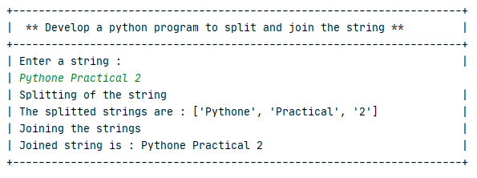

**(b) To write a program merge two lists**

**Solution :**

from format import *  
  
obj = Line_maker()  
obj.start_Line()  
obj.string_Line(string = **"To write a program merge two lists"**)  
obj.start_Line()  
  
list1 = []  
list2 = []  
  
obj.string_Line(string = **"Enter number of elements for list1 : "**)  
print(**"| "**,end=**""**)  
n = int(input())  
for i in range(n):  
 string1 = **"Enter element of number "**+str((i+1))+**" :"** obj.string_Line(string=string1)  
 print(**"| "**,end=**""**)  
 list1.append(input())  
obj.string_Line(string = **"Enter number of elements for list2 : "**)  
print(**"| "**,end=**""**)  
n = int(input())  
for i in range(n):  
 string2 = **"Enter element of number "**+str((i+1))+**" :"** obj.string_Line(string=string2)  
 print(**"| "**, end=**""**)  
 list2.append(input())  
list1.extend(list2)  
obj.start_Line()  
print(**"| Merged list is : "** , end=**""**)  
print(list1)  
obj.start_Line()

**output :**

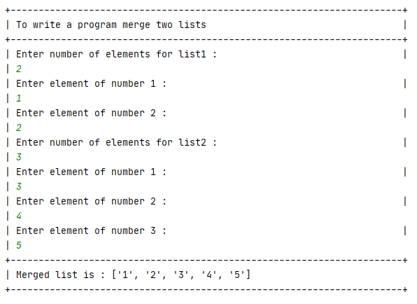

**(c) Develop a python program to print even numbers in**

**Solution** :

from format import *  
  
obj = Line_maker()  
obj.start_Line()  
  
obj.string_Line(string = **"Develop a python program to print even numbers in list "**)  
list1 = []  
obj.string_Line(string = **"Enter number of elements in list : "**)  
print(**"| "**,end=**""**)  
n =int(input())  
for i in range(n):  
 obj.string_Line(string=**"Enter element "**+str(i+1)+ **": "**)  
 print(**"| "**,end=**""**)  
 list1.append(int(input()))  
obj.start_Line()  
obj.string_Line(string = **"Even elements in list"**)  
obj.start_Line()  
for i in list1:  
 if i % 2 == 0:  
 obj.string_Line(string=str(i))  
obj.start_Line()

**Output** :

