**Name : jadav savan**

**Roll No : 31**

**PRN : 2017095900001955**

**Sub : Python Programming ☺**

**Sem : 7th**

**Branch : Computer Engineering**

**__________________________________________________________________________**

**Practical 3:**

**(a)To add ' ing ' at the end of a given string (length should be at least 3). If the given string**

**already ends with 'ing' then add 'ly' instead. If the string length of the given stringis less than**

**3, leave it unchanged.**

**Sample String : 'abc' Sample String : 'string'**

**Expected Result :'abcing' Expected Result: 'stringly'**

**Solution:**

from format import *  
  
obj = Line_maker()  
obj.start_Line()  
for i in range(3):  
 obj.string_Line(string=**"Enter A String : "**)  
 print(**"| "**,end=**""**)  
 str1 = input()  
 if len(str1) >= 3:  
  
 if str1.endswith(**'ing'**):  
 str1 += **'ly'** else:  
 str1 += **'ing'** obj.string_Line(string=**"String Updated Is "**+str1)  
  
 else:  
 obj.string_Line(string=**"There is no change in string "**)  
 obj.string_Line(string=**"The String Is "**+str1)  
 obj.start_Line()

**output**:

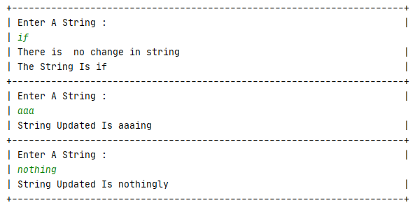

**(b) To get a string from a given string where all occurrences of its first char have been**

**changed to '$', except the first char itself.**

**Sample String : 'restart'**

**Expected Result :'**

**Solution:**

from format import *  
  
obj = Line_maker()  
obj.start_Line()  
  
obj.string_Line(string=**"Enter the string : "**)  
print(**"| "**,end=**""**)  
str1 = input()  
obj.start_Line()  
char = str1[0]  
str1 = str1.replace(char, **'$'**)  
str1 = char + str1[1:]  
  
obj.string_Line(string=**"The Expected String is "**+str1)  
obj.start_Line()

**output:**

