**Name : jadav savan**

**Roll No : 31**

**PRN : 2017095900001955**

**Sub : Python Programming**

**Sem : 7th**

**Branch : Computer Engineering**

**________________________________________________________________________________________**

**Practical 8**

**(a) : To read and write from a file.**

**Solution:**

from format import *  
  
obj = Line_maker()  
obj.start_Line()  
obj.string_Line(string=**"To read and write from a file "**)  
  
source = open(**"src.txt"**,**"r"**)  
des = open(**"des.txt"**,**"w"**)  
while True:  
 new_line = source.readline()  
 if new_line == **""**:  
 break  
 des.write(new_line)  
obj.string_Line(string=**"Copying is done "**)  
obj.start_Line()  
source.close()  
des.close()

**output :**

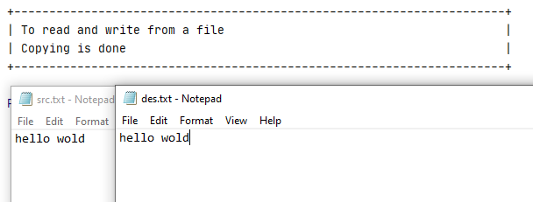

**(b) : To write a python program to find the most frequent words from a file.**

**Solution:**

from format import *  
  
obj = Line_maker()  
obj.start_Line()  
obj.string_Line(**"write a python program to find the most frequent words from a file"**)  
  
source = open(**"src.txt"**,**"r"**)  
d = dict()  
maximum = 0  
max_key = []  
for line in source:  
 line = line.strip()  
 line = line.lower()  
 words = line.split(**" "**)  
 for word in words:  
 if word in d:  
 d[word] += 1  
 else:  
 d[word] = 1  
for key in list(d.keys()):  
 obj.string_Line(str(key)+**":"**+str(d[key]))  
 if d[key] >= maximum:  
 maximum = d[key]  
 max_key.append(key)  
  
obj.string_Line(**"The maximum occured words : "**)  
for key in max_key:  
 obj.string_Line(str(key) + **":"** + str(d[key]))  
obj.start_Line()

**Output** :

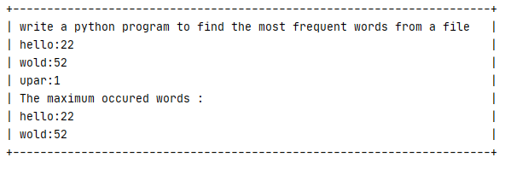

**(b) : To write a python program to count a number of words in a file.**

**Solution:**  
from format import *  
  
obj = Line_maker()  
obj.start_Line()  
obj.string_Line(**"To write a python program to count a number of words in a file"**)  
src = open(**"src.txt"**,**"r"**)  
d = dict()  
count = 0  
for line in src:  
 line = line.strip()  
 words = line.split(**" "**)  
 count += len(words)  
obj.string_Line(**"The number of words in file is : "**+str(count))  
obj.start_Line()

**Output:**

