**Name : jadav savan**

**Roll No : 31**

**PRN : 2017095900001955**

**Sub : Python Programming ☺**

**Sem : 7th**

**Branch : Computer Engineering**

**Practical 4:**

**(a)Develop a python program to find largest element in array**

**Solution:**

import array  
from format import *  
  
obj = Line_maker()  
obj.start_Line()  
obj.string_Line(**"Enter Number up to which get the elements : "**)  
obj.start_Line()  
print(**"| "**,end=**""**)  
n = int(input())  
obj.start_Line()  
a = array.array(**'L'**,[])  
for i in range(0,n):  
 obj.string_Line(**"Enter element no "**+str(i+1)+**" : "**)  
 print(**"| "**, end=**""**)  
 temp = int(input())  
 a.append(temp)  
obj.start_Line()  
obj.string_Line(**"The largest element in array is "**+str(max(a)))  
obj.start_Line()

**Output :**

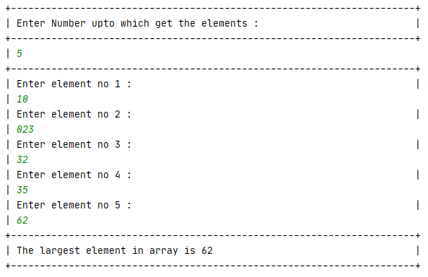

**( b ) To write a python to change, delete, add and remove elements in Dictionary**

**Solution:**

dict1 = {}  
flag = **'y'**while flag == **'y'**:  
 print(**"+------------------------------------------------------------------+"**)  
 print(**"|**\t**The program to change, delete, add the items in dictionary |"**)  
 print(**"+------------------------------------------------------------------+"**)  
 print(**"| => Enter 1 to add item |"**)  
 print(**"| => Enter 2 to remove item |"**)  
 print(**"| => Enter 3 to change item |"**)  
 print(**"+------------------------------------------------------------------+"**)  
 try:  
 n = int(input(**"| Enter your choice : |"**))  
 except ValueError:  
 print(**"| ****** Please enter valid input ****** |"**)  
 print(**"+------------------------------------------------------------------+"**)  
 n=0  
  
 if n == 1:  
 key = input(**"| Enter Key : |"**)  
 dict1[key] = input(**"| Enter value for the entered key : |"**)  
 print(**"| value is inserted |"**)  
 print(**"+------------------------------------------------------------------+"**)  
  
 elif n == 2:  
 delete = input(**"| Enter the key to remove the item : |"**)  
 try:  
 poped_item = dict1.pop(delete)  
 print(**"| The removed item is "**, poped_item)  
 print(**"+------------------------------------------------------------------+"**)  
 except:  
 print(**"| *** given key is not available in data *** |"**)  
 print(**"+------------------------------------------------------------------+"**)  
  
  
 elif n == 3:  
 change = input(**"| Enter the key to change the value : |"**)  
 dict1[change] = input(**"| Enter new value for the entered key : |"**)  
 print(**"| The value is changed |"**)  
 print(**"+------------------------------------------------------------------+"**)  
  
 else:  
 print(**"+------------------------------------------------------------------+"**)  
 print(**"| ************************ Wrong input *************************** |"**)  
 print(**"+------------------------------------------------------------------+"**)  
  
 print(**"| Dictionary is : "**, dict1)  
  
 flag = input(**"| Do You want to continue ? y/n**\t**: |"**)

**Output :**

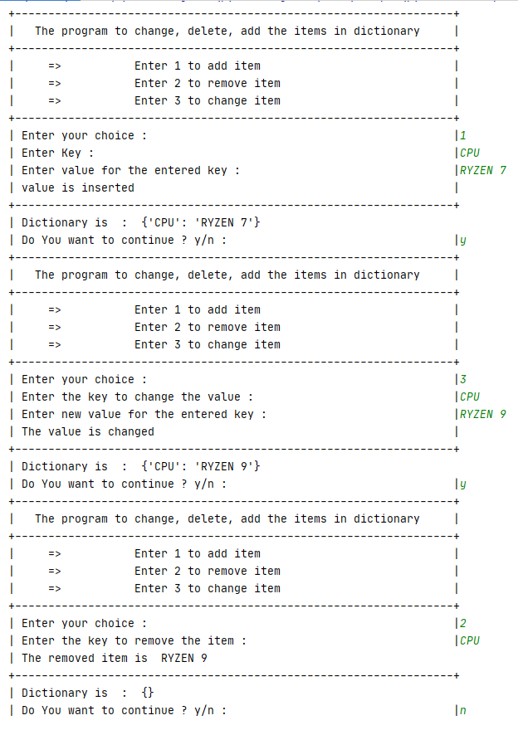

**(c)Develop a python program to sort dictionary by key or value**

**Solution:**

from format import *  
  
obj = Line_maker()  
obj.start_Line()  
  
dict1 = {}  
  
obj.string_Line(**"Enter Number : "**)  
print(**"| "**,end=**""**)  
  
n = int(input())  
obj.start_Line()  
for i in range(n):  
 obj.string_Line(**"Enter Key : "**)  
 print(**"| "**, end=**""**)  
 a = input()  
  
 obj.string_Line(**"Enter Value in term of number : "**)  
 print(**"| "**, end=**""**)  
 dict1[a] = int(input())  
  
sorted_by_keys = sorted(dict1.keys())  
  
sorted_by_values = sorted(dict1.values())  
obj.start_Line()  
obj.string_Line(**"The Dictionary sorted by keys : "**+str(sorted_by_keys))  
obj.string_Line(**"The Dictionary sorted by values :"**+str(sorted_by_values))  
obj.start_Line()

**output:**

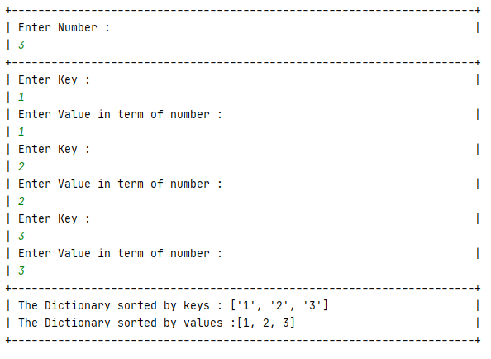

**(d)Develop python program to find sum all items in dicttionary**

**Solution**:

from format import *  
  
obj = Line_maker()  
obj.start_Line()  
  
dict1 = {}  
sum = **' '**obj.string_Line(**"Enter Number : "**)  
print(**"| "**,end=**""**)  
n = int(input())  
obj.start_Line()  
for i in range(n):  
 obj.string_Line(**"Enter Key : "**)  
 print(**"| "**, end=**""**)  
 a = input()  
  
 obj.string_Line(**"Enter Value in term of number : "**)  
 print(**"| "**, end=**""**)  
 dict1[a] = int(input())  
for i in dict1.keys():  
 sum = sum + i +**" , "**sum1 = 0  
for i in dict1.values():  
 sum1 = sum1 + i  
try :  
 obj.string_Line(**"Sum of values is "**+sum1)  
 obj.string_Line(**"Sum of keys is "** + sum)  
except:  
 obj.string_Line(**"Sum of keys is "** +str(sum) )  
 obj.string_Line(**"Sum of values is "** +str(sum1))  
obj.start_Line()

**Output:**

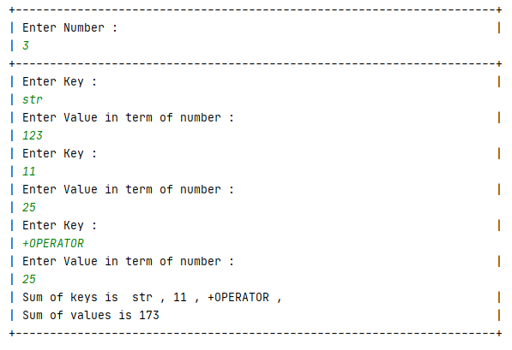

**(e) Develop a python program to sort five integer values**

**Solution :**

from format import *  
  
obj = Line_maker()  
obj.start_Line()  
  
l1 =[]  
for i in range(1,6):  
 obj.string_Line(**"Enter integer value "**+str(i)+**" : "**)  
 print(**"| "**, end=**""**)  
 l1.append(int(input()))  
l1.sort()  
obj.string_Line(**"Sorted values are "**+str(l1)+**" : "**)  
obj.start_Line()

**Output:**

