

Event Management sytem

Project PHP





Jad Chahine - 104384

1. **Database Creation**

Step 1 :

Create user in phpmyadmin > privileges with username “jadchahine” and password “jadali123” (grant all permissions)

Step 2 :

Run Script “localhost/project-php/src/setup-db.php” to create database “evlu”

Step 3 :

Run Script “localhost/project-php/src/insert.php” to insert data into database

1. **Introduction Page**

Basic intro page about the event

* Contact form using phpmailer
* Langage using php to change langage
* Press “Get Started” to take you to (3-)

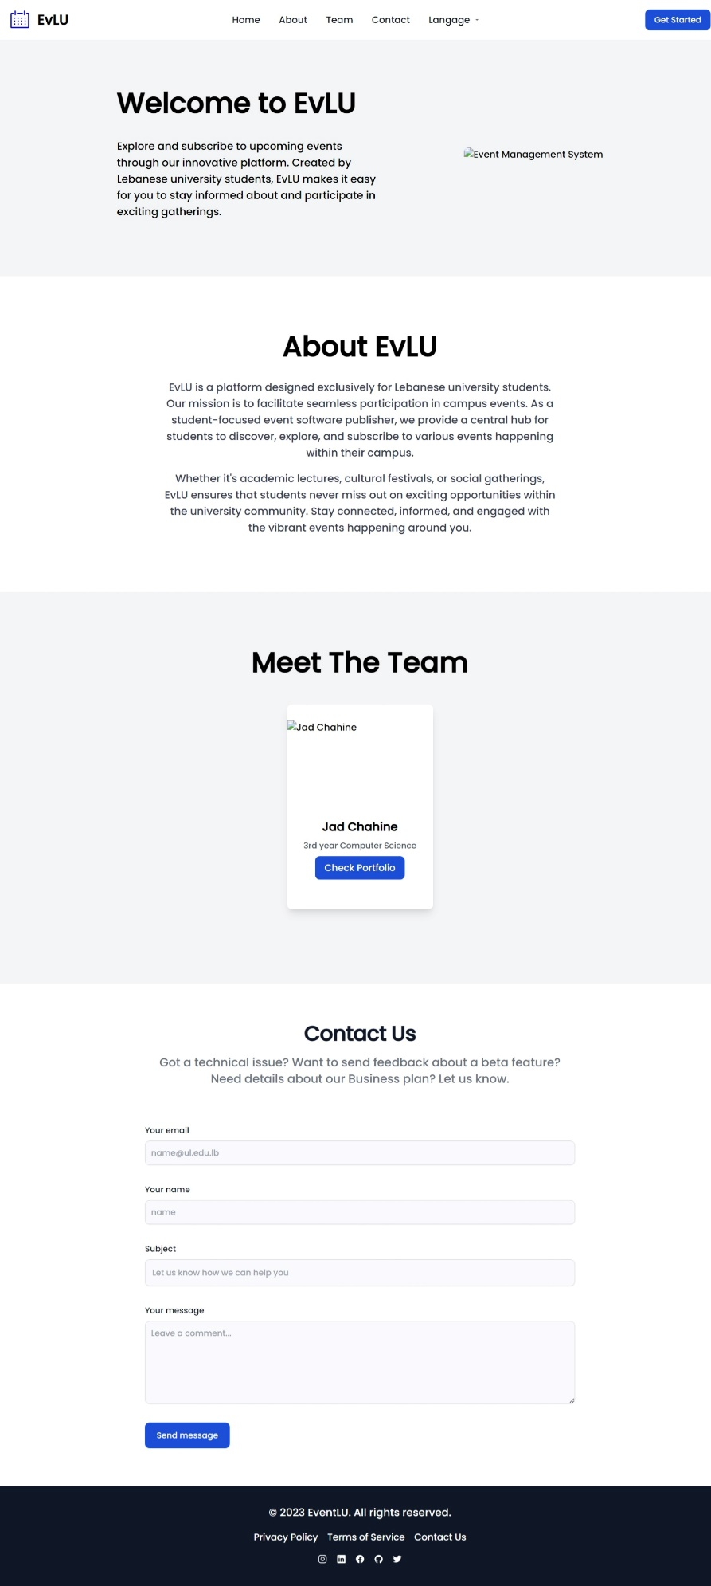

1. **Login/Register/Forget Password Page**

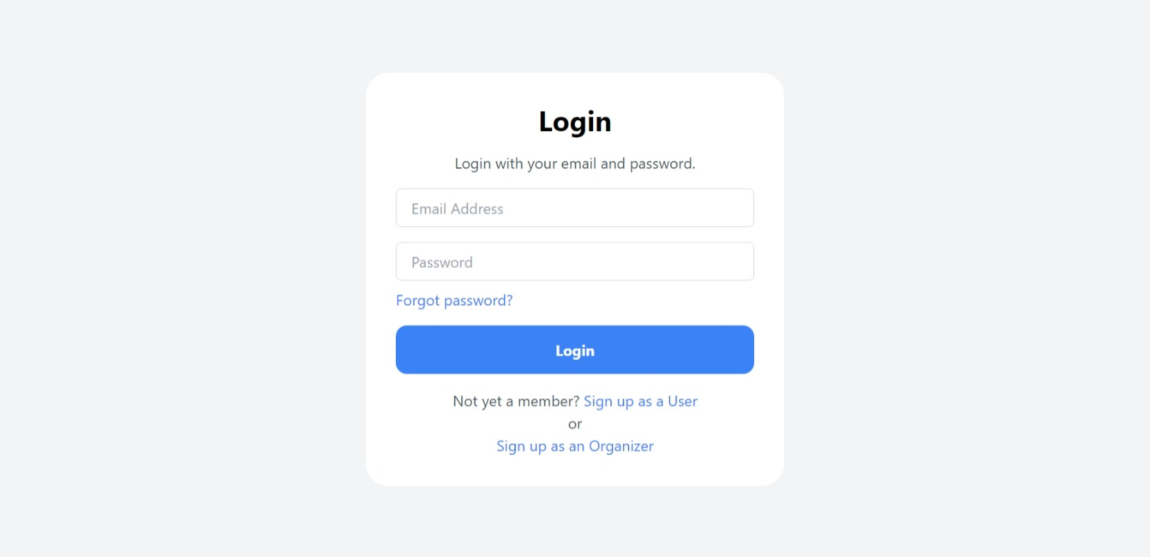

Here you can login as:

* Administrator (email: [jad.chahine.2@st.ul.edu.lb](mailto:jad.chahine.2@st.ul.edu.lb) and password J@dchahine12)
* Organizer
* User

Forget password incase you forget password

Signup as User to sign up as a user and sign up as organizer to sign up as organizer.. the forms will be displayed when u press the blue links

1. **Admin Page**
2. **Dashboard**

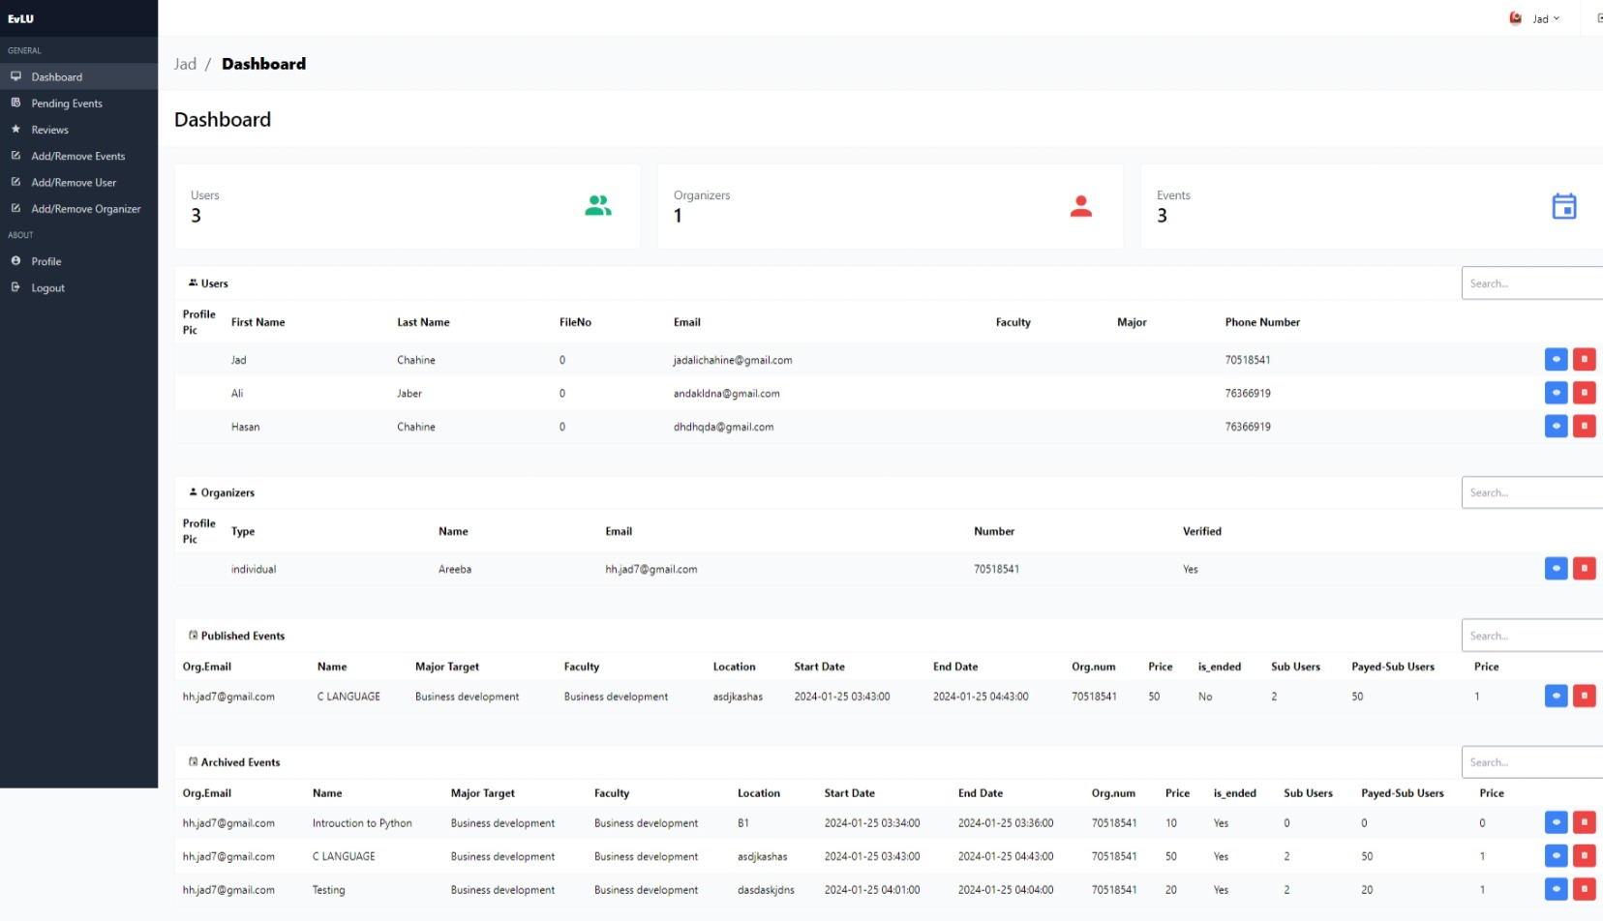

* Displays total user, event and organizers in cards
* Table for users,organizers, published events (events approved by admin), pending events (events published by organizer but not approved by admin yet) and archived events (events that ended)
* Dynamic search textboxes for Users,Organizers and Published Events (all the other ones are not working since I didn’t configure them)
* Blue eye button to see user,organizer,published event and archived event in detail on another page. Can generate the statistics for published and pending event
* Read trash button to delete user,organizer,published event or pending event from the database
* Delete user -> Delete user review + Delete user subscription + Delete the user
* Delete Published/Archived Event -> Update reviews set organizer id of the delete organizer to NULL in the database + Delete subscriptions of the event + Delete the event
* Delete organizer -> Update reviews set organizer id of the delete organizer to NULL in the database
* Blue button in organizer/user page

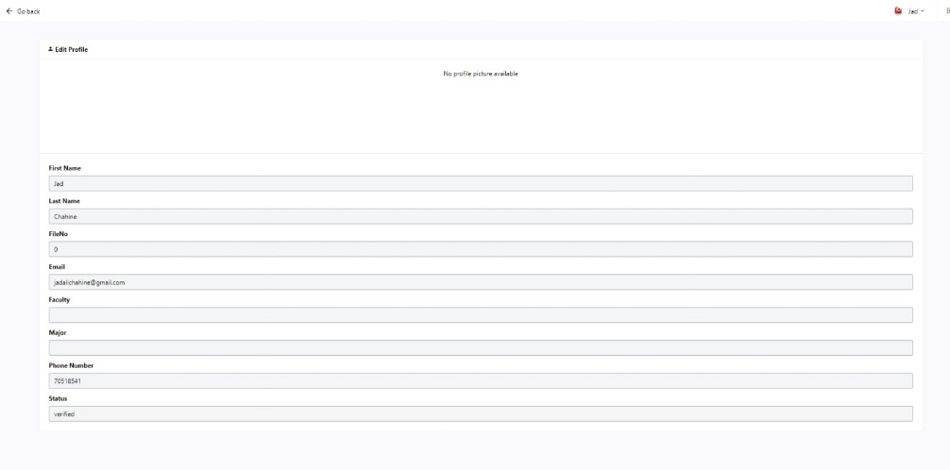

* Blue button in published/archived/pending events (located in pending section)

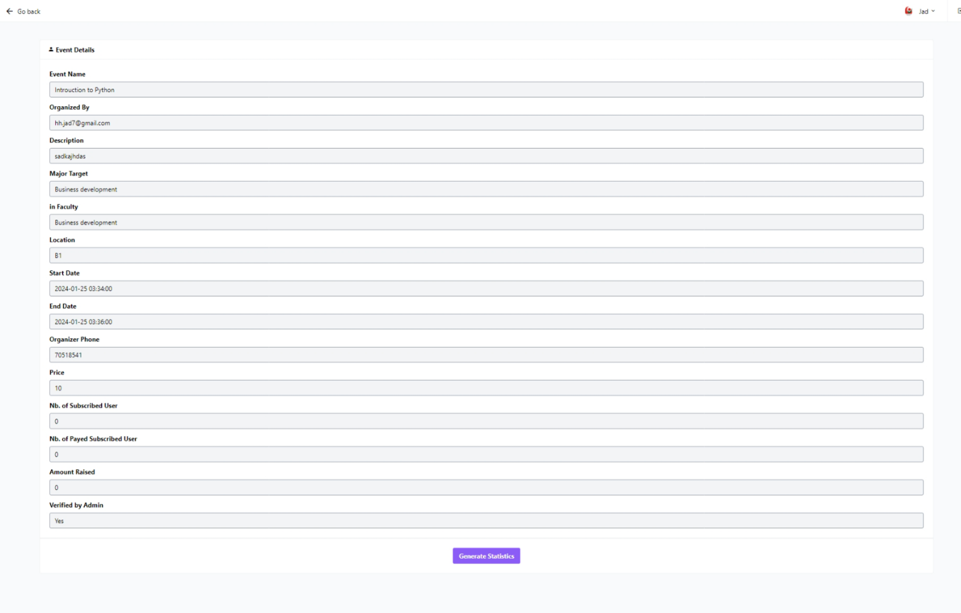

* Generate statistics button to generate event statistics in a file with event-name.txt

1. **Pending Events**

* Events added by organizer are displayed here
* Admin has the option to delete (red button), accept (green button which if is pressed then will send an email to organizer that event accepted) and blue button (view the event)

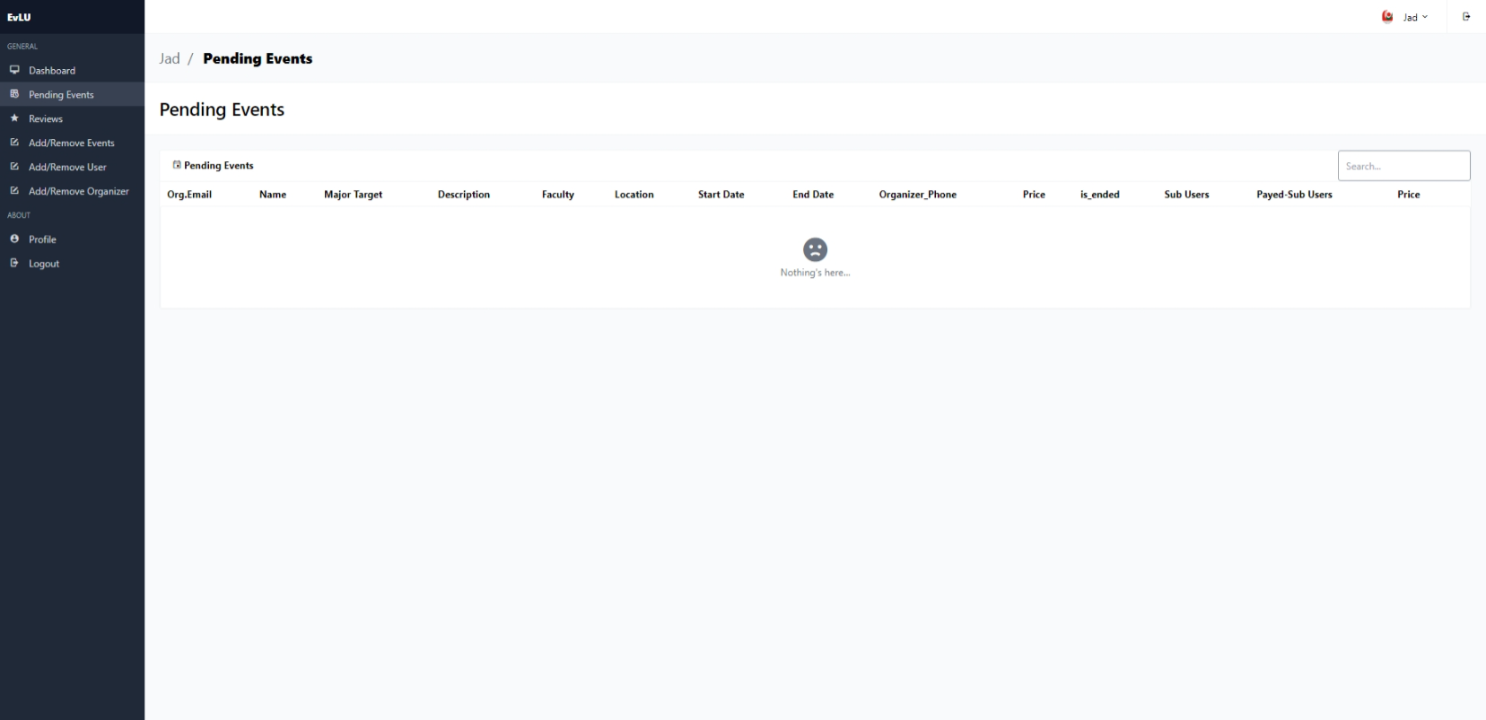

1. **Reviews**

* Displays all reviews from all events

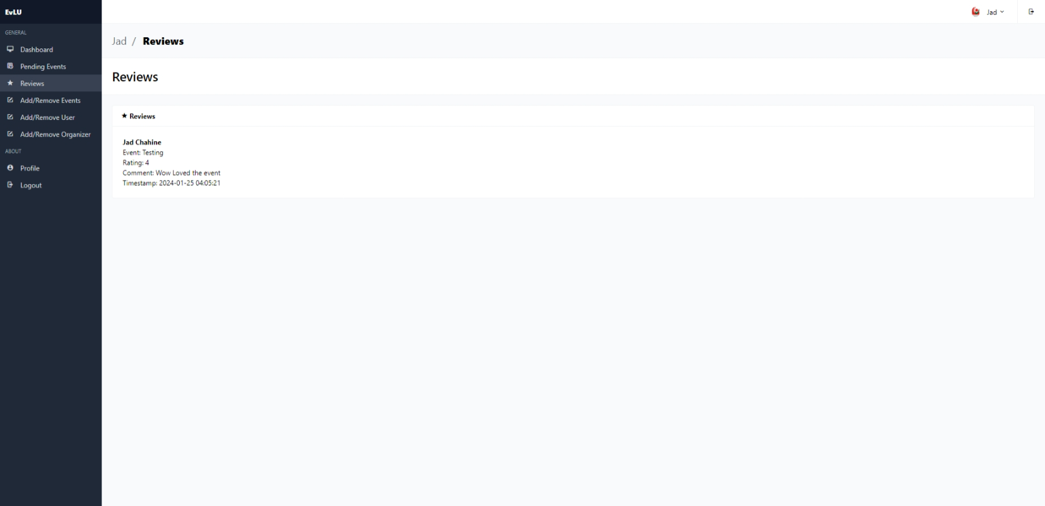

1. **Add/Remove events**

* Add or remove an event from the database.
* Event added here is considered as a Published Event
* Email is sent to organizer that event has been approved by admin

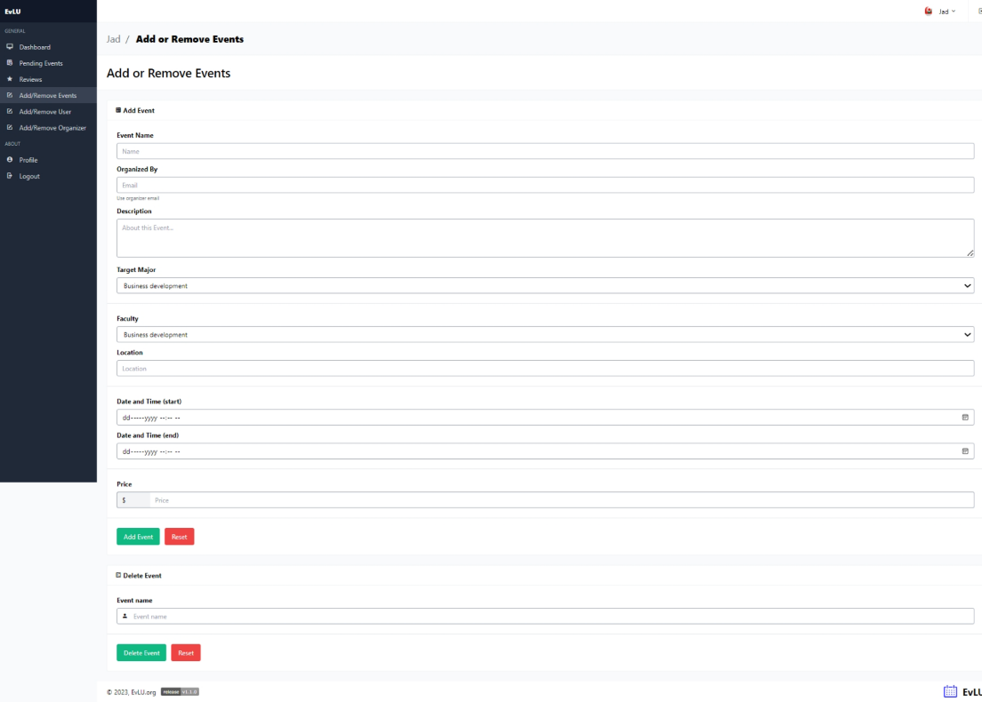

1. **Add/Remove users**

* Add or remove a user from the database.
* Email is sent to user that his account was created by admin with its credentials

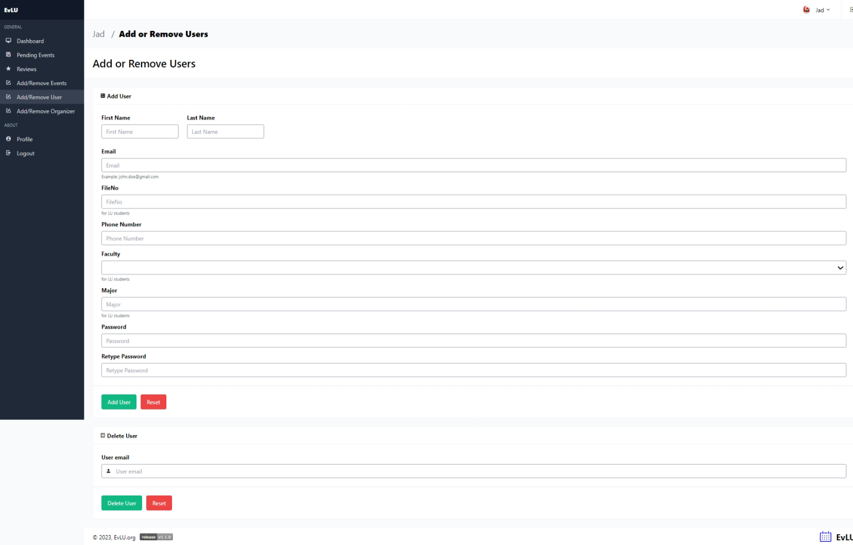

1. **Add/Remove organizers**

* Add or remove an organizer from the database.
* Email is sent to organizer that his account was created by admin with its credentials

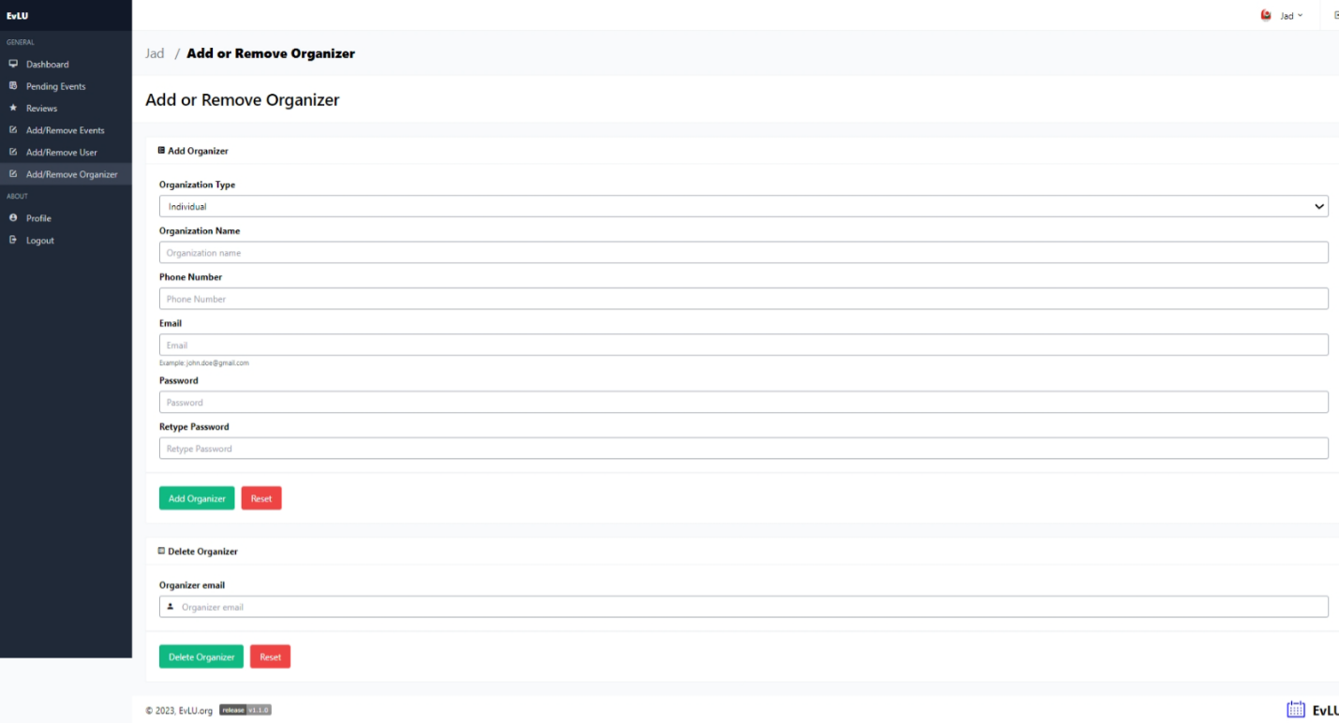

1. **Profile (Section is the same in user and organizer)**

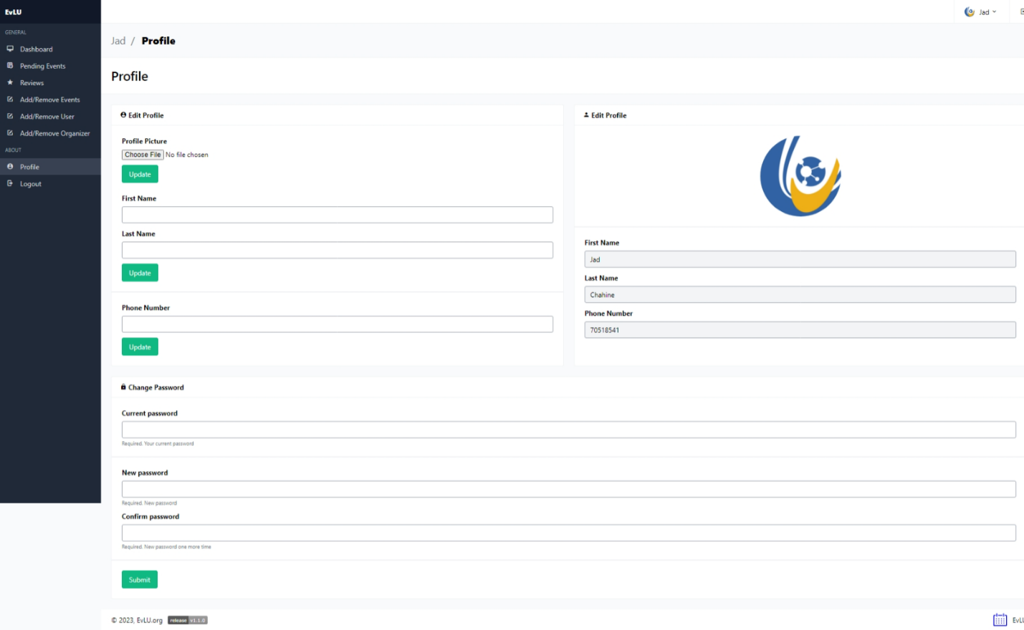

* Update Profile Picture
* Update first name, last name, and phone number
* Update password

1. **Organizer Page**
2. **Organizer Statistics**

* Total Statistics of all the events combined

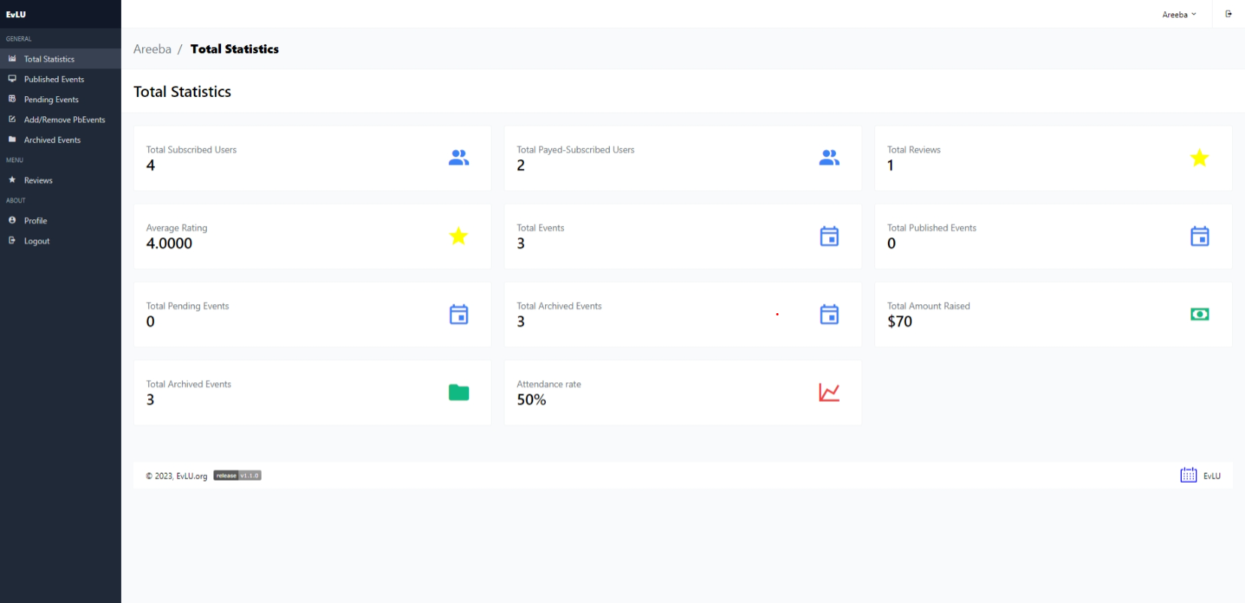

1. **Published Events**

* Publish Events of the organizer (which are the events that are accepted by admin)

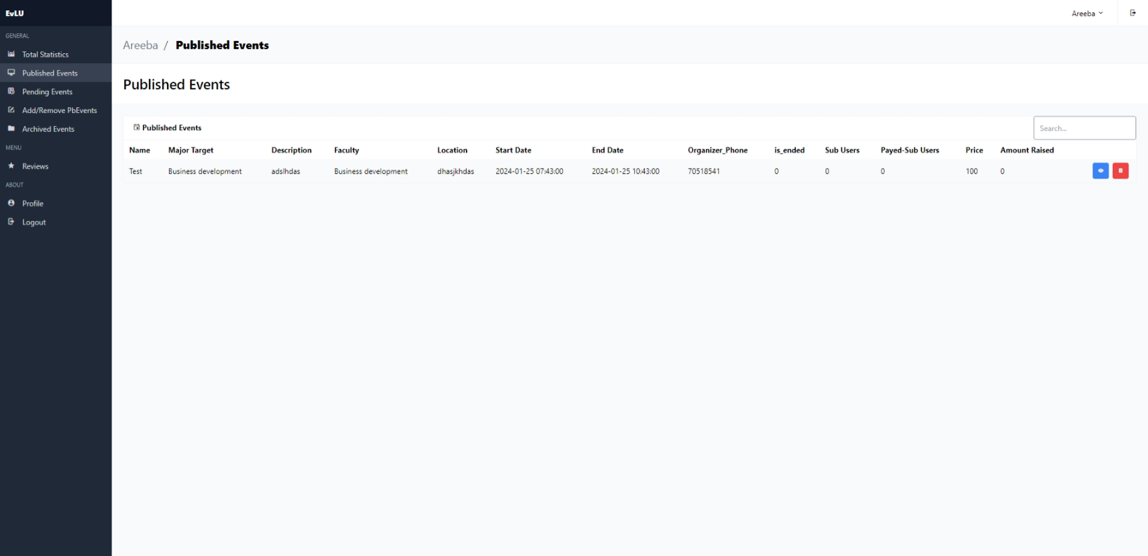

* Red button deletes the published event from the database
* Blue button takes you to event details with section subscribed user, payed subscribed user and Generate statistics:

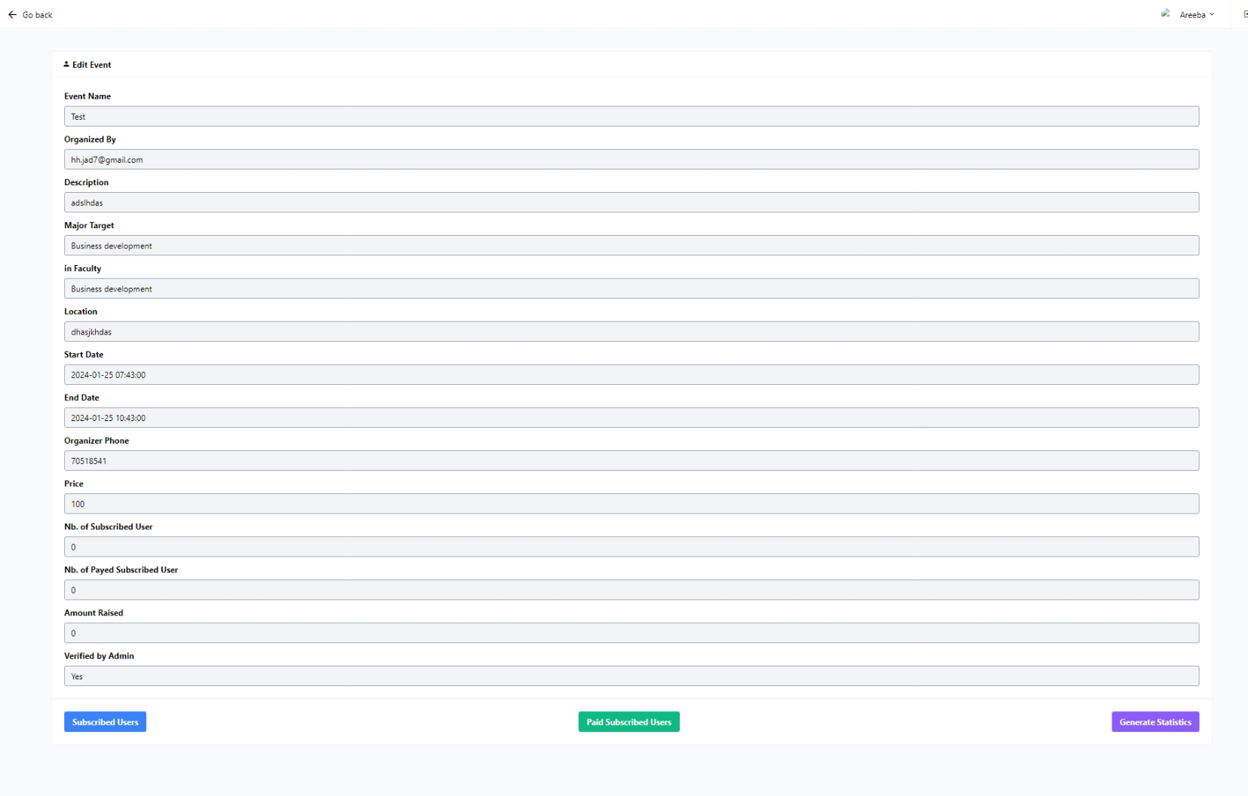

* Inside Subscribed Users: Display all the users that subscribed to the event

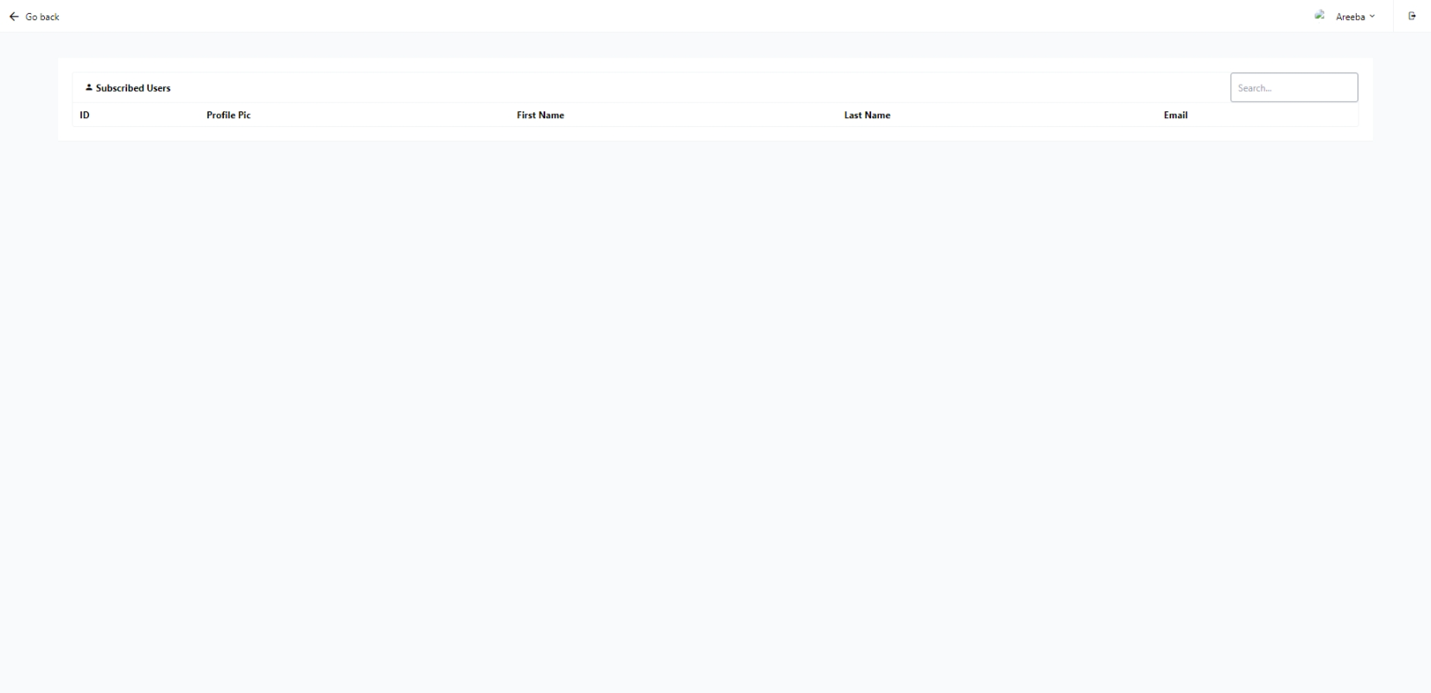

* Inside Payed Subscribed Users:

Turn the subscriber into a payed subscribed user which increments the total payed subscribed users, also add the price to the total amounts

Can also delete a payed subscribed user by click on the red trash can button near its name on the table (not showing in picture will show when payed sub user is added)

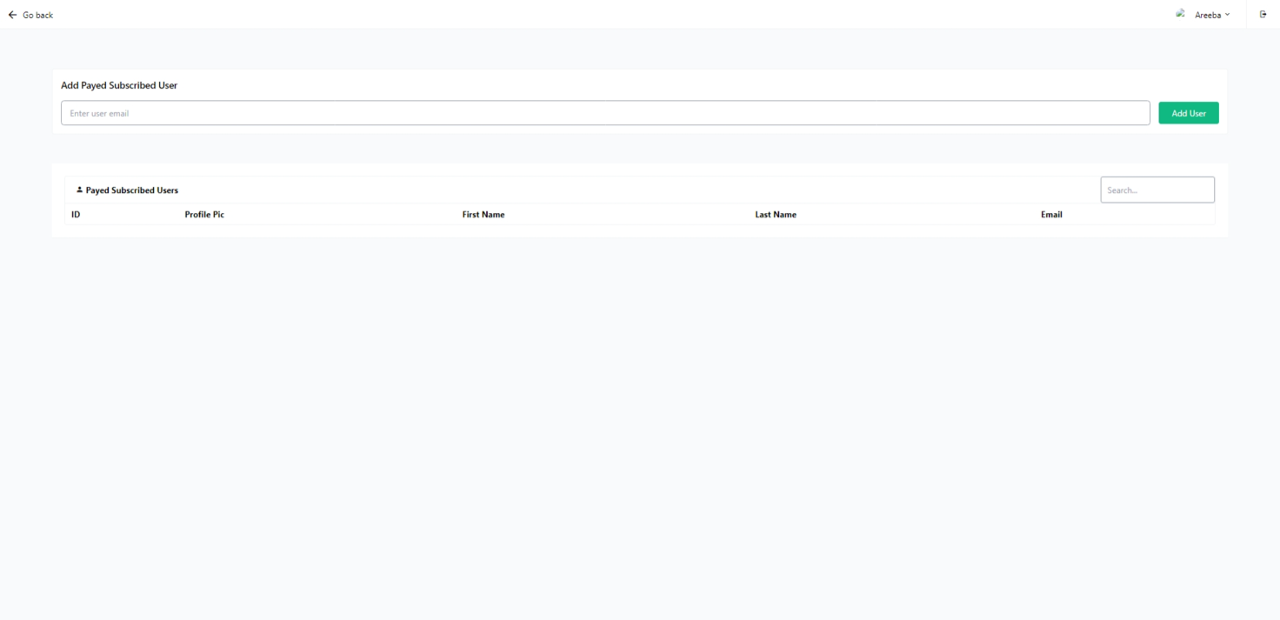

**c- Pending Events**

* Pending Events of the organizer (which are the events that are arred by the organizer but aren’t accepted by admin or haven’t been accepted by admin yet)

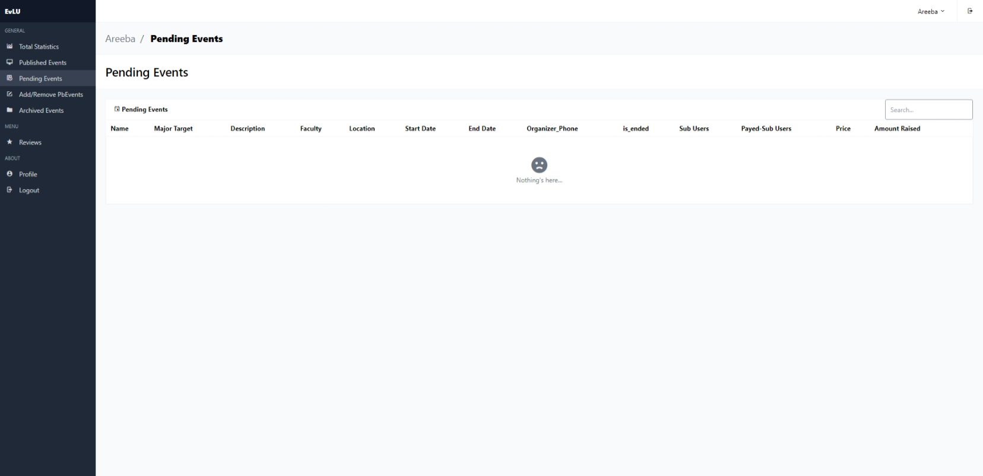

**d- Add/Remove Events**

* Add or Remove events from the database.
* Added events are added as Pending Events

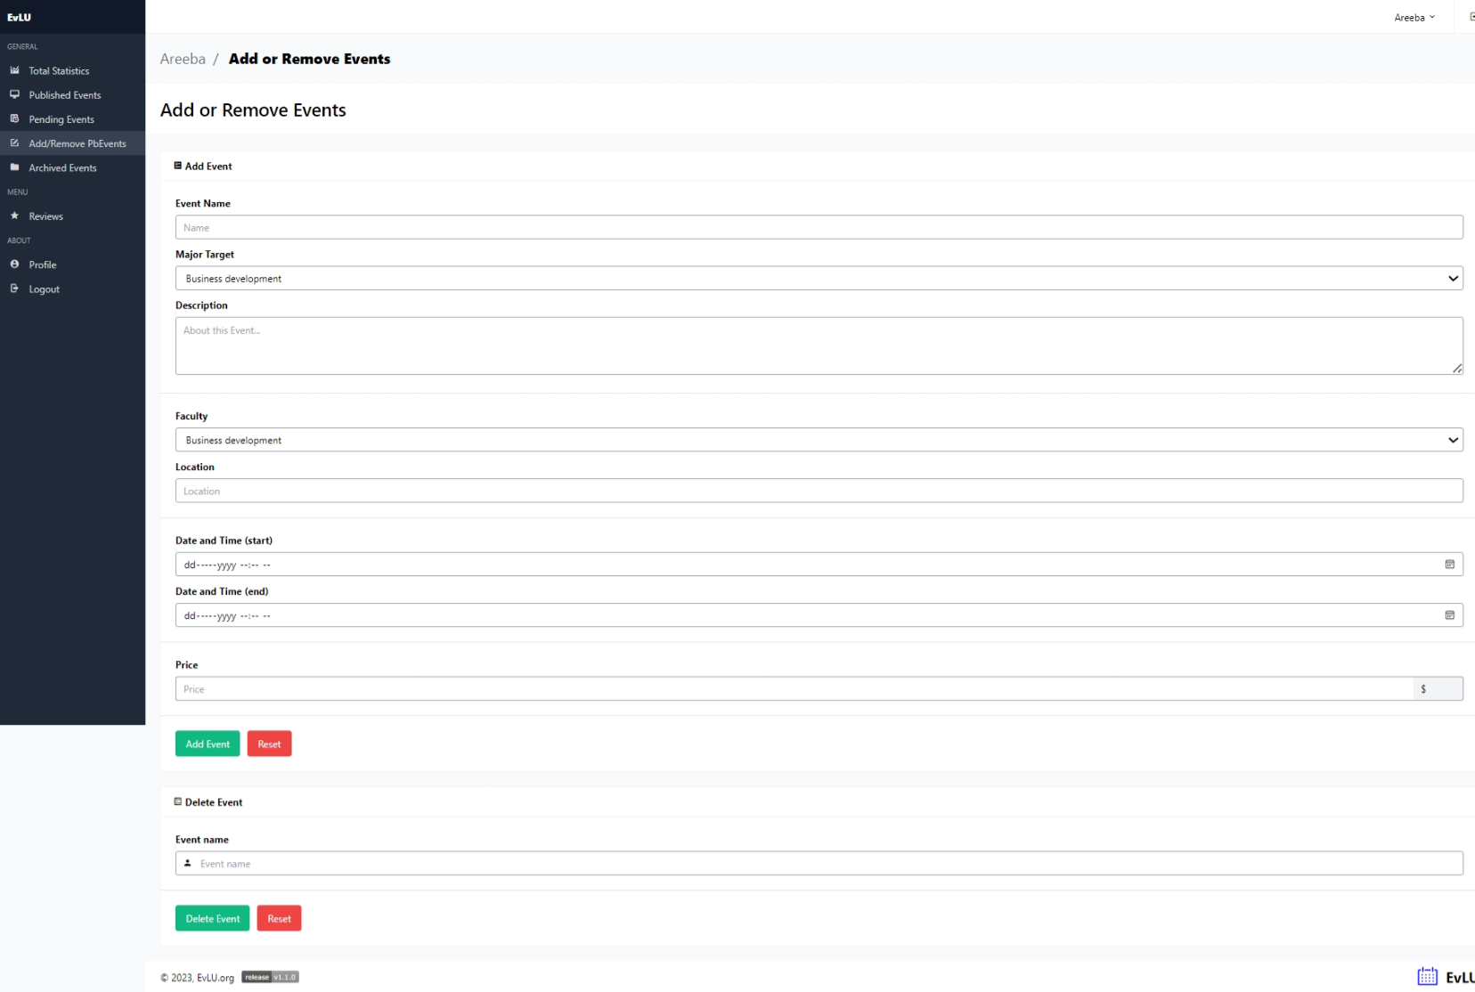

**d- Archived Events**

* Events that were published and have ended

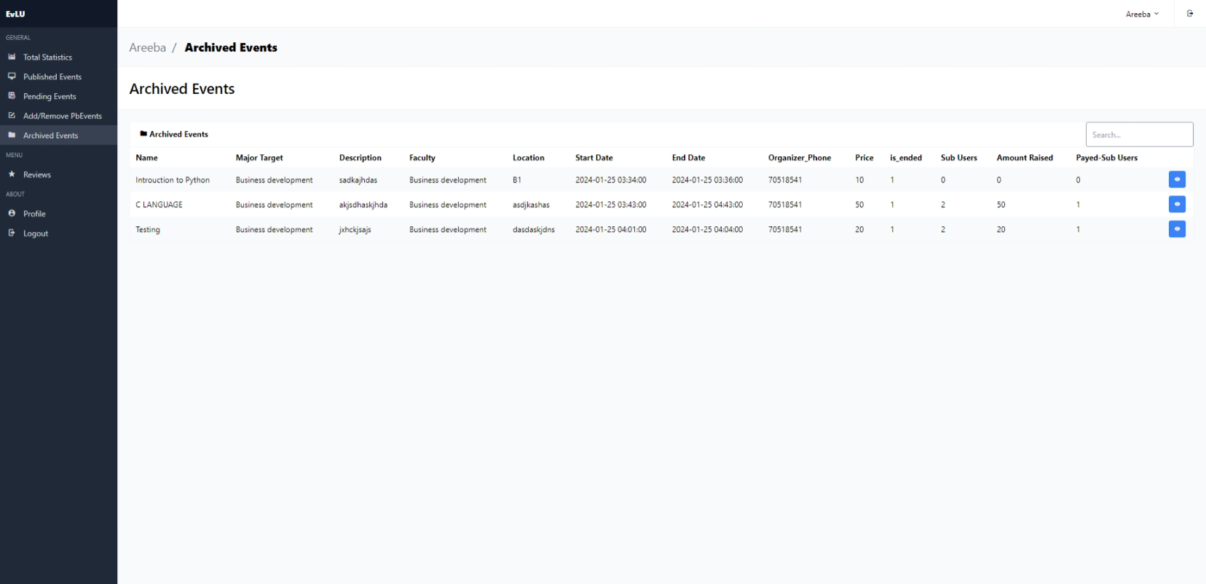

**e- Reviews**

* All the reviews of the organizer’s events

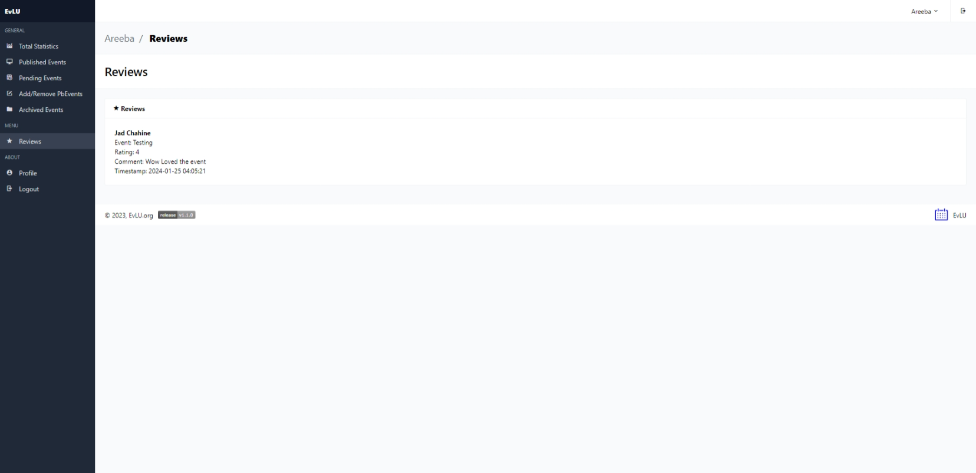

**f- Profile**

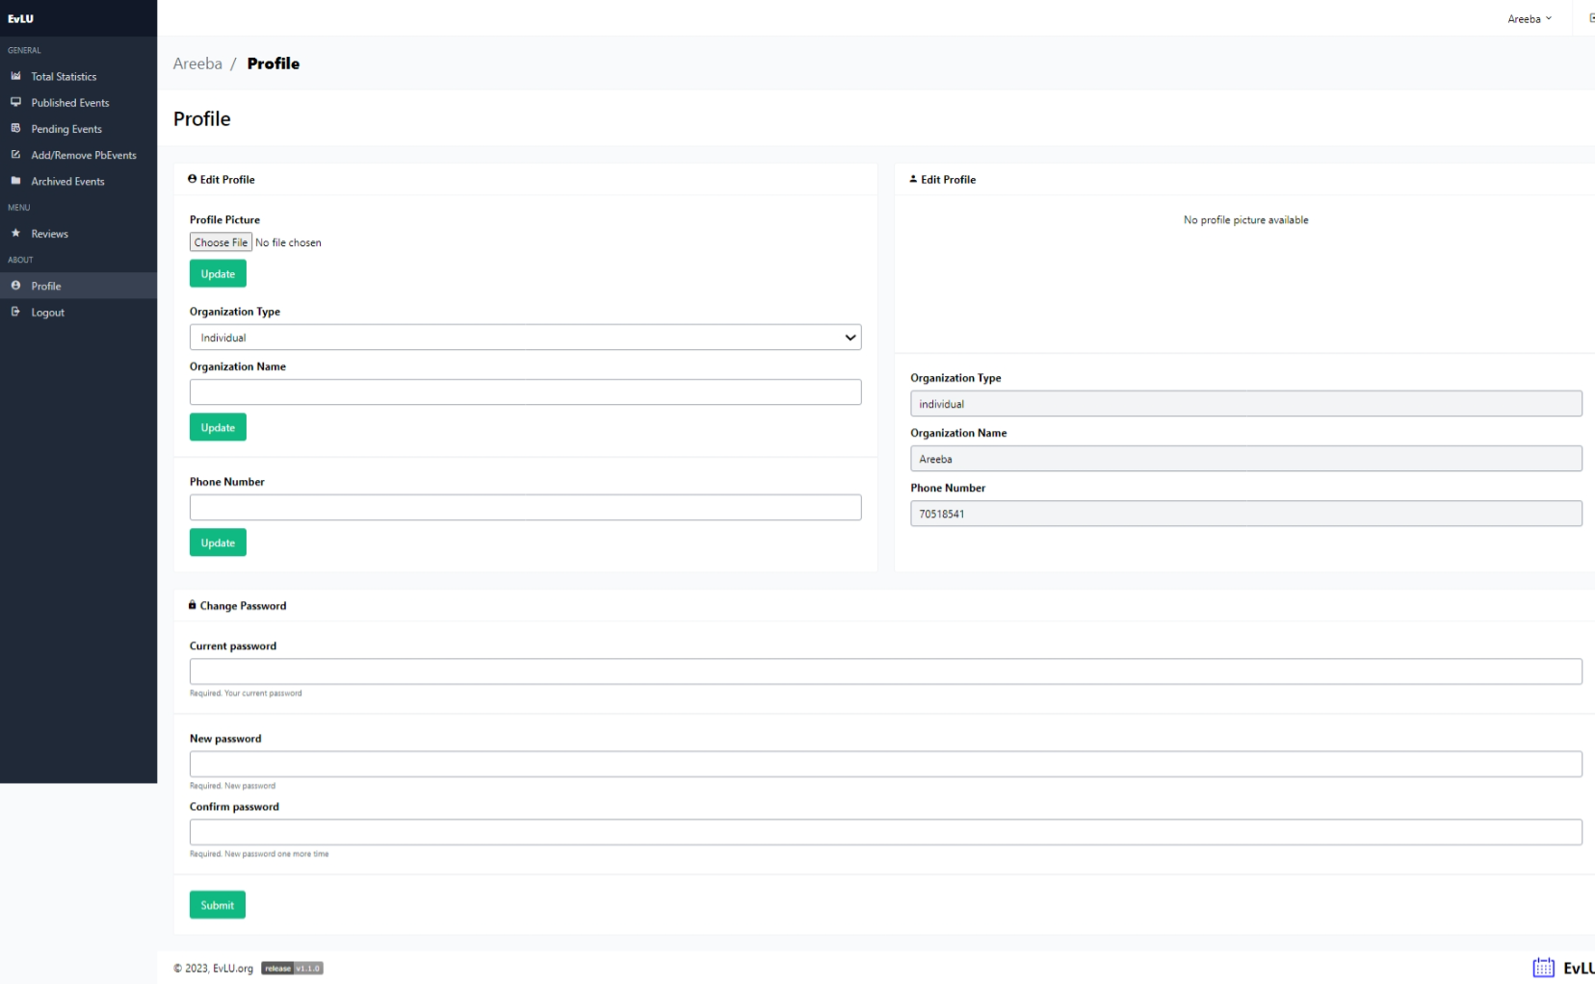

1. **User Page**
2. **Events**

* Events displayed by organizers are shown here
* User can subscribed once
* Can also view event

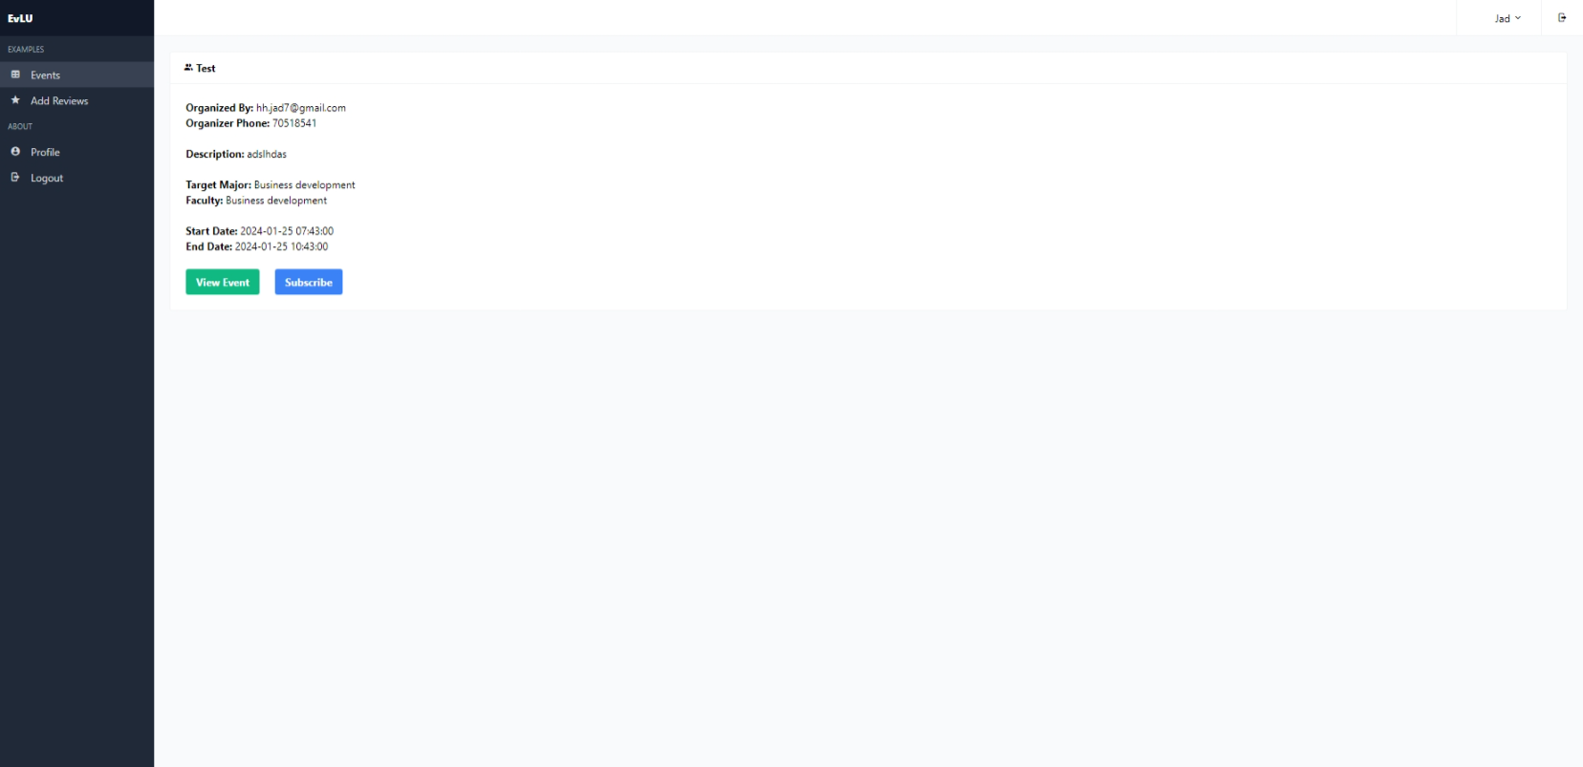

1. **Add Reviews**

* User can add reviews on archived events where he was a paid subscriber only
* People who don’t fit the category above cant add a review

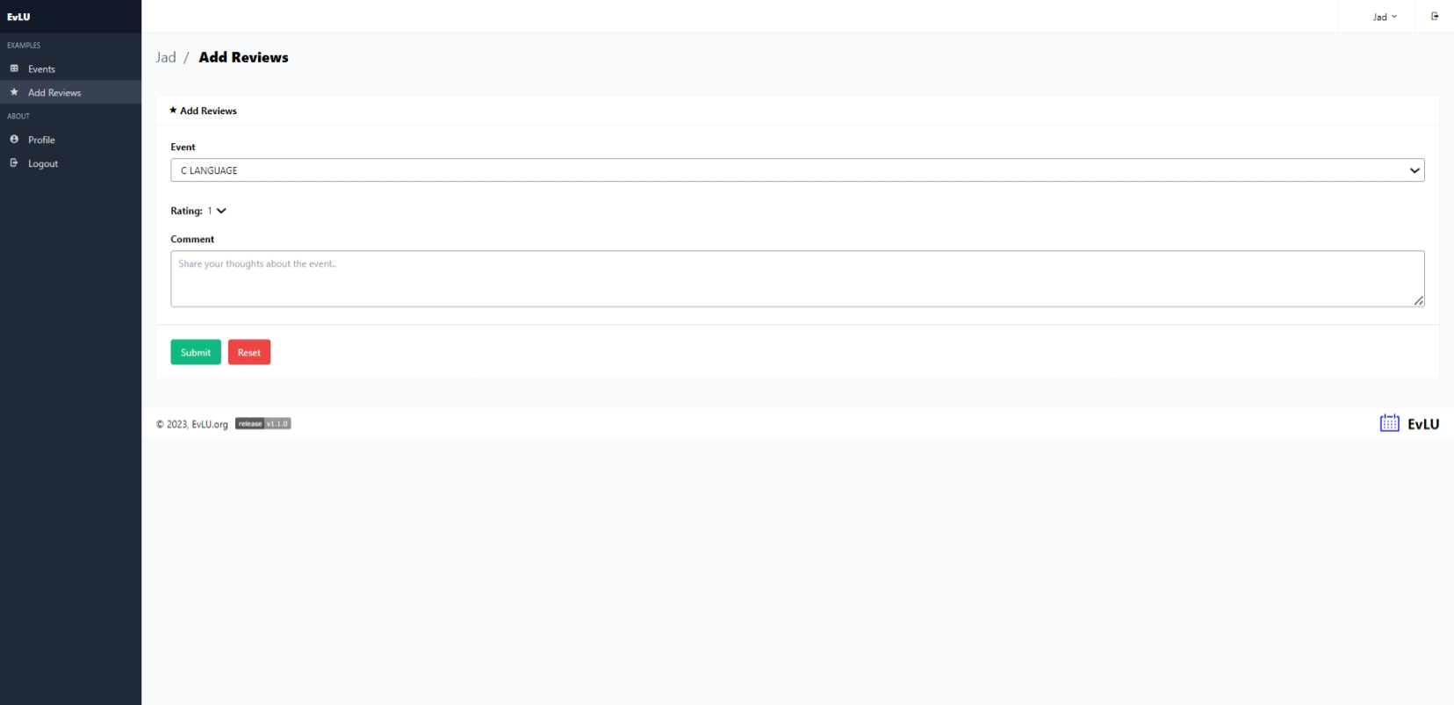

1. **Profile**

