

Date: 16/12/2022

# TO WHOMSOEVER IT MAY CONCERN

This is to certify that Jad Chehade has done his internship in the development team at Bluemint.ai, from 01/11/2022 - 15/12/2022 .

He has worked on:

* Python Basics
* Django Rest FrameWork back-end web development

This project was aimed at learning and applying this knowledge for multiple mini-projects which he successfully completed

During his internship, Jad has demonstrated self-motivation and the ability to learn and apply new skills. His performance and dedication exceeded our expectations and he was able to complete his assigned tasks on time.

We wish him all the best for his upcoming education and career.

Sincerely,

Samer Abdallah

Executive Manager

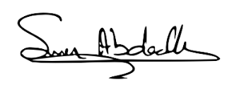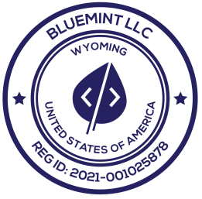

## BLUEMINT.AI

info@bluemint.ai

1309 Coffeen Avenue STE 1200, Sheridan, WY 82801 United States