HIGH LEVEL DESIGN (HLD)

Brand Recognition

Final Document Version

Date: 30/08/2022

DOCUMENT VERSION CONTROL

Author:

Jaddumahanthi Vinay

Date:30/08/2022

Final Version

CONTENTS:

Document Version Control……………………………………………………….…2

Abstract………………………………………………………………………………….…..4

1 Introduction…………………………………………………………………..…..5

* 1. Why this High Level Design Document?.......................5
  2. Scope……………………………………………….………..................5

1. General description…………………………………………………………....6
   1. Product perspective……………………………………………….….6
   2. Problem statement…………………………………………………...6
   3. Proposed solution……………………………………………………..6
   4. Further improvements……………………………………….……..6
   5. Technical requirements………………………………………..……6
   6. Data requirements………………………………………………….…6
   7. Tools used……………………………………………………………..….7
2. Design Details…………………………………………….………………………8
   1. Process flow………………………………………………………….….8
   2. Logging……………………………………………………………….…….9
   3. Exception handling……………………………………………...……9
3. Performance…………………………………………………………………....10
   1. Resource utilization………………………………………………...10
   2. Deployment…………………………………………………………....10

5 Conclusion……………………………………………………………………...11

Abstract

These days, with rise in content in social media and other platforms with millions of views, companies are focusing on advertising on these new platforms for wide publicity, cheaper marketing options and targeted advertising. Thus the project is aimed at detecting brand logos in images and thumbnails of social media and other platform images and videos. This would determine the amount of publicity the brand receives, the sales revenue company could expect and identify the marketing cost per sale based on cost of advertising in contents. This would also help in comparing various advertising options and in determining the final price of the product based on advertising costs. This is also essential in determining budgets for next financial year.

1 Introduction

* 1. Why this High Level Design Document?

The document gives high level perspective, analyses problem and provides solution at high level, clears all kinds of doubts and can be used as reference for project execution and coding.

1.2 Scope

HLD includes:

1. Design aspects
2. User interface
3. Hardware and software details
4. Key performance indicators
5. Product architecture
6. Security features, maintenability, reliability etc.
7. General Description

2.1 Product perspective

Product detects and recognizes brands on images that have been retrieved from various content across multiple platforms.

2.2 Problem statement

Detect brand logos of four brands – Priya (Telangana brand sold worldwide), pistahouse (Hyderabad brand with presence in 6 countries), skippi icepops (got all shark investment in sharktank India) and beyondsnack (got investment in sharktank India).

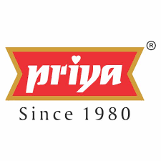

2.3 Proposed solution

Best yolo object detection model is selected based on training, hardware compatibility and mean average precision. This cloud deployed model is used for detection through api/UI.

2.4 Further improvements

Future data can be used to retrain the model continuously for better predictions. Better hardware and larger models would increase accuracy.

2.5 Technical requirements

Atleast 12 GM RAM GPU is required.

2.6 Data requirement

Training data is obtained from client and online platforms. Images that need detection is shared by client.

2.7 Tools used

Yolo, roboflow, pytorch, Numpy, scikit-learn, flask etc to build the model. Pycharm IDE is used. Model will be deployed on user determined platform.



1. Design Details
   1. Process flow

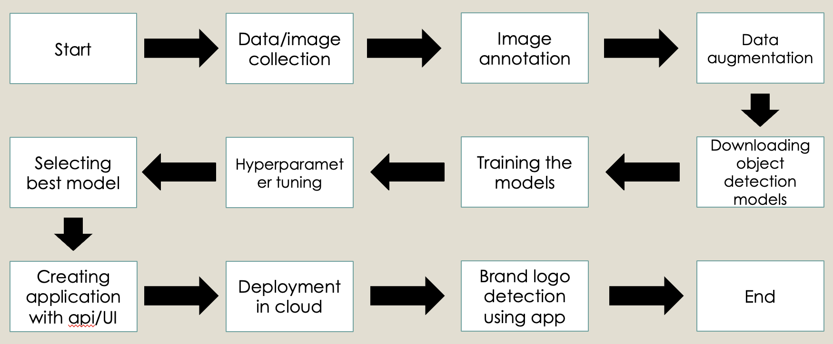

* 1. Logging

Logging is done to let user know of the processes running internally. It also helps in easy maintenance of product.

* 1. Exception handling

Exception handling is done to prevent unusual stoppage of code and to address unexpected and rare shocks.

4 Performance

4.1 Resource utilization

All the processors are utilised.

* 1. Deployment

Project will be deployed in user preferred cloud or private server.



1. Conclusion

Clients will be able to detect and recognise their brands.