Image Crop Edge Cases
DrawingML source cropping keeps the destination size while selecting an asymmetric bitmap region.
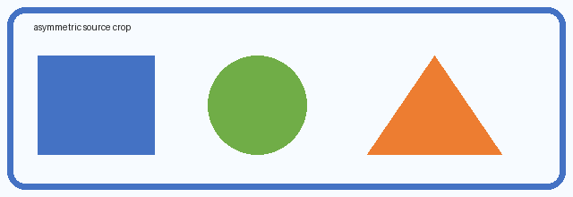
Asymmetric crop: left 15%, top 5%, right 25%, bottom 10%.

