Table and Object Edge Cases
Merged cells, a nested table, an inline image, and a VML textbox in one compact document.
Merged title across three grid columns
Nested table
  A | long wrapping value
  B | 日本語 / RTL: مرحبا
Inline image | 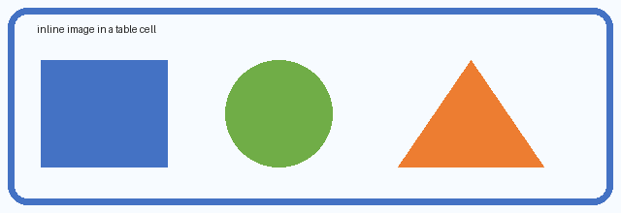

VML textbox after table
Textbox preserves run boundaries.
Trailing text verifies flow resumes after the object.

