Word Compatibility Comprehensive Fixture
Real OOXML fields covering TOC InstrText, captions, bookmarks, tables, images, textboxes, and header/footer run boundaries.

1. TOC InstrText matrix

Default hyperlinks and outline levels
1. TOC InstrText matrix........................................1

Page-number omission and custom separator
Level 1 entry-1
Level 2 entry

Custom style mapping
Appendix compatibility.......................................2

Preserve source tabs and manual line breaks
Part One
Overview..........................................2
Bookmarked section begins

Bookmarked heading A
Bookmarked section ends

Bookmark-scoped partial TOC
Bookmarked heading A.........................................2
Appendix compatibility

Part One
Overview

2. Captions and field results
Figure 1: Architecture
Figure 2: Deployment
Table 1: Compatibility matrix

Table of figures (label and number retained)
Figure 1: Architecture.......................................3
Figure 2: Deployment.........................................3

Description-only figure list
Architecture................................................3
Deployment..................................................3
Referenced compatibility text

Heading with REF: Referenced compatibility text

3. Table, image, and textbox
Feature | OOXML shape | Expected behavior
Table | fixed grid and merged title | Borders, wrapping, vertical alignment
Objects | inline image + VML textbox | Visible without text loss
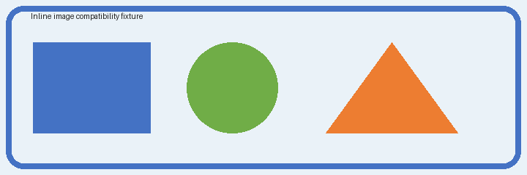
Textbox: wrapping, padding, border, and nested text.
End of compatibility fixture.

