**Dizzion UAG Deploy from Content Library**

This guide is intended to provide a step by step process to deploy the Unified Access Gateway appliance to a vCenter.

The process is written entirely in PowerShell and contained in a module named Dizzion.

This module assumes you have the following required Modules installed in PowerShell before proceeding:

* Logging – Module included with Dizzion in the repository
* VMware.PowerCLI – Available on the PSGallery
* PSExcel – Available on the PSGallery

Assuming these modules are in place, we can start the Deploy process.

1. First open an Administrative PowerShell window.

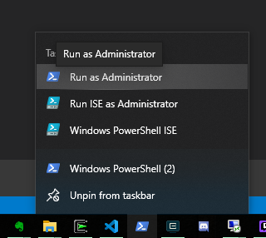

1. From your corresponding PowerShell prompt, Import the Module Dizzion from the location that you downloaded it. In this example the module is located in ..\Dizzion\Dizzion

The syntax of the Import-Module Command is:

**Import-Module *Path*Dizzion.psm1**

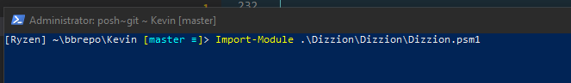

1. Start the Dizzion Deploy interface with the command:

**Invoke-DizzionInterface**

1. The first prompt you will receive is to type a FQDN of a vCenter you can connect to from the machine you are running as. In this example, we will use **mcvcenter.mcnet.pri**

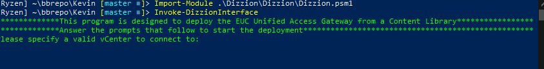

1. The module will now ping the fqdn to verify it is valid and then prompt you for credentials to connect to the vCenter. These credentials need to have full permissions to the ContentLibrary, the ability to manipulate VMs, and the ability to deploy ovas. For this example we will use [**administrator@vsphere.local**](mailto:administrator@vsphere.local)

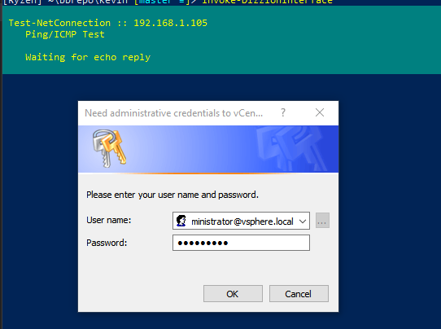

1. The module will now attempt to connect to the vCenter using the credentials provided. It will then pull a list of available clusters to perform the deploy to and prompt for a numerical selection. In this example, we will select the **McNetv** cluster by typing 1 and hitting enter.

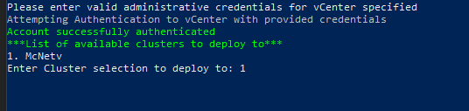

1. The module will set the cluster to the one chosen. It will then pull a list of available Datastores to perform the deploy to and prompt for a numerical selection. In this example, we will select the **NFS01** Datastore by typing 2 and hitting enter.

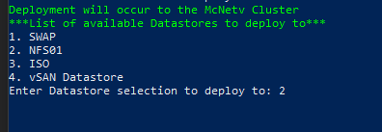

1. The module will set the Datastore to the one chosen. It will then pull a list of available Folders to perform the deploy to and prompt for a numerical selection. In this example, we will select the **Appliance** Folder by typing 3 and hitting enter.

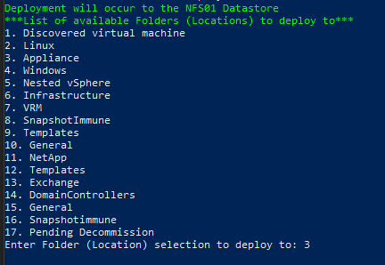

1. The module will set the Folder (location) to the one chosen. It will then open a File Browse dialog to chose the OVA for deploy. In the example, the file is in **E:\Dizzion.**  We will select the

**euc-unified-access-gateway-3.7.0.0-14567523_OVF10.ova** file and click Open.

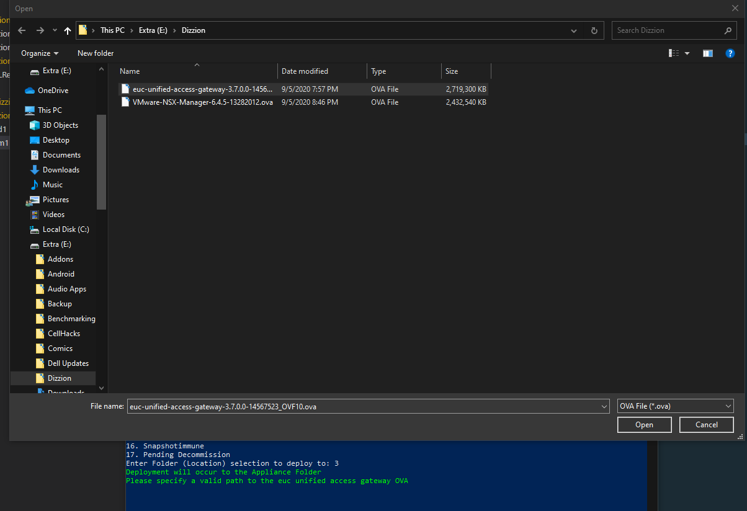

1. The file will be set accordingly. Next you will be prompted for a name of the UAC appliance when completed. This should be the name you want to use for the UAC appliance as the final product. Here we will use **McUAC.** Type the name and hit enter.



1. The name will now be set. A menu will now appear to select the IP Mode of the appliance.

Here we will chose **STATICV4** by typing 1 and hitting enter.



1. The IP Mode will now be set. Next you are prompted for an IP address for the primary interface. In the example, we will type **192.168.1.222** and hit enter to set the IPv4 address.



1. The IPv4 address will now be set. Next you are prompted for a IPv4 subnet mask. In the example, we will type **255.255.255.0** and hit enter to set the subnet mask.



1. The subnet mask will now be set. Next you are prompted for an IPv4 gateway. In the example, we will type **192.168.1.254** and hit enter to set the gateway.



1. The gateway will now be set. You are now prompted whether CEIP should be enabled. In the example, we will type **Y** and hit enter.



1. You will now be prompted for a root password and confirmation of the root password. Type the password twice and hit enter after each entry.



1. You will now be prompted for an admin password and confirmation of the admin password. Type the password twice and hit enter after each entry.



1. You will now be prompted on whether SSH should be enabled. In the example, we will type **Y** and hit enter.



1. You are now prompted for the Deployment Option of the UA Gateway. In the example we will choose the **ThreeNic** option by typing 3 and hitting enter.

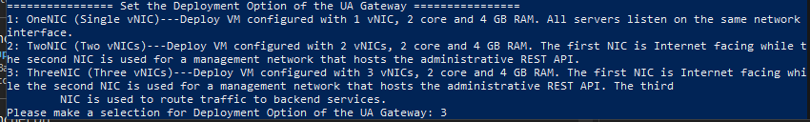

1. Based on the Deployment Option chosen, you will be prompted to set the Network mapping to port groups. The Portgroups listed are polled dynamically from the vCenter. In this example for the Internet Interface, we will use **McNET VM Network** by typing 5 and hitting enter.

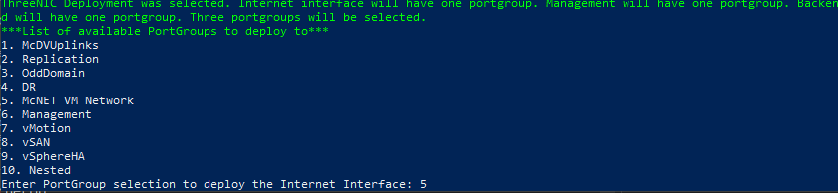

1. Since we chose the Threenic option, we will continue this process for the Management interface. You will notice the Internet Interface portgroup chosen is removed from the list. In this example, we will use the **Management** by typing 5 and hitting enter.

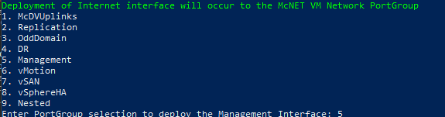

1. Finally for the Threenic option, we will continue this process for Backend interface. You will notice both the Internet portgroup and the Management portgroup are removed from the list. In this example, we will use **OddDomain** by typing 3 and hitting enter.

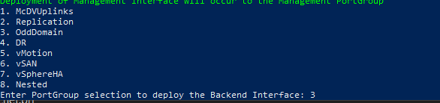

Deployment will now being with progress being reported in the console window.

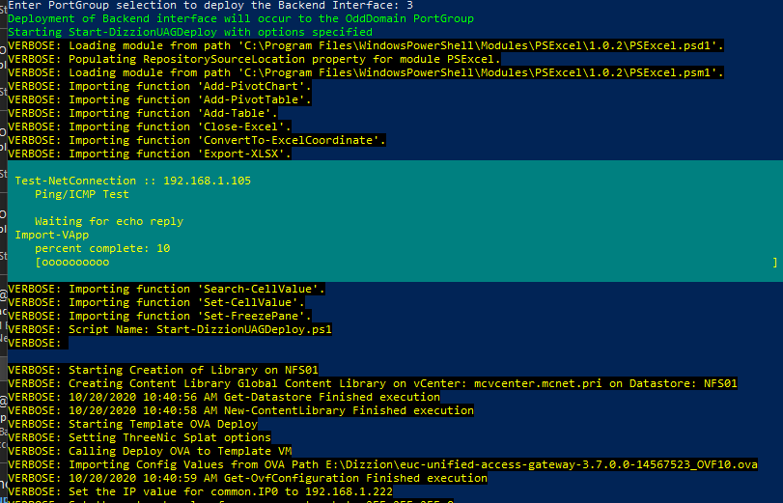

Progress can also be viewed in the tasks of the corresponding vCenter UI.



When completed, a log of operations is available in C:\Temp named DizzionXXXX.log

An email is also sent with the final deploy report.

