Jaden Maciel
Networking Project
CYBR-2500-02

Table of Contents
- Title Page: Page 1
- Table of Contents: Page 2
- Executive Summary: Page 3
- Item Catalog and Specifications: Pages 4-17
- Network Diagram: Page 18-19
- Summary Spreadsheet: Page 20
- Configuration: Page 21-23
- Justification Dialog: Pages 24-26

Executive Summary
This final project is the completion and understanding of my learning for the CYBR-2500 course in Data Networking and Communications. As a Software Development major with minors in Computer Science and Business Management. I have created this network to benefit both academically and professionally as an aspiring Software Engineer. My dream network must support a broad variety of development workflows, from web and mobile application development to software testing, version control, and later on deployment to the cloud with a high-level security, performance, and reliability.
To support this network I’ve envisioned of, I’ve included high-performance Linux, Windows and macOS machines to simulate real-world development environments. Alongside with tools that will enable efficient remote coding, debugging, and deployment. Security is always a priority, with configuration settings that protect codebases and projects. This setup will not only reflect my technical knowledge but also conveys the multi-platform, hybrid environments commonly used in professional software engineering settings.

Item Catalog
Name | (Windows Low-End Desktop) Dell OptiPlex 7010 Micro
Diagram Code | A1
Specs | 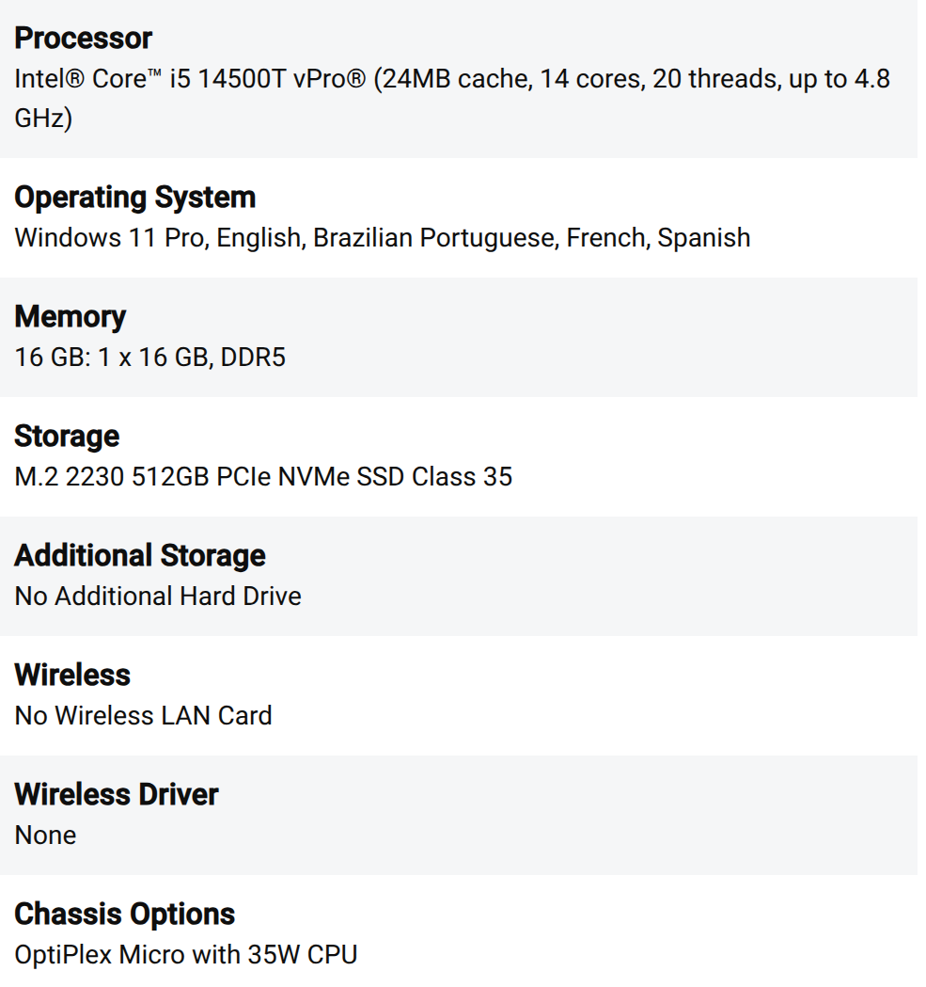
Price | $959.00
Where to Buy? | Dell OptiPlex Micro From Factor | Dell USA

Name | (Windows High-End Desktop) Alienware Aurora R16
Diagram Code | A2
Specs | 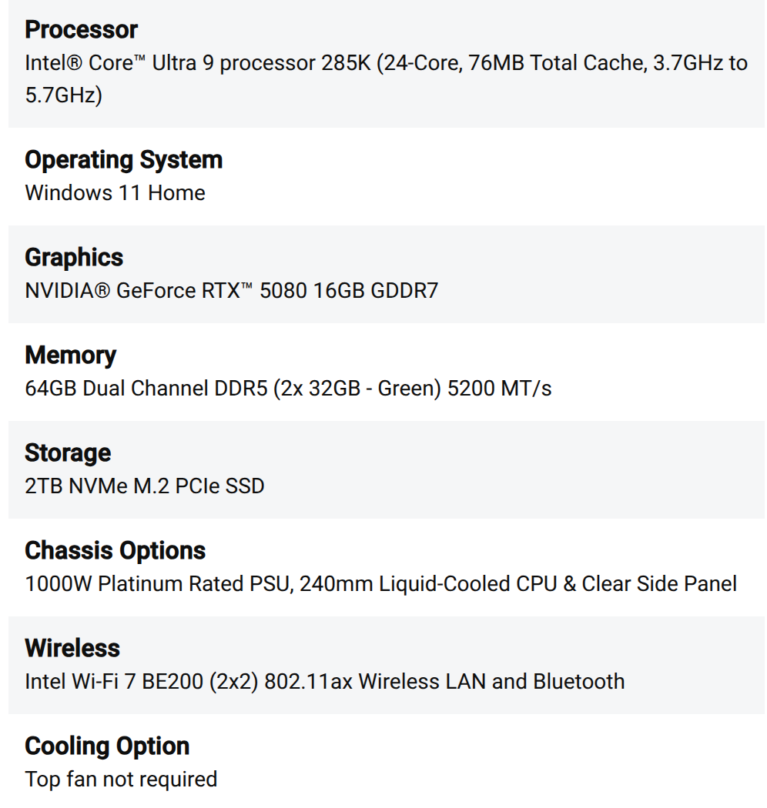
Price | $3,349.99
Where to Buy? | Alienware R16 Gaming Desktop with Air Cooling & Liquid Cooling | Dell USA

Name | (Linux Desktop) Precision 5860 Tower Workstation
Diagram Code | B1
Specs | 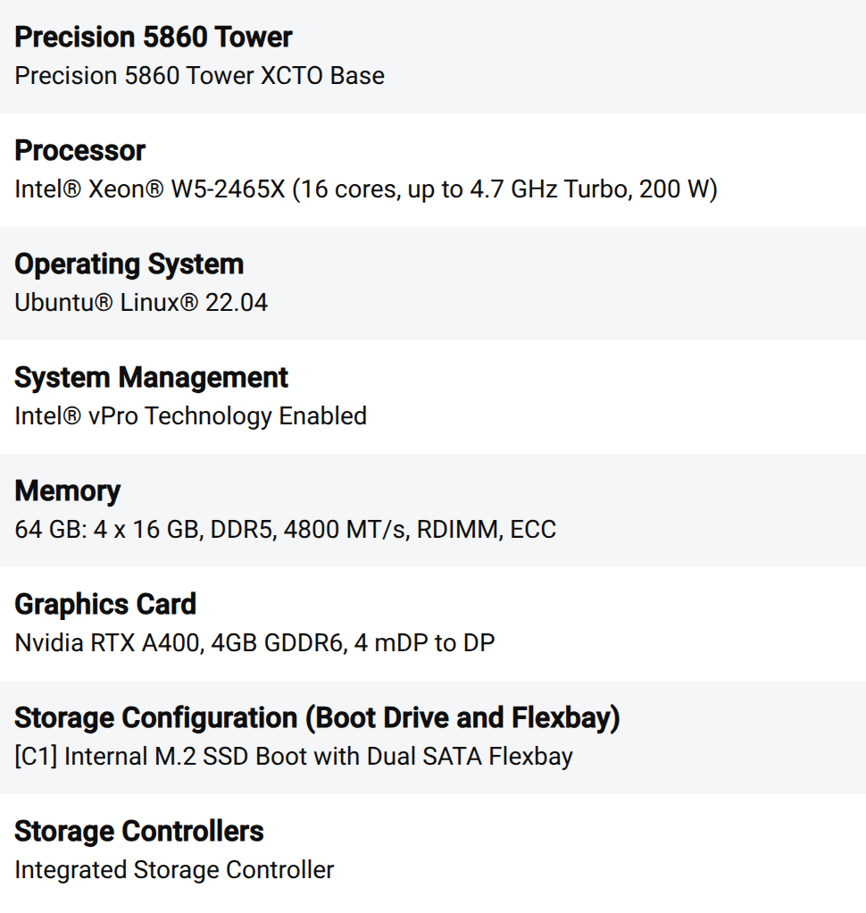
Price | $5,344.35
Where to buy? | Precision 5860 Tower Workstation | Dell USA

Name | (macOS Desktop) Mac Studio (M3 Ultra)
Diagram Code | B2
Specs | 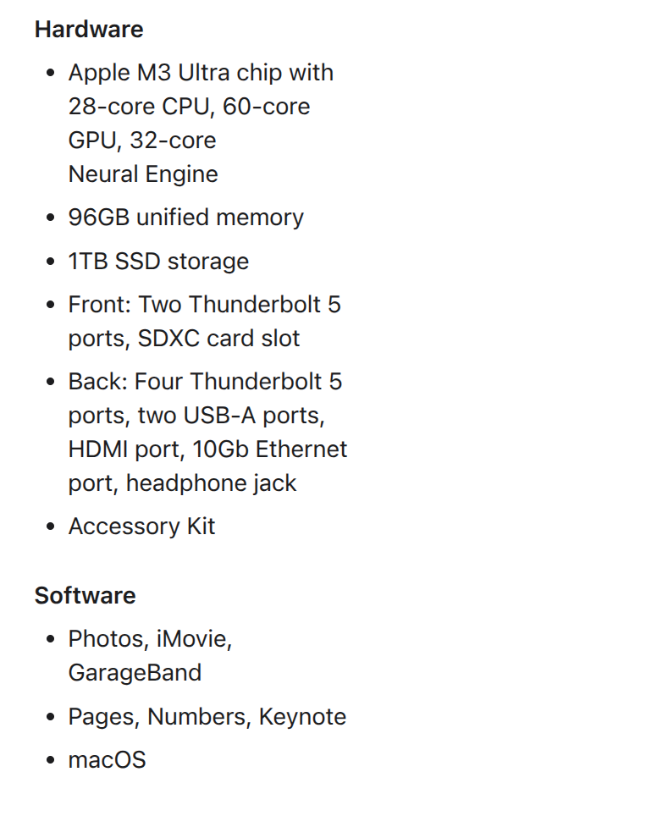
Price | $3,999.00
Where to Buy? | Mac Studio (M3 Ultra) | Apple

Name | (Windows Low-End Laptop) Dell Inspiron 14
Diagram Code | A3
Specs | 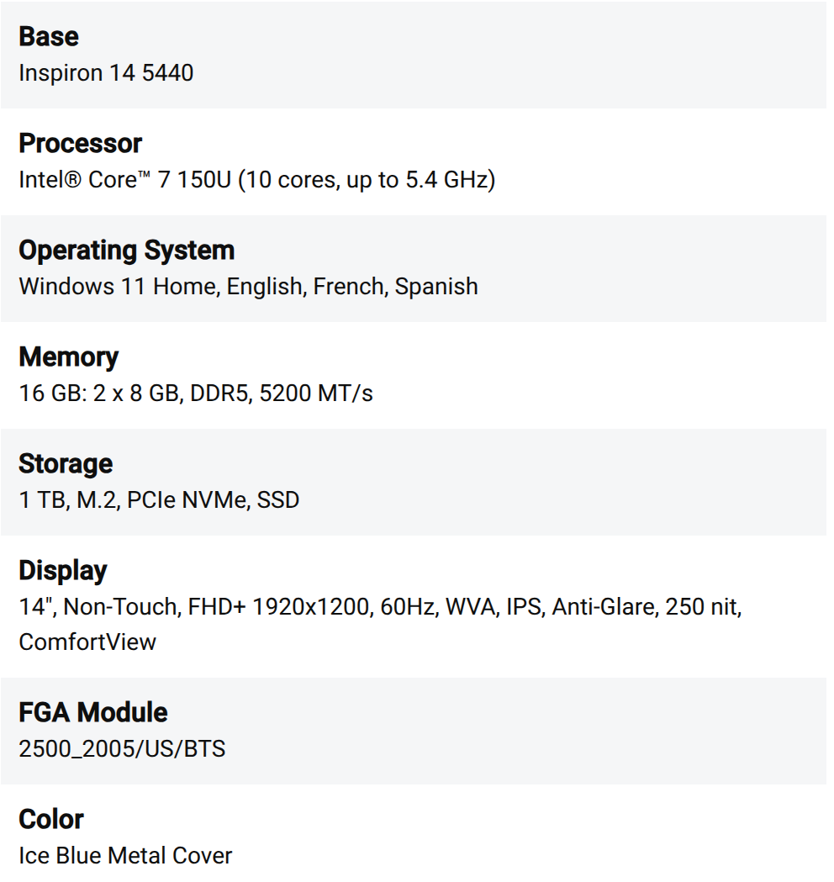
Price | $699.99
Where to Buy? | Inspiron 14 Laptop | Dell USA

Name | (Windows High-End Laptop) Dell XPS 13
Diagram Code | A4
Specs | 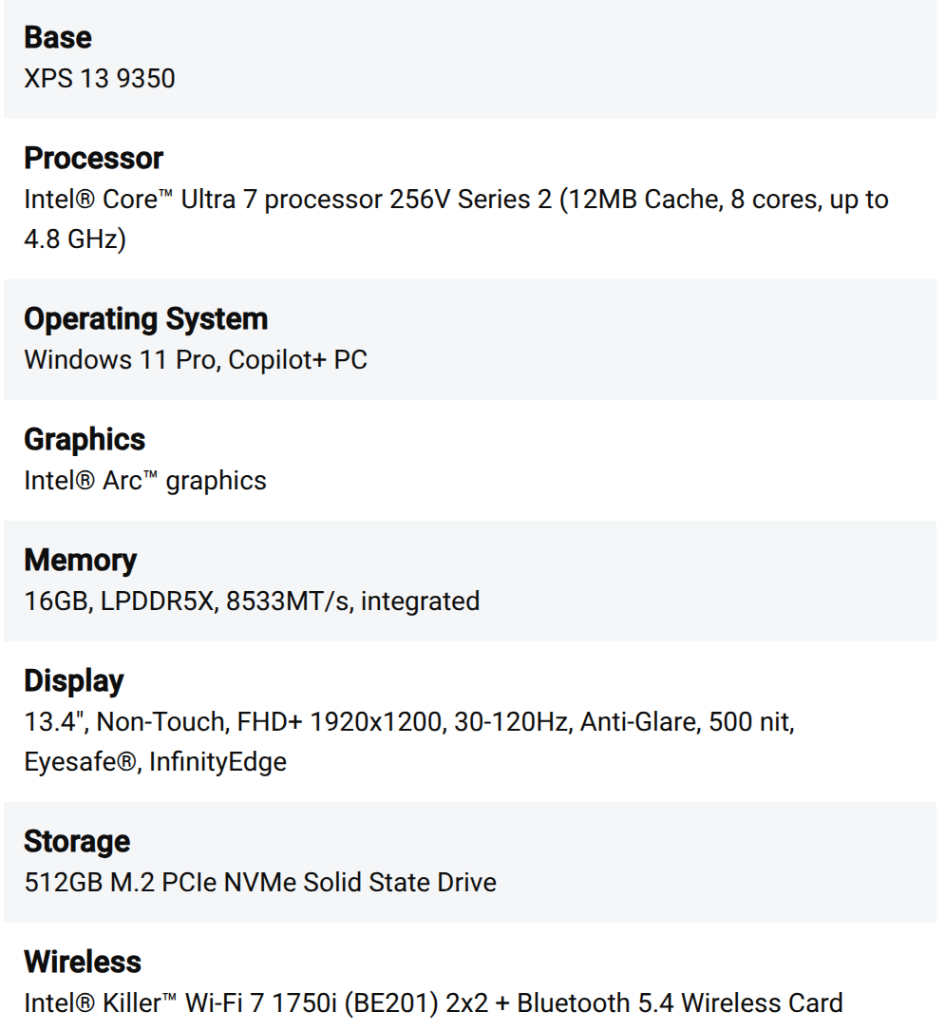
Price | $1,459.99
Where to buy? | New XPS 13 Laptop | Dell USA

Name | (macOS Laptop) MacBook Pro 16” (M4 Max)
Diagram Code | B3
Specs | 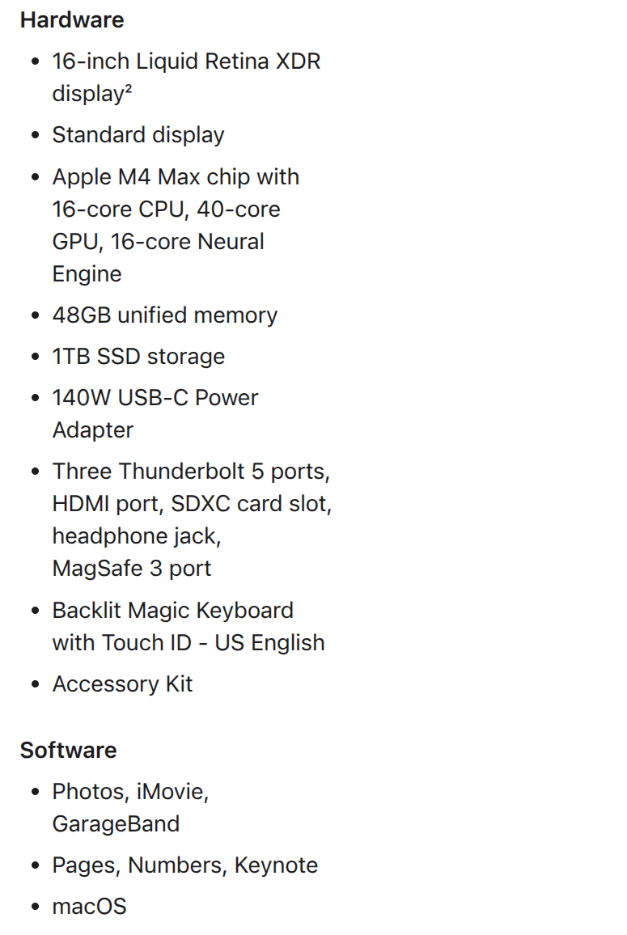
Price | $3,999.00
Where to buy? | 16-inch MacBook Pro | Apple

Name | (Smartphone) iPhone 16 Pro 1TB Black
Diagram Code | M1
Specs | A18 Pro chip with 6-core GPU, 1TB Storage, 6.3″ Super Retina XDR display, ProMotion technology
Price | $1,499.00
Where to buy? | iPhone 16 Pro | Apple

Name | (Tablet) iPad Pro 13”
Diagram Code | M2
Specs | M4 Chip, 1TB Storage, 13” Ultra Retina XDR display, ProMotion technology
Price | $1,899.00
Where to Buy? | iPad Pro | Apple

Name | (Printer) Brother Color MFC-L8900CDW
Diagram Code | B4
Specs | 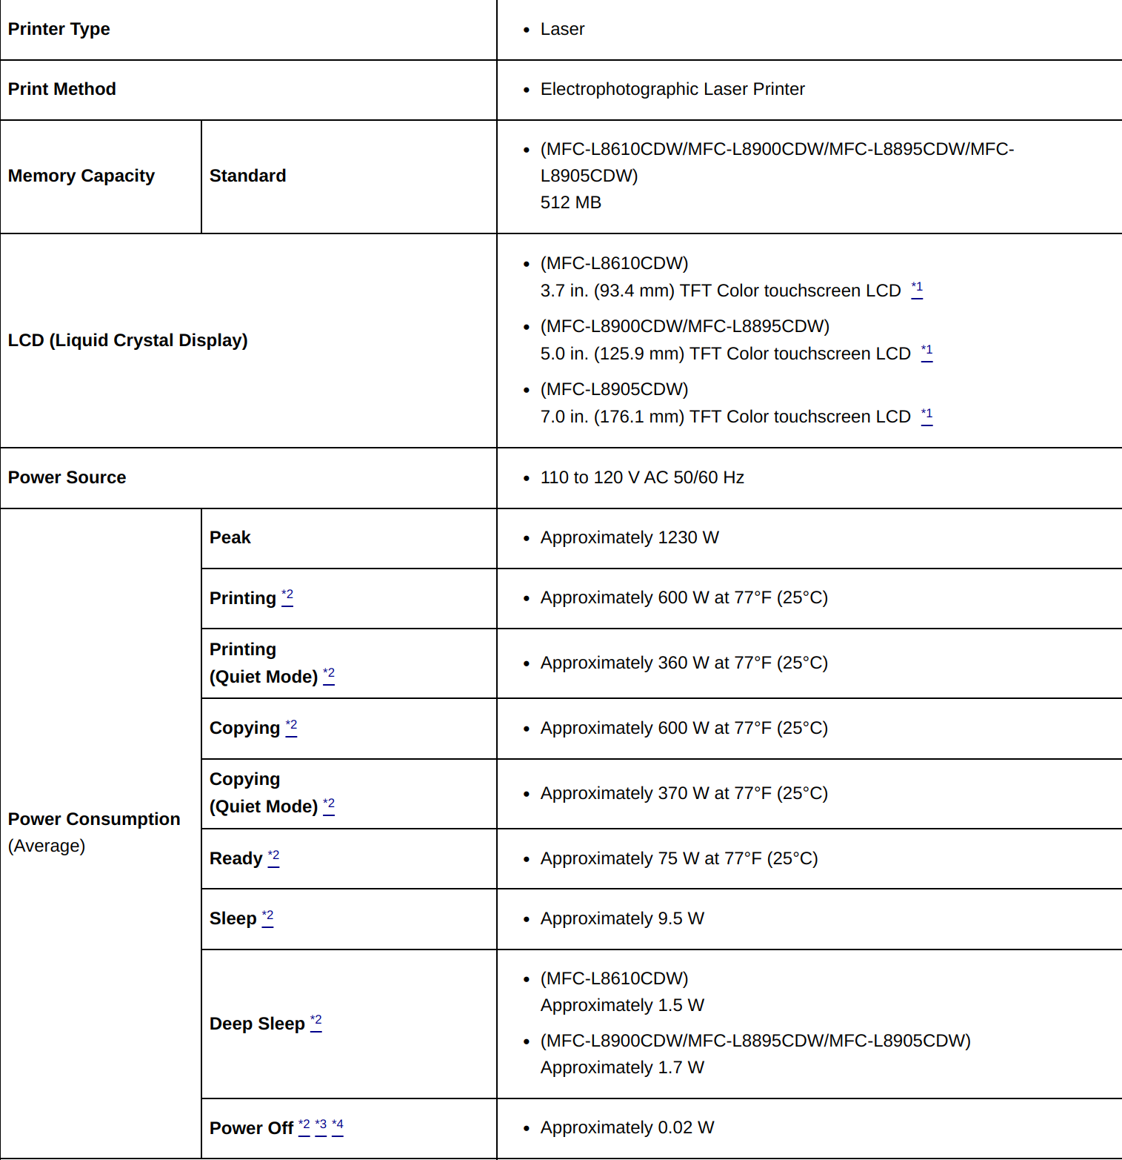
Price | $649.99
Where to buy? | Brother Color MFC-L8900CDW | Amazon

Name | (Switch) 8-Port Gigabit Ethernet Unmanaged PoE+ Essentials Switch with 8-Ports PoE+ (83W) (x2)
Diagram Code | C1
Specs | 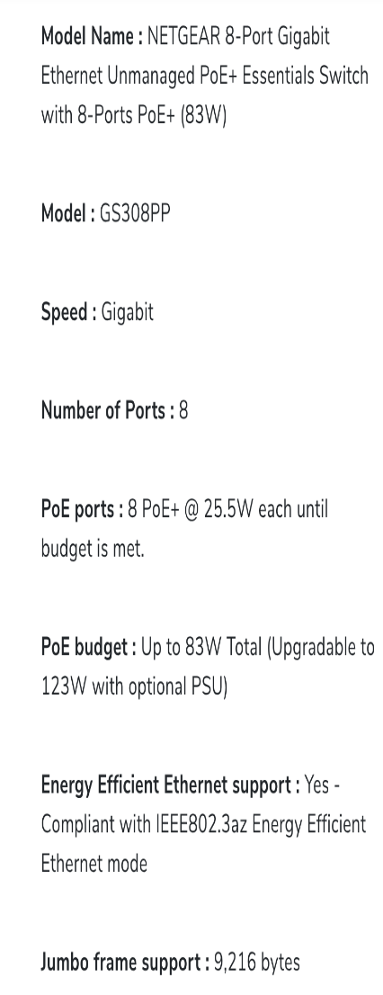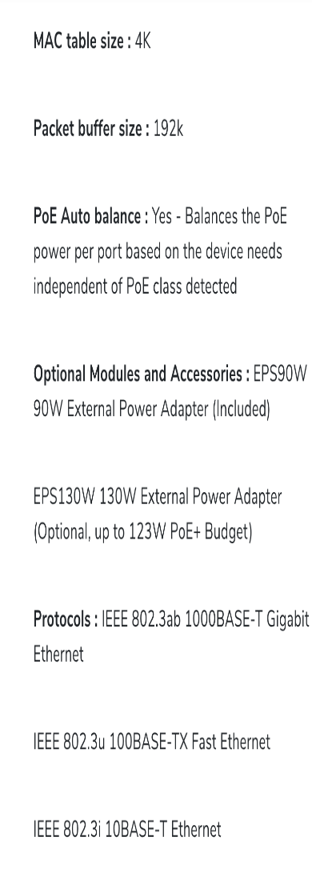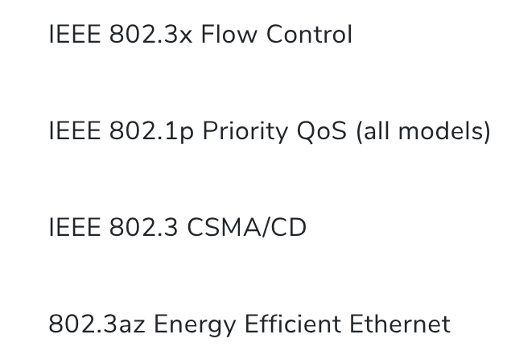
Price | Unit: $129.99  Total: $259.98
Where to Buy? | 8-Port Gigabit Ethernet Unmanaged PoE+ Essentials Switch with 8-Ports PoE+ (83W) | NETGEAR

Name | (Router/AP) SXK30 — Orbi Pro WiFi 6 Mini AX1800 WiFi System
Diagram Code | C2
Specs | 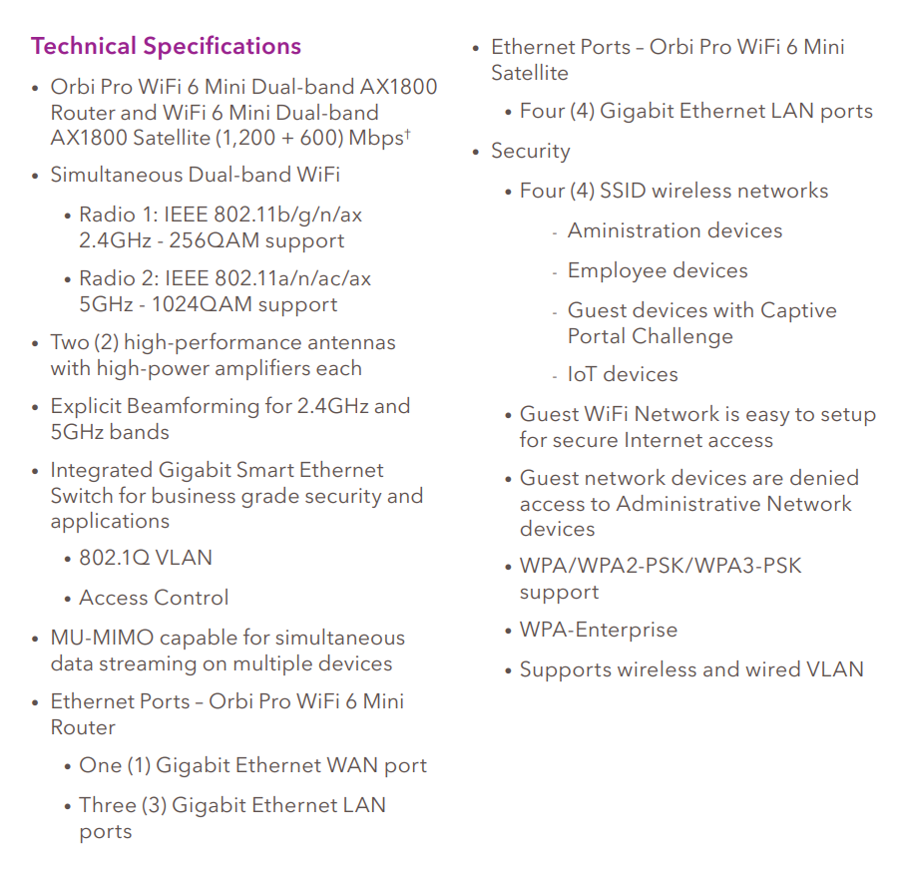
Price | $299.99
Where to Buy? | Orbi Pro WiFi 6 Mini System, 2-Pack AX1800 (SXK30) | NETGEAR

Name | (MODEM) SURFboard S33 DOCSIS 3.1 Cable
Diagram Code | C3
Specs | 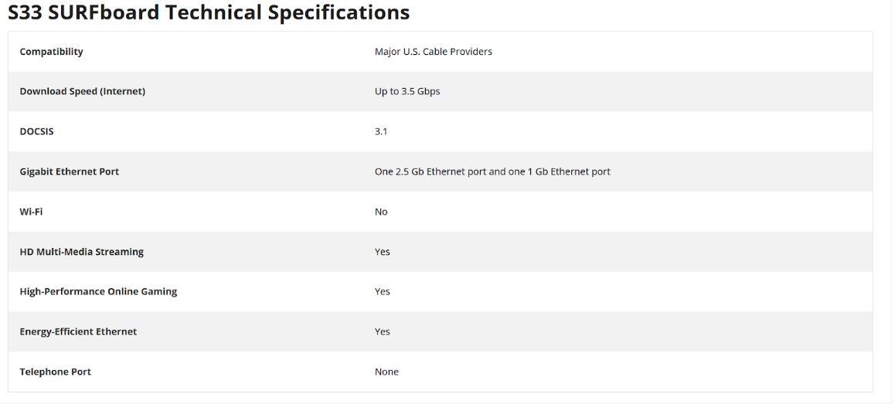
Price | $199.00
Where to Buy? | SURFboard S33 DOCSIS 3.1 Cable Modem | SURFboard Store

Network Diagram
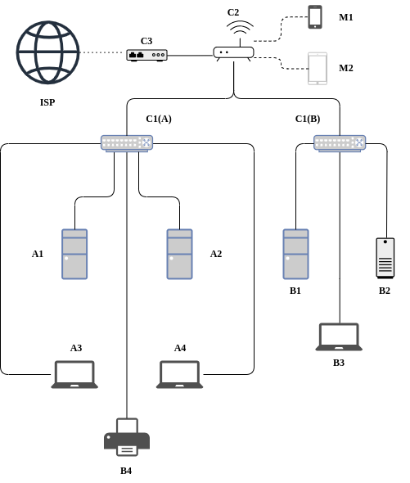

Legend
Code | Device Name | Device Type | Network Role
A1 | Dell OptiPlex 7010 Micro | Windows Low-End Desktop | Primary Network (A)
A2 | Alienware Aurora R16 | Windows High-End Desktop | Primary Network (A)
A3 | Dell Inspiron 14 | Windows Low-End Laptop | Primary Network (A)
A4 | Dell XPS 13 | Windows High-End Laptop | Primary Network (A)
B1 | Precision 5860 Tower Workstation | Linux Desktop | Secondary Network (B)
B2 | Mac Studio (M3 Ultra) | macOS Desktop | Secondary Network (B)
B3 | MacBook Pro 16” (M4 Max) | macOS Laptop | Secondary Network (B)
B4 | Brother MFC-L8900CDW | Printer | Primary Network (A)
M1 | iPhone 16 Pro (1TB) | Smartphone | Secondary Network (B, Wi-Fi)
M2 | iPad Pro 13” (1TB, M4 Chip) | Tablet | Secondary Network (B, Wi-Fi)
C1 | NETGEAR 8-Port PoE+ Switch (x2) | Switch | Network Backbone
C2 | Orbi Pro WiFi 6 Mini AX1800 | Router/Wireless AP | Wireless Routing/AP
C3 | SURFboard S33 DOCSIS 3.1 Cable Modem | Modem | ISP Gateway
Solid Line | Cat 6a Ethernet Cable
Dotted Line | Coaxial Cable Line
Dashed Line | 802.11 a WiFI

Summary Spreadsheet
Category | Total Quantity | Subtotal
Desktops | 4 | $13,652.34
Laptops | 3 | $6,158.98
Networking Equipment | 4 | $758.97
Mobile & Peripherals | 3 | $4,047.99
Grand Total | 14 | $24,618.28

Device Name | Diagram Code | Unit Price | Quantity | Total
Dell OptiPlex 7010 Micro | A1 | 959 | 1 | 959
Alienware Aurora R16 | A2 | 3,349.99 | 1 | 3,349.99
Precision 5860 Tower Workstation | B1 | 5,344.35 | 1 | 5,344.35
Mac Studio (M3 Ultra) | B2 | 3,999 | 1 | $3,999

Device Name | Diagram Code | Unit Price | Quantity | Total
Dell Inspiron 14 | A3 | 699.99 | 1 | 699.99
Dell XPS 13 | A4 | 1459.99 | 1 | 1459.99
MacBook Pro 16” (M4 Max) | B3 | 3999 | 1 | 3999

Device Name | Diagram Code | Unit Price | Quantity | Total
NETGEAR 8-Port PoE+ Switch (x2) | C1 | 129.99 | 2 | 259.98
Orbi Pro WiFi 6 Mini (SXK30) | C2 | 299.99 | 1 | 299.99
SURFboard S33 DOCSIS 3.1 Cable Modem | C3 | 199 | 1 | 199

Device Name | Diagram Code | Unit Price | Quantity | Total
iPhone 16 Pro 1TB Black | M1 | 1499 | 1 | 1499
iPad Pro 13” | M2 | 1899 | 1 | 1899
Brother Color MFC-L8900CDW | B4 | 649.99 | 1 | 649.99

Configuration
The network is established on a fast and secure basis, beginning with the SURFboard S33 DOCSIS 3.1 Cable Modem (C3). The modem is then connected to the ISP and provides up to 3.5 Gbps throughput. The modem is then connected to the Orbi Pro WiFi 6 Mini AX1800 Router (C2) using a Cat6a Ethernet cable, which then provides internet access to the network. The router is configured with DHCP to provide dynamic IP addresses to most of the devices and reserve specific static addresses to key endpoints.
Parameter | Value
SSID | Hidden
Encryption | WPA3
MAC Address Filtering | Enabled
DHCP Range | 192.168.10.10 – 192.168.10.200
Reserved Static IP - Linux Workstation (B1) | 192.168.10.201
Reserved Static IP - Printer (B4) | 192.168.10.100
Firmware Version | V1.0.9.90
Firewall Default | Block all inbound traffic
Firewall Allowed | SSH (TCP 22), HTTPS (TCP 443), Dev Server (TCP 3000)
ICMP (ping) from WAN | Blocked

Network Address Translation (NAT)
Enabled by default on the Orbi Pro WiFi 6 Mini router.
Conducts dynamic NAT to enable internal private IP addresses (192.168.10.0/24) to access external public networks through the ISP.
NAT allows hiding of internal IPs and is a fundamental part of outbound traffic direction and security.

External Port | Forwarded To
TCP 22 | Linux Workstation (SSH)
TCP 3000 | Dev Server Instance
TCP 443 | Mac Studio Web Server

Parameter | Value
Model | NETGEAR 8-Port PoE+ Unmanaged Switch
Ports | Auto-negotiated 1Gbps
PoE Power Budget | 83W each
Energy Efficiency | Enabled

Diagram Code | Device | OS/Firmware | IP Assignment | Applications/Functions
A1 | Dell OptiPlex 7010 Micro | Windows 11 Pro (64-bit) | DHCP | MS Office, Edge, GitHub Desktop
A2 | Alienware Aurora R16 | Windows 11 Pro (64-bit) | DHCP | Visual Studio, Unity, Docker, Postman
A3 | Dell Inspiron 14 | Windows 11 Home (64-bit) | DHCP | Email, Slack, VSCode
A4 | Dell XPS 13 | Windows 11 Pro (64-bit) | DHCP | PyCharm, Git, VirtualBox
B1 | Precision 5860 Tower Workstation | Ubuntu 22.04 LTS (64-bit) | Static (192.168.10.201) | Docker, SSH, Node.js, VSCode Server
B2 | Mac Studio (M3 Ultra) | macOS Sonoma (ARM64) | DHCP | Xcode, Swift, Figma, Slack
B3 | MacBook Pro 16” (M4 Max) | macOS Sonoma (ARM64) | DHCP | Xcode, GitHub CLI, Zoom
M1 | iPhone 16 Pro | iOS 18 | DHCP via Wi-Fi | Safari, Mail, TestFlight
M2 | iPad Pro 13” | iPadOS 18 | DHCP via Wi-Fi | Notability, Procreate, Safari
B4 | Brother MFC-L8900CDW | Firmware vL8.00 | Static (192.168.10.100) | Printing, Scanning, Network Backup

Feature
Unique login passwords for each device
Local firewall enabled (Windows Defender, UFW, macOS firewall)
SSH key authentication for Linux (B1)
Remote wipe enabled on M1 and M2
All unused ports closed via router/firewall

Connectivity
Cat6a Ethernet for all wired connections
802.11ax WiFi 6 with dual-band for wireless (M1, M2)
DHCP and DNS services managed via router

Backup Strategy
Daily backups to Google Drive, iCloud, OneDrive
Development files version-controlled (GitHub/GitLab)
macOS/Linux backups with Time Machine or rsync

Justification
To support my career in software development and computer science, I selected each piece of equipment within my network selective based on performance, flexibility, compatibility, and requirements for development. The network was divided into two; a Primary Network (A) for Windows productivity and general development purposes, and a Secondary Network (B) for macOS, Linux, mobile, and testing environments.
Primary Network (A):
To be within a reasonable budget for everyday computing, I chose the Dell OptiPlex 7010 Micro (A1) as a budget Windows desktop. Primarily used for documentation, admin, and a bit of development with cloud-based IDEs or GitHub Copilot. For the heavier workloads, I added the Alienware Aurora R16 (A2), a high-end Windows desktop with the newest graphics and processing features, ideal for running intensive workloads locally like Visual Studio, or training AI models. Mobility is needed in the hybrid work environment of today. Which lead me to the Dell Inspiron 14 (A3) as my affordable lightweight laptop for taking notes, editing code on the go, and working remotely. For the high end I choose the Dell XPS 13 (A4), my high-end Windows laptop of choice for full-stack development, Docker, and virtual environment on the road. A Brother MFC-L8900CDW (B4) printer with multifunction features is supplied to perform high-duty printing and scanning of reports, contracts, and project documentation. It is network-enabled, so it can be accessed by everyone in the SOHO setup.

Secondary Network (B):
Cross-platform compatibility is the first consideration in my software development. To simulate Linux-based servers and cloud-native infrastructure, I opted for the Precision 5860 Tower Workstation (B1) with Ubuntu LTS. The computer will serve as host for containerized workflow, backend testing, and remote server emulations using Docker and Visual Code Server.
Apple development is also critical for both iOS/macOS compatibility testing and native Swift development. Choosing macOS desktop for Xcode intensive builds, design, and mobile app emulation is the Mac Studio (B2). For mobility the MacBook Pro 16"" (B3) is a high-end portable macOS workstation, which is ideal for cross-platform dev, Swift UI prototyping, hackathons or client meetings.
For mobile access, the iPhone 16 Pro (M1) and iPad Pro 13" (M2) will allow me to test responsive designs, natively test mobile applications, and address remote work for a project. The iPad also doubles as a whiteboard or planning session tool for project sprints as it uses the Apple Pencil and has an M4 chip powering it.
Network Backbone:
For connectivity and security, the fast ISP connectivity is provided by the SURFboard S33 DOCSIS 3.1 Modem (C3). A reliable wireless performance with WPA3 encryption is provided by the Orbi Pro WiFi 6 Mini (C2) router/AP. Two NETGEAR 8-Port PoE+ Switches (C1) offering enough wired ports, with future expansion ability, and power over Ethernet for neat cabling.
All the gear is linked using Cat6a cabling for secure gigabit speeds, and DHCP is switched on for IP address management on the fly. Security is also turned on with MAC filtering, port shutdowns, device-specific firewalls, and individual passwords per device. All these combined enable my full-stack development process, mobile test procedures, and collaboration tools with performance and security considerations.

