COSC 442
Software Quality Assurance & Testing
Fall 2026

Project #4 –Mutation Testing, Regression Testing and Continuous Integration

"Software testers do not make software; they only make them better."
- Anonymous

Repository URL: <paste your public GitHub repository URLs here, to make it easy for me, make it a link >
Directions: This project has 5 tasks that build on the JUnit 5, systematic test-design, and structural coverage work from prior projects. You will develop a JUnit 5 test suite for the CoffeeMaker application, establish that suite as a regression-testing baseline, evaluate and strengthen it using PIT mutation testing, and automate the regression and mutation checks using GitHub Actions. This is an individual project; however, students are encouraged to discuss general questions on the #project4 Slack channel. Please read through all instructions prior to starting.
Goals: The intention of this project is to move beyond asking whether tests execute code and begin asking whether tests are strong enough to detect faults and preserve required behavior as software changes. The project follows the progression: requirements-based unit testing -> regression testing -> mutation testing -> automated continuous integration quality gates.
Points: 23

Deadline: Wednesday, November 4, 2026 11:59pm All required source code, tests, Maven/PIT configuration, GitHub Actions workflow files, reports/evidence, and this completed document must be submitted as directed.
Language/Environment Requirements: Java, VS Code, JUnit 5, Maven, Git/GitHub, GitHub Actions, PIT mutation testing, and the VS Code Java tooling must be used. Use the JDK configured in the provided CoffeeMaker Maven project. If you have problems, this project has been verified to work on the vw.towson.edu CIS Desktop image.
Terminology Note: GitHub Actions is commonly described as CI/CD tooling. This project focuses on continuous integration (CI): automatically building and testing software changes. There is no deployment stage in this project.
Before You Begin - Understanding the Maven Project Structure. Download CoffeeMaker.zip from Blackboard (Projects / Project 4), extract it to a normal local folder, and open the CoffeeMaker project folder in VS Code. Examine the requirements, Javadocs, production source code, and pom.xml before doing anything else. First run the clean compile command shown above and verify that the project builds successfully.
The provided CoffeeMaker application has already been converted to a Maven project. It contains the “production” source code, Maven configuration, Maven Wrapper, and JUnit 5 dependency, but it intentionally contains no test cases. You will create the tests in Task 1.

Maven separates production source code from test source code using two standard directory roots:

src/main/java production Java classes
src/test/java JUnit test classes
For this project, the production classes are located under:
src/main/java/edu/towson/cis/cosc442/project4/coffeemaker/
Create your JUnit 5 tests under the matching test package directory:
src/test/java/edu/towson/cis/cosc442/project4/coffeemaker/
The directory roots are different, but the Java package remains the same. For example, CoffeeMaker.java and CoffeeMakerTest.java should both declare:
package edu.towson.cis.cosc442.project4.coffeemaker;
Important: Do not place JUnit tests under src/main/java. Production code belongs under src/main/java; test code belongs under src/test/java. While we have been putting them in the same directory as the source code in prior projects, it is best practice to separate test and source code as done here.
Use the Maven Wrapper supplied with the starter project issued in VS Code’s Command Line Terminal to verify that the project works with your computer. The local command differs by operating system:
Environment | Compile project | Run test suite
macOS / Linux | ./mvnw clean compile | ./mvnw test
Windows PowerShell | .\mvnw.cmd clean compile | .\mvnw.cmd test
Windows Command Prompt | mvnw.cmd clean compile | mvnw.cmd test

If macOS/Linux reports "permission denied" when running ./mvnw, run chmod +x mvnw once and retry. On Windows, the VS Code terminal can be opened with Terminal -> New Terminal; select PowerShell from the terminal profile menu if needed.
Task 1 – Develop the Junit 5 Regression Test Baseline. Using the requirements (see reqs directory) and Javadocs (see docs directory) as the specification, develop JUnit 5 tests for the CoffeeMaker, Inventory, and Recipe classes. Use the testing practices from prior projects and class activities: Arrange -> Act -> Assert, descriptive test names, normal/validation tests, invalid or exception tests, boundary cases, parameterized tests when appropriate, and systematic input selection such as input-space partitioning and boundary-value analysis where useful.

Do not use generative AI tools to create, rewrite, or suggest the JUnit test cases required in Task 1. The purpose of this task is to demonstrate your own ability to derive tests from the requirements using the test-design techniques covered in class. Standard IDE assistance such as code completion and syntax suggestions is permitted. We will get to generative AI magic in the next project.

Create the test classes under the Maven test directory. Typical files will be:
src/test/java/edu/towson/cis/cosc442/project4/coffeemaker/CoffeeMakerTest.java
src/test/java/edu/towson/cis/cosc442/project4/coffeemaker/InventoryTest.java
src/test/java/edu/towson/cis/cosc442/project4/coffeemaker/RecipeTest.java
You can develop and run your JUnit 5 tests using the normal Testing “beaker” view in VS Code, as you have done in previous projects. Use it to run individual tests, individual test classes, or the complete suite while you are developing and debugging tests.
Periodically, and before moving to mutation testing, also run the complete suite using the Maven Wrapper from the VS Code terminal. This verifies that your tests run correctly outside the VS Code Testing view and prepares the project for the GitHub Actions workflow used later in this project.
Environment | Run all JUnit tests with Maven
macOS / Linux | ./mvnw test
Windows PowerShell | .\mvnw.cmd test
Windows Command Prompt | mvnw.cmd test

If macOS/Linux reports "permission denied" when running ./mvnw, run chmod +x mvnw once and retry. On Windows, the VS Code terminal can be opened with Terminal -> New Terminal; select PowerShell from the terminal profile menu if needed.
All tests must pass before you move to mutation testing – if not, mutation testing will throw exceptions and not work correctly!
Next, use the VS Code Testing view to run the suite with coverage, using the same Java test coverage functionality used in previous projects. Refine the test suite until you have a strong structural-testing baseline, with at least 90% statement/line coverage and strong decision/branch coverage for CoffeeMaker, Inventory, and Recipe. If a small amount of code cannot reasonably be covered, document why rather than developing meaningless tests solely to increase the coverage.
Before completing Task 1, verify both of the following:
- The complete test suite passes in the VS Code Testing “beaker” view.
- The complete test suite passes using the Maven Wrapper command for your operating system.
Record the final baseline:
Class / Measure | Result | Notes
Number of passing JUnit 5 tests
CoffeeMaker statement/line coverage
Inventory statement/line coverage
Recipe statement/line coverage
Decision/branch coverage, where reported

Describe one test you added because structural coverage, Input Space Partitioning / Boundary Value Analysis, or another systematic test-design technique revealed a gap that you had not originally considered.
At the end of this Task 1, your passing JUnit test suite becomes the project regression suite. A regression test is not a special kind of JUnit test; it is an existing test that is rerun after changes to detect whether previously working behavior has been broken (i.e., don’t break what previously worked!).
Create a public GitHub repository for this project if you have not already done so. Commit and push the baseline source and test suite before beginning Task 2. Use frequent commits and informative commit messages.
Task 2 – Evaluate and Strengthen the Test Suite with PIT. Code coverage tells us whether source code was executed, but it does not tell us whether the tests would detect an incorrect implementation. Mutation testing addresses this limitation by creating small changes (i.e., mutants) in the program and running the test suite against those mutants to determine if the tests can detect a change in program behavior.

Step 1 – Add PIT to pom.xml
For mutation testing, we will use the PIT tooling. To review the concepts of mutation testing,
see An intro to Mutation Testing - or why coverage sucks and http://pitest.org/ and familiarize yourself with
the basic concepts and mutation operators available in PIT.

To use Pit for mutation testing, we will utilize Maven and configure Pit as a build plugin. To do so, open the pom.xml file in Coffeemaker and locate the existing <build> section and its <plugins> element. Add PIT as another <plugin> entry inside <plugins>; do not place it in the normal project <dependencies> section. For this project, use PIT 1.20.2 and the PIT JUnit 5 plugin 1.2.3. Specifically, add the following plugin block inside <build><plugins>...</plugins></build>:
<plugin>
<groupId>org.pitest</groupId>
<artifactId>pitest-maven</artifactId>
<version>1.20.2</version>
<dependencies>
<dependency>
<groupId>org.pitest</groupId>
<artifactId>pitest-junit5-plugin</artifactId>
<version>1.2.3</version>
</dependency>
</dependencies>
<configuration>
<targetClasses>
<param>edu.towson.cis.cosc442.project4.coffeemaker.*</param>
</targetClasses>

<excludedClasses>
<param>edu.towson.cis.cosc442.project4.coffeemaker.Main</param>
</excludedClasses>
</configuration>
</plugin>

The pitest-junit5-plugin belongs inside the PIT plugin because it extends the PIT tool so it can run your JUnit 5 tests. The targetClasses entry tells PIT to mutate production classes in the CoffeeMaker package. At this point, we will not add the mutation threshold yet; first establish your initial mutation baseline.
The official PIT Maven documentation that I used to configure this initial pom.xml file is available at: https://pitest.org/quickstart/maven/. You may consult it for additional explanation but use the versions and package target specified above for this project.

Step 2 - Verify the normal unit/regression suite before PIT
Mutation testing is meaningful only after the normal JUnit unit/regression suite passes. First run the complete suite using the Maven Wrapper. Then, only if all JUnit tests pass, run PIT. Use the command for your operating system and terminal:

Environment | Regression suite | PIT mutation testing
macOS / Linux | ./mvnw test | ./mvnw test-compile org.pitest:pitest-maven:mutationCoverage
Windows PowerShell | .\\mvnw.cmd test | .\\mvnw.cmd test-compile org.pitest:pitest-maven:mutationCoverage
Windows Command Prompt | mvnw.cmd test | mvnw.cmd test-compile org.pitest:pitest-maven:mutationCoverage

If macOS/Linux reports "permission denied" when running ./mvnw, run chmod +x mvnw once and retry. On Windows, the VS Code terminal can be opened with Terminal -> New Terminal; select PowerShell from the terminal profile menu if needed.
A successful run should produce something like the following in the terminal window, indicating that the tests correctly ran within Maven build.
Unit/regression suite results:
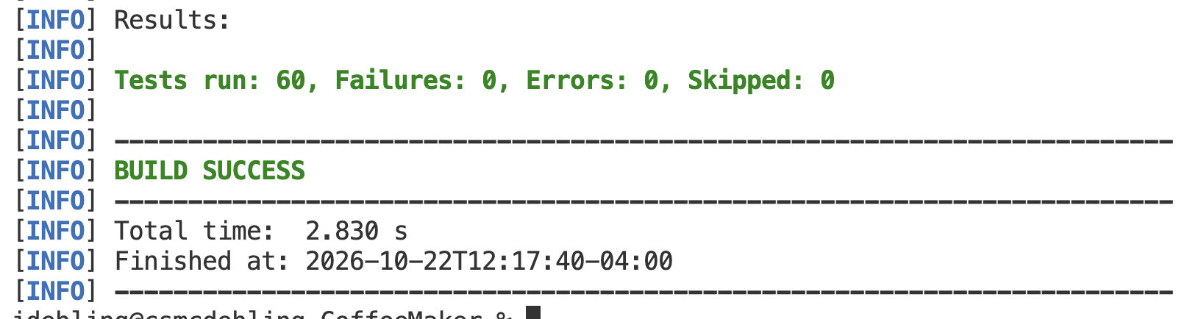
Pit mutation testing results:
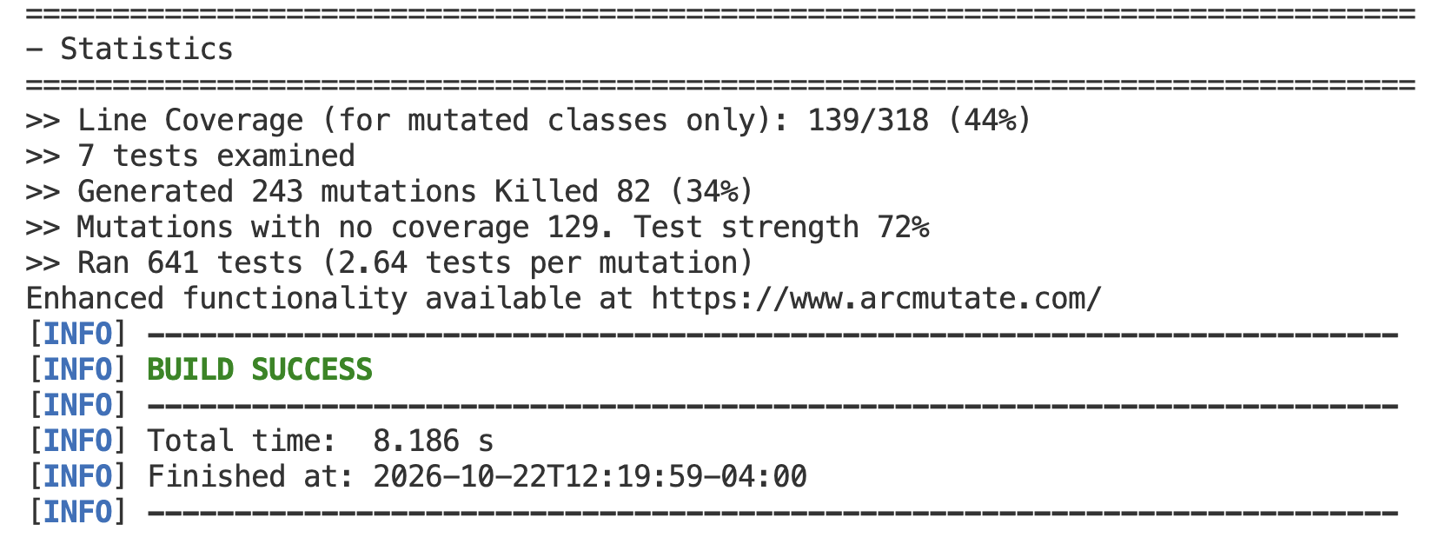
Step 3 - Confirm that PIT is working
A successful PIT run creates an HTML report under target/pit-reports. Open the index.html report in a browser and confirm that CoffeeMaker, Inventory, and Recipe appear, that mutants were generated, and that PIT reports which mutants were killed, survived, or had no test coverage. After clicking on the edu.towson.cis.cosc442.project4.coffeemaker link, you should see a report like:

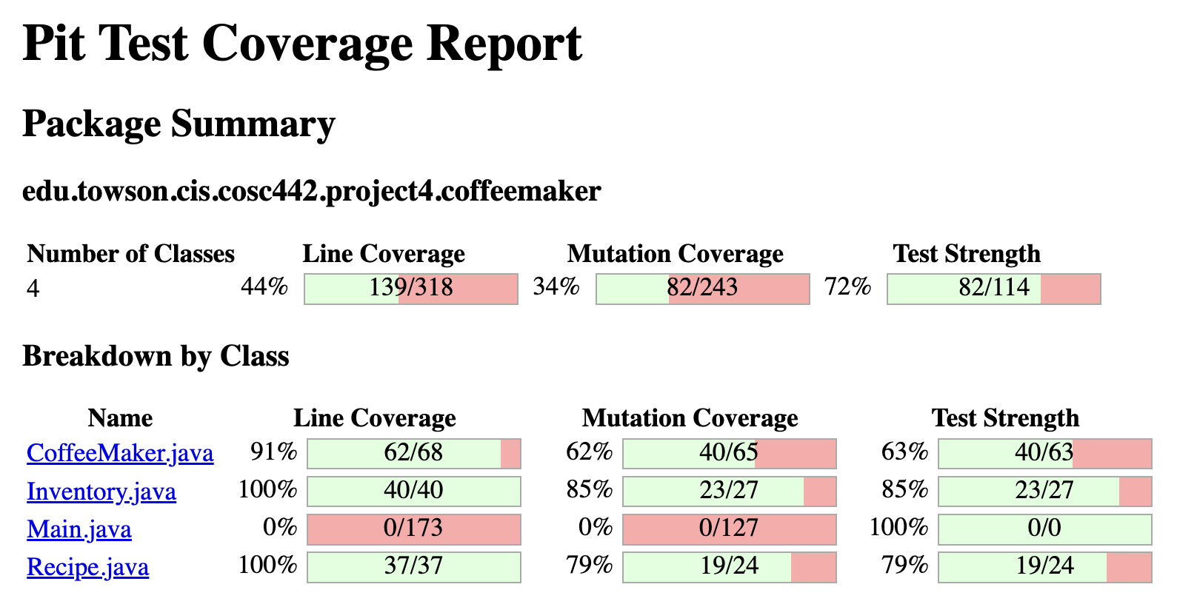

If PIT does not run correctly, check the following:

- The normal Maven/JUnit command succeeds first.
- The PIT plugin is inside <build><plugins>...</plugins></build>.
- pitest-junit5-plugin is a dependency of the PIT plugin, not a normal project dependency.
- targetClasses exactly matches edu.towson.cis.cosc442.project4.coffeemaker.* .
- You are running the Maven Wrapper command from the project root containing pom.xml.

Step 4 - Record the initial mutation baseline
While the idea of mutation testing is to point out deficiencies in your test suite (i.e., surviving, non-equivalent mutants), do not immediately change or add tests. First record the initial mutation results produced by the unit/regression suite. These results provide the baseline that you will try to improve.

Measure | Initial Result | Final Result
Total mutants
Killed mutants
Surviving mutants
Mutants with no coverage
Mutation score
Test strength, if reported

Step 5 - Investigate surviving mutants and strengthen the tests
Use the PIT HTML report to inspect surviving mutants. For each selected survivor, determine what change PIT made and why your existing tests did not detect it. Then strengthen the test suite only when the new or revised test represents meaningful required behavior.

- Inspect surviving mutants and determine what production behavior was changed by each mutant.
- Determine why the existing regression suite did not detect the change. Look for missing test inputs, missing assertions, weak assertions, or untested requirements.
- Add or improve JUnit 5 tests only when they represent meaningful required behavior. Do not add an assertion solely because it kills a mutant.
- Rerun the complete JUnit regression suite and then rerun PIT.
- Repeat until you achieve at least an 80% mutation score for CoffeeMaker.java, Recipe.java, and Inventory.java. A score near or above 85% is the target. If meaningful surviving mutants remain, justify them rather than attempting to reach 100% artificially.

As a general production-code rule, do not change or remove correct production behavior merely to improve the mutation score. If mutation testing reveals an actual production defect or code issue, document the defect and your proposed correction before changing the production code.

Document at least four surviving mutants that you investigated:

Mutated Code / Operator | Why It Survived | Test Added or Changed | Result | Rationale

Step 6 - Add the mutation quality threshold
After you have completed the mutation-testing improvement cycle and established your final mutation baseline, add a mutationThreshold of at least 80 to the existing PIT <configuration> block. For example:

<configuration>
<targetClasses>
<param>edu.towson.cis.cosc442.project4.coffeemaker.*</param>
</targetClasses>
<mutationThreshold>80</mutationThreshold>
</configuration>

The threshold converts mutation testing from an informational report into a quality gate: if the mutation score later falls below 80%, the Maven/PIT build fails. Do not set the threshold to 100%; equivalent or otherwise unhelpful mutants can make a perfect mutation score inappropriate.

Rerun both the JUnit regression suite and PIT after adding the threshold. Your final version should pass both. Include a screenshot of the final PIT summary/report below and commit the PIT configuration and strengthened test suite to GitHub.



In 3-5 sentences, explain why high statement/branch coverage does not guarantee a high mutation score. Include one concrete example from your CoffeeMaker testing.

Task 3 - Automate Regression and Mutation Testing with GitHub Actions. To mimic a realistic software development team workflow, we will now shift the testing tooling from running locally to running in the repository in the CI/CD build process as a software quality gateway. To do so, we will move the local testing process into GitHub Actions so the same quality checks run automatically when the repository changes (i.e., new commits/pushes). GitHub provides a Java with Maven workflow as a starting point, see https://docs.github.com/en/actions/tutorials/build-and-test-code/java-with-maven. The goal is to automate the JUnit unit/regression suite first and then run PIT mutation testing only after the regression suite passes.

This task also introduces a basic branch and pull-request workflow so changes can be evaluated before they are merged into main. Important: Do not make the initial CI workflow changes directly on main. Use a separate development branch so you can test the workflow safely before merging it.

Step 1 - Create a development branch using VS Code
In VS Code, make sure the CoffeeMaker repository is open. Use either the branch name shown in the lower-left status bar or the Source Control view to confirm that you are currently on main, and:

- If VS Code indicates that remote changes are available, use Sync Changes / Pull so your local main branch is current before creating the new branch.
- Click the current branch name and choose Create new branch (or use the branch controls in Source Control).
- Create a branch named ci-setup and confirm that the new branch name now appears as the active branch in VS Code.

If you’d rather do this at the command line (or for reference), you’d use the following command: git checkout -b ci-setup.

Step 2 - Create the GitHub Actions workflow file in VS Code
Using the VS Code Explorer, create the following folders at the root of the project:

.github/
└── workflows/

Inside workflows, create a new file named quality.yml. GitHub Actions recognizes workflow files stored under .github/workflows. Workflow files use YAML syntax.

When you create or open quality.yml, VS Code may prompt you to install the GitHub Actions extension published by GitHub. Install this extension for Project 4. It provides YAML syntax support, validation, code completion, workflow/run status, and access to GitHub Actions logs directly from VS Code. You may be prompted to sign in to GitHub and authorize access. The extension helps you create and troubleshoot the workflow, but you are still responsible for understanding what each workflow step does. This extension is different from the optional GitHub Pull Requests and Issues extension. The Actions extension supports quality.yml and workflow runs; normal Git/source-control operations remain available through VS Code's built-in Source Control view.

Step 3 - Start with JUnit unit/regression testing only
Paste the following starter workflow into quality.yml. Use the Java version required by the provided CoffeeMaker project:

name: CoffeeMaker Quality Checks
on:
push:
pull_request:
branches:
- main
jobs:
test:
runs-on: ubuntu-latest
steps:
- name: Check out repository
uses: actions/checkout@v4
- name: Set up Java
uses: actions/setup-java@v4
with:
distribution: temurin
java-version: '17'
cache: maven
- name: Run JUnit regression tests
run: ./mvnw test
# Add PIT mutation testing later
# Add PIT report artifact upload later
What this workflow does:
- Any push runs the workflow whenever commits are pushed to the repository
- pull_request targeting main runs the workflow when a pull request proposes changes to main branch
- ubuntu-latest uses a Linux GitHub-hosted runner
- actions/checkout makes the repository files available to the runner
- actions/setup-java configures the JDK and Maven dependency cache
- ./mvnw test runs the complete JUnit regression suite
Note that, even if you use Windows locally, the workflow runs on a Linux GitHub-hosted runner. Therefore, the workflow uses ./mvnw, not .\mvnw.cmd.

Step 4 - Commit and push the JUnit-only workflow using VS Code
Use the Source Control view in VS Code, review the changed quality.yml file and, with an informative commit message, commit and push this change to your repository. Afterwards open the repository on GitHub and select the Actions tab. Confirm that the workflow starts and that the JUnit regression-test step passes before adding PIT. You should see a green checkmark next to the workflow (as shown below) if the unit tests pass.
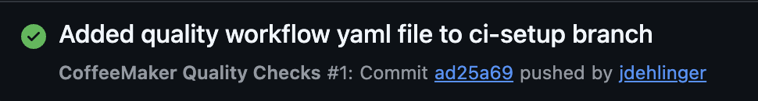

Step 5 - Add PIT mutation testing after JUnit passes
Return to quality.yml in VS Code and add this step immediately after the JUnit step:

- name: Run PIT mutation testing
run: ./mvnw test-compile org.pitest:pitest-maven:mutationCoverage

Because GitHub’s CI/CD Actions workflow steps execute in order, PIT runs only after the JUnit regression suite succeeds. If JUnit fails, the PIT step is skipped as this would violate the ideas of mutation testing. As in Step 4, confirm in the GitHub Actions tab that the workflows both pass.

Step 6 - Preserve the PIT report as a workflow artifact
With the unit testing and mutation testing workflows set up, we would also like to maintain the mutation testing report artifact produced by Pit. To do so, in the quality.yml file add the following after the PIT step:

- name: Upload PIT report
if: always()
uses: actions/upload-artifact@v4
with:
name: pit-report
path: target/pit-reports/
The if: always() condition is intentional. It allows GitHub Actions to attempt to preserve the PIT report even when PIT fails because the mutation threshold was not met.
Step 7 - Commit and push the completed workflow using VS Code
With the complete testing CI workflow now established using GitHub Actions, review and stage the updated quality.yml file and, when ready, commit and push it with an informative commit message. Then open the Actions tab on GitHub and confirm that the workflow follows this sequence:

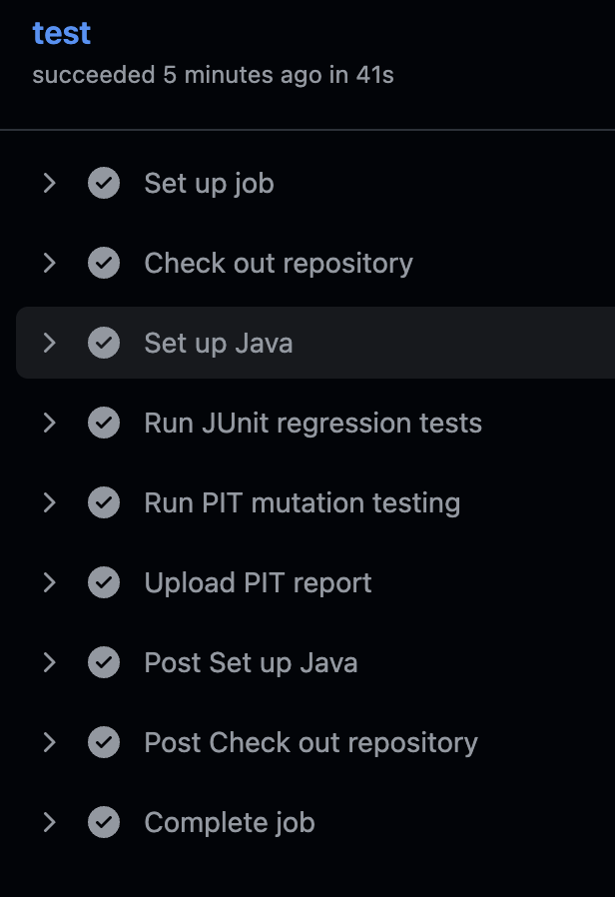

The workflow should fail if the JUnit regression suite fails or if the PIT mutation score falls below the configured mutationThreshold.

Step 8 - Open a pull request
After the ci-setup branch has a successful workflow run, open a pull request from ci-setup to main. If you use the GitHub Pull Requests and Issues extension in VS Code, you may create and review the pull request from VS Code. Otherwise, use VS Code to open the repository on GitHub and create the pull request in the browser. Review the JUnit and PIT checks associated with the pull request before merging.

Why use a branch and pull request? The branch allows workflow and code changes to be evaluated before they reach main. The pull request becomes the point where automated JUnit and PIT results provide quality evidence for deciding whether the change is safe to merge. Do not merge the pull request until all required checks pass.

To show that you have successfully completed this step, include a screenshot showing a successful GitHub Actions run with the JUnit step, PIT step, and PIT artifact visible. Also include a screenshot of the pull request showing the successful checks before merge.

In addition, briefly answer the following:
- Why is PIT placed after JUnit in the workflow?
- Why is it useful to evaluate the workflow in a pull request before merging into main?
For this project, JUnit and PIT run on every push and pull request so you repeatedly practice the complete automated quality process. Yet, mutation testing is substantially more expensive than ordinary unit testing as it generates many “mutant” versions of your application and, in parallel, runs the test suite against each version. In larger real-world projects, fast regression tests may run on every change while mutation testing runs only on pull requests, changed code, scheduled/nightly builds, or through incremental/history-based analysis.
Task 4 - Demonstrate Regression Detection and the Mutation Quality Gate. Task 3 established some of the CI/CD quality gateway tools that GitHub Actions can run against committed/pushed code. To demonstrate the utility of this workflow (especially in a software development team / regression testing setting), we will intentionally trigger workflow failures. To do so, create a new branch from the updated main branch, named quality-gate-demo. Use this branch to demonstrate that the two automated checks detect different quality problems. All temporary faults or weakened tests must be corrected before anything is merged into main.

Step 1 - Demonstrate regression detection
- Choose a behavior already covered by the regression suite and make one small, deliberate production-code change that violates a requirement (i.e., insert a fault/bug). Examples include changing a boundary comparison, altering a returned value, or removing a required state update. Do not change the tests.
- Without testing locally, commit and push the deliberate faulty code to the quality-gate-demo branch.
- Observe GitHub Actions. The JUnit regression step should fail. Because PIT comes after JUnit, PIT should not run when the regression suite has already detected the problem.
- If the existing JUnit suite does not detect the deliberate defect, you have discovered a regression-test weakness. Add a test that exposes the defect, confirm that it fails against the defective code, and retain that test in the final suite.
- Restore the correct production behavior, push again, and confirm that the regression suite passes.

Step 2 - Demonstrate the mutation-testing quality gate
- With production code corrected after the previous step, temporarily disable or remove one or more tests that you know are important for killing mutants. Do not change production code.
- Verify locally that the remaining JUnit suite still passes but the PIT mutation score falls below the configured mutationThreshold. Use the local Maven Wrapper commands appropriate for your operating system from Task 2.
- Commit and push the temporarily weakened test suite. JUnit should pass, but PIT should fail the quality gate.
- Restore the disabled/removed tests, push again, and confirm that both JUnit and PIT pass.
- Open or update the pull request. Merge only the final restored version after all required checks are green.

To show completion of this task, include GitHub screenshots showing: (1) the failed regression run; and, (2) the PIT quality-gate failure while JUnit passes.

Task 5 – On Your Own: Move JoshHack into an Automated Regression and Mutation-Testing CI/CD Workflow. Based on the mutation testing and software quality gateway built into the CI/CD process using GitHub’s Actions you suffered through so far in this project, it is time to apply what you’ve learned.

In this game, the goal is to “descend the Caves Of Slight Danger, find the lost Teddy Bear, and return to the surface to win. Use what you find to avoid dying.” The game can be run in VS Code as a Java Application in the standard way. The Maven starter project has also been configured so that JoshHack can be run from the VS Code terminal using the Maven Wrapper commands provided below. Once presented with the main screen (shown below), you can press the ? key for help and playing instructions.
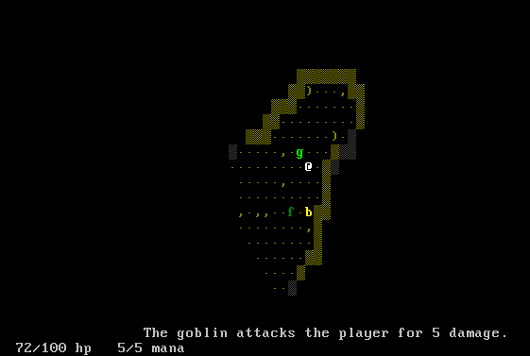
While the game is functional (and fun to play!), we are interested in improving quality of the software.

In Projects 2 and 3, you previously developed and improved tests for the JoshHack application. For this task, reuse that work rather than designing a new test suite from scratch.
Your goal is to take the JoshHack source code and the tests/improvements you developed previously and place them into the same Maven-based testing and CI/CD workflow used for CoffeeMaker. The emphasis in this task is not on achieving a particular coverage or mutation score. Instead, the goal is to establish a working automated unit/regression- and mutation-testing workflow that will be used later in the semester.
To do so, complete the following:
- Download the JoshHack source code provided on Blackboard under Project 4. I have already migrated this version to a Maven project and configured the Maven Wrapper and basic build/run commands.
- Add the JUnit 5 tests and other test improvements you developed for JoshHack in Projects 2 and 3 to the appropriate Maven test directory and package structure.
- Run the complete JoshHack test suite locally and verify that the existing tests still pass.

Task | macOS / Linux | Windows PowerShell
Clean project | ./mvnw clean | .\mvnw.cmd clean
Compile project | ./mvnw compile | .\mvnw.cmd compile
Run tests | ./mvnw test | .\mvnw.cmd test
Run JoshHack | ./mvnw exec:java | .\mvnw.cmd exec:java

- Configure PIT for JoshHack so that JoshHack can be mutation tested locally. Use the same general PIT configuration approach you used for CoffeeMaker. Configure targetClasses for the JoshHack production classes you could mutation test later in the semester. Because the UI package contains primarily GUI code, configure the targetClasses to only be in the game package (i.e., game.*). Do not configure a mutationThreshold for JoshHack, for now.
- Run PIT locally for JoshHack and verify that it successfully generates a mutation report. There is no required mutation-score threshold for JoshHack in this task. Record the result, but you are not required to improve the JoshHack test suite based on surviving mutants at this time.
- Create a GitHub Actions workflow in the JoshHack repository that runs its automated JUnit and PIT checks. The workflow should:
  - Run the JoshHack JUnit regression tests.
  - Run PIT only after the JUnit tests pass.
  - Produce or preserve the PIT result/report so it can be reviewed.
  - Run automatically on the same push/pull-request events used for the CoffeeMaker workflow.
- Create/push the JoshHack project to its own public GitHub repository (with link included at the top of this document when submitted) and verify that its workflow completes successfully.

To demonstrate completion, provide the following screenshots:

- A screenshot showing that the JoshHack JUnit tests pass locally or in the VS Code Testing view.
- A screenshot showing that PIT successfully ran against JoshHack.
- A screenshot showing a successful GitHub Actions run in which the JoshHack JUnit tests run before PIT.

Grading: This project will be graded out of 23 (5 for Task 1, 7 for Task 2, 4 for Task 3, 4 for Task 4, and 3 for Task 5) possible points.

Submission: Submit the completed project through your public GitHub repository and submit the completed project document to Blackboard, including repository links. The submitted repositories must contain the following, as appropriate:

- CoffeeMaker source code and JUnit 5 tests
- JoshHack source code and the JUnit 5 tests/improvements developed in Projects 2 and 3
- Maven configuration
- PIT configuration
- GitHub Actions workflow files
- Relevant project history

Your repository history, branches, pull requests, and GitHub Actions runs should demonstrate that the testing and CI workflow was developed incrementally rather than uploaded as one final version.

Important Final Checks: Before submitting, verify that:

- All CoffeeMaker JUnit 5 tests pass locally
- All JoshHack JUnit 5 tests pass locally
- CoffeeMaker PIT mutation testing runs successfully
- JoshHack PIT mutation testing runs successfully
- The CoffeeMaker mutation score meets the required threshold
- No mutation-score threshold is required for JoshHack in Task 5
- GitHub Actions runs JUnit before PIT
- The GitHub Actions workflow successfully runs the required JUnit and PIT checks for both CoffeeMaker and JoshHack
- PIT results/reports are available for review from the workflow
- The public GitHub repository URL is correct and accessible (make it easy for me !)
- The repository history shows incremental testing, mutation analysis, and CI workflow development

Note: There are at least 3 Easter eggs (this isn’t one of them) in this project. If you find one, let me know via direct message on Slack. Happy hunting!

