# CS 255 System Design Document Template

## UML Diagrams

### UML Use Case Diagram

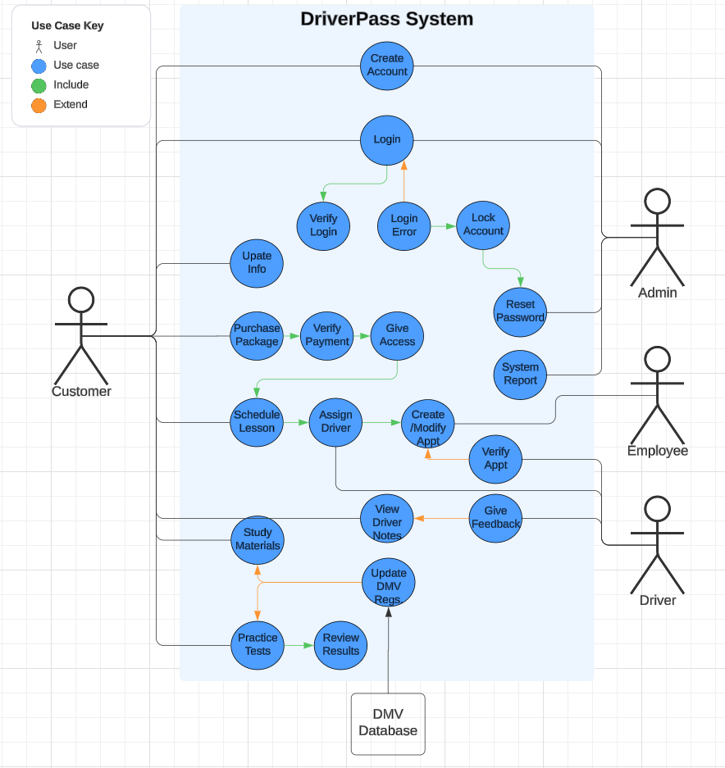

### UML Activity Diagrams

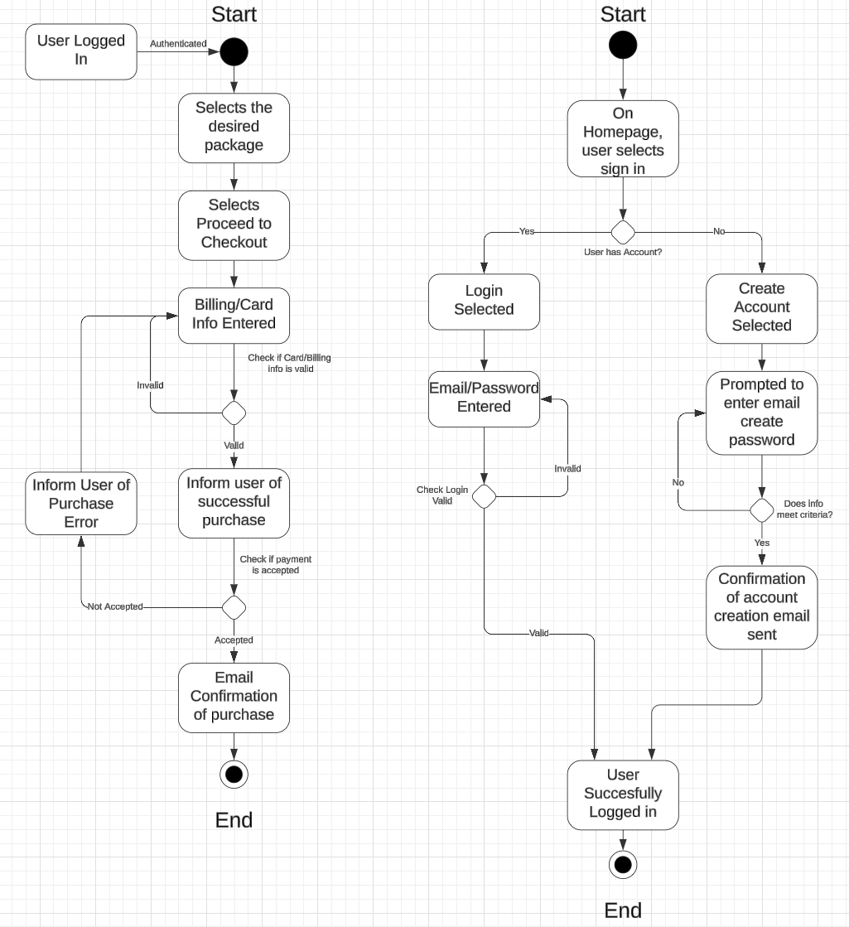

### UML Sequence Diagram

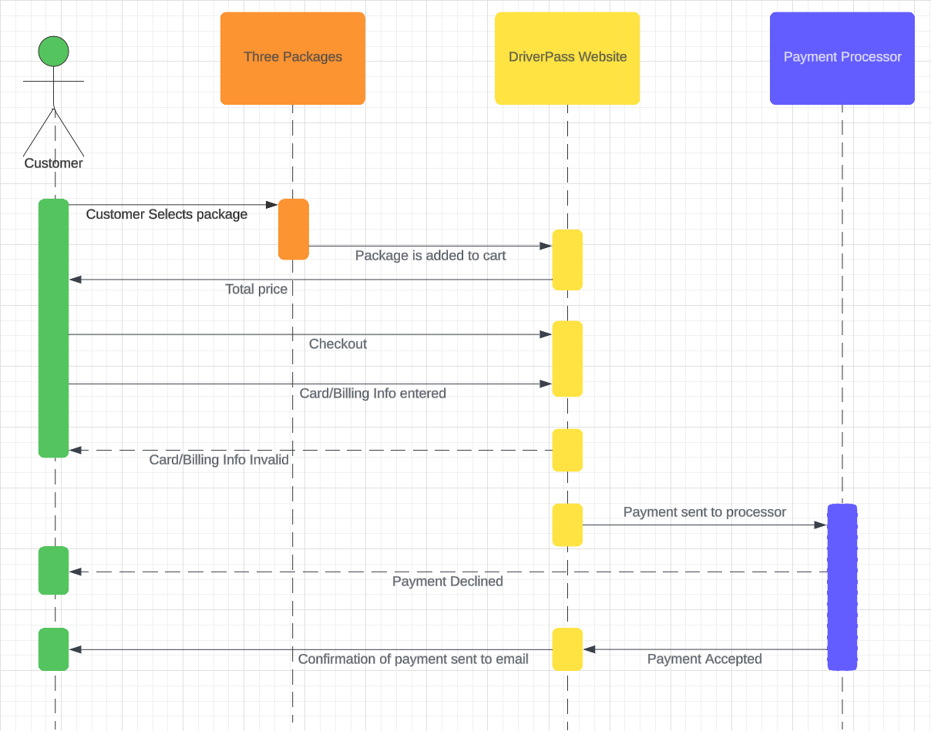

### UML Class Diagram

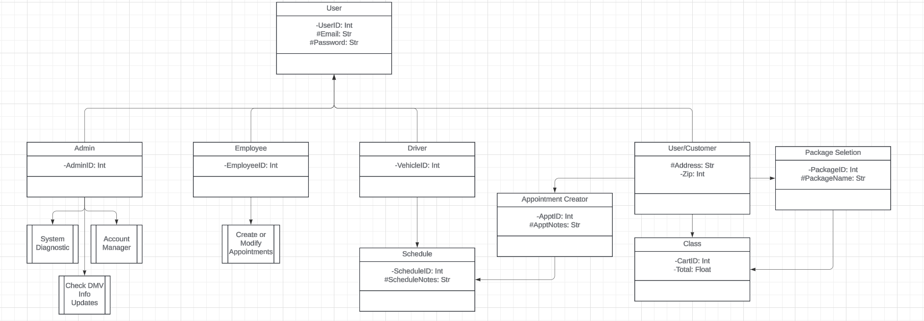

## Technical Requirements

*Hardware:*

* *Dedicated Servers to run the system*
* *Databases for information storage*
* *Computer/Mobile device*
* *Network connection*
* *Firewall for security*

*Software:*

* *SQL server*
* *Some form of a security software to monitor threats*
* *Backup server/databases for server information and system info*
* *Web server to host*