Lab 3 source codes; No Questions to be answered. Programs will be demoed in next lab

Task #1:

Task #2:

Task #3:

Task #4:

Task #5:

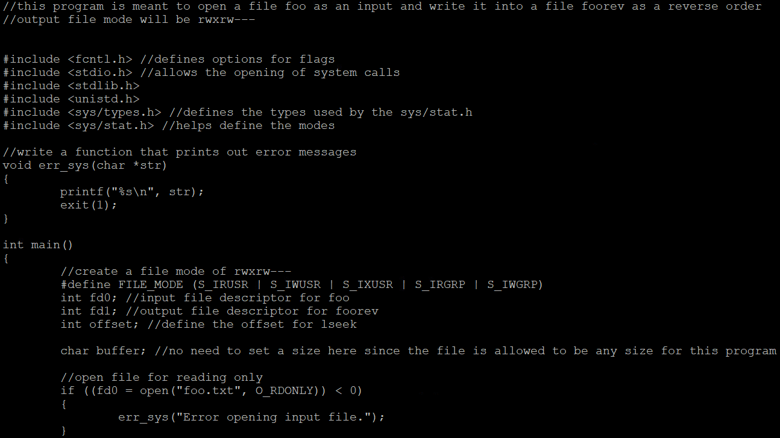

Task #6:

Task #7:

Task #8:

Task #9:

