1. (1) people that are similar in terms non-protected characteristics should receive similar predictions, and (2) differences in predictions across groups of people can only be as large as justiﬁed by non-protected characteristics.

Are we supposed to check the 1st type (direct discrimination) as well (by twin test)?

1. Mutiple discrimination?
2. 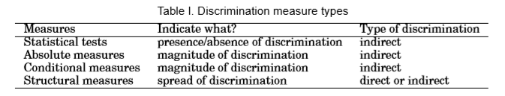

So statistical test first and measures second?

1. How to get regression function? Thru all the dummy variables of one feature or combine them together??