# Result

The results we obtained are shown as in Figure 1 and Figure 2. The first table shows the results based on person-level data, and the second table shows the results by vehicle_level data.

Dependent Variable: INJSEV_IM

|  |  |  |  |  |
| --- | --- | --- | --- | --- |
| Algorithm | # of independent variables | Cross validation? | tuning? | Accuracy |
| KNN |  | 10 |  | 0.6805 |
| SVC |  | 10 |  | 0.7155 |
| DT |  | 10 |  | 0.9161 |
| RF |  | 10 |  | 0.9307 |
| XGBoost |  |  |  | 0.8770 |
| LGBM |  |  |  | 0.8407 |

More observations (confusing matrix etc.):

DT:

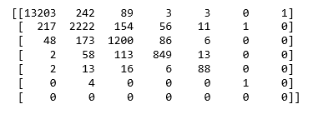

RF:

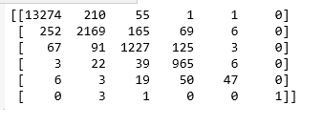

KNN:

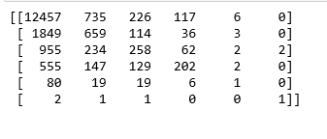

SVC:

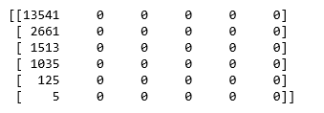

Feature importance Result:

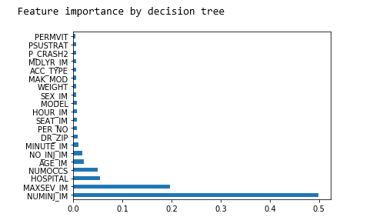

Dependent Variable: MXVSEV_IM

|  |  |  |  |  |
| --- | --- | --- | --- | --- |
| Algorithm | # of independent variables | Cross validation? | tuning? | Accuracy |
| KNN | 88 | 10 |  | 0.6627 |
| SVC | 88 | 10 |  | 0.6723 |
| DT | 88 | 10 |  | 0.7826 |
| RF | 88 | 10 |  | 0.8240 |
| XGBoost |  |  |  | 0.8549 |
| LGBM |  |  |  |  |

Feature importance Result:

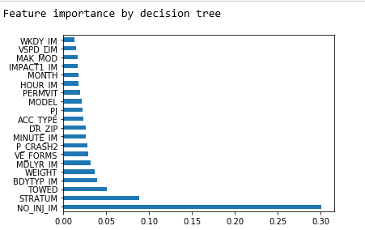

More observations (confusing matrix etc.):

DT:

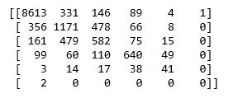

RF:

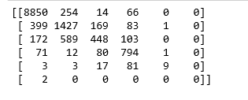

KNN:

