Xinyu(Jade) Zeng

ISQA 3900 Web Development

7/2/2019

**Part I Screenshots of Website**

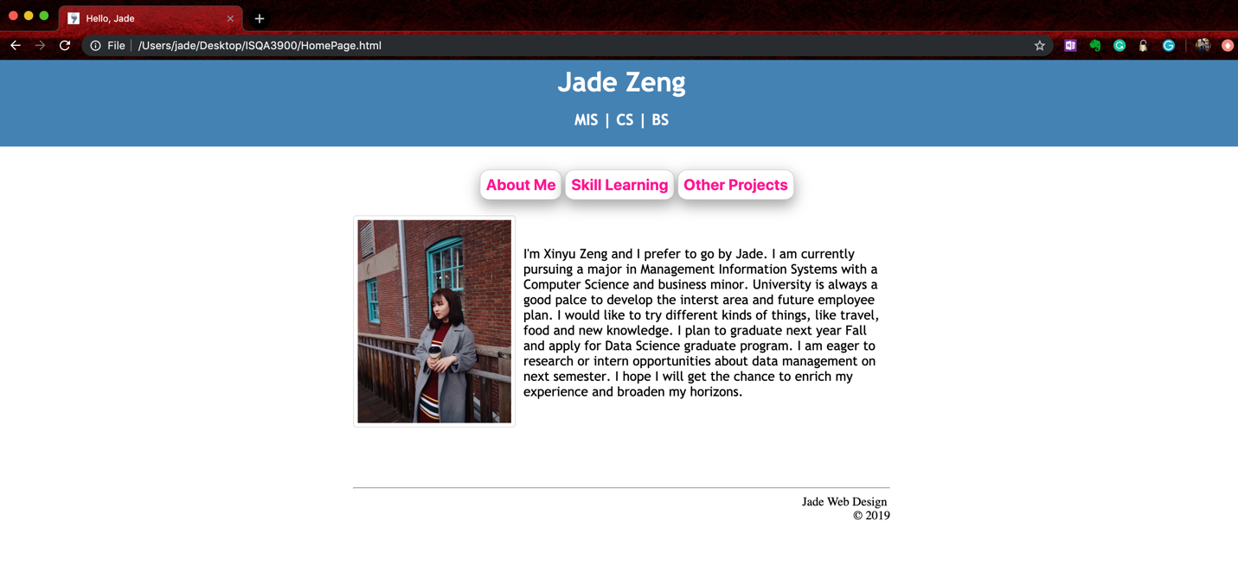

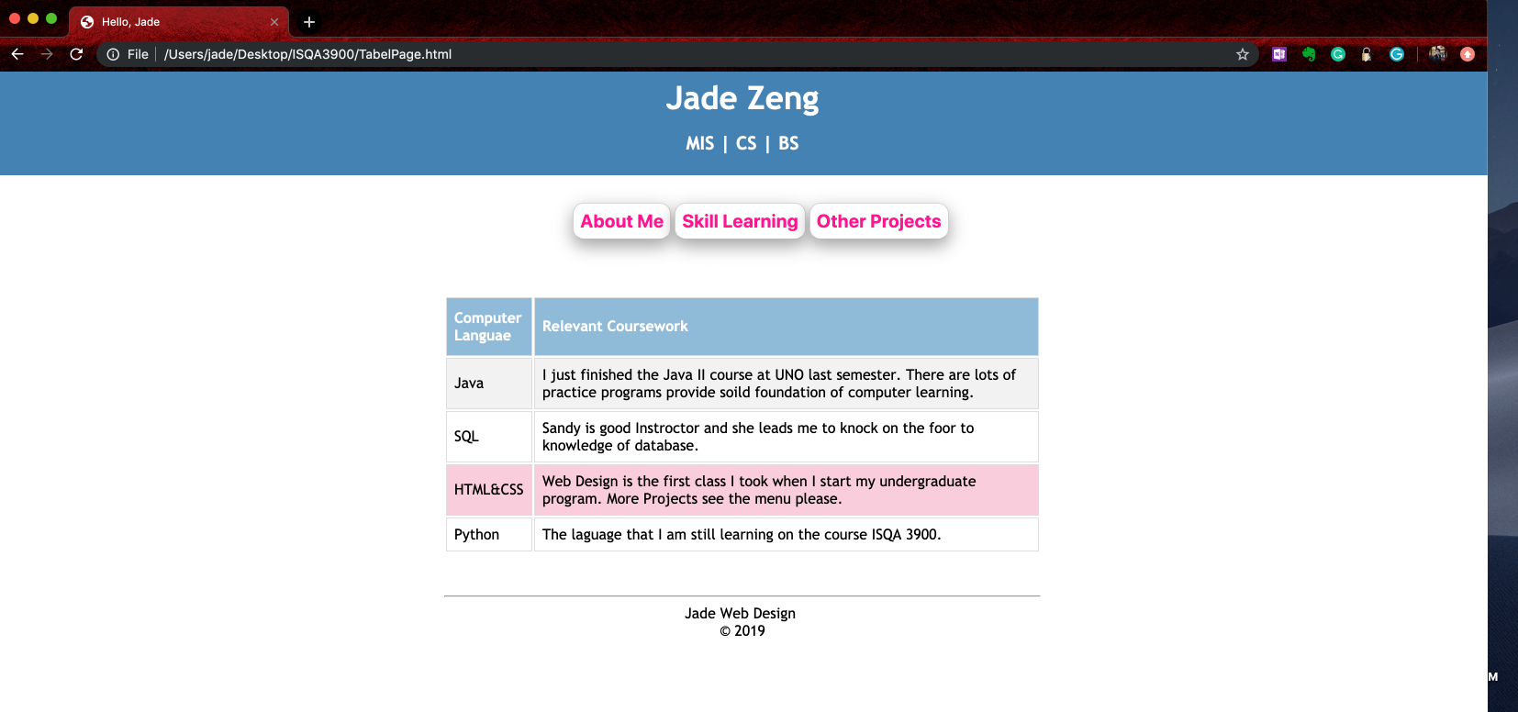

**Part II Questions**

1. What is the value of having a CSS in one page HTML in other pages? Why not simply embed the CSS in each web page?

Separate CSS file and HTML file could avoid unnecessary code duplicates. For example, if there have multiple pages but they all share common pattern (which are styled by CSS). If embed CSS in each page, we need copy and paste the same code multiple times to each HTML pages. What's more, once we have modification of one common pattern of one page, it means we have to update the rest of HTML pages one by one.

1. There are many cloud based document replication facilities such as DropBox, Box, Microsoft OneDrive. What is the advantage of using a tool like Git and GitHub over simply using something like Box to manage code?

GitHub provides a powerful technique such as issue tracking that could help developers locate and fix bug easier. Developers who work in a group could assign issue to their teammate through GitHub base on different branch each group member dealing with. If any submission of pull request is accepted by the developer who handle the code validation, the fork could be merged with the master branch.