Physics-guided machine learning for estimating the time of concentration of roof runoff in multi-storey buildings under tropical design storms
Jadfan Sidqi Fidari^{a,*}
ª Doctoral Program in Water Resources Engineering, Faculty of Engineering, Universitas Brawijaya, Jl. MT. Haryono 167, Malang 65145, Indonesia
* Corresponding author. E-mail address: quackerzunk@gmail.com

Highlights
• Building drainage cascade simulated from roof plane to collector pipe
• Kinematic-wave sum misjudged green-roof time of concentration by 76%
• Hybrid LightGBM reached NSE = 0.998 and 4.6% mean error on test data
• Downpipe share of time of concentration rose from 7% to 32% with height
• Hybrid inputs halved extrapolation error for buildings over 15 floors

Abstract
The time of concentration (t_{c}) controls design rainfall intensity in the rational method, yet no method resolves the drainage cascade of a multi-storey building, where runoff passes from the roof through gutters, outlets, downpipes and collector pipes. This study developed a physics-guided machine learning (ML) framework for building-scale t_{c}. A reference simulator combining an analytical kinematic-wave roof, a numerical kinematic-wave gutter, a level-pool outlet, a Wyly–Eaton downpipe and a kinematic collector was coupled iteratively to a Mononobe intensity relation fitted to 20 years of rainfall in Malang, Indonesia. Latin hypercube sampling of 16 design variables (2–30 floors, four roof types) produced 5780 hydraulically adequate configurations. Three conventional methods and six ML algorithms, each in a purely data-driven and a hybrid form that also received the kinematic-wave estimate, were compared on an independent test set and in three extrapolation tests. Reference t_{c} ranged from 0.6 to 42.7 min. Conventional methods performed poorly (Nash–Sutcliffe efficiency, NSE ≤ 0.35); the kinematic-wave component sum was accurate for impervious roofs (median bias −0.5% to −7.1%) but underestimated green-roof t_{c} by 76%. Hybrid LightGBM performed best (NSE = 0.998; mean absolute percentage error, MAPE = 4.6%; 88% of predictions within ±10%). When trained on buildings of up to 15 floors and tested on taller ones, the hybrid input reduced MAPE from 10.8% to 5.0%. Shapley additive explanations showed that substrate detention dominated green roofs, whereas collector length, roof slope, outlet diameter and the number of floors controlled impervious roofs; the downpipe share of t_{c} increased from 7% to 32% between low-rise and 26–30-floor buildings. Under a 5-min minimum storm duration, t_{c} errors mattered for design peaks mainly on green roofs, where conventional methods overestimated peak discharge by 103–177%. The framework provides a fast, interpretable estimator for building-scale inputs to urban drainage models.
Keywords: Building drainage; Explainable machine learning; Green roof; Kinematic wave; LightGBM; Rational method

1. Introduction
The time of concentration (t_{c}) is the single timing parameter that links a design storm to peak runoff in the rational method and in most time–area and unit-hydrograph procedures (Kuichling, 1889; Chow et al., 1988). Because rainfall intensity in intensity–duration–frequency (IDF) relations decays steeply with duration, an error in t_{c} propagates directly into the design discharge and, consequently, into the size of gutters, downpipes, collector pipes and on-site detention. Despite this central role, t_{c} remains one of the most uncertain quantities in engineering hydrology: dozens of empirical formulas coexist, they were calibrated on catchments of very different scales, and they can disagree by an order of magnitude when applied to the same site (McCuen et al., 1984; Gericke and Smithers, 2014; Grimaldi et al., 2012; Beven, 2020).
The disagreement is most acute at the smallest urban scale, the individual building. A multi-storey building is not a miniature catchment. Runoff is generated on a roof plane that may be a smooth metal sheet, a flat concrete slab or a vegetated green roof; it is collected by a gutter that receives time-varying lateral inflow; it passes through a roof outlet whose weir or orifice behaviour can temporarily pond water; it then falls through a vertical downpipe whose length grows with the number of floors, before travelling along a horizontal collector pipe to the site drainage network. Standard formulas for overland flow such as Kirpich (1940) and Kerby (1959) were derived for agricultural or turf surfaces and ignore every element of this cascade except the first, whereas the kinematic-wave solution for a plane (Woolhiser and Liggett, 1967; Ragan and Duru, 1972) describes the roof but not the hydraulic interaction between components. Building-drainage codes such as BS EN 12056-3 (CEN, 2000) and SNI 8153:2015 (BSN, 2015) size components with a fixed design intensity and therefore sidestep the estimation of t_{c} altogether.
This gap matters increasingly in rapidly urbanising tropical cities. In Indonesia, campus and commercial districts are densifying vertically, and building roofs now form a large share of the directly connected impervious area of urban sub-catchments. Design practice relies on the Mononobe IDF relation (Sosrodarsono and Takeda, 2003; BSN, 2016) with very high short-duration intensities, so that the coupling between t_{c} and intensity is strong. In our recent analysis of the drainage network of the Universitas Brawijaya (UB) Veteran campus in Malang, a modified rational model with a dynamic contributing area (Rasional–Jalibri) required building-scale response times as inputs for every sub-catchment, yet no method was available that resolved the building drainage cascade without full hydrodynamic simulation.
Machine learning (ML) offers a pragmatic route to bridge this gap. Tree-based ensembles and neural networks are now routine in hydrology for rainfall–runoff modelling, flood prediction and parameter regionalisation (Kratzert et al., 2018; Mosavi et al., 2018; Shen, 2018; Xu and Liang, 2021), and they are increasingly used as surrogates that emulate expensive process-based simulators at negligible computational cost (Razavi et al., 2012). For t_{c} specifically, however, ML studies have targeted natural watersheds with observed hydrographs, and the building scale has received no attention. Two further issues limit the usefulness of black-box surrogates in design: they may extrapolate poorly outside the training domain, and they offer little physical insight unless they are combined with explainability tools such as Shapley additive explanations (SHAP; Lundberg and Lee, 2017; Lundberg et al., 2020).
This study addresses these gaps by developing and testing a physics-guided ML framework for the t_{c} of roof runoff in multi-storey buildings. Specifically, we (i) formulate a process-based reference simulator of the complete roof–gutter–outlet–downpipe–collector cascade, coupled iteratively to a Mononobe IDF relation derived from 20 years of daily rainfall at the UB hydrology station; (ii) generate a Latin-hypercube library of building configurations that spans 2 to 30 floors and four roof types; (iii) benchmark three conventional t_{c} methods against six ML algorithms, in both a purely data-driven form and a hybrid form that receives the kinematic-wave estimate as an input feature; (iv) test extrapolation to taller buildings, rarer storms and larger roofs; and (v) interpret the best model with SHAP to identify which design variables control building t_{c}. We hypothesised that a hybrid model would outperform both conventional formulas and purely data-driven ML, particularly outside the training domain, and that building height would matter less than roof and outlet hydraulics for impervious roofs.

2. Materials and methods

2.1. Overview of the framework
The framework has four steps (Fig. 1). First, a process-based reference simulator computes t_{c} for a building drainage cascade under a design storm whose intensity depends on t_{c} itself. Second, the simulator is run on a Latin-hypercube library of building configurations to create a labelled dataset. Third, three conventional t_{c} methods and six ML algorithms are evaluated against the reference values on an independent test set and under three extrapolation scenarios. Fourth, the best model is interpreted with SHAP. Because no field measurements of building-scale t_{c} were available, the reference simulator plays the role that observations would play in a data-driven study; the implications of this choice are discussed in Section 4.4.
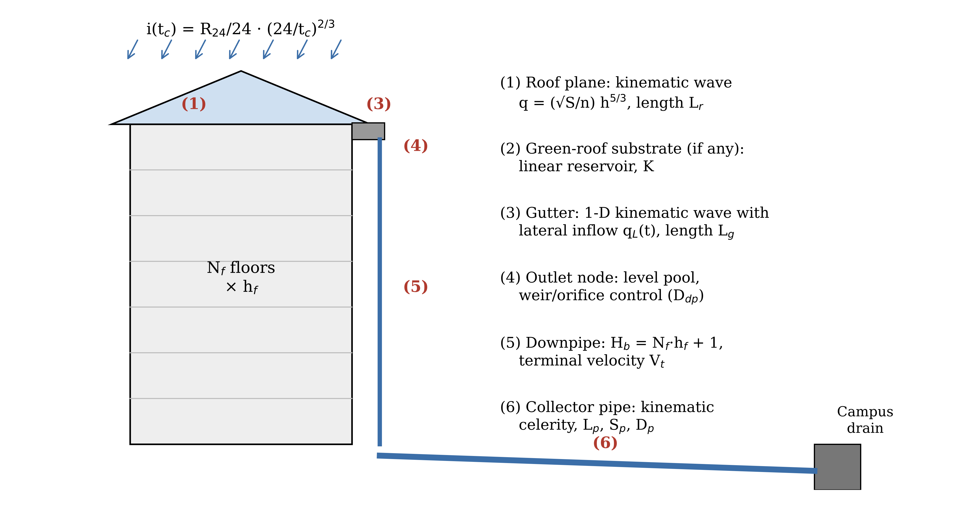
Fig. 1. Building drainage cascade represented by the reference simulator. Rainfall intensity i depends on t_{c} through the Mononobe relation, so t_{c} is obtained by fixed-point iteration. Numbers in brackets identify the six components described in Section 2.3.

2.2. Design rainfall
Design rainfall was derived from annual maximum daily rainfall recorded at the hydrology laboratory station of Universitas Brawijaya, Malang, Indonesia, for 2005–2024 (n = 20; mean = 107.8 mm, standard deviation = 34.2 mm). The series passed the rescaled adjusted partial sums (RAPS) consistency test (Q/√n = 0.752; R/√n = 1.066). The Gumbel distribution was rejected because the sample skewness (Cs = 2.00) and kurtosis (Ck = 8.68) departed from its theoretical values of 1.14 and 5.40. The log-Pearson type III distribution (log-space Cs = 0.827) passed both the Kolmogorov–Smirnov test (Δmax = 0.199 < Δcr = 0.294 at α = 0.05) and the chi-square test (χ² = 3.4 < χ²cr = 7.815) and was adopted. The resulting design daily rainfalls R₂₄ were 99.8, 128.6, 150.1, 172.8, 180.4 and 205.2 mm for return periods T = 2, 5, 10, 20, 25 and 50 years, respectively.
Rainfall intensity for a storm of duration t_{c} was computed with the Mononobe relation used in Indonesian design practice (Sosrodarsono and Takeda, 2003; BSN, 2016):
i = (R₂₄ / 24) · (24 / t_{d})^(2/3), t_{d} = max(t_{c}, 5 min) (1)
where i is in mm h⁻¹, R₂₄ in mm and t_{d} in hours. The 5-min lower bound on storm duration follows common design convention and prevents the unrealistic intensities that Eq. (1) yields at durations of 1–2 min. A uniform excess intensity equal to i was applied to the roof after depression storage had been satisfied; t_{c} is therefore measured from the onset of runoff.

2.3. Reference simulator of the building drainage cascade
Each building was idealised as a rectangular roof of plan area A_{roof} and aspect ratio r, drained by two parallel eaves or parapet gutters along its long sides (Fig. 1). The number of roof outlets N_{dp} was set by the roof area served per downpipe, a_{dp}, rounded up to an even number so that outlets were distributed symmetrically. Each outlet therefore receives flow from two gutter runs of length L_{g} = B/N_{dp}, where B is the long side of the roof, and each gutter run receives lateral inflow from a roof plane of slope length L_{r} = (W/2)(1 + S_{roof}²)^0.5, where W is the short side. The cascade consists of six components, simulated in sequence.
(1) Roof plane. Overland flow was described by the kinematic-wave approximation with Manning friction, q = αh^m, α = S_{roof}^0.5/n_{roof} and m = 5/3 (Woolhiser and Liggett, 1967). For a constant excess intensity the rising limb has the exact solution q(L_{r}, t) = α(it)^m for t < t_{e} and q = iL_{r} thereafter, with equilibrium time t_{e} = [L_{r}/(α i^(m−1))]^(1/m). This analytical solution, which is the basis of the Ragan and Duru (1972) nomograph, was used without discretisation.
(2) Green-roof substrate. For extensive green roofs, detention in the substrate and drainage layer was represented by a linear reservoir with storage constant K (120–600 s), in line with the storage-routing interpretation of green-roof detention (Stovin et al., 2012; Vesuviano et al., 2014). Initial retention was treated as part of depression storage.
(3) Gutter. Flow in each rectangular gutter of width b_{g}, depth d_{g}, slope S_{g} and Manning coefficient n_{g} = 0.013 was solved with the one-dimensional kinematic-wave equation with time-varying lateral inflow, ∂A/∂t + ∂Q/∂x = q_{L}(t), discretised with a first-order explicit upwind finite-volume scheme on 30 cells (Courant number 0.8 based on the equilibrium celerity). A grid-convergence test on 300 configurations showed that the outlet response time with 30 cells differed from a 120-cell solution by a median of 0.14% (95th percentile 0.58%).
(4) Roof outlet. The outlet was modelled as a level-pool node with a ponding area equal to b_{g}L_{g}, representing the backwater wedge in the two gutter runs, and with outflow controlled by the smaller of the weir discharge 1.6πD_{dp}H^1.5 and the orifice discharge 0.6(πD_{dp}²/4)(2gH)^0.5, following the logic of BS EN 12056-3 (CEN, 2000). The node equation was integrated implicitly with Newton iterations. Configurations in which the node head exceeded the gutter depth, or the equilibrium gutter depth exceeded d_{g}, were classed as hydraulically inadequate and excluded, because t_{c} is not defined when part of the runoff overflows the system.
(5) Downpipe. The vertical drop height was H_{b} = N_{f}·h_{f} + 1 m, where N_{f} is the number of floors and h_{f} the floor-to-floor height. The travel time through the downpipe was computed from the terminal velocity of annular flow, V_{t} = 10.07(Q_{d}/D_{dp})^0.4 with Q_{d} in L s⁻¹ and D_{dp} in mm, and the terminal length L_{t} = 0.1706V_{t}², which are SI conversions of the Wyly and Eaton (1961) relations.
(6) Collector pipe. Flow from all downpipes was conveyed by a horizontal collector of length L_{p}, slope S_{p} and Manning coefficient n_{p} = 0.012 to the site drain. The collector diameter D_{p} was the smallest commercial size whose full-bore capacity exceeded the 5-min design flow multiplied by a sizing factor of 0.7–1.3, so that the library included both generously sized and slightly surcharged collectors. The travel time was L_{p}/c, where c = dQ/dA is the kinematic celerity of the part-full circular section; for surcharged pipes the bulk velocity Q/A_{full} was used.
The reference t_{c} was defined as the time at which the discharge leaving the outlet node reached 95% of its equilibrium value, plus the downpipe and collector travel times. Because the intensity in Eq. (1) depends on t_{c}, the simulator was embedded in a fixed-point problem t_{c} = G[i(t_{c})], which was solved by a damped secant iteration in log space. Of the 6000 configurations, 5998 converged to a relative residual below 0.2% and the remaining two were solved by bisection, exploiting the monotonicity of G.

2.4. Building configuration library
Sixteen continuous or discrete design variables were sampled by Latin hypercube sampling (McKay et al., 1979; Table 1). Roof type was drawn as a categorical variable with probabilities of 0.40 (flat concrete), 0.30 (metal sheet), 0.15 (clay tile) and 0.15 (extensive green), and roof slope and roughness were sampled within type-specific ranges. Roof area was sampled log-uniformly between 300 and 6000 m², and the number of floors between 2 and 30. Of the 6000 configurations, 220 (3.7%) were hydraulically inadequate, leaving 5780 configurations for model development.
Table 1. Design variables and sampling ranges of the building configuration library.
Variable | Symbol | Range or levels | Unit
Number of floors | N_{f} | 2–30 (integer) | –
Floor-to-floor height | h_{f} | 3.2–4.5 | m
Roof plan area | A_{roof} | 300–6000 (log-uniform) | m²
Roof aspect ratio | r | 1–4 | –
Roof type | – | Flat concrete / metal sheet / clay tile / extensive green | –
Roof slope | S_{roof} | 0.01–0.03 / 0.09–0.36 / 0.36–0.70 / 0.01–0.05 | m m⁻¹
Roof Manning coefficient | n_{roof} | 0.012–0.016 / 0.010–0.013 / 0.016–0.024 / 0.15–0.35 | s m^{−1/3}
Green-roof storage constant | K | 120–600 (green roofs only) | s
Roof area per downpipe | a_{dp} | 30–150 | m²
Outlet/downpipe diameter | D_{dp} | 100, 125, 150 | mm
Gutter width | b_{g} | 0.15–0.40 | m
Gutter depth | d_{g} | 0.15–0.30 | m
Gutter slope | S_{g} | 0.002–0.010 | m m⁻¹
Collector length | L_{p} | 5–100 | m
Collector slope | S_{p} | 0.005–0.020 | m m⁻¹
Collector diameter | D_{p} | 200–1000 (sized for 0.7–1.3 × 5-min design flow) | mm
Design daily rainfall | R₂₄ | 99.8–205.2 (T = 2–50 years) | mm
Roof slope and roughness ranges are listed in the order flat concrete / metal sheet / clay tile / extensive green. Roof-type probabilities were 0.40, 0.30, 0.15 and 0.15.

2.5. Conventional time-of-concentration methods
Three conventional methods representative of current practice were applied to every configuration. (a) Kirpich (1940): t_{c} = 0.0195L^0.77S^−0.385 (min, L in m), with L the total flow path L_{r} + L_{g} + H_{b} + L_{p} and S the mean slope of that path. (b) Kerby–Manning: the Kerby (1959) overland time t₀ = 1.44(L_{r}N/S_{roof}^0.5)^0.467 (min), with retardance N = 0.02 for smooth roofs, 0.10 for tiles and 0.40 for vegetated roofs, plus channel travel times L_{g}/V_{g} and L_{p}/V_{p} from Manning velocities at bankfull and full-bore conditions and a downpipe time H_{b}/(3 m s⁻¹). This sum mirrors the t₀ + t_{d} procedure common in Indonesian urban drainage texts (Suripin, 2004). (c) Kinematic-wave component sum (KW): the analytical roof equilibrium time plus gutter and collector travel times at equilibrium flow and the Wyly–Eaton downpipe time, iterated with Eq. (1). Method (c) shares the physics of the reference simulator but neglects the dynamic interaction between the rising roof hydrograph and the gutter, outlet storage and substrate detention.

2.6. Machine learning models
Six algorithms were compared: multiple linear regression on log-transformed variables (MLR), which yields an explicit power-law equation; support vector regression with a radial basis kernel (SVR; Drucker et al., 1997); a multilayer perceptron (ANN); random forest (RF; Breiman, 2001); extreme gradient boosting (XGBoost; Chen and Guestrin, 2016); and LightGBM (Ke et al., 2017). All models predicted ln t_{c} from the 16 design variables plus four one-hot roof-type indicators. Each algorithm was trained in two forms: a purely data-driven form, and a hybrid form in which the logarithm of the KW estimate was added as a 21st input. The hybrid form tests whether a cheap physics-based estimate helps ML to learn the residual behaviour of the cascade.
The dataset was split into training (80%) and test (20%) subsets, stratified by roof type. Hyperparameters were tuned on the training subset by randomised search (25 candidates) with five-fold cross-validation, minimising the root mean square error (RMSE) of ln t_{c}. Inputs to SVR and ANN were standardised. All computations used Python 3 with NumPy, scikit-learn 1.9 (Pedregosa et al., 2011), XGBoost 3.4, LightGBM 4.7 and SHAP 0.54.

2.7. Performance evaluation and interpretation
Predictions were back-transformed to minutes and evaluated with the coefficient of determination (R²), Nash–Sutcliffe efficiency (NSE; Nash and Sutcliffe, 1970), Kling–Gupta efficiency (KGE; Gupta et al., 2009), RMSE, mean absolute error (MAE), mean absolute percentage error (MAPE), percent bias (PBIAS) and the share of predictions within ±10% of the reference (W10). Rating thresholds followed Moriasi et al. (2007). Differences in absolute error between the best ML models and the KW method were tested with the two-sided Wilcoxon signed-rank test.
Generalisation was examined with three block-wise extrapolation tests (Roberts et al., 2017): training on buildings with N_{f} ≤ 15 and testing on N_{f} ≥ 16; training on T ≤ 10 years and testing on T ≥ 20 years; and training on A_{roof} ≤ 2500 m² and testing on larger roofs. A learning curve was computed by training on random subsets of 100 to 4624 configurations (three repetitions). The best purely data-driven tree model was interpreted with TreeSHAP (Lundberg et al., 2020). Finally, the effect of t_{c} errors on design peak discharge was quantified through Eq. (1): for a given runoff coefficient and area, the relative error in the rational-method peak equals the relative error in i(t_{d}). This propagation was evaluated both with the 5-min duration floor and with a 1-min floor, to separate the effect of the convention from the effect of the t_{c} estimate.

3. Results

3.1. Reference time of concentration of the building library
The converged design intensities ranged from 45.5 to 372.8 mm h⁻¹ (median 272.8 mm h⁻¹). Reference t_{c} ranged from 0.57 to 42.7 min (median 1.9 min) and was strongly bimodal (Fig. 2a). Impervious roofs responded within minutes: median t_{c} was 1.99 min for flat concrete roofs (5th–95th percentile 1.33–3.25 min), 1.55 min for metal roofs (0.93–2.88 min) and 1.57 min for clay-tile roofs (0.97–3.17 min). Extensive green roofs were an order of magnitude slower, with a median of 24.1 min (11.9–35.4 min). Consequently, 99.5% of impervious-roof configurations, but none of the green-roof configurations, had t_{c} shorter than the 5-min minimum design duration. Outlet or gutter overflow eliminated 3.4%, 3.8% and 7.7% of the flat, metal and tile configurations, respectively, and none of the green roofs, whose detention attenuated the inflow to the outlets.
For impervious roofs, the response of the roof–gutter–outlet subsystem was 1.51 times the analytical roof equilibrium time at the median (5th–95th percentile 1.02–5.58), showing that gutter routing and outlet ponding can more than double the roof response. The vertical drop added a systematic height effect (Fig. 2b, c). In buildings with 2–5 floors, the roof–gutter–outlet subsystem, the downpipe and the collector contributed on average 66.8%, 6.6% and 26.6% of t_{c}; in buildings with 26–30 floors, the corresponding shares were 49.4%, 32.1% and 18.5%. The median downpipe travel time increased from 5.3 s to 37.4 s, and the median impervious-roof t_{c} increased from 1.51 to 2.05 min. The Spearman rank correlation between the number of floors and t_{c} for impervious roofs was 0.34, indicating that height is a real but secondary control. Collectors were surcharged in 12.5% of configurations.
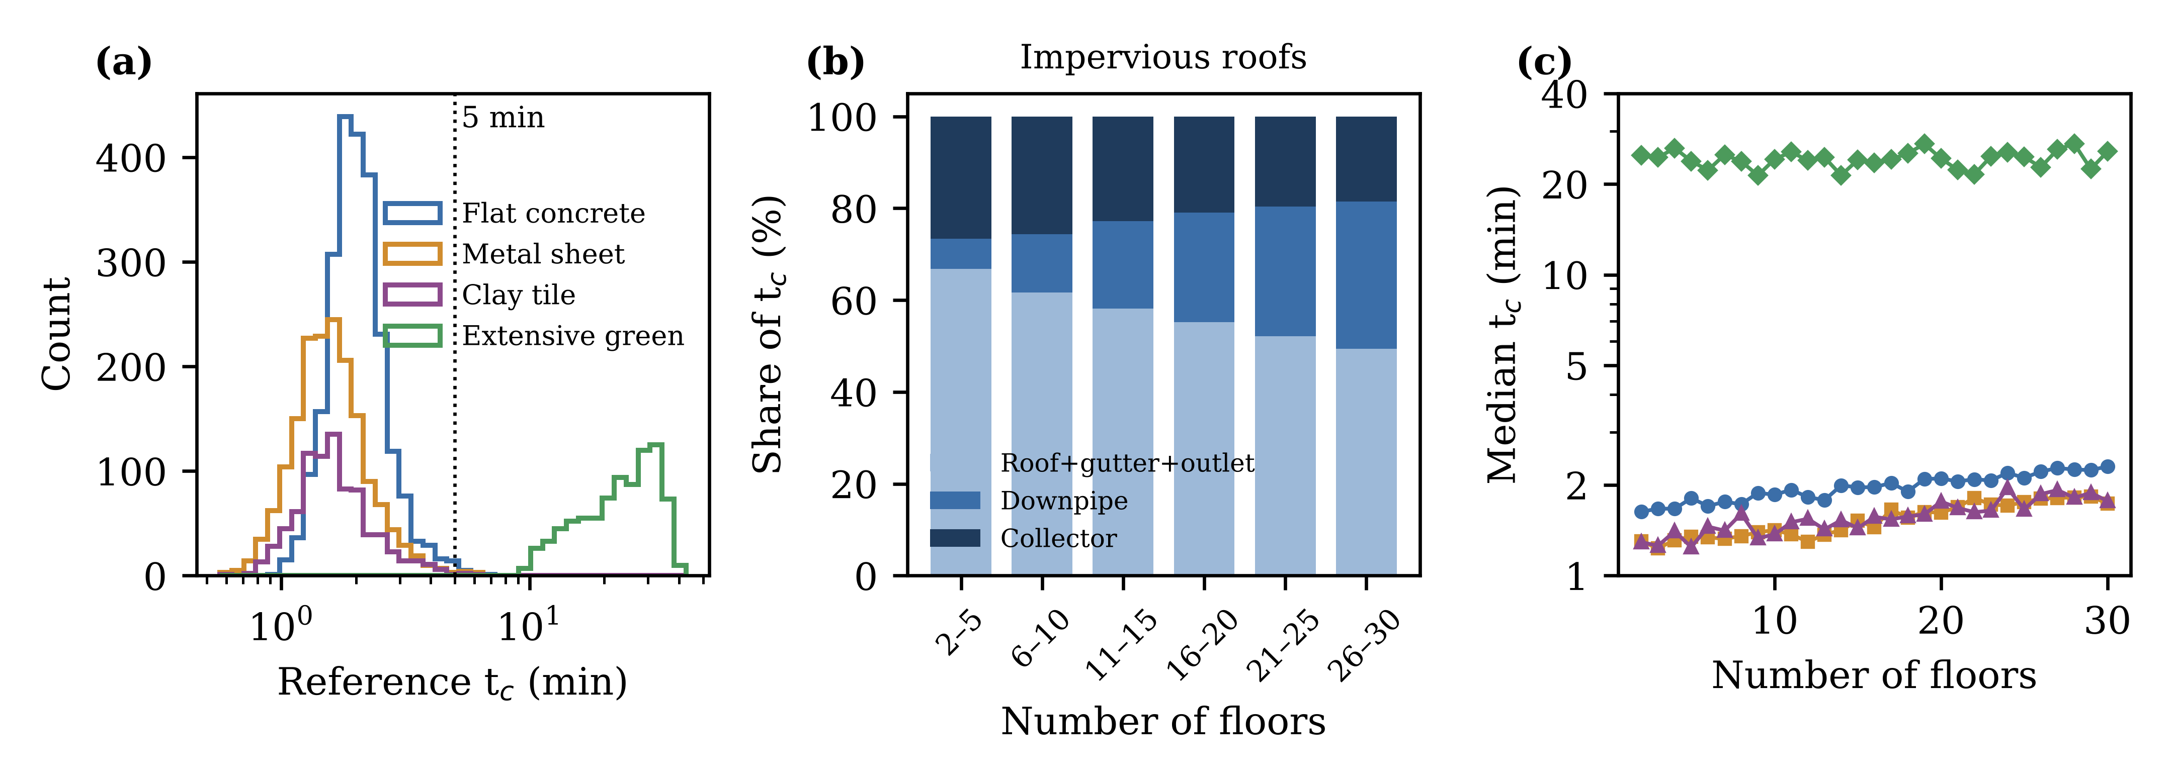
Fig. 2. Characteristics of the reference dataset (n = 5780). (a) Distribution of reference t_{c} by roof type; the dotted line marks the 5-min minimum design duration. (b) Mean contribution of the roof–gutter–outlet subsystem, downpipe and collector to t_{c} for impervious roofs, by number of floors. (c) Median t_{c} by number of floors and roof type (colours as in panel a).

3.2. Performance of conventional methods
All three conventional methods performed unsatisfactorily on the test set (Table 2; Fig. 3). The Kirpich formula had NSE = -0.234 and PBIAS = -77.8%: when applied to the full flow path, the vertical drop of the downpipe dominated the mean slope and the formula returned values near 1 min regardless of roof type. The Kerby–Manning sum (NSE = 0.350, MAPE = 52.4%) overestimated impervious-roof t_{c} (median bias +46.5%, +34.3% and +85.7% for flat, metal and tile roofs) and underestimated green-roof t_{c} (−66.5%). The kinematic-wave component sum had the smallest MAPE among conventional methods (22.9%) and placed 52.5% of predictions within ±10%, but its NSE was only 0.196. This apparent contradiction reflects a split performance: for impervious roofs the median bias was only −0.5% (flat), −6.6% (metal) and −7.1% (tile), with MAPE of 11.5–16.9%, whereas for green roofs t_{c} was underestimated by 76.2% (MAPE = 72.5%), because the method ignores substrate detention. Since green roofs contain the largest t_{c} values, they dominate the squared-error metrics.
Table 2. Performance of conventional methods and machine learning models on the independent test set (n = 1156).
Method | R² | NSE | KGE | RMSE (min) | MAE (min) | MAPE (%) | PBIAS (%) | W10 (%)
Kirpich | 0.000 | -0.234 | -0.598 | 9.14 | 3.98 | 45.9 | -77.8 | 6.4
Kerby–Manning | 0.783 | 0.350 | 0.180 | 6.64 | 3.00 | 52.4 | -33.3 | 8.1
KW component sum | 0.709 | 0.196 | 0.024 | 7.38 | 2.89 | 22.9 | -55.7 | 52.5
MLR | 0.937 | 0.935 | 0.962 | 2.10 | 0.84 | 14.7 | -1.5 | 42.0
SVR | 0.996 | 0.996 | 0.997 | 0.50 | 0.24 | 5.6 | -0.2 | 85.5
ANN | 0.992 | 0.992 | 0.989 | 0.73 | 0.31 | 6.6 | -0.9 | 80.2
RF | 0.995 | 0.995 | 0.984 | 0.56 | 0.30 | 8.7 | -1.3 | 67.7
XGBoost | 0.997 | 0.997 | 0.991 | 0.44 | 0.20 | 5.9 | -0.9 | 82.9
LightGBM | 0.998 | 0.998 | 0.992 | 0.39 | 0.21 | 5.6 | -0.7 | 84.6
MLR (hybrid) | 0.943 | 0.937 | 0.939 | 2.07 | 0.78 | 12.4 | -0.1 | 48.9
SVR (hybrid) | 0.997 | 0.997 | 0.997 | 0.45 | 0.22 | 5.2 | -0.1 | 88.1
ANN (hybrid) | 0.996 | 0.995 | 0.968 | 0.57 | 0.27 | 5.8 | -1.7 | 85.0
RF (hybrid) | 0.998 | 0.998 | 0.992 | 0.36 | 0.19 | 6.2 | -0.7 | 82.0
XGBoost (hybrid) | 0.998 | 0.998 | 0.988 | 0.37 | 0.16 | 4.7 | -0.9 | 88.2
LightGBM (hybrid) | 0.998 | 0.998 | 0.994 | 0.38 | 0.17 | 4.6 | -0.5 | 88.5
KW = kinematic-wave component sum; MLR = multiple linear regression on log-transformed variables; SVR = support vector regression; ANN = multilayer perceptron; RF = random forest. Hybrid models received ln t_{c,KW} as an additional input. W10 = share of predictions within ±10% of the reference value. Best values are those of LightGBM (hybrid).

3.3. Performance of machine learning models
All ML models outperformed the conventional methods (Table 2). The explicit power-law MLR reached NSE = 0.935 but retained a MAPE of 14.7%, with a visible curvature of residuals for impervious roofs (Fig. 3), because the response of the cascade is not a single power law. The nonlinear learners achieved NSE ≥ 0.992. Among the purely data-driven models, LightGBM gave the lowest RMSE (0.39 min; NSE = 0.998) and SVR the lowest MAPE (5.6%). Adding the kinematic-wave estimate improved every algorithm: MAPE decreased by 0.4–2.5 percentage points and W10 increased by 3–14 percentage points. Hybrid LightGBM had the best overall performance (NSE = 0.998, KGE = 0.994, RMSE = 0.38 min, MAPE = 4.6%, PBIAS = -0.46%, W10 = 88.5%), followed closely by hybrid XGBoost (MAPE = 4.7%). The absolute errors of both hybrid models were significantly smaller than those of the kinematic-wave sum (Wilcoxon signed-rank test, p < 0.001).
Accuracy was consistent across roof types. Hybrid LightGBM had MAPE of 4.0%, 5.6%, 6.4% and 2.6% for flat, metal, tile and green roofs, respectively, compared with 11.5%, 16.9%, 16.9% and 72.5% for the kinematic-wave sum. Within individual impervious roof types, where the range of t_{c} is narrow, the hybrid model still explained 92–93% of the variance (NSE = 0.916–0.931), whereas the kinematic-wave sum had negative within-type NSE (−0.047 to 0.080). The tuned hyperparameters are listed in Table A1.
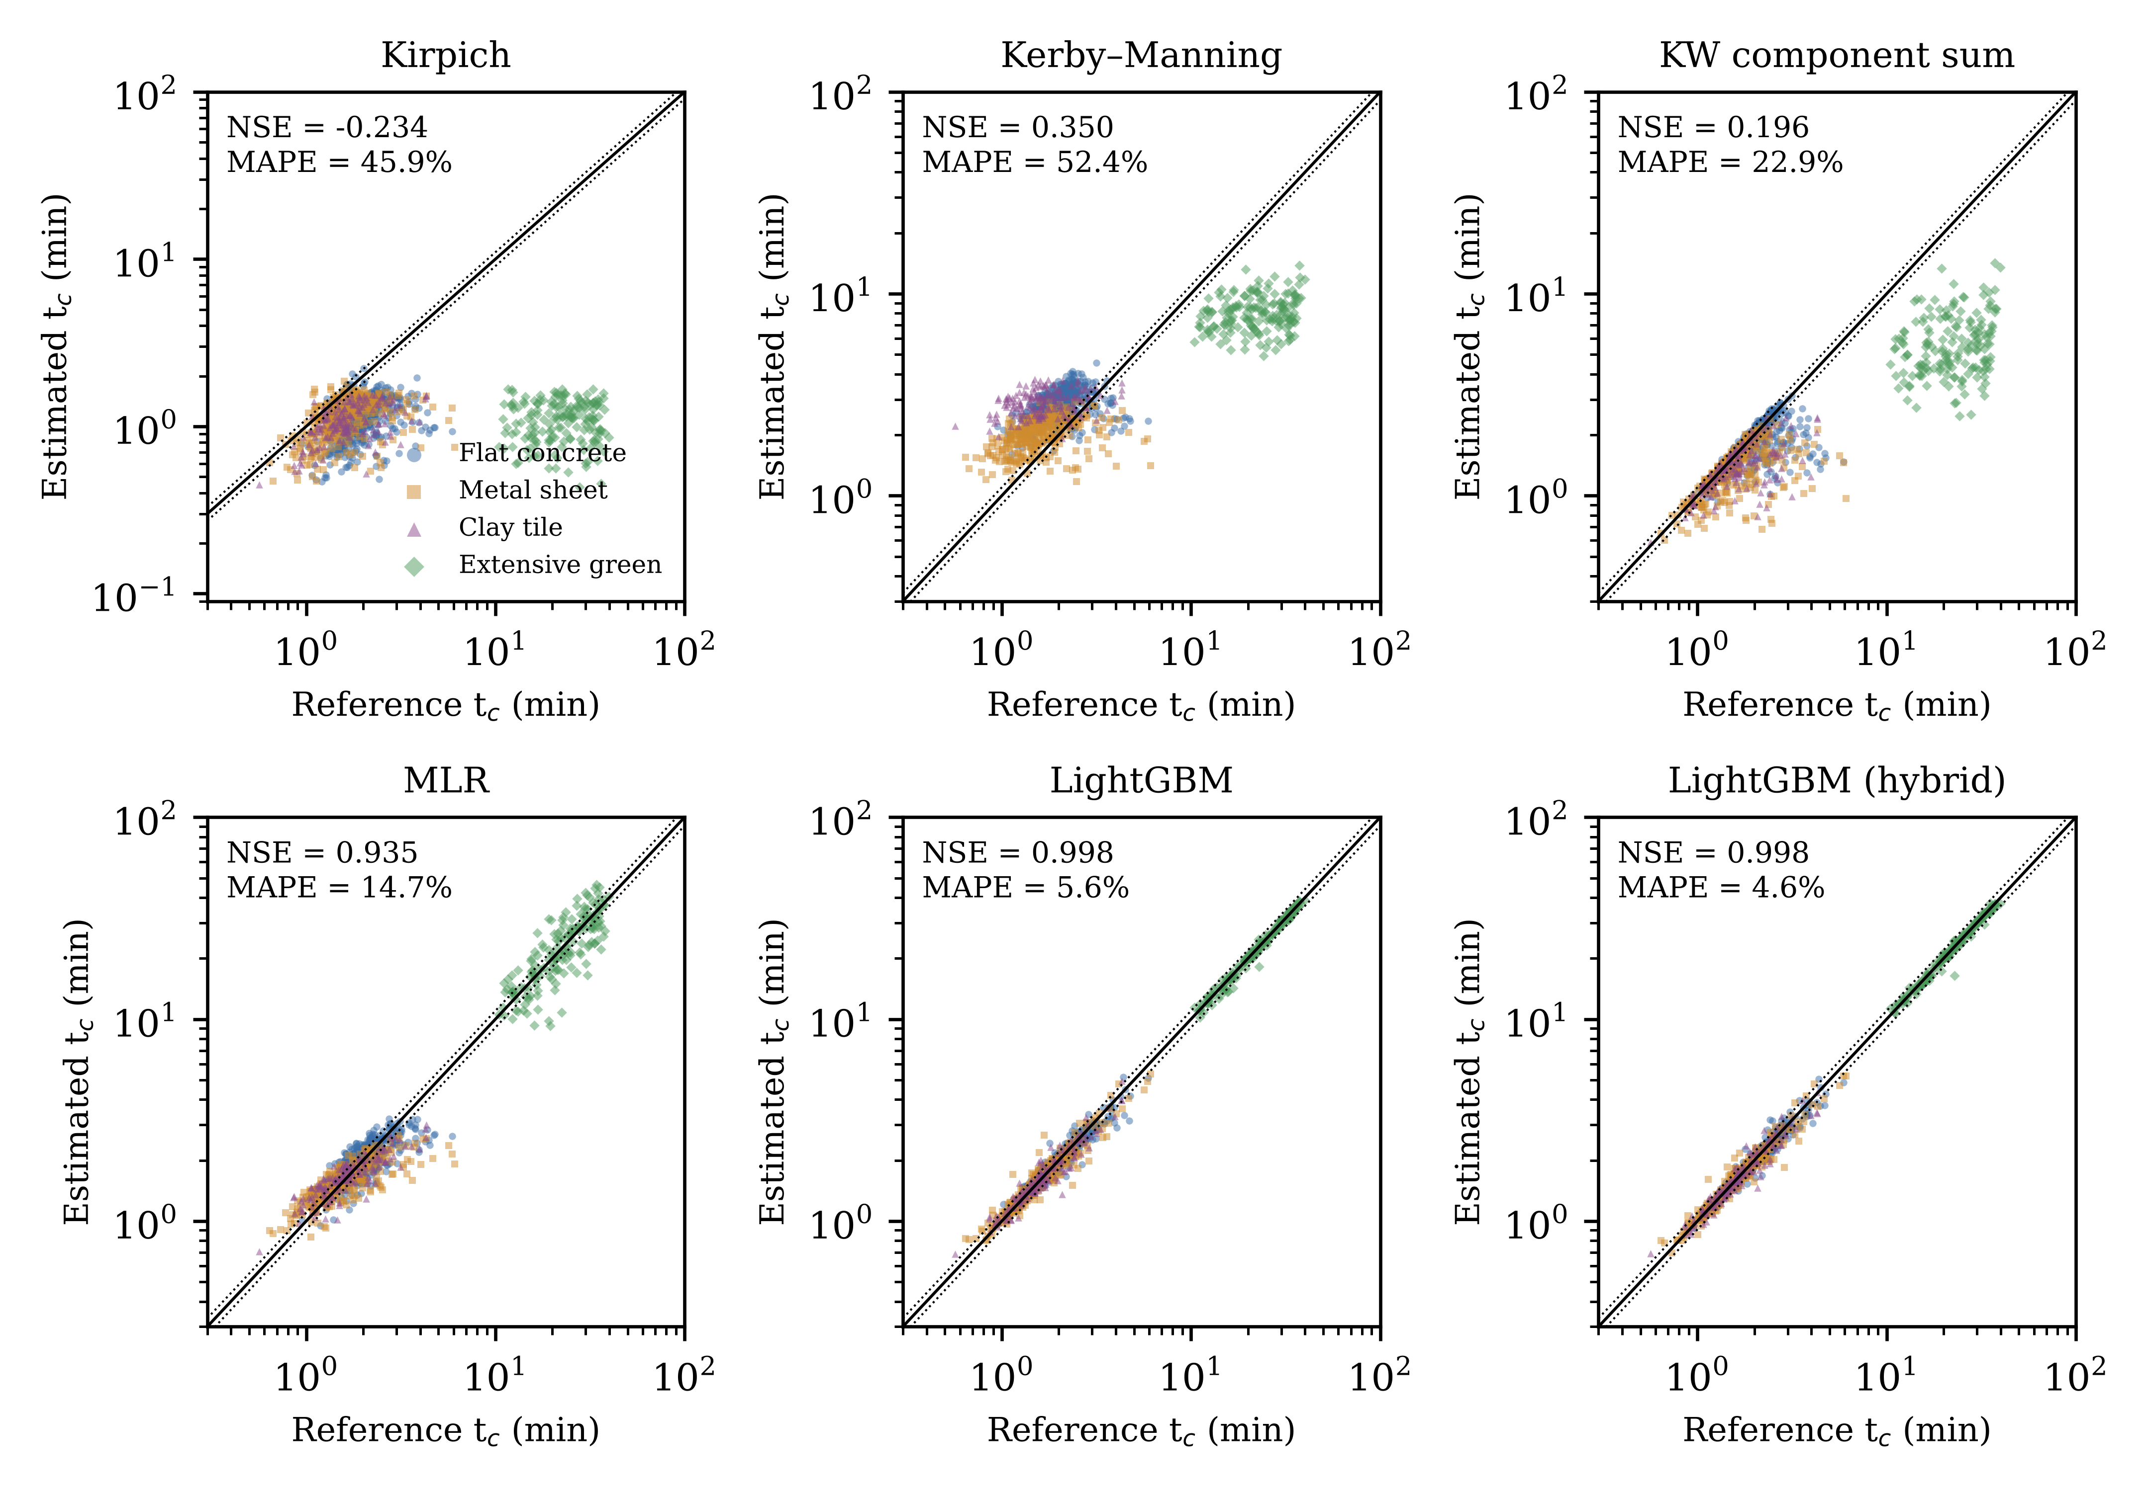
Fig. 3. Estimated versus reference t_{c} on the test set for three conventional methods and three ML models. Solid line, 1:1; dotted lines, ±10%. Note the logarithmic axes; the Kirpich panel has an extended lower limit.

3.4. Extrapolation and data requirements
Block-wise extrapolation revealed a clear advantage of the hybrid form (Table 3). When models were trained on buildings with up to 15 floors and tested on buildings with 16–30 floors, the purely data-driven LightGBM retained a high NSE (0.997) but its MAPE doubled to 10.8% and only 51.6% of predictions fell within ±10%, with a systematic underestimation (PBIAS = -4.5%). Tree ensembles cannot extrapolate the downpipe travel time beyond the largest height seen during training. The hybrid LightGBM, which receives a physically extrapolated estimate, kept its MAPE at 5.0% and W10 at 87.6%. Similar but smaller gains occurred for rarer storms (MAPE 9.3% versus 6.8%) and for larger roofs (7.5% versus 5.0%). The MLR remained near 14–15% in all tests but developed a bias of -12.9% for large roofs.
Table 3. Block-wise extrapolation tests: NSE, MAPE (%) and W10 (%) on the held-out block.
Method | Height NSE | MAPE | W10 | Return period NSE | MAPE | W10 | Roof size NSE | MAPE | W10
KW component sum | 0.195 | 21.2 | 55.4 | 0.156 | 24.1 | 48.4 | 0.293 | 17.9 | 63.8
MLR | 0.910 | 14.3 | 45.1 | 0.945 | 15.4 | 38.4 | 0.918 | 14.8 | 43.6
XGBoost | 0.997 | 10.9 | 50.5 | 0.995 | 9.9 | 59.4 | 0.994 | 7.4 | 72.7
XGBoost (hybrid) | 0.998 | 4.8 | 88.8 | 0.996 | 7.0 | 77.7 | 0.997 | 5.4 | 84.6
LightGBM | 0.997 | 10.8 | 51.6 | 0.996 | 9.3 | 61.8 | 0.993 | 7.5 | 72.3
LightGBM (hybrid) | 0.998 | 5.0 | 87.6 | 0.997 | 6.8 | 76.8 | 0.997 | 5.0 | 86.3
Columns 2–4: trained on N_{f} ≤ 15 (n = 2792), tested on N_{f} ≥ 16 (n = 2988). Columns 5–7: trained on T ≤ 10 years (n = 2978), tested on T ≥ 20 years (n = 2802). Columns 8–10: trained on A_{roof} ≤ 2500 m² (n = 4114), tested on larger roofs (n = 1666). Hyperparameters were those tuned in Section 2.6.
The learning curves (Fig. 5c) show that the tree ensembles needed about 500 training configurations to reach a MAPE near 10% and continued to improve up to the full training set. With only 100 samples, XGBoost (MAPE = 19.4%) and even MLR (17.1%) outperformed LightGBM (31.6%) and the ANN (84.9%). The hybrid LightGBM overtook its purely data-driven counterpart from 250 samples onwards and reached 5.5% at 2000 samples, close to its final value of 4.6%.

3.5. Controls on building time of concentration
SHAP analysis of the purely data-driven LightGBM (Fig. 4) identified the green-roof storage constant K as the dominant variable (mean |SHAP| = 0.533 in ln t_{c} units), which encodes both the presence of a green roof and the strength of its detention. Below it, six variables had similar importance: collector length L_{p} (0.092), roof slope S_{roof} (0.091), outlet diameter D_{dp} (0.088), number of floors N_{f} (0.081), roof area per downpipe a_{dp} (0.081) and roof roughness n_{roof} (0.065). Roof area (0.023), design rainfall R₂₄ (0.020), floor height (0.015) and gutter slope (0.005) were minor. The weak influence of R₂₄ follows from the 5-min duration floor, which fixes the design intensity for most impervious roofs.
The dependence plots clarify the mechanisms (Fig. 5a, b). The SHAP contribution of N_{f} increased almost linearly from about −0.2 to +0.2 across 2–30 floors, which corresponds to a factor of about 1.5 in t_{c}, and was flatter for green roofs, where the downpipe time is small relative to substrate detention. The contribution of a_{dp} was negative below about 80 m² and rose steeply above about 100 m², most strongly for 100-mm outlets. This interaction reflects outlet ponding: when each outlet serves a large area through a small diameter, the head required to pass the inflow increases and the ponded gutter volume delays the response.
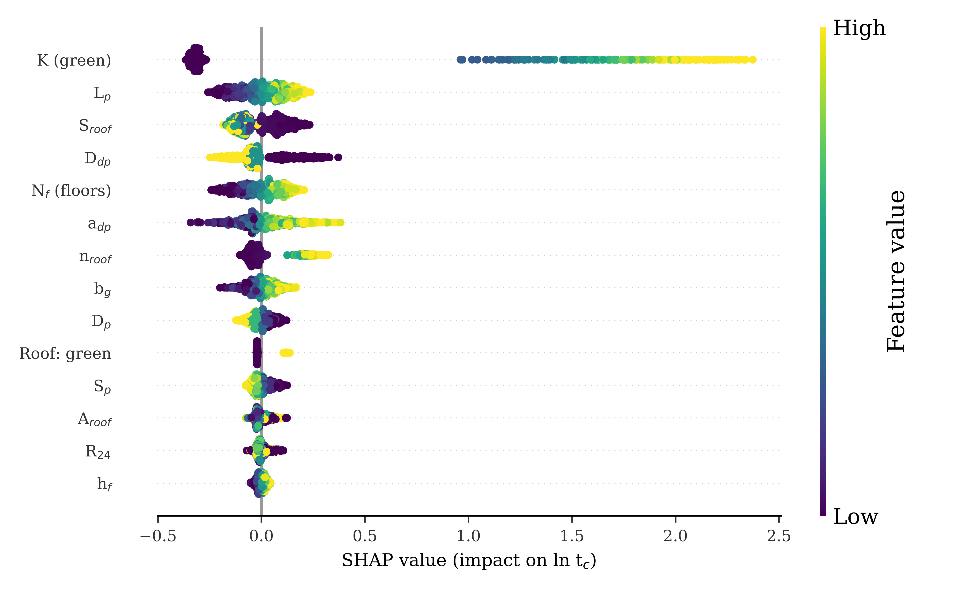
Fig. 4. SHAP summary of the purely data-driven LightGBM model on the test set. Each point is one configuration; colour shows the value of the input variable and the horizontal position its contribution to ln t_{c}. Variables are ranked by mean absolute SHAP value.
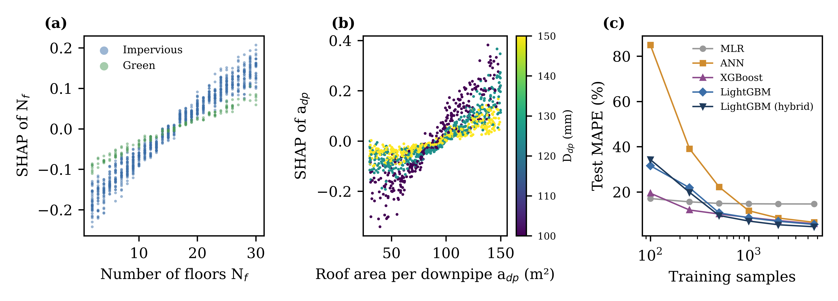
Fig. 5. (a) SHAP dependence of the number of floors, separated by impervious and green roofs. (b) SHAP dependence of the roof area per downpipe, coloured by outlet diameter. (c) Learning curves: test MAPE versus number of training configurations (mean of three random subsets below the full training set).

3.6. Consequences for design peak discharge
Because the rational-method peak is proportional to i(t_{d}), the t_{c} errors translate into peak-discharge errors through Eq. (1). With the 5-min duration floor, errors for impervious roofs were negligible for every method (mean absolute error ≤ 0.05%), because both the reference and the estimated t_{c} were mostly below 5 min. For green roofs, however, the underestimation of t_{c} by conventional methods translated into mean overestimates of the peak of 177% (Kirpich), 103% (Kerby–Manning) and 144% (kinematic-wave sum), against 0.3% for hybrid LightGBM. Over the whole test set, the mean absolute peak error was 21.4% for the kinematic-wave sum and 0.29% for hybrid LightGBM. When the duration floor was lowered to 1 min, so that t_{c} governed intensity for all roofs, the mean absolute peak error rose to 125% (Kirpich), 35% (Kerby–Manning) and 36% (kinematic-wave sum), compared with 3.0% for hybrid LightGBM (95th percentile 9.9%).

4. Discussion

4.1. Why conventional formulas fail at the building scale
The results confirm, at the scale of a single building, the long-standing concern that t_{c} formulas transferred outside their calibration domain produce large and systematic errors (McCuen et al., 1984; Gericke and Smithers, 2014; Grimaldi et al., 2012). Two failure modes were distinct. The first is structural: the Kirpich formula collapses the cascade into a single path whose mean slope is dominated by the vertical downpipe, so that its estimates depend on building height in the wrong way and ignore roof roughness entirely. The second is the omission of storage. The kinematic-wave sum shares the physics of the reference simulator for the roof and conduits and is unbiased within about 7% for impervious roofs, consistent with the good performance of kinematic-wave formulas for smooth planes (Ragan and Duru, 1972; Wong, 2005). It nevertheless underestimated green-roof t_{c} by three quarters because substrate detention, which is the hydrological purpose of a green roof (Berndtsson, 2010; Stovin et al., 2012), is absent from every overland-flow formula. The Kerby retardance coefficient partly compensates for vegetation, but a single coefficient cannot represent a storage process, and the Kerby–Manning sum consequently overestimated impervious roofs and underestimated green roofs at the same time.
A subtler finding concerns outlet hydraulics. Even for impervious roofs, the roof–gutter–outlet subsystem responded on average 1.5 times more slowly than the roof alone, and up to 5.6 times more slowly when outlets were small relative to the area they served. Building codes treat the outlet as a capacity check (CEN, 2000), but our results show that it is also a timing element: ponding behind a weir- or orifice-controlled outlet introduces storage that delays the approach to equilibrium. The SHAP interaction between a_{dp} and D_{dp} (Fig. 5b) captures exactly this effect, and it is the main reason why the purely physics-based component sum, which neglects outlet storage, retained errors of 11–17% for impervious roofs.

4.2. Value of the physics-guided hybrid
On the in-distribution test set, all nonlinear learners were accurate, and the improvement offered by the hybrid input was modest (MAPE 5.6% to 4.6% for LightGBM). The decisive benefit appeared under extrapolation. Tree ensembles predict piecewise-constant functions and cannot represent the continued growth of downpipe travel time beyond the tallest building seen in training; the purely data-driven LightGBM therefore underestimated the t_{c} of tall buildings and its W10 dropped to 52%. Providing the kinematic-wave estimate as an input converts the learning problem into the correction of a physically extrapolating baseline, and W10 stayed near 88%. This behaviour is consistent with the broader argument that hybrid and physics-guided formulations improve the robustness of ML in hydrology (Razavi et al., 2012; Shen, 2018; Xu and Liang, 2021). For practice, the implication is that a building-scale t_{c} model should not be used as a pure black box for buildings taller, roofs larger or storms rarer than those in its training library, unless a physical baseline is part of its input.
The explicit MLR equation (Table A2) is less accurate (MAPE ≈ 15%) but transparent and usable without software. Its exponents are physically plausible: t_{c} increases with the number of floors (exponent 0.13), roof roughness (0.16), area per downpipe (0.19) and collector length (0.16), and decreases with outlet diameter (−0.58), collector diameter (−0.29) and roof slope (−0.07). The small roof-slope exponent, compared with the theoretical −0.3 of the kinematic-wave plane solution, reflects the fact that roof flow accounts for only part of the building t_{c}. The equation is suitable for preliminary design; the hybrid model is preferable when accuracy matters.

4.3. Implications for urban drainage design
With the 5-min minimum duration conventionally used with the Mononobe relation, almost all impervious-roof configurations fall below the floor, so their design peak discharge is insensitive to t_{c} estimation. This result should not be read as evidence that building t_{c} is unimportant. First, green roofs are increasingly promoted in Indonesian cities, and for them conventional formulas overestimated the design peak by a factor of two to almost three, which would lead to oversized downstream conduits and an underestimate of the detention benefit. Second, building t_{c} enters catchment-scale models as a lag that controls when each building's hydrograph reaches the street or campus network. In the Rasional–Jalibri model developed for the Universitas Brawijaya Veteran campus, the contributing area expands with time, and the timing of building contributions determines when the critical downstream outfalls approach capacity. A building t_{c} that is wrong by a factor of two shifts this timing accordingly. Third, the height effect is not negligible for tall buildings: the downpipe accounted for about one third of t_{c} above 25 floors, an element absent from all overland-flow formulas. Finally, if design practice moves towards shorter minimum durations or sub-hourly IDF curves derived from high-resolution rainfall, the 30–125% mean peak errors of conventional methods found with a 1-min floor would become directly relevant to pipe sizing.

4.4. Limitations and future work
The main limitation is that the reference values come from a process-based simulator rather than field observations; the ML models therefore reproduce the simulator, and their accuracy relative to real buildings is bounded by the simulator's adequacy. The simulator rests on established components (Woolhiser and Liggett, 1967; Wyly and Eaton, 1961; CEN, 2000), passed a grid-convergence test, and the analytical roof solution is exact for kinematic flow, but several simplifications remain: uniform rainfall without wind-driven rain on façades, a level-pool representation of gutter backwater, a linear-reservoir substrate, gravity rather than siphonic outlets, and identical outlets on a symmetric rectangular roof. Stepped roofs, podium–tower layouts and balconies draining into the same stack were not represented. The rainfall analysis used a single 20-year station record and the Mononobe relation, which extrapolates daily totals to short durations. Field monitoring of rooftop rainfall and downpipe discharge on instrumented campus buildings would allow the simulator to be calibrated and the ML models to be fine-tuned on observations, as done for catchment-scale ML hydrology (Kratzert et al., 2018). Extending the library to siphonic systems, blue–green roofs and non-rectangular plans, and replacing the level-pool node with a diffusive-wave gutter model, are natural next steps.

5. Conclusions
This study developed a physics-guided ML framework to estimate the time of concentration of roof runoff in multi-storey buildings, trained on 5780 simulated configurations driven by design rainfall from Malang, Indonesia. Conventional formulas were unsuitable at the building scale (NSE ≤ 0.35): the Kirpich and Kerby–Manning approaches were structurally biased, and the kinematic-wave component sum, although nearly unbiased for impervious roofs, underestimated green-roof t_{c} by 76% because it ignores substrate detention. Hybrid LightGBM, which combined 20 design variables with the kinematic-wave estimate, reached NSE = 0.998 and MAPE = 4.6% and, unlike purely data-driven models, kept its accuracy when extrapolated to taller buildings, rarer storms and larger roofs. Outlet sizing, collector length, roof slope and roughness and the number of floors were the main controls for impervious roofs, and the downpipe share of t_{c} rose from 7% to 32% between low-rise and 26–30-floor buildings. The framework offers practitioners a fast and interpretable estimator for building-scale inputs to rational and dynamic-area drainage models, and it provides a template that can be recalibrated once field measurements of building runoff become available.

CRediT authorship contribution statement
Jadfan Sidqi Fidari: Conceptualization, Methodology, Software, Formal analysis, Investigation, Data curation, Visualization, Writing – original draft, Writing – review & editing.

Declaration of competing interest
The author declares no known competing financial interests or personal relationships that could have appeared to influence the work reported in this paper.

Declaration of generative AI and AI-assisted technologies in the writing process
During the preparation of this work the author used Claude (Anthropic) to assist with code development for the simulation and machine learning workflow and with drafting and language editing of the manuscript. After using this tool, the author reviewed and edited the content as needed and takes full responsibility for the content of the publication.

Data availability
The rainfall series, the simulator source code, the generated configuration library and the trained models will be made available in a public repository upon acceptance.

Acknowledgements
The author thanks the Hydrology Laboratory, Department of Water Resources Engineering, Universitas Brawijaya, for providing the rainfall data.

Appendix A
Table A1. Hyperparameters selected by randomised search with five-fold cross-validation.
Model | Purely data-driven | Hybrid
MLR | none (OLS) | none (OLS)
SVR | C = 53.368; epsilon = 0.0052; gamma = 0.0205 | C = 53.368; epsilon = 0.0052; gamma = 0.0205
ANN | alpha = 0.0082; hidden_layer_sizes = (64, 64); learning_rate_init = 0.0019 | alpha = 0.0067; hidden_layer_sizes = (256, 128, 64); learning_rate_init = 0.0022
RF | max_features = 0.6702; min_samples_leaf = 1; n_estimators = 537 | max_features = 0.9479; min_samples_leaf = 2; n_estimators = 272
XGBoost | colsample_bytree = 0.806; learning_rate = 0.0635; max_depth = 7; min_child_weight = 9; n_estimators = 557; reg_lambda = 0.6173; subsample = 0.6241 | colsample_bytree = 0.9207; learning_rate = 0.0221; max_depth = 5; min_child_weight = 4; n_estimators = 744; reg_lambda = 2.069; subsample = 0.6019
LightGBM | colsample_bytree = 0.9458; learning_rate = 0.0767; min_child_samples = 37; n_estimators = 1049; num_leaves = 26; reg_lambda = 0.0155; subsample = 0.9255; subsample_freq = 1 | colsample_bytree = 0.9458; learning_rate = 0.0767; min_child_samples = 37; n_estimators = 1049; num_leaves = 26; reg_lambda = 0.0155; subsample = 0.9255; subsample_freq = 1
Table A2. Coefficients of the explicit power-law model (MLR): ln t_{c} = β₀ + Σ β_{j} x_{j}, with t_{c} in seconds.
Term x_{j} | β_{j}
Intercept (ln s) | +1.2579
ln N_{f} | +0.1295
ln h_{f} (m) | +0.1920
ln A_{roof} (m²) | +0.0476
ln r | +0.0156
ln S_{roof} | -0.0656
ln n_{roof} | +0.1636
ln(1 + K) (K in s) | +0.7496
ln a_{dp} (m²) | +0.1874
ln D_{dp} (m) | -0.5753
ln b_{g} (m) | +0.1907
ln d_{g} (m) | +0.0491
ln S_{g} | -0.0162
ln L_{p} (m) | +0.1569
ln S_{p} | -0.1234
ln D_{p} (m) | -0.2860
ln R₂₄ (mm) | -0.0431
δ metal sheet | -0.0528
δ clay tile | -0.0507
δ extensive green | -2.3905
δ are 0/1 indicators (reference: flat concrete). Test-set performance: NSE = 0.935, MAPE = 14.7%. Valid within the ranges of Table 1.

References
Berndtsson, J.C., 2010. Green roof performance towards management of runoff water quantity and quality: A review. Ecol. Eng. 36(4), 351–360. https://doi.org/10.1016/j.ecoleng.2009.12.014
Beven, K.J., 2020. A history of the concept of time of concentration. Hydrol. Earth Syst. Sci. 24(5), 2655–2670. https://doi.org/10.5194/hess-24-2655-2020
Breiman, L., 2001. Random forests. Mach. Learn. 45(1), 5–32. https://doi.org/10.1023/A:1010933404324
BSN (Badan Standardisasi Nasional), 2015. SNI 8153:2015 Sistem plambing pada bangunan gedung [Plumbing systems in buildings]. BSN, Jakarta.
BSN (Badan Standardisasi Nasional), 2016. SNI 2415:2016 Tata cara perhitungan debit banjir rencana [Procedure for computing design flood discharge]. BSN, Jakarta.
CEN (European Committee for Standardization), 2000. EN 12056-3:2000 Gravity drainage systems inside buildings – Part 3: Roof drainage, layout and calculation. CEN, Brussels.
Chen, T., Guestrin, C., 2016. XGBoost: A scalable tree boosting system, in: Proceedings of the 22nd ACM SIGKDD International Conference on Knowledge Discovery and Data Mining. ACM, New York, pp. 785–794. https://doi.org/10.1145/2939672.2939785
Chow, V.T., Maidment, D.R., Mays, L.W., 1988. Applied Hydrology. McGraw-Hill, New York.
Drucker, H., Burges, C.J.C., Kaufman, L., Smola, A., Vapnik, V., 1997. Support vector regression machines, in: Advances in Neural Information Processing Systems 9. MIT Press, Cambridge, MA, pp. 155–161.
Gericke, O.J., Smithers, J.C., 2014. Review of methods used to estimate catchment response time for the purpose of peak discharge estimation. Hydrol. Sci. J. 59(11), 1935–1971. https://doi.org/10.1080/02626667.2013.866712
Grimaldi, S., Petroselli, A., Tauro, F., Porfiri, M., 2012. Time of concentration: a paradox in modern hydrology. Hydrol. Sci. J. 57(2), 217–228. https://doi.org/10.1080/02626667.2011.644244
Gupta, H.V., Kling, H., Yilmaz, K.K., Martinez, G.F., 2009. Decomposition of the mean squared error and NSE performance criteria: Implications for improving hydrological modelling. J. Hydrol. 377(1–2), 80–91. https://doi.org/10.1016/j.jhydrol.2009.08.003
Ke, G., Meng, Q., Finley, T., Wang, T., Chen, W., Ma, W., Ye, Q., Liu, T.-Y., 2017. LightGBM: A highly efficient gradient boosting decision tree, in: Advances in Neural Information Processing Systems 30. Curran Associates, Red Hook, NY, pp. 3146–3154.
Kerby, W.S., 1959. Time of concentration for overland flow. Civ. Eng. 29(3), 174.
Kirpich, Z.P., 1940. Time of concentration of small agricultural watersheds. Civ. Eng. 10(6), 362.
Kratzert, F., Klotz, D., Brenner, C., Schulz, K., Herrnegger, M., 2018. Rainfall–runoff modelling using Long Short-Term Memory (LSTM) networks. Hydrol. Earth Syst. Sci. 22(11), 6005–6022. https://doi.org/10.5194/hess-22-6005-2018
Kuichling, E., 1889. The relation between the rainfall and the discharge of sewers in populous districts. Trans. Am. Soc. Civ. Eng. 20(1), 1–56.
Lundberg, S.M., Erion, G., Chen, H., DeGrave, A., Prutkin, J.M., Nair, B., Katz, R., Himmelfarb, J., Bansal, N., Lee, S.-I., 2020. From local explanations to global understanding with explainable AI for trees. Nat. Mach. Intell. 2(1), 56–67. https://doi.org/10.1038/s42256-019-0138-9
Lundberg, S.M., Lee, S.-I., 2017. A unified approach to interpreting model predictions, in: Advances in Neural Information Processing Systems 30. Curran Associates, Red Hook, NY, pp. 4765–4774.
McCuen, R.H., Wong, S.L., Rawls, W.J., 1984. Estimating urban time of concentration. J. Hydraul. Eng. 110(7), 887–904. https://doi.org/10.1061/(ASCE)0733-9429(1984)110:7(887)
McKay, M.D., Beckman, R.J., Conover, W.J., 1979. A comparison of three methods for selecting values of input variables in the analysis of output from a computer code. Technometrics 21(2), 239–245. https://doi.org/10.1080/00401706.1979.10489755
Moriasi, D.N., Arnold, J.G., Van Liew, M.W., Bingner, R.L., Harmel, R.D., Veith, T.L., 2007. Model evaluation guidelines for systematic quantification of accuracy in watershed simulations. Trans. ASABE 50(3), 885–900. https://doi.org/10.13031/2013.23153
Mosavi, A., Ozturk, P., Chau, K.-W., 2018. Flood prediction using machine learning models: Literature review. Water 10(11), 1536. https://doi.org/10.3390/w10111536
Nash, J.E., Sutcliffe, J.V., 1970. River flow forecasting through conceptual models part I – A discussion of principles. J. Hydrol. 10(3), 282–290. https://doi.org/10.1016/0022-1694(70)90255-6
Pedregosa, F., Varoquaux, G., Gramfort, A., Michel, V., Thirion, B., Grisel, O., Blondel, M., Prettenhofer, P., Weiss, R., Dubourg, V., Vanderplas, J., Passos, A., Cournapeau, D., Brucher, M., Perrot, M., Duchesnay, E., 2011. Scikit-learn: Machine learning in Python. J. Mach. Learn. Res. 12, 2825–2830.
Ragan, R.M., Duru, J.O., 1972. Kinematic wave nomograph for times of concentration. J. Hydraul. Div. 98(10), 1765–1771.
Razavi, S., Tolson, B.A., Burn, D.H., 2012. Review of surrogate modeling in water resources. Water Resour. Res. 48(7), W07401. https://doi.org/10.1029/2011WR011527
Roberts, D.R., Bahn, V., Ciuti, S., Boyce, M.S., Elith, J., Guillera-Arroita, G., Hauenstein, S., Lahoz-Monfort, J.J., Schröder, B., Thuiller, W., Warton, D.I., Wintle, B.A., Hartig, F., Dormann, C.F., 2017. Cross-validation strategies for data with temporal, spatial, hierarchical, or phylogenetic structure. Ecography 40(8), 913–929. https://doi.org/10.1111/ecog.02881
Shen, C., 2018. A transdisciplinary review of deep learning research and its relevance for water resources scientists. Water Resour. Res. 54(11), 8558–8593. https://doi.org/10.1029/2018WR022643
Sosrodarsono, S., Takeda, K., 2003. Hidrologi untuk Pengairan [Hydrology for Irrigation], 9th ed. Pradnya Paramita, Jakarta.
Stovin, V., Vesuviano, G., Kasmin, H., 2012. The hydrological performance of a green roof test bed under UK climatic conditions. J. Hydrol. 414–415, 148–161. https://doi.org/10.1016/j.jhydrol.2011.10.022
Suripin, 2004. Sistem Drainase Perkotaan yang Berkelanjutan [Sustainable Urban Drainage Systems]. Andi, Yogyakarta.
Vesuviano, G., Sonnenwald, F., Stovin, V., 2014. A two-stage storage routing model for green roof runoff detention. Water Sci. Technol. 69(6), 1191–1197.
Wong, T.S.W., 2005. Assessment of time of concentration formulas for overland flow. J. Irrig. Drain. Eng. 131(4), 383–387. https://doi.org/10.1061/(ASCE)0733-9437(2005)131:4(383)
Woolhiser, D.A., Liggett, J.A., 1967. Unsteady, one-dimensional flow over a plane – The rising hydrograph. Water Resour. Res. 3(3), 753–771. https://doi.org/10.1029/WR003i003p00753
Wyly, R.S., Eaton, H.N., 1961. Capacities of Stacks in Sanitary Drainage Systems for Buildings. National Bureau of Standards Monograph 31. U.S. Government Printing Office, Washington, DC.
Xu, T., Liang, F., 2021. Machine learning for hydrologic sciences: An introductory overview. WIREs Water 8(5), e1533. https://doi.org/10.1002/wat2.1533

