

Spam Detector

AI & ML Project Report

Submitted By: KUMARI SHIKHA KUSHWAHA
Registration no.: 25BCE11243
Couse code: CSA2001
Course: Fundamentals of AI and ML
Faculty: SATYENDRA SINGH
Submitted on: March 26, 2026
Deadline: March 31, 2026

1. Introduction

Spam messages are unwanted or unsolicited messages that users receive through email, SMS, or online platforms. They waste time, reduce productivity, and sometimes contain harmful links or malware. Manually identifying spam is difficult due to the large volume of messages.
This project develops a Spam Detection System using AI and ML techniques. The system automatically identifies messages as Spam or Not Spam. It uses text preprocessing, feature extraction, and the Naive Bayes classification algorithm to detect spam accurately. The system helps users save time, improves communication safety, and reduces the risk of exposure to malicious content.

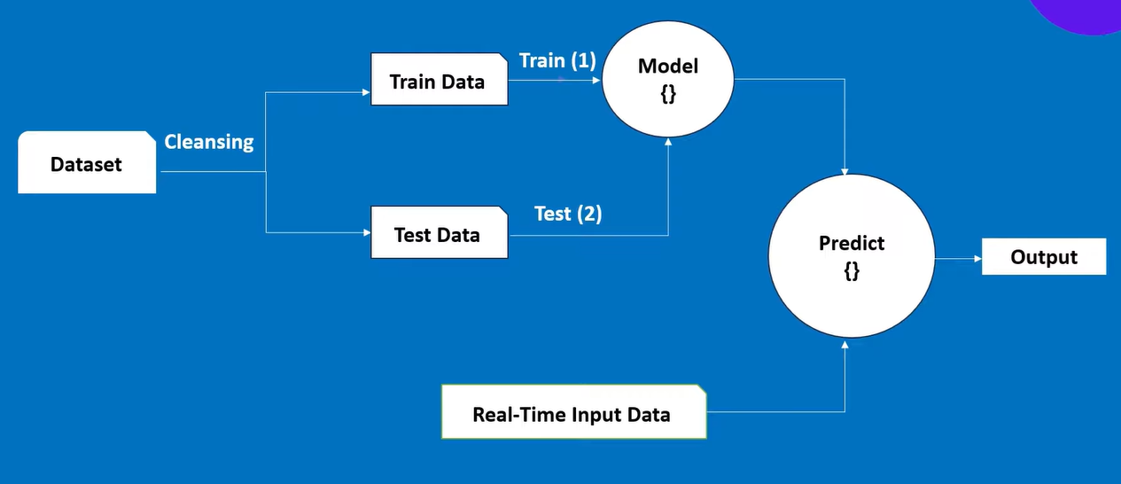

2. Problem Statement

Problem Statement: In the digital world, users receive a large number of messages daily through email, SMS, and online platforms. Among these messages, a significant portion are spam messages—unwanted, unsolicited, and often harmful messages. These spam messages can waste time, reduce productivity, and sometimes contain phishing links or malware, putting users at risk of financial loss, identity theft, or other cyber threats. Manually identifying spam messages is inefficient and impractical due to the high volume of messages.
Solution and Benefits: The Spam Detection System developed in this project addresses this problem by using Artificial Intelligence (AI) and Machine Learning (ML) techniques to automatically detect and classify messages as Spam or Not Spam. By applying text preprocessing, feature extraction, and supervised learning through the Naive Bayes classification algorithm, the system identifies patterns and characteristics of spam messages with high accuracy. This approach reduces human effort, improves message safety, and ensures a cleaner and more productive communication experience. The system benefits both individual users and organizations by minimizing exposure to malicious content, preventing potential cyberattacks, and saving time spent manually filtering messages. This project demonstrates the practical application of AI and ML to solve a real-world problem efficiently.

3. Relevance to AI and ML

3.1 Artificial Intelligence (AI) Concepts
- Intelligent Automation: The system can automatically identify and filter spam messages without human intervention.
- Decision Making: Based on the content of a message, the system decides whether it is Spam or Not Spam.
- Pattern Recognition: The system learns patterns in message content, such as common spam keywords or phrases, which allows it to make intelligent predictions.

3.2 Machine Learning (ML) Concepts
- Supervised Learning: The model is trained on labeled data, where each message is marked as Spam or Not Spam.
- Classification Problem: Each message is assigned a category (Spam or Not Spam) based on its features.
- Feature Extraction: Text messages are converted into numerical vectors using CountVectorizer, making the text
readable for the ML model. 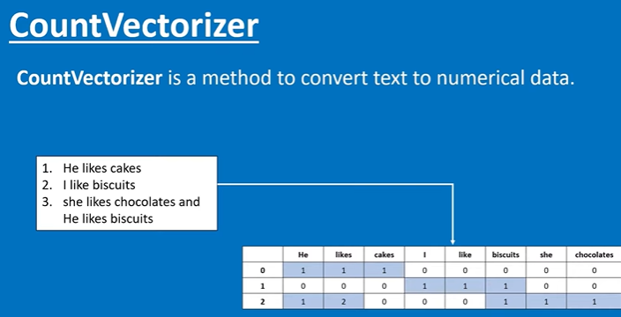
- Naive Bayes Algorithm: Multinomial Naive Bayes is used to classify messages because it handles text data effectively by analyzing word frequency.
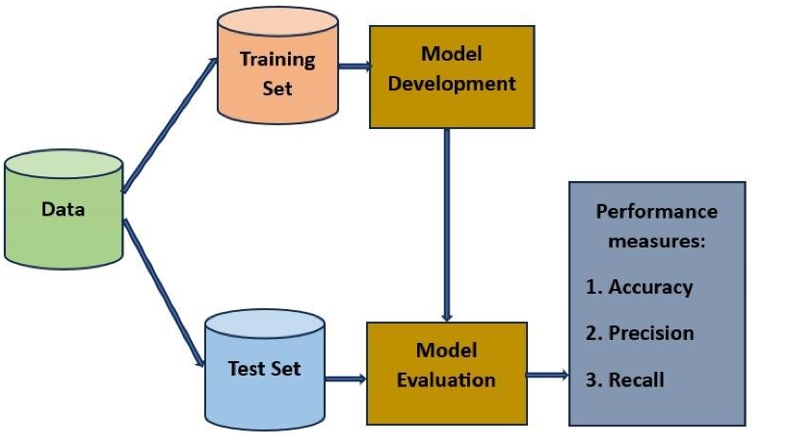
- Model Evaluation: Accuracy, precision, recall, and F1-score are used to measure how well the model predicts spam.

4. Tools and Technologies Used

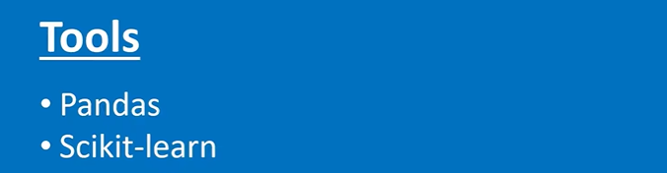

4.1 Programming Language
- Python: Python is widely used in AI and ML projects due to its simplicity, readability, and a rich ecosystem of libraries for data analysis, machine learning, and deployment.
4.2 Libraries
- pandas: Used for loading, cleaning, and manipulating the dataset. It allows handling large datasets, removing duplicates, and preprocessing messages for training.
- scikit-learn: Provides tools for implementing machine learning algorithms, model training, and evaluation. Key features used include:
  - CountVectorizer: Converts text messages into numerical vectors, enabling ML models to process text data.
  - Multinomial Naive Bayes: A classification algorithm suited for text data that analyzes word frequency patterns to identify spam messages.
  - train_test_split: Splits the dataset into training and testing sets to evaluate model performance on unseen data.
- NLTK (Natural Language Toolkit): Used for text preprocessing, such as removing stop words, tokenization, and preparing data for feature extraction.

4.3 Dataset
- SMS Spam Collection Dataset: A publicly available dataset containing labeled SMS messages classified as spam or ham (Not Spam). It provides the data needed to train and test the machine learning model effectively.
.

5. Approach / Methodology

- Data Collection: Load CSV dataset and remove duplicates.
- Data Preprocessing:
  - Convert text to lowercase.
  - Remove special characters and stop words.
  - Label spam and ham as “Spam” and “Not Spam.”
- Feature Extraction: Convert messages to numerical vectors using CountVectorizer.
- Model Training:
  - Split data into 80% training and 20% testing sets.
  - Train a Multinomial Naive Bayes classifier on training data.
- Testing & Evaluation: Test model on unseen messages, calculate accuracy, precision, recall.

6. Code

import pandas as pd
from sklearn.model_selection import train_test_split
from sklearn.feature_extraction.text import CountVectorizer
from sklearn.naive_bayes import MultinomialNB

data = pd.read_csv(r"C:\Users\tanan\Downloads\shikha.aiml\spam.csv")

data.drop_duplicates(inplace=True)
data['Category']=data['Category'].replace(['ham','spam'],['Not Spam','Spam'])

mess=data['Message']
cat=data['Category']

(mess_train,mess_test,cat_train,cat_test)= train_test_split(mess, cat , test_size=0.2)

cv=CountVectorizer(stop_words='english')
features=cv.fit_transform(mess_train)

#Creating Model

model=MultinomialNB()
model.fit(features,cat_train)

#Testing my model
features_test=cv.transform(mess_test)
accuracy = model.score(features_test, cat_test)

print(f"\nModel Accuracy: {accuracy*100:.2f}%")

#Predict Data
def predict(message):
input_message = cv.transform([message]).toarray()
return model.predict(input_message)[0]

# CLI loop
while True:
user_input = input("\nEnter a message to be checked(or type 'exit' to quit): ")

if user_input.lower() == 'exit':
print("Exiting...")
break

if user_input.strip() == "":
print("Please enter a valid message.")
continue

result = predict(user_input)
print(f"Prediction: {result}")

.

7.Setting Up

Step 1: Clone the GitHub Repository
Step 2: Set Up Python Environment
Step 3: Install Required Libraries
Step 4: Add the Dataset
Step 5: Run the code using command

8. Challenges Faced

- Cleaning the dataset to remove duplicates and irrelevant characters.
- Handling very short messages that do not contain enough information to classify.
- Converting the trained ML model into an interactive real-time application.
- Selecting the right preprocessing and feature extraction steps for best performance.

9. Results

- The model achieved 98.64%accuracy on the test dataset.
- Confusion matrix shows correct identification of spam and non-spam messages.
- Real-time interface allows users to validate messages easily.

10. Conclusion

The Spam Detection System effectively classifies messages as Spam or Not Spam, saving time and reducing exposure to malicious content. It demonstrates practical application of AI and ML concepts, including supervised learning, classification, and Naive Bayes algorithm. The project can be further extended to detect spam emails, social media messages, or phishing attacks.

11. References

- UCI Machine Learning Repository: SMS Spam Collection Dataset
- Scikit-learn Documentation: https://scikit-learn.org/
- NLTK Documentation: https://www.nltk.org/

