|  |
| --- |
|  |

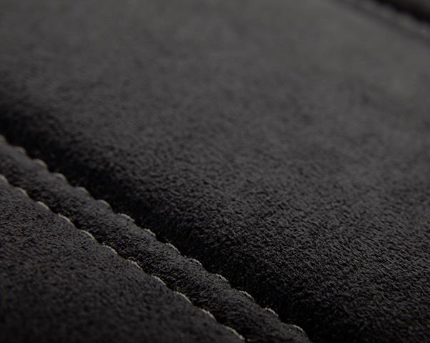

|  |
| --- |
| **RFQ for** |

**FSC 4W RH**

|  |
| --- |
| **FSC 4W RH + HA Fastening fixture** |

|  |
| --- |
| **12thApr 2025** |

|  |
| --- |
| **Improving the experience of a world in motion** |

|  |
| --- |
| Adient – INTERNAL |

**Overview**

**Secrecy/Confidentiality :**   
This document and all attachments should be considered confidential and proprietary to Adient India Pvt. Ltd.. and are intended only for the individual or company to whom addressed, and only for the purpose stated or intended. Any other viewing, copying, distribution or other use of this information is prohibited.

**AME/ : Satish Vighe (98812 44609) (For technical query) Program Management : Jyoti B.**

**CONTACTS**

|  |
| --- |
| **Purchasing :Sagar Kamthe ( 985055 7755 )** |

|  |  |
| --- | --- |
| **ADDRESS** | **Adient India Pvt. Ltd. ,**  **Rajiv Gandhi Infotech Park, Hinjewadi** |

|  |  |  |  |  |
| --- | --- | --- | --- | --- |
| **PROJECT NAME** | **Tal. Mulshi, Pune** | |  | | --- | | Adient – INTERNAL | | 2 |
| **M & M – U171** |
| **SITE LOCATION** | **Adient, Pune** |
| **ANNUAL VOLUME** | **120,000 car set** |
| **PROGRAM LIFE** | **7 YEARS** |
| **QUOTE TYPE** | **Final Production Equipment** |
| Adient / Presentation Title / Date |

**INDEX**

|  |  |
| --- | --- |
| 1.  2.  3.  4.  5.  6.  7.  8.  9. | SUPPLIER SCOPE OF WORK  MACHINE DEFINATION, REFERENCE IMAGES CTPS REQUIREMENTS  MACHINE CONTENTS  OPERATIONAL DETAILS  ADIENT INPUT FOR MACHINE DESIGN  MACHINE DESIGN REQUIREMENTS  QUALITY REQUIREMENT FOR PRODUCT  PRODUCT INFORMATION |

10. INDUSTRIAL ENGINEERING REQUIREMENTS   
11. RECOMMENDED MAKES   
12. ACCEPTANCE CRITERIA   
13. DOCUMENTATION, SPARE & TRAINING   
14. PACKAGING, TRANSPORTATION & INSTALLATION   
15. TIMELINE   
16. DV/PV BUILD SUPPORT   
17. 19.WARRENTY, SUPPORT TILL SOP & AFTER SALES SUPPORT   
18. RFQ SIGN OFF

|  |  |  |  |
| --- | --- | --- | --- |
| Adient / Presentation Title / Date | |  | | --- | | Adient – INTERNAL | | 3 |

**1.SUPPLIER SCOPE OF WORK**

Supplier will design & manufacture complete Workstations as per details in RFQ. After manufacturing, supplier will do trials & prove at their end and later after installation at Adient works location. Supplier should meet Adient’s Quality, Safety & Cycle time requirements.

**Supplier should comply to all requirements mentioned in RFQ. For any deviation, separate sign-off will be done.**

**2.MACHINE DEFINATION & REFERENCE IMAGES**

This is a CoC Fastening workstation for Fastening of Height Adjuster (MHA-3000) to FSC 4W RH Assembly. This workstation should be made to carry out CoC fastening of following variants   
1) FSC 4W RH   
**This is based on existing design of workstation**. It consist of item no 1 to 7, The workstation controls through HMI & PLC. It has part presence sensors. This workstation should be made for safe working. **The workstation should meet all 39 requirements of CTPS**

|  |  |  |  |  |
| --- | --- | --- | --- | --- |
| System will have other accessories as per Adient requirements. | |  | |  | | --- | | Overall Workstation Schematic view | |
| • | Machine should have Biometric Bypass system |
| • | Siemens HMI (KTP-700) to be used as back end |
| * Machine should have server connectivity | |  |
| Adient / Presentation Title / Date | | |  | | --- | | Adient – INTERNAL | | 4 |

|  |  |  |  |  |  |  |  |  |  |  |  |  |  |
| --- | --- | --- | --- | --- | --- | --- | --- | --- | --- | --- | --- | --- | --- |
| |  | | --- | | **FSC 4W RH + HA Fastening**    There should special clamping  arrangement with 2 pneumatic cylinders along with 3 Nos. Air pressure switch to apply forces F1, F2 & F3 in given  sequence as per existing arrangement | | |  |  |  |  |  |  |  |  |  |  | | --- | --- | --- | --- | --- | --- | --- | --- | --- | --- | | |  |  |  |  | | --- | --- | --- | --- | | |  | | --- | | Operator Panel | | Explains every |  | | assembly step by | | visualizing the | | assembly station | | and the work | | steps to be done | | | 5 |
| |  |  |  |  | | --- | --- | --- | --- | | |  |  |  | | --- | --- | --- | | |  | | --- | | Fixture | |  | | |
| Adient / Presentation Title / Date | |  | | --- | | Adient – INTERNAL | |

**3.CTPS REQUIREMENTS**

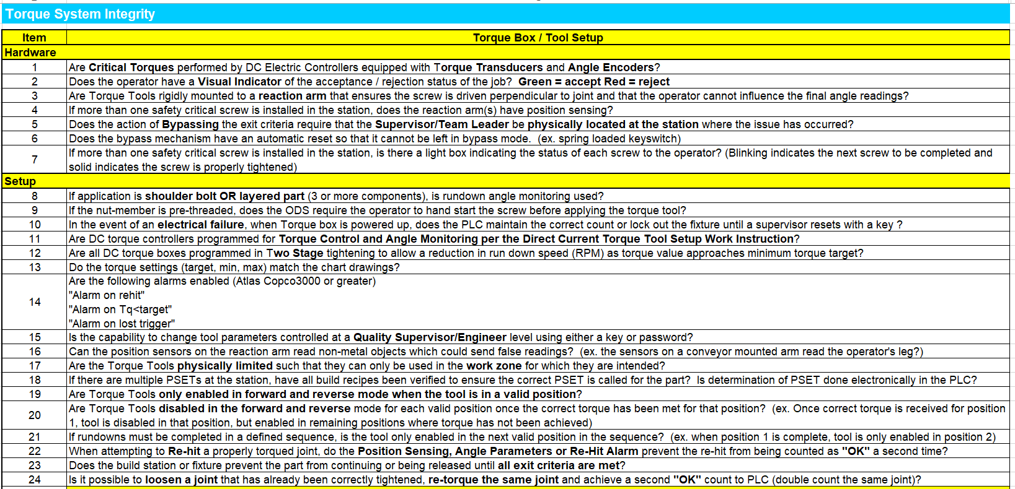

|  |  |  |  |
| --- | --- | --- | --- |
| Adient / Presentation Title / Date | |  | | --- | | Adient – INTERNAL | | 6 |

|  |
| --- |
| **CTPS Requirements** |

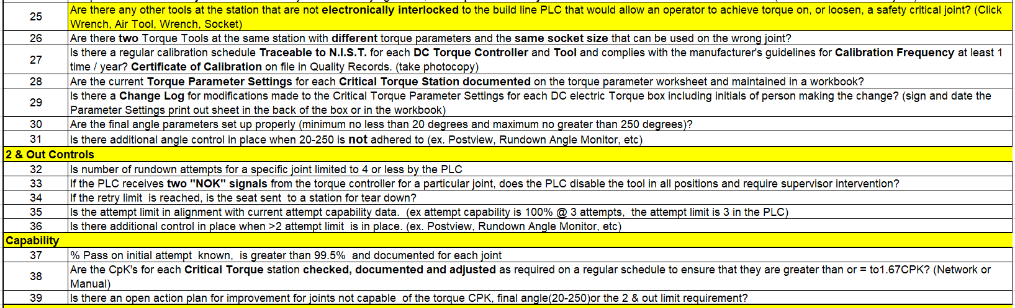

|  |  |  |  |
| --- | --- | --- | --- |
| Adient / Presentation Title / Date | |  | | --- | | Adient – INTERNAL | | 7 |

|  |
| --- |
| **CTPS Requirements** |

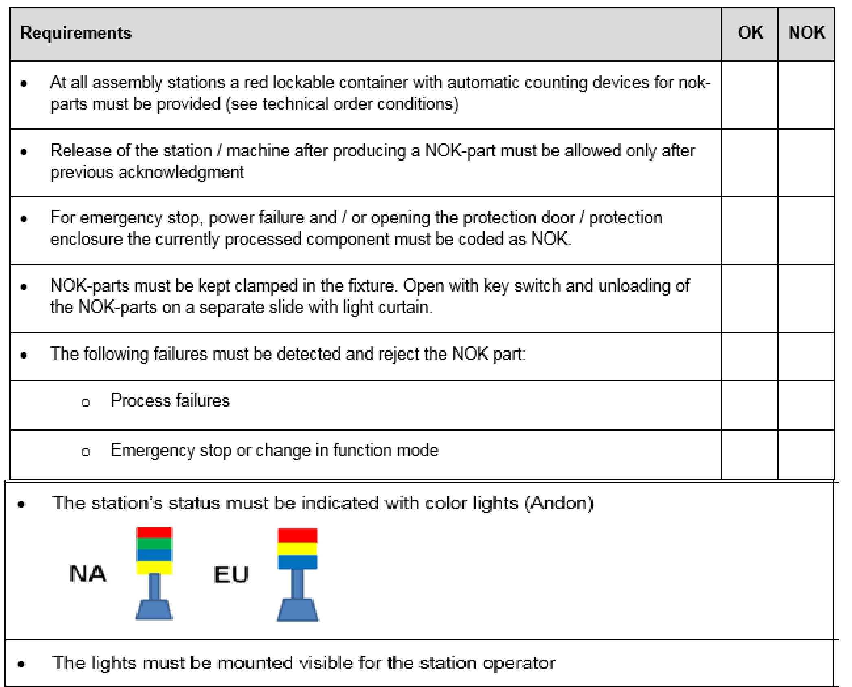

|  |  |  |  |
| --- | --- | --- | --- |
| Adient / Presentation Title / Date | |  | | --- | | Adient – INTERNAL | | 8 |

**4.MACHINE CONTENTS**

|  |  |  |  |
| --- | --- | --- | --- |
| **Functional Area** | **SN** | **Content** | **Brief Description of Content** |
| Adient Scope of Supply | 1 | 1 Electric Nut-runner &   Accessories (Atlas Copco) | Electric Nut runner –Controller – PF 8000  Accessories – RBU Silver, Tensor ST cable 5 mtr, Suspension Yoke |
| Workstation  structure & fixture | 1 | 1 Base stand | Fixture base stand to be made from Standard MS square tube of section 72 mm x 72 mm x 4 mm thk  Complete machine structure should be painted with red oxide & high quality spray painting as per RAL shade 9010 (Ivory colour) |
| MS top plate on stand with 20 mm thickness.(Appr height of MS plate 850 mm from ground) |
| 4 no. of Anti-vibration pads(Dia-100 mm) to avoid any movement of machine during operation & enable machine levelling upto (+/- 25 mm) |
| 2 | Upper structure above 850 mm | Upper structure to be made from 72 mm x 72 mm x 4 mm thk MS sq. tube, painted with red oxide & high quality spray painting as per RAL shade 9010 (ivoey colour). Other support members should be made from suitable Aluminium extrusions (40x40 or 40x80) as per strength requirements |
| Overhead structure for positioning of Electric nut runner in X, Y & Z directions using Zero gravity balancer, Rail & Tool trolley with reaction arm. High quality Ni-Cr plated dia 32 mm guide rod & recirculating ball bearing (Misumi). LM Guides, End stopper & shock absorber as per requirements. |
| Electric nut runner housing and reaction arm arrangement for movement of Electric Nut runner for tightening. |
| Structure to support Tubelight & Fan mounting. Also arranagment for display of Work instruction sheet & Mimic board |
| 3 | Fixture | Fixture consist of Base plate, Location & resting blocks, Location pins & Pneumatic clamps |
| Clamping – 4 nos. of clamping cylinders to ensure no gap between parts & proper locking of parts. (Cylinder dia – minimum 40 mm) |
| Location block, resting block, location pin & clamping pad should be made from hardened steel and should be blacodized |
| **For HA Clamping – 2 Nos of clamping cylinders + 3 Nos of air pressure switches to be used for application of forces F1, F2 & F3 as per sequence mentioned in product drawing (Minimum cylinder dia 40 mm). PLC programming should be done to achieve this.** |
| All location block will be located by dowel and clamped by Allen bolts |
| All pneumatic cylinders should have flow control valve at inlet & outlet. All pneumatic cylinder should have built in cushioning arrangement. |
| Necessary end stopper & shock absorber should be provided to avoid any jerky movement. |
| All pneumatic cylinder sizes are approximate for quote working purpose. Actual size will be close to above mentioned sizes. These sizes will be finalised after DAP |

|  |  |  |  |
| --- | --- | --- | --- |
| Adient / Presentation Title / Date | |  | | --- | | Adient – INTERNAL | | 9 |

|  |  |  |  |
| --- | --- | --- | --- |
| **Functional Area** | **SN** | **Content** | **Brief Description of Content** |
| Controls | 1 | Main Control Panel | Main control panel will have required SMPS, PLC, Relays, Wire connectors etc. |
| This panel will be mounted at suitable position for easy access & maintenance |
| Panel will have Light, fan, 3 pin socket & door lock arrangement |
| Additional 20% space will be kept empty for any future changes |
| PLC-Siemens based on number of I/O |
| 2 | Operator Control Panel | Operator control panel will have HMI, Lights & Buttons as per below description.  It should be mounted at shoulder level. It should be opened from front side & should have locking arrangement |
| **Lights & buttons on Operator Control Panel** |
| Push button with light - Control ON, Push button with light - Control OFF, Display light – JOB OK |
| Display light – JOB NOK (with blinking light) + RESET button |
| Two position selector switch - Machine Light + Fan - ON/OFF, Push Button - EMERGENCY STOP |
| Push button – RESET |
| Two position selector switch - AUTO/MAINTENANCE - Authorisation Key along with Buzzer |
| Display Light - START CYCLE (with blinking light)  Electric nut runner – parking location light  RED Light - If JOB is NOK (If cycle stopped halfway)  **Mimic Board** – Nut fastening map with LED for each tightening location. Light blinking for each successive location.  Total – 3 Nos |
|  | 3 | Display | **HMI** |
| Main control of machine through Colour HMI (7 inch) Siemens make |
| Main screen of HMI should show MODE SELECTION - Auto mode and Manaul/Maintenance mode |
| I/O Status, MACHINE STARTUP INSTRUCTIONS, MACHINE END OF SHIFT INSTRCUTIONS |
| Counter - Shiftwise/daywise part produced (OK & NOK) (Record for 1 day); Tool change alarm after 10,000 cycles. |
| Part presence sensor status & Reed switch map (Pneumatic cylinder). Mark all reedwitch position on Pneumatic cylinder. |
| Pokayoke functioning - Robust pokayoke logic to detect NOK conditions before operation |
| Pokayoke/Reedswitch by-pass should be with Password protect |
| Error log (1 shift error should be traced), Dispay latest 10 errors |
| Supplier name,contact details, Adient logo, date & time, cycle time, machine mode etc. |
| Any setting/program change should be Password protected |

|  |  |  |  |
| --- | --- | --- | --- |
| Adient / Presentation Title / Date | |  | | --- | | Adient – INTERNAL | | 10 |

|  |  |  |  |
| --- | --- | --- | --- |
| **Functional Area** | **SN** | **Content** | **Brief Description of Content** |
| Controls | 4 | Machine Operation switch | Machine will be operated by two hand Banner K30 Pick to Light touch buttons. One Additional EMERGENCY button will be provided beside this switch. |
| 5 | Process parameter display | Digital air pressure switch (1 No) - Switch for showing incoming air pressure |
| 6 | Part/Condition check sensor | Inductive sensor for track presence (2 Nos/track) – Total – 8 Nos |
| 7 | Nut runner position sensing | X-Y Linear scale for Electric nutrunner position sensing. Separate controller for X-Y scale |
| All sensor should be mounted with 2 bolts & guarded with proper guard to avoid any damage or setting change during regular operation |
| 8 | Electric Connector & wire routing | Inside machine, all electric wire should be routed properly with proper numbering & mounting/harnessing. No loose wires allowed. |
| Outside machine, all electric wire should be routed though conduit pipe |
| Input/Output connector module (WAGO/Siemens) should be used for connectivity of wire inside outside of machine. .These modules should be mounted outside of machine for easy maintenance |
| 9 | Pneumatic pipes & control | Inside machine, all pneumatic pipes should be routed properly through conduit with proper numbering & mounting/harnessing. No losse pipes are allowed. |
| Outside machine, all pneumatic pipes should be routed though Metal square section (60 mm x 60 mm) conduit |
| Standalone valves can be used for less numbers of valves. All pneumatic valve should be 5/3 (5 port/3 postion) so that during emergency situations (Light curtain interruption/ Emergency press/ Power off), all pneumatic cylinder should stop instantly in same position. |
| 10 | 10 Light inside machine | 2 no. of LED lights 10 Watt each should be fixed on machine structure to project light on Fixture area |
| 11 | 11 Machine earthing | Machine should have internal bus bar to connect to all individual electric units  Main supply supply to machine should be connected through ELCB (Earth Leakage Circuit Breaker) as per machine's total power requirement. In case of Earthing failure, machine electric supply will trip. |
| 12 | 12 Bar code printer & scanner | Zebra bar code printer (1 D/2D) & suitable scanner to be selected for tracibility |
| Proper mounting of Bar code printer & scanner to avoid any damages during regular working |
| NOK parts | 1 | 1 NOK part handling | NOK part will be produced in case of emergency stop/Torque not achieved to preset value |
| After NOK part is produced in above condition, NOK part light will glow. There will be 2 + 2 retake |
| If torque not achieved after 4 retake then use operator bypass by biometric and remove part and send for rework |
| After completion of above, operator will press reset button to resume normal cycle. |

|  |  |  |  |
| --- | --- | --- | --- |
| Adient / Presentation Title / Date | |  | | --- | | Adient – INTERNAL | | 11 |

|  |  |  |  |
| --- | --- | --- | --- |
| **Functional Area** | **SN** | **Content** | **Brief Description of Content** |
| Safety | 1 | LOTO | Main electrical switch of machine should have LOTO attachment |
| Pneumatic FRL unit shoud have LOTO attachment |
| 2 | Safety Indication Sticker | Machine should be provided with Standard Safety Indication Stickers e.g. HIGH VOLTAGE, MAIN SUPPLY etc. |
| Material storage | 3 | Raw material storage bins | SS bin for storage for M8 nut  Appr size 300 mm x 300 mm x 20 mm - 1 No |
| All other child part storage – Adient scope |
| SS Grease storage container for Appr weight 1 kg + Brush for grease application |
| FG storage - Adient scope |
| Other  requirements | 4 | First piece storage bin | For storage of 1st piece, make arrangement below machine base table |
| 5 | Rejection bin with Lock & key | Red colour Powder coated box made from MS Sheet 2 mm thk with Lock & Key.  The opening hole size should be100 mm x 100 mm. -  Overall size - 200 mm x 200 mm x 200 mm. Bin to be fixed on lower side base plate |
| 6 | Work instruction (ODS) Display | Two parallel Aluminium Extrusion Stand for fixing Work Instruction sheet of size 420 mm x 300 mm |
| 7 | Fan for operator | Machine should have mounted Air Recirculation Fan (12") (Cromption Greaves/Almonard/Bajaj) |
| 8 | Machine Name plate | Name plate size 100 mm x 80 mm made from 1 mm thk Aluminium sheet & fixed to base plate. It should have following details Name & address of manufacturer, name of machine, month & year of dispatch, Asset number (Blank field) |
| 9 | Operation Description Plate | Operation description name plate in Blue background & white letter (Use Acrylic sheet 5 mm thk) with mounting (Board height 125 mm, Letter height - 100 mm |

|  |  |  |  |
| --- | --- | --- | --- |
| Adient / Presentation Title / Date | |  | | --- | | Adient – INTERNAL | | 12 |

The complete workstation should be connected to central Controller & Server though Toots Net (or equivalent system

|  |  |  |
| --- | --- | --- |
|  | | **Reference Image**  13 |
| Adient / Presentation Title / Date | |  | | --- | | Adient – INTERNAL | |

**5.OPERATIONAL DETAILS**

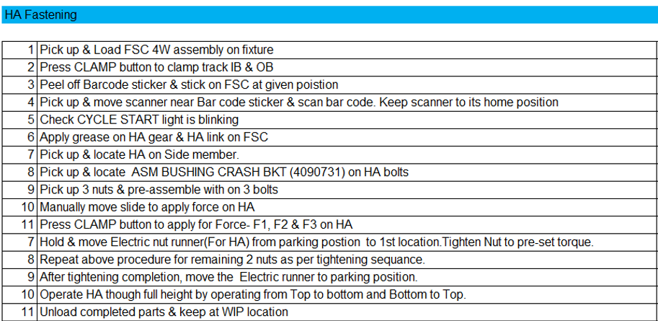

|  |  |  |  |
| --- | --- | --- | --- |
| Adient / Presentation Title / Date | |  | | --- | | Adient – INTERNAL | | 14 |

**6. ADIENT INPUT FOR MACHINE DESIGN**

Adient will share detailed RFQ along with following data to the supplier   
1.CAD Data (3D) for each assembly   
2. Engineering Drawing of assembly & its child parts with all details

**7. MACHINE DESIGN REQUIREMENTS**

1)Supplier will understand quality & functional requirement of drawings & accordingly design the machine 2)For fixture manufacturing following points should be considered   
➢Modular jig/Fixture design to adopt product design changes  
➢Robust Poka yoke system for prevention of missing, mis-oriented & wrong parts   
3)Supplier should have necessary 3D CAD design software for design   
4)Supplier & Adient will do necessary design reviews.

5)Supplier will take care of all safety interlocks during design   
6)Machine shall be fork-truck accessible. All machine parts shall be mounted inside perimeter of frame.

7)Machine should be maintenance friendly & easy to maintain   
8)Machine PLC logic should be edited from remote location through Data card using software like Teamviewer After DAP sign off, Machine will be kicked off for manufacturing

**8.QUALITY REQUIREMENT FOR PRODUCT**

After operation   
1)HA tightening torque – 11 ± 1 N-m ( 3 Locations)   
2)Sequence of tightening (As per pre-decided sequence)

|  |  |  |  |
| --- | --- | --- | --- |
| Adient / Presentation Title / Date | |  | | --- | | Adient – INTERNAL | | 15 |

**9.PRODUCT INFORMATION**   
Height Adjuster Fastening (FSC 4W LH)   
Tightening torque – 11 ± 1 N-m ( 3 Locations)

|  |  |  |  |  |  |  |  |
| --- | --- | --- | --- | --- | --- | --- | --- |
|  | + |  | | + |  |  | 16 |
| HA (RH) | | M6 NUT |
| (3 Nos) |
| FSC 4W Assly. (with Tracks) | FSC 4W Assly.  (with Tracks+HA) | | | | | |
|  | | |  | | | |
| Adient / Presentation Title / Date | |  | | --- | | Adient – INTERNAL | | | | | | |

**10.INDUSTRIAL ENGINEERING REQUIREMENTS**

|  |  |  |  |
| --- | --- | --- | --- |
| 1.  2.  3.  4.  5. | Machine should be designed with proper ergonomics to reduce operator fatigue.  Machine Usage - Three shift & six days working per week. Machine availability should be - 95% No of operator per workstation – 1 No.  Machine down time : Should be less than 20 minutes per day  Target Cycle time is shown below | | |
|  | **SN** | |  | | --- | | **Assembly Description** | | **Target Cycle Time with 100% efficency** |
|  | 1 | |  | | --- | | Fastening of HA (FSC 4W RH) | | 70 seconds |

**11. RECOMMENDED MAKES**

|  |  |
| --- | --- |
| 1.  2.  3.  4.  5.  6.  7.  8.  9. | Electrical switchgears/Contactor : Schnider  Sensors – Keyance Retro-diffuse Laser sensor, Inductive sensor - Omron Push Buttons & Indicators – Schnider  Cables – Lapp  PLC & HMI – Siemens  FRL unit & Pneumatics –Festo  SMPS/Power Supply – Meanwell/Omron  Control Panel & Machine Panel : Local make  Recirculating fan – Crompton Greaves , Almonard |

10. Aluminum extrusion 40 mm & 80 mm– Local make   
11. Polycarbonate sheet 8 mm thk – Lexan

**All makes will be finalized at the time of DAP**

|  |  |  |  |
| --- | --- | --- | --- |
| Adient / Presentation Title / Date | |  | | --- | | Adient – INTERNAL | | 17 |

**12. ACCEPTANCE CRITERIA**

|  |  |
| --- | --- |
| 1.  2.  3.  4.  5.  6.  7. | Equipment run-off and trials will be held at supplier end.  All necessary Components will be provided by Adient before trials at supplier end.  Required consumables/compressed air/Electric supply will be arranged by supplier.  Trial production batch of minimum 100 nos. will be produced at supplier end to meet all Quality & Cycle time requirements Supplier will provide facility for quality checking  Completed Equipment Qualification Form **&** safety analysis using the Adient Job Safety Analysis form.  No weld flash or burrs. No sharp corners or edges permitted in any area. Pinch points must be avoided |

**13.DOCUMENTATION, SPARES & TRAINING**

1. Supplier will provide necessary Operating & Maintenance supplier’s Manuals as Hardcopy & CD (pdf file) with following details 1) System operating instructions  
 2) Machine Layout   
 3) Electrical diagram, wiring diagram   
 4) Pneumatic circuit diagram  
 5) Complete Fixture Assembly   
 6) Bill of Material (Electrical & Mechanical)  
 7) Preventive maintenance sheet (Electrical & Mechanical)  
 8) List of recommended spare parts & wear parts (Electrical & Mechanical)   
 9) Engineering drawing of wear part in pdf file

|  |  |
| --- | --- |
| 2.  **3.**  4. | Supplier will provide 3D CAD data, drawings, Detailed CMM report of fixture showing datum, location & resting surfaces dimensions **Supplier will provide 1 set of spare wear parts (Locator, Top punch etc.)**  Supplier will provide necessary training to Adient personnel for Usage, Handling & Trouble shooting of complete system at supplier end |

during trials and at Adient plant during installation.

|  |  |  |  |
| --- | --- | --- | --- |
| Adient / Presentation Title / Date | |  | | --- | | Adient – INTERNAL | | 18 |

**14.PACKING, TRANSPORTATION & INSTALLATION**

1. Supplier is responsible for proper packaging of machine. For packaging machine should be mounted in heavy duty base wooden platform. Machine should be fixed to base wooden platform by bolts. Complete machine will be Shrink-wrapped to avoid any damage due to water. Machine should be covered with wooden sheets from all side & top side.

2. After packaging supplier will use proper lifting devices to safety load packed machine into Transport vehicle 3. Transport of machine from supplier end to Hinjewadi plant is supplier responsibility.

4. Machine unloading at Adient Hinjewadi plant will be done by Adient team, with recommended unloading instructions from supplier.

Supplier should provide specific unloading instruction if any through e-mail communication to Adient Program manager, Launch Manger & AME before dispatch of system   
5. Machine installation, integration and setup in Adient plant will be the responsibility of the suppler.

6. Adient will provide Required consumables/compressed air/water/Oil during installation.

**15.TIMELINE**

After receipt of PO/LOI from Adient, within one week period, supplier should provide timeline for implementation mentioning major milestones like

|  |  |  |  |  |
| --- | --- | --- | --- | --- |
| ➢ | Clarity of additional inputs required from Adient | |  | | --- | | Adient – INTERNAL | | 19 |
| ➢ | 1st Design review between Adient & supplier |
| ➢ | Final design review |
| ➢ | Kick off for long lead time items |
| ➢ | Receipt of manufactured & bought out parts |
| ➢ | Completion of assembly for 1st trials |
| ➢ | Completion of trials after corrections |
| ➢ | Final Trial run & equipment validation |
| ➢ | Equipment packing & dispatch etc. |
| Adient / Presentation Title / Date | |

**16.DV/PV BUILD SUPPORT**

Before dispatch of system/machine to Adient, if any DV/PV build of limited quantity (e.g. 50 to 100 nos.) need to be done at supplier end, same should be supported by supplier. This build will be separate from trial run mentioned in **ACCEPTANCE CRITERIA.**

**17.WARRENTY, SUPPORT TILL SOP & AFTER SALES SUPPORT**

1.Complete system should be warranted for 12 months from date of installation   
2. After installation of system/machine in Adient, till SOP (Start of regular production) supplier should provide support for any technical issues with 24 hours.

3.After SOP till 1 year period, supplier should provide support for any technical issues with 24 hours

**18.RFQ SIGN OFF**

**The selected supplier need to sign off with Company Seal on each page of RFQ as token of acceptance. The final machine/system will be checked against the signed RFQ details. Deviation sign off will be referred for any deviations.**

|  |  |  |  |
| --- | --- | --- | --- |
| Adient / Presentation Title / Date | |  | | --- | | Adient – INTERNAL | | 20 |

Thank You

|  |  |  |  |
| --- | --- | --- | --- |
| Adient / Presentation Title / Date | |  | | --- | | Adient – INTERNAL | | 21 |