|  |
| --- |
|  |

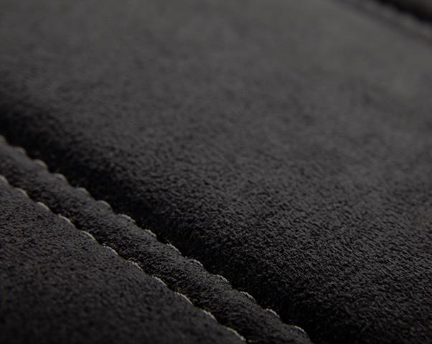

|  |
| --- |
| **RFQ for** |

**Towel bar fitment & POP**

|  |
| --- |
| **riveting (FSC 4W/FSC 2W)** |

|  |
| --- |
| **12thApr 2025** |

|  |
| --- |
| **Improving the experience of a world in motion** |

|  |
| --- |
| Adient – INTERNAL |

**Overview**

**Secrecy/Confidentiality :**   
This document and all attachments should be considered confidential and proprietary to Adient India Pvt. Ltd.. and are intended only for the individual or company to whom addressed, and only for the purpose stated or intended. Any other viewing, copying, distribution or other use of this information is prohibited.

**AME/ : Satish Vighe (98812 44609) (For technical query) Program Management : Jyoti B.**

**CONTACTS**

|  |
| --- |
| **Purchasing :Sagar Kamthe ( 985055 7755 )** |

|  |  |
| --- | --- |
| **ADDRESS** | **Adient India Pvt. Ltd. ,**  **Rajiv Gandhi Infotech Park, Hinjewadi** |

|  |  |  |  |  |
| --- | --- | --- | --- | --- |
| **PROJECT NAME** | **Tal. Mulshi, Pune** | |  | | --- | | Adient – INTERNAL | | 2 |
| **M & M – U171** |
| **SITE LOCATION** | **Adient, Pune** |
| **ANNUAL VOLUME** | **120,000 car set** |
| **PROGRAM LIFE** | **7 YEARS** |
| **QUOTE TYPE** | **Final Production Equipment** |
| Adient / Presentation Title / Date |

**INDEX**

|  |  |
| --- | --- |
| 1.  2.  3.  4.  5.  6.  7.  8.  9. | SUPPLIER SCOPE OF WORK  MODIFICATION DETAILS & REFERENCE IMAGES WORKSTATION CONTENTS  ADIENT INPUT FOR WORKSTATION DESIGN   WORKSTATION DESIGN REQUIREMENTS  PRODUCT INFORMATION  ACCEPTANCE CRITERIA  DOCUMENTATION, SPARE & TRAINING  PACKAGING, TRANSPORTATION & INSTALLATION |

10. TIMELINE   
11. DV/PV BUILD SUPPORT   
12. WARRENTY, SUPPORT TILL SOP & AFTER SALES SUPPORT   
13. RFQ SIGN OFF

|  |  |  |  |
| --- | --- | --- | --- |
| Adient / Presentation Title / Date | |  | | --- | | Adient – INTERNAL | | 3 |

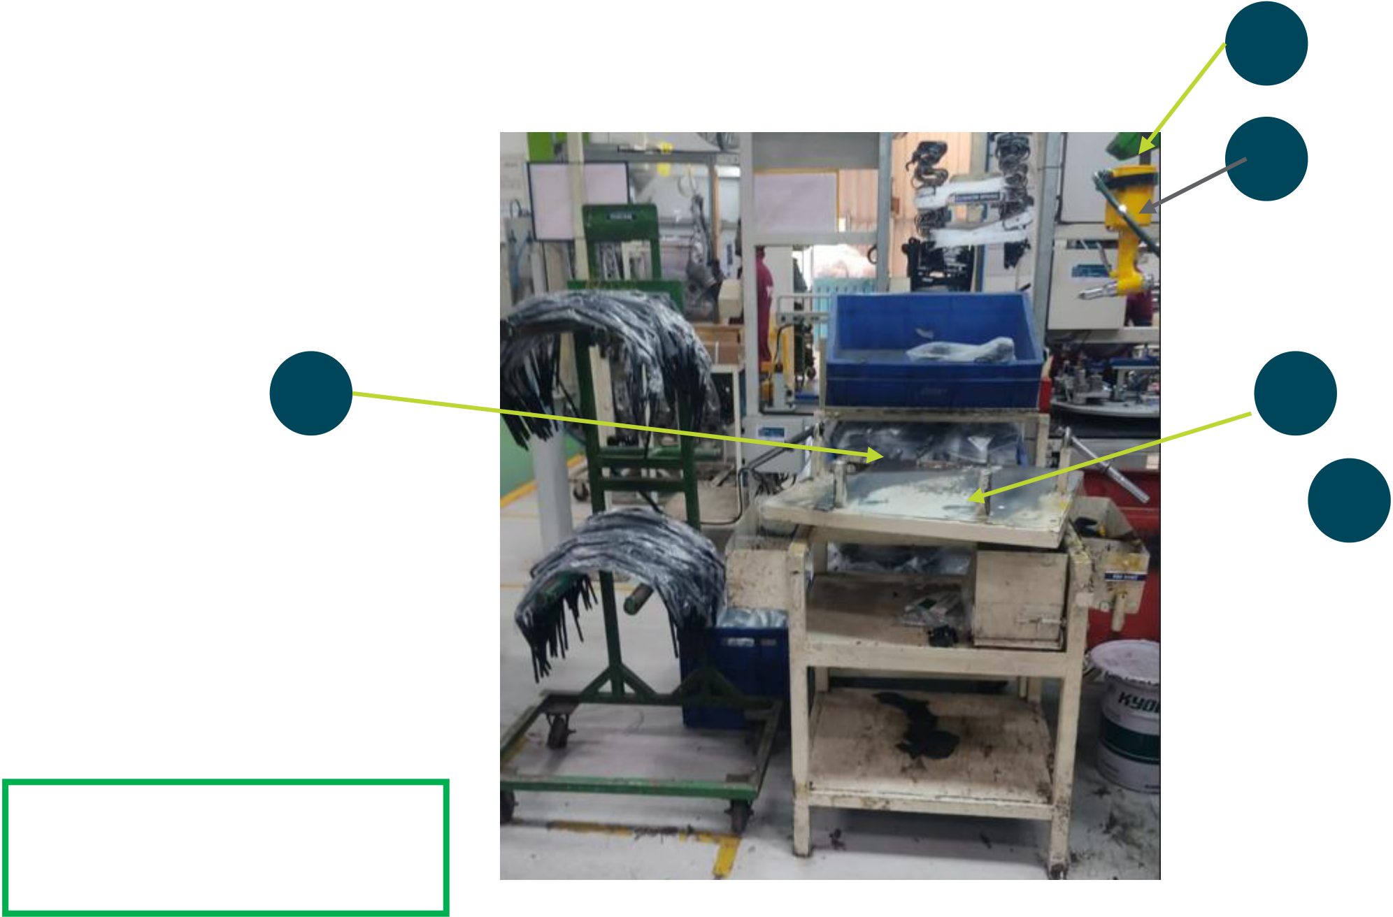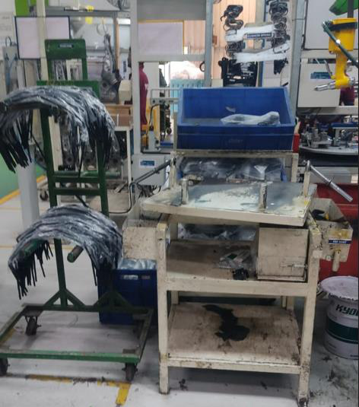

**1.SUPPLIER SCOPE OF WORK**

Supplier will design & manufacture complete Workstations as per details in RFQ. After manufacturing, supplier will do trials & prove at their end and later after installation at Adient works location. Supplier should meet Adient’s Quality, Safety & Cycle time requirements.

**Supplier should comply to all requirements mentioned in RFQ. For any deviation, separate sign-off will be done.**

**2. WORKSTATION DEFINATION & REFERENCE IMAGES**

This is a workstation for fitment of towel bar with FSC structure and pop riveting of ODS bkt. This workstation should be made to operation on

|  |  |  |
| --- | --- | --- |
| following variants | | 5  4 |
| 1) | FSC 4W RH |
| 2) | FSC 2W LH |
| 3) | FSC 2W RH |
| **This is based on existing design of workstation** as per reference image shown | |

Main parts are follows   
1)Fabricated Workstation 1000 mm x 800 mm (Table top)

|  |  |  |  |
| --- | --- | --- | --- |
| with RM storage arrangement based on existing design | 3 | 2 | 1 |
| 2)Towel bar fitment fixture |
| 3)Greasing bowl & brush |
| 4)Pop riveting gun |

5)Spring balancer

Also workstation should have 2 nos. tube lights (LED) + 300 mm Fan

Overall Workstation   
Schematic view

Adient / Presentation Title / Date   
 Adient – INTERNAL

**3.WORKSTATION CONTENTS**

|  |  |  |  |  |
| --- | --- | --- | --- | --- |
| **Functional Area** | **SN** | **Content** | | **Brief Description of Content** |
| Workstation  structure & fixture | 1 | 1 Base stand | | Fixture base stand to be made from Standard MS square tube of section 50 mm x 50 mm x 3 mm thk  Complete machine structure should be painted with red oxide & high quality spray painting as per RAL shade 9010 (Ivory colour) |
| MS top plate on stand with 20 mm thickness.(Appr height of MS plate 850 mm from ground) |
| 4 no. of Anti-vibration pads(Dia-100 mm) to avoid any movement of machine during operation & enable machine levelling upto (+/- 25 mm) |
| 2 | Upper structure above 850 mm | | Upper structure to be made from 50 mm x 50 mm x 3 mm thk MS sq. tube, painted with red oxide & high quality spray painting as per RAL shade 9010 (Ivory colour). Other support members should be made from suitable Aluminium extrusions (40x40 or 40x80) as per strength requirements |
| Structure to support Tubelight & Fan mounting. Also arranagment for display of Work instruction sheet & Mimic board |
| 3 | Fixture | | Fixture consist of Base plate, Location & resting blocks, Location pins & Guide blocks |
| Location block, resting block, location pin & clamping pad should be made from hardened steel and should be blacodized |
| All location block will be located by dowel and clamped by Allen bolts |
| **Riveting** | **4** | **4 Pop riveting** | **Pop riveting Gun (Sumake) & spring balancer ( 5kg)** | |
| Safety | 5 | LOTO | Main electrical switch of machine should have LOTO attachment | |
| Safety Indication Sticker | Machine should be provided with Standard Safety Indication Stickers e.g. HIGH VOLTAGE, MAIN SUPPLY etc. | |
| Material storage | 6 | Raw material storage bins | Plasric bin bin for storage stand made from MS angle  Appr size 600 mm x 300 mm x 40 mm - 1 No | |
| All other child part storage – Adient scope | |
| SS Grease storage container for Appr weight 1 kg + Brush for grease application | |
| FG storage - Adient scope | |
| Other  requirements | 7 | 7 First piece storage bin | For storage of 1st piece, make arrangement below machine base table | |
| 8 | 8 Work instruction (ODS) Display | Two parallel Aluminium Extrusion Stand for fixing Work Instruction sheet of size 420 mm x 300 mm | |
| 9 | 9 Fan for operator | Machine should have mounted Air Recirculation Fan (12") (Cromption Greaves/Almonard/Bajaj) | |
| 10 | 10 Workstation Name plate | Name plate size 100 mm x 80 mm made from 1 mm thk Aluminium sheet & fixed to base plate. It should have following details Name & address of manufacturer, name of machine, month & year of dispatch, Asset number (Blank field) | |
| 11 | Operation Description Plate | Operation description name plate in Blue background & white letter (Use Acrylic sheet 5 mm thk) with mounting (Board height 125 mm, Letter height - 100 mm | |

|  |  |  |  |
| --- | --- | --- | --- |
| Adient / Presentation Title / Date | |  | | --- | | Adient – INTERNAL | | 5 |

**4. ADIENT INPUT FOR MACHINE DESIGN**

Adient will share detailed RFQ along with following data to the supplier   
1.CAD Data (3D) for each assembly   
2. Engineering Drawing of assembly & its child parts with all details

**5. WORKSTATION DESIGN REQUIREMENTS**

1)Supplier will understand quality & functional requirement of drawings & accordingly submit proposal 2)For fixture manufacturing following points should be considered   
➢Modular jig/Fixture design to adopt product design changes  
➢Robust Poka yoke system for prevention of missing, mis-oriented & wrong parts   
3)Supplier should have necessary 3D CAD design software for design   
4)Supplier & Adient will do necessary design reviews.

5)Supplier will take care of all safety interlocks during design   
6)Machine should be maintenance friendly & easy to maintain   
8)Machine PLC logic should be edited from remote location through Data card using software like Teamviewer After DAP sign off, Machine will be kicked off for manufacturing

|  |  |  |  |
| --- | --- | --- | --- |
| Adient / Presentation Title / Date | |  | | --- | | Adient – INTERNAL | | 6 |

**6.PRODUCT INFORMATION**

|  |  |  |  |  |
| --- | --- | --- | --- | --- |
| |  | | --- | | FSC 4W RH |     Adient / Presentation Title / Date | |  | | --- | | FSC 2W LH & RH | | |
| |  | | --- | | Adient – INTERNAL | | 7 |

**7. ACCEPTANCE CRITERIA**

|  |  |
| --- | --- |
| 1.  2.  3.  4.  5.  6.  7. | Equipment run-off and trials will be held at supplier end.  All necessary Components will be provided by Adient before trials at supplier end.  Required consumables/compressed air/Electric supply will be arranged by supplier.  Trial production batch of minimum 10 nos. will be produced at supplier end to meet all Quality & Cycle time requirements Supplier will provide facility for quality checking  Completed Equipment Qualification Form **&** safety analysis using the Adient Job Safety Analysis form.  No weld flash or burrs. No sharp corners or edges permitted in any area. Pinch points must be avoided |

**8.DOCUMENTATION, SPARES & TRAINING**

1. Supplier will provide necessary Operating & Maintenance supplier’s Manuals as Hardcopy & CD (pdf file) with following details 1)Complete Fixture Assembly   
 2) Bill of Material (Electrical & Mechanical)  
 3) List of recommended spare parts & wear parts (Electrical & Mechanical)   
 4) Engineering drawing of wear part in pdf file

|  |  |
| --- | --- |
| 2.  **3.**  4. | Supplier will provide 3D CAD data, drawings,  **Supplier will provide 1 set of spare wear parts (Locator, Top punch etc.)**  Supplier will provide necessary training to Adient personnel for Usage, Handling & Trouble shooting of complete system at supplier end |

during trials and at Adient plant during installation.

|  |  |  |  |
| --- | --- | --- | --- |
| Adient / Presentation Title / Date | |  | | --- | | Adient – INTERNAL | | 8 |

**9.PACKING, TRANSPORTATION & INSTALLATION**

1. Supplier is responsible for proper packaging of machine. For packaging machine should be mounted in heavy duty base wooden platform. Machine should be fixed to base wooden platform by bolts. Complete machine will be Shrink-wrapped to avoid any damage due to water. Machine should be covered with wooden sheets from all side & top side.

2. After packaging supplier will use proper lifting devices to safety load packed machine into Transport vehicle 3. Transport of machine from supplier end to Hinjewadi plant is supplier responsibility.

4. Machine unloading at Adient Hinjewadi plant will be done by Adient team, with recommended unloading instructions from supplier.

Supplier should provide specific unloading instruction if any through e-mail communication to Adient Program manager, Launch Manger & AME before dispatch of system   
5. Machine installation, integration and setup in Adient plant will be the responsibility of the suppler.

6. Adient will provide Required consumables/compressed air/water/Oil during installation.

**10.TIMELINE**

After receipt of PO/LOI from Adient, within one week period, supplier should provide timeline for implementation mentioning major milestones like

|  |  |  |  |  |
| --- | --- | --- | --- | --- |
| ➢ | Clarity of additional inputs required from Adient | |  | | --- | | Adient – INTERNAL | | 9 |
| ➢ | 1st Design review between Adient & supplier |
| ➢ | Final design review |
| ➢ | Kick off for long lead time items |
| ➢ | Receipt of manufactured & bought out parts |
| ➢ | Completion of assembly for 1st trials |
| ➢ | Completion of trials after corrections |
| ➢ | Final Trial run & equipment validation |
| ➢ | Equipment packing & dispatch etc. |
| Adient / Presentation Title / Date | |

**11. DV/PV BUILD SUPPORT**

Before dispatch of system/machine to Adient, if any DV/PV build of limited quantity (e.g. 50 to 100 nos.) need to be done at supplier end, same should be supported by supplier. This build will be separate from trial run mentioned in **ACCEPTANCE CRITERIA.**

**12. WARRENTY, SUPPORT TILL SOP & AFTER SALES SUPPORT**

1.Complete system should be warranted for 12 months from date of installation   
2. After installation of system/machine in Adient, till SOP (Start of regular production) supplier should provide support for any technical issues with 24 hours.

3.After SOP till 1 year period, supplier should provide support for any technical issues with 24 hours

**13. RFQ SIGN OFF**

**The selected supplier need to sign off with Company Seal on each page of RFQ as token of acceptance. The final machine/system will be checked against the signed RFQ details. Deviation sign off will be referred for any deviations.**

|  |  |  |  |
| --- | --- | --- | --- |
| Adient / Presentation Title / Date | |  | | --- | | Adient – INTERNAL | | 10 |

Thank You

|  |  |  |  |
| --- | --- | --- | --- |
| Adient / Presentation Title / Date | |  | | --- | | Adient – INTERNAL | | 11 |