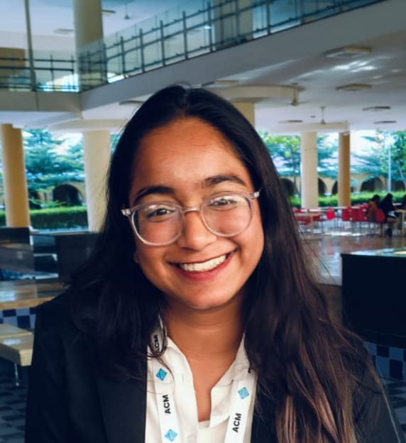 |  | AADHYA ROHATGI  STUDENT
profile  A highly motivated and proactive individual with 8 years of experience in leadership roles, including being a Class Representative and leading debating teams. Adept at team management, public speaking, and communication. Looking to apply my leadership skills and experience in an exciting and dynamic environment.  Contact  PHONE:  7983815754  EMAIL:  aadhyarohatgi13@gmail.com  Hobbies  Reading  Dancing |  | EDUCATION  BTECH IN COMPUTERS SCIENCE (DATA SCIENCE)  MANIPAL UNIVERSITY JAIPUR  2024-2028  work experience  EVENTS TEAM HEAD (ACM MUJ) ( July 2025-)  I am currently volunteering in this organization and I play an active role in ideation, planning and execution of events. I am also responsible for managing the junior working team as well as collaboration with different departments.  EVENTS WORKING TEAM (ACM MUJ) (Dec 2024- April 2025)  I was responsible for ideation as well as crowd management including but not limited to handling menial tasks and marketing.  SKILLS  • Basic C  • Java - NPTEL CERTIFIED  • Basic Python  • Leadership: Strong team management and group dynamics skills.  • Communication: Excellent verbal, written, and presentation skills.  • Teamwork: Collaborative with peers and instructors to achieve goals.  • Time Management: Effective at juggling responsibilities and meeting deadlines.  • Problem Solving: Critical thinker with a calm, effective approach to issues.  **: Proven ability to lead teams and manage group dynamics effectively.  - **Communication**: Strong verbal and written communication skills, including public speaking and presentations.  - **Teamwork**: Experienced in collaborating with peers and instructors to achieve common goals.  - **Time Management**: Skilled at managing multiple responsibilities and meeting deadlines.  - **Problem Solving**: Able to think critically and resolve issues in a calm and effective manner.

