**Reactive Cloud Application**

Contents

Features of Play: 2

Platform Components: 2

Code Components: 2

Architecture Diagrams: 3

Building react-app 4

Deployment 5

Screenshots of App 6

Screenshot of App deployed on PCF: 9

Screenshot of Jmeter for App running on PCF 10

# Features of Play:

* Reactive
  + Asynchronous/Non-blocking
  + Fault-tolerant
  + Self-healing
* Zero Down-time
* Horizontally scaling

# Platform Components:

* Play Framework for Web UI with Websockets
* Akka Actors to invoke back-end Webservices with Promise
* Use of Akka Distributed Data to provide fault-tolerant shopping cart and user session
* REST APIs using Play to talk to backend database
* UI in angular.js (1.3.14) & bootstrap.js(3.3.6)
* Backend Database – MongoDB
  + Reactive Streams Mongo Driver
* Apache Jmeter for performance testing.

# Code Components:

1. reactive-ecomm-app

Play framework for signup, signin, adding single or bulk products.

<https://github.com/jadhavj/reactive-ecomm-app>

1. reactive-ecomm-billing-app

Akka framework with an akka cluster and raabitmq for billing subsystem.

<https://github.com/jadhavj/reactive-ecomm-billing-app>

Architecture Diagrams: 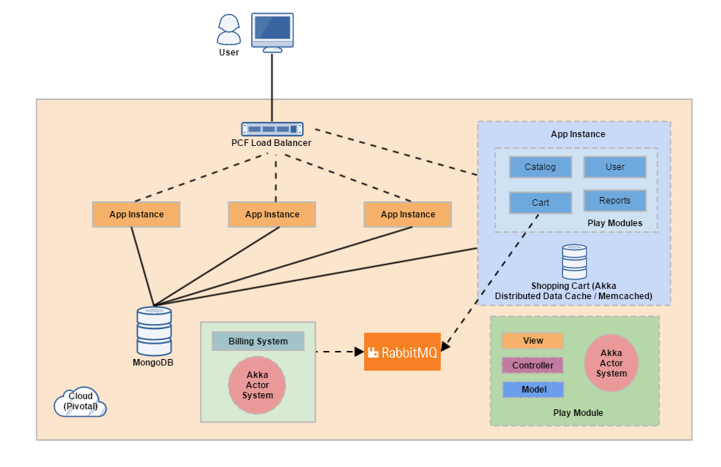

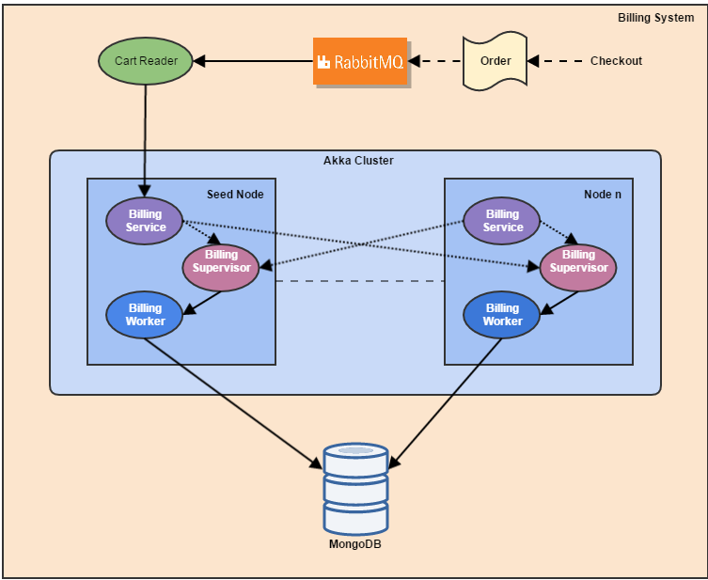

# Building react-app

**Softwares used:**

|  |  |
| --- | --- |
| **SOFTWARE** | **VERSION** |
| JDK | 1.7 onwards |
| RabbitMQ | 3.6.0 |
| SBT | 0.13.9.2 |
| Activator | 0.13.8 |
| MongoDB | 3.2 |
| MemcacheD | 1.4.4-14 |
| Scala | 2.11.7 |
| Play | 2.11 |

**Dependencies**

|  |  |
| --- | --- |
| Mongo-java-driver | 3.2.0 |
| Mongodb-driver-async | 3.2.1 |
| Rabbitmq-client |  |
| Akk-actor-2.11 | 2.3.13 |

**DEPLOYMENT ARCHITECTURE**

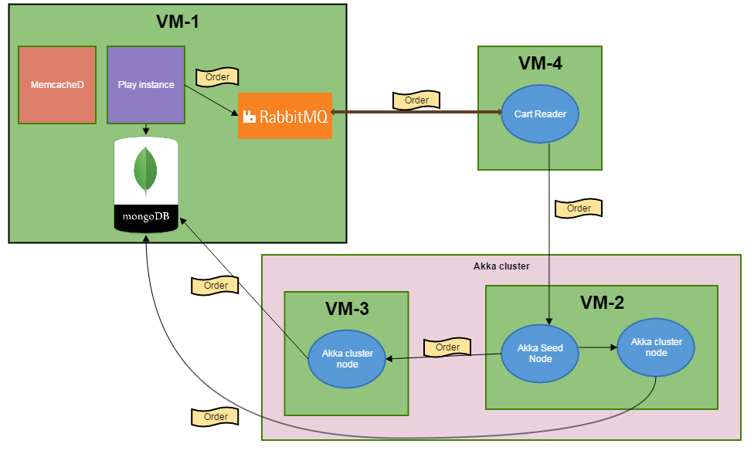

**How to build the app?**

1. Pre-requisites:

Mongodb should be installed and running

Memcached should be installed and running

RabbitMQ should be installed and running (a user ‘test’ with password ‘test’ which can connect remotely should be added.)

1. Get the reactive-ecomm-app code from git from the above link.
2. Change the memcahed, mongo and rabbitmq details in conf/application.conf file
3. Now go to the folder reactive-ecomm-app and run the command

activator run

1. Import the reactive-ecomm-billing-app repo from git to you preferred IDE from the link given above.
2. Change the akka preferred hostname and port in the files billingcluster.conf, billingclusternode.conf and cartreader.conf and run following commands in the given sequence (preferably on different machines to avoid conflicts between the cluster systems)
3. mvn clean package
4. Run the java program BillingClusterNode as

reactive-ecomm-billing-app/target$ java -Dconfig.file=billingclusternode.conf -jar billing-system-1.0-SNAPSHOT-shaded.jar start node --mongo-host localhost

1. Run the java program BillingCluster as

reactive-ecomm-billing-app/target$ java -Dconfig.file=billingcluster.conf -jar billing-system-1.0-SNAPSHOT-shaded.jar start cluster

1. d. Run the java program CartReader as:

java -Dconfig.file=cartreader.conf -jar billing-system-1.0-SNAPSHOT-shaded.jar start cart-reader --seed-host 10.20.3.61 --mongo-host localhost --rabbit-host 10.20.3.90 --rabbit-user test --rabbit-pass test

1. Now hit the below url to go the login page

<hostname>/assets/index.html

# Deployment

**How to deploy the app to PCF?**

1. Go the folder reactive-ecomm-app and run the command

sbt dist

1. Go to <https://console.run.pivotal.io/register> and while registering give the ORG name as react-app.
2. Login to PCF - <https://login.run.pivotal.io/login>
3. Installing cf 6.14 command line tools

For Linux (64 bit) - Download <https://cli.run.pivotal.io/stable?release=debian64&source=pws>

As user “root” execute following command,

% sudo dpkg -i cf-cli-installer_6.14.0_x86-64.deb

Follow the steps given here for getting started - https://console.run.pivotal.io/tools

1. Now go to the application_root_dir and run the following command

cf push react-app -p target/universal/ reactive-ecomm-app-1.0-SNAPSHOT.zip -b https://github.com/cloudfoundry/java-buildpack.git

1. Go to the PCF Web UI and in the bottom of the react-app page and click on Services ->Add from Marketplace and from the marketplace add following services to your app

CloudAMQP ,MongoLab and Memcached Cloud

1. Now hit the below url to go to login page

http://react-app.cfapps.io/assets/index.html

# Screenshots of App

1. **Login Page:**

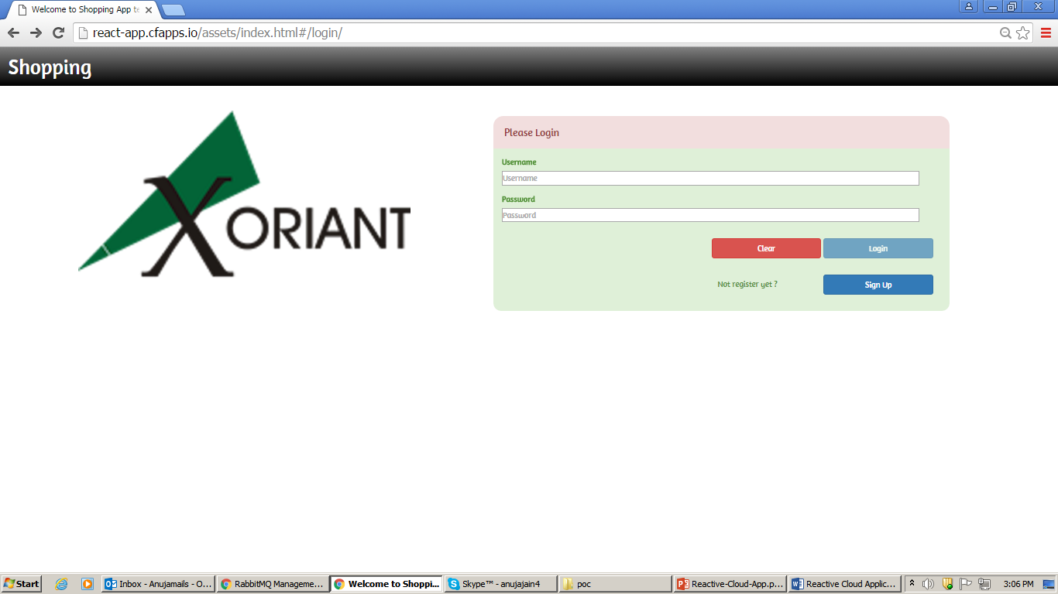

1. **Signup Page:**

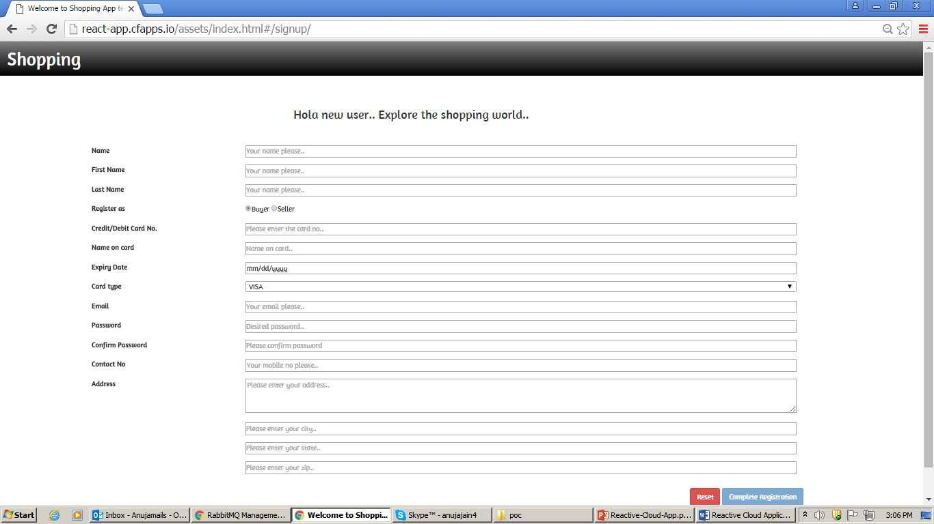

1. **Catalog Page:**

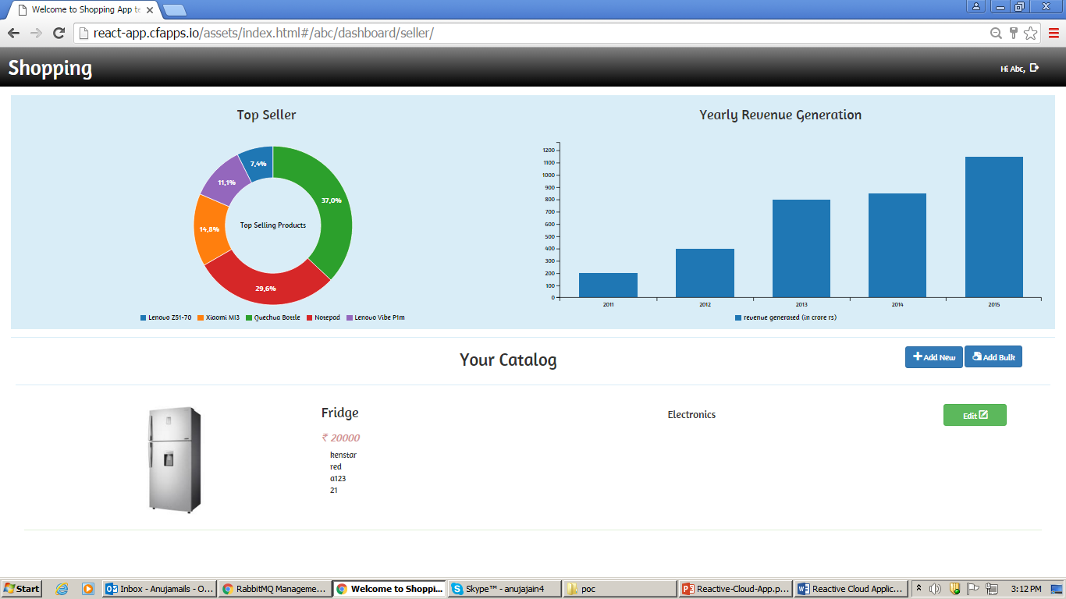

1. **Buyer home page:**

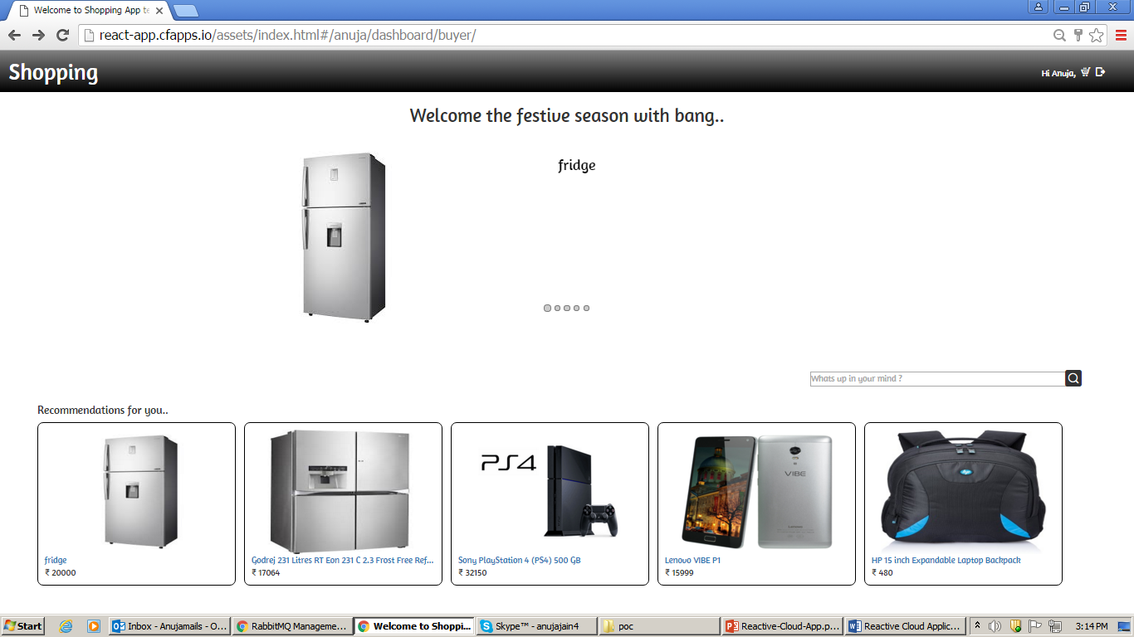

1. **Checkout:**

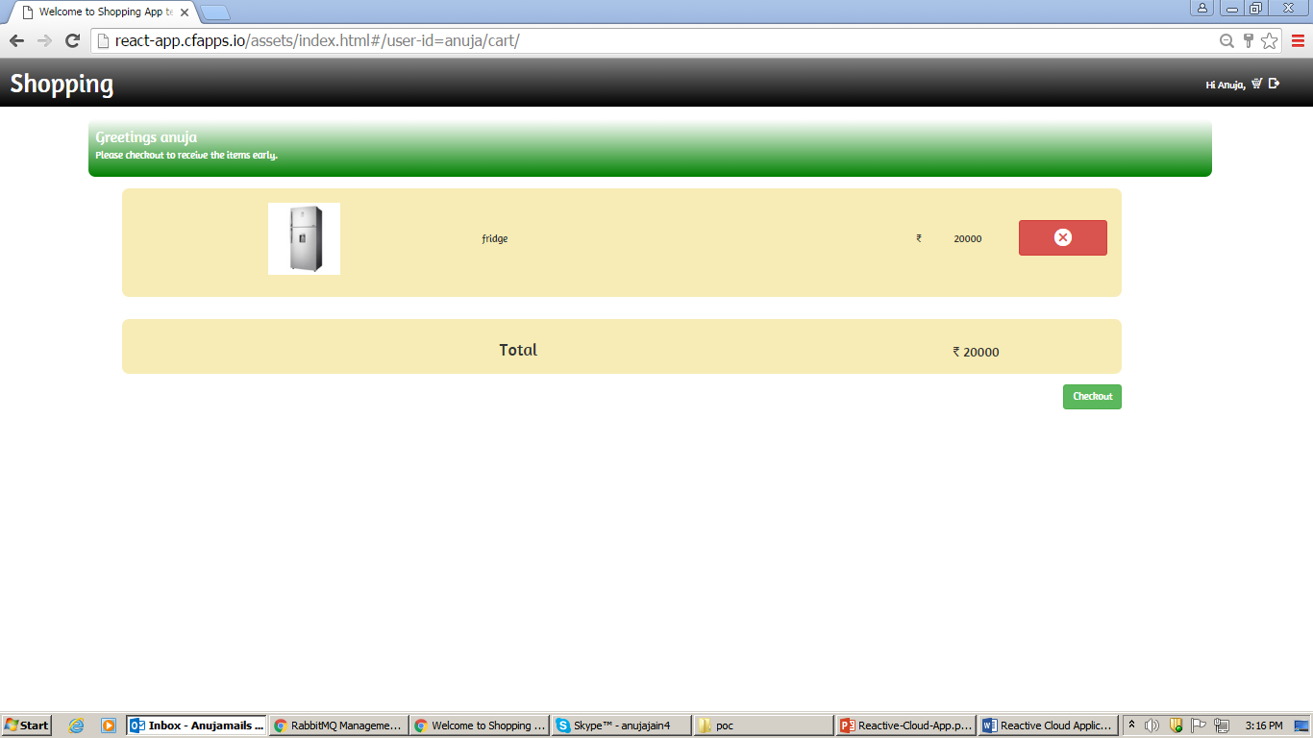

1. **Order complete Page:**

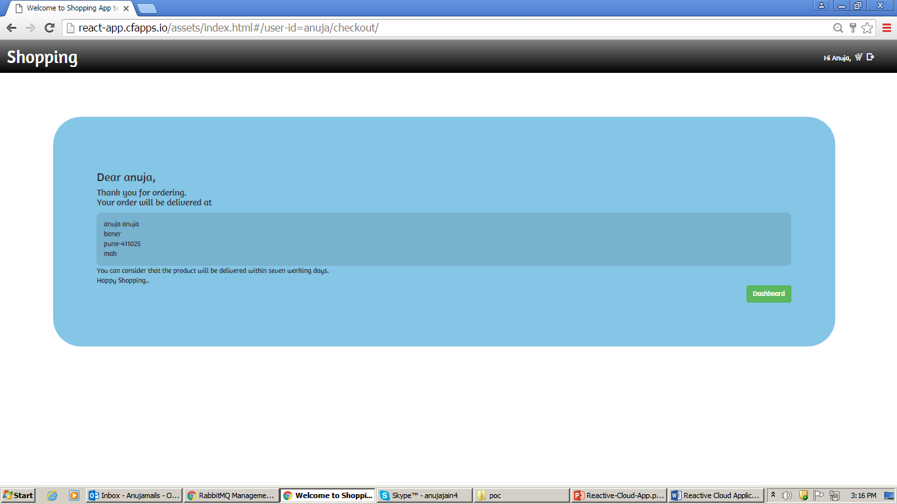

# Screenshot of App deployed on PCF:

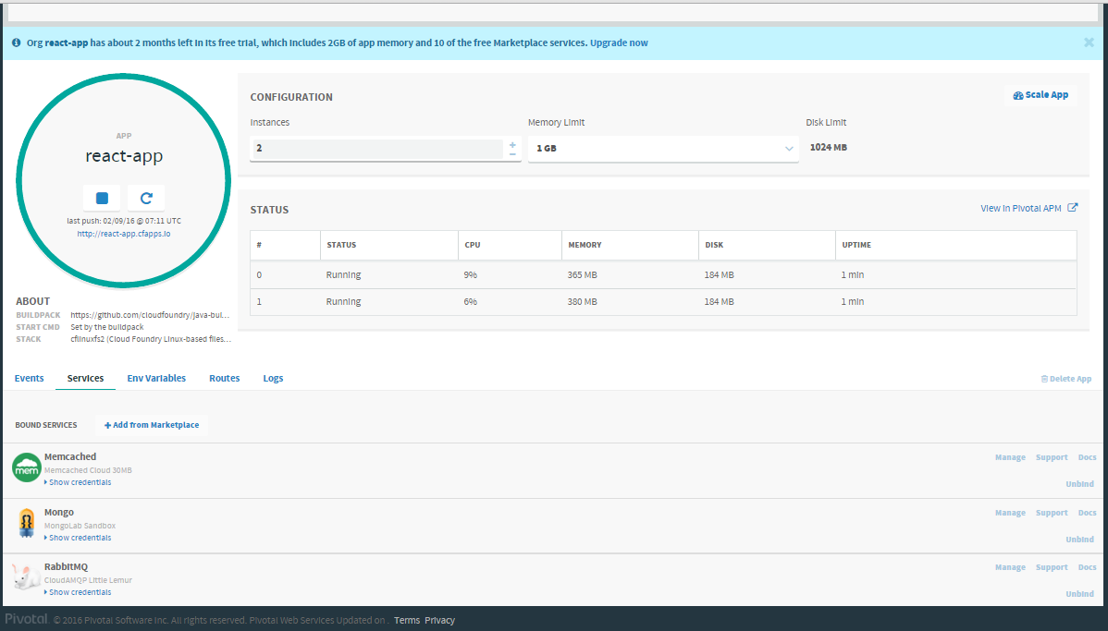

# Screenshot of Jmeter for App running on PCF

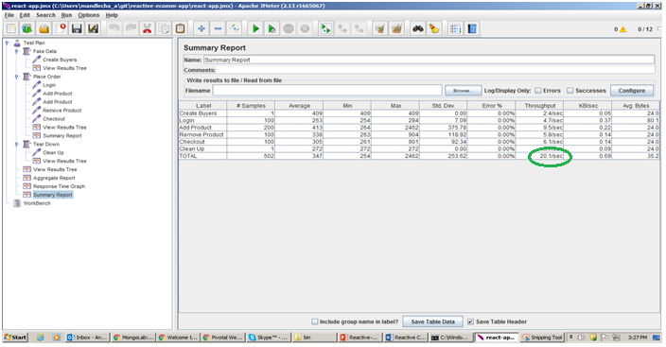

**With a single play instance, throughput is ~9 ops/sec while with two play instances the throughput is over ~20 ops/sec**