Group Name: The Programmers

ITCS 6160: Database systems

Deliverable 2: Scope, Use Case, Business Rules EERD, Schema

Group Members:

Samruddhi Godbole

Nikhil Jadhav

Mukul Khilnani

Alzarrio Rolle

**Table of Contents**

**Scope of Project** 2

**Business Rules** 5

Persons (Campus Faculty, Staff, Students) 5

Location 6

Golf Cart 6

Payment 7

Ride Details 7

Rate my ride 7

Define Roles 7

**Enhanced Entity Relationship Diagram** 8

**Data Dictionary** 9

**List of Tables** 9

Persons 9

Location 9

GolfCart 10

Payments 10

Ride 11

# **Scope of Project**

We are developing a golf cart reservation system for our university. In which a University student/employee can reserve a Golf cart for immediate or future use. The user will have to provide the following details while making a book:Name, Type (Status), Email, Department, Phone Number (cell), UniversityID. While making a booking the software will check if the location is with the radius of the campus. If the location is not beyond the bounds of the university a Golf cart will be assigned to the user, the golf cart will have the following details: ID, Model, Make, Number of Seats, Weather, Year, VIN, Color, Power supply, Electro-magnetic parking Brake. After this the user will have to make a payment to get the confirmation, the payment can be made through Credit card, Debit card, Declining Balance (49er ID card account). No cash payment is allowed in our system. Post the ride the user can rate the experience of the ride and provide feedback

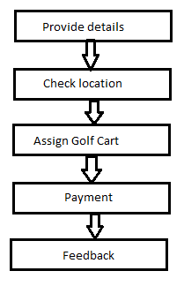

**Figure 1: Diagram of the entire process from start to finish**

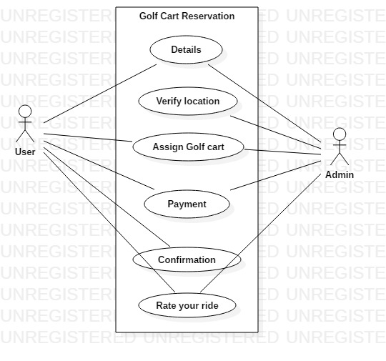

**Figure 2: Diagram of Golf Cart Reservation.**

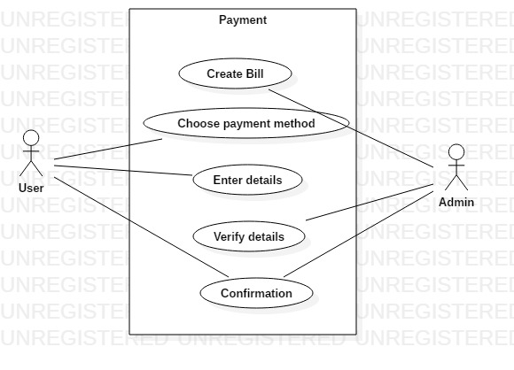

**Figure 3: Diagram of the Payment Details**

# **Business Rules**

## Persons (Campus Faculty, Staff, Students)

* personid (PK)
  + No two value in this table can be the same
* Name
  + Must include First Name (String or Varchar (25))
  + Must include Middle Initial (one alphabetical character)
  + Must include Last Name (String or Varchar (25))
* Type (Status)
  + Must be only Students, Staff and Faculty
    - Students – Grad Year (Must be in future) and Birthday (Must be at least 18 years old)
    - Staff – Position and Admin (must be yes or no)
    - Faculty – Title and Fulltime (Must be yes or no)
* Email
  + Must enter a valid email
* Department
  + Must states each person’s affiliation (e.g. Computer Science, Dining Services)
* Phone Number (cell)
  + Must be a valid US number
* UniversityID
  + Must be exactly nine digits (800 Number)
  + No two number can be the same.
  + Must have a 16-digit number associated will 800 Number
* SSN
  + Must be exactly nine digits.
  + No two number can be the same.
* License
  + Drivers can have a driver’s license but must not have a driver’s license.
  + Currently recognized driver’s license – Yes or No
    - If Yes person must have licensenumber and datehired.
    - Driver’s License Number must be a unique 12-digit number
    - Driver’s License must have an issue date in the past and an expiration date in the future.

## Location

* LocationID
  + All values in this table must be unique
* LocationName
  + Can have the same value for different entries.
* LocationAddress
  + Can have the same value for different entries.
* Latitude
  + Must be a decimal (non int) value between 0 and 90
* Longitude
  + Must be a decimal (non int) value between 0 and 180
* All locations can be used to pick up or drop out golf carts.
* Pickup must occur during operating hours
* Dropoff must occur during operating hours

## Golf Cart

* ID
  + Must be unique for each golf cart
* Model
  + Must be a valid model in the world
  + Can be the same as another entry value
* Make
  + Must be a valid make in the world
  + Can be the same as another entry value
* NumSeats
  + Four carts have 1 extra seat (in addition to the driver)
  + Four different carts have 2 extra seats
* Weather
  + All carts can be used during raining conditions
* Year
  + Has to be the current year or a year in the past
* VIN (Vehicle Identification Number)
* Color
  + Must be a valid color issue from the manufacturer
* Power supply
  + Internal combustion
  + Battery
  + Hybrid
* Electro-magnetic parking Brake
  + Yes or No value

## Payment

* Online
  + All payments must be conducted online
* Payment types
  + Credit card
  + Debit card – can only rent lesser value golf carts (Rental car model)
  + Declining Balance (49er ID card account)
  + No Cash
* Transactions
  + A deposit is charged in addition to the rental cost upon receiving golf cart
  + Deposit is refunded after returning golf cart and no damage was done

## Ride Details

* personid (PK) (Driver)
* Persons can sign up for zero to many rides
* Start and end location can be the same
* Start and End Times
  + A person cannot have a golf for more than 10 hours.
* Distance
  + Tracks the number of miles driven during rental.

## Rate my ride

* Stars (between 1 to 5) - one being the lowest and five being the highest.
* Only one feedback per person

## Define Roles

* Admin
  + Read and Write permissions
* Guest
  + Read only and very limited write

# **Enhanced Entity Relationship Diagram**



# **Data Dictionary**

## **List of Tables**

### Persons

|  |  |  |
| --- | --- | --- |
| **Column** | **Data Type** | **Description** |
| personid | int | Primary Key |
| first_name | nvarchar (100) | first name, not NULL |
| middle_name | nvarchar (100) | Middle name, optional |
| last_name | nvarchar (100) | Last name, not NULL |
| Status | nvarchar (10) | type or status, Not NULL e.g. Student, Faculty etc. |
| email | nvarchar (50) | Must enter a valid email, Not NULL |
| department | nvarchar (50) | department name, e.g. "Computer Science”, Not NULL |
| phone_number | int (10) | primary contact number, 10-digit length, not NULL, unique |
| university_ID | int (9) | university id e.g. 800101212. Must be of length=9 and Not Null, Unique |
| SSN | int (9) | Social security number. Must be of length=9 and Not Null, Unique |
| license_number | int (12) | Optional field, license number. |
| gender | char (1) | M=male, F=female, O=Others/Unknowns |

### Location

|  |  |  |
| --- | --- | --- |
| **Column** | **Data Type** | **Description** |
| location_ID | int | Primary Key |
| location_name | nvarchar (100) | name of the location, not NULL |
| location_address | nvarchar (100) | detailed location address |
| latitude | DECIMAL (10, 8) | Must be a decimal (non int) value between 0 and 90. not NULL, Unique |
| longitude | DECIMAL (11, 8) | Must be a decimal (non int) value between 0 and 180.not NULL, Unique |

### GolfCart

|  |  |  |
| --- | --- | --- |
| **Column** | **Data Type** | **Description** |
| golf_cart_ID | int | Primary Key |
| model | nvarchar (100) | name of the model, not NULL |
| make | nvarchar (100) | brand details, not NULL |
| num_of_seats | int (1) | number of seats allowed other than driver (could be 2/4). not NULL |
| can_used_during_rain | char (1) | Y=Yes, N=NO. not NULL |
| year | int (4) | Must be exactly 4 digits, Not Null |
| VIN | int | Vehicle identification number. not Null, Unique |
| color | nvarchar (10) | color of the cart, not Null |
| power_supply | nvarchar (50) | type of power supply e.g. Battery, hybrid. Not Null |
| electro_magnetic_parking_break | char (1) | Y=Yes, N=NO. not NULL |

### Payments

|  |  |  |
| --- | --- | --- |
| **Column** | **Data Type** | **Description** |
| payment_ID | int | Primary Key |
| transaction_date | date | date and time of the payment, not NULL |
| method | nvarchar(100) | payment details e.g. Credit card, debit card etc. , not NULL |
| amount | decimal | amount paid. not NULL |
| status | char (1) | Successful? Y=Yes, N=NO P=pending. not NULL |
| deposit_Amount | decimal | Not Null |
| deposit_paid | char (1) | Successful? Y=Yes, N=NO P=pending. not NULL |
| deposit_refund | char (1) | Successful? Y=Yes, N=NO P=pending. not NULL |

### Ride

|  |  |  |
| --- | --- | --- |
| **Column** | **Data Type** | **Description** |
| payment_ID | int | foreign key, table=payments |
| golf_cart_ID | int | foreign key, table=golf cart |
| personid | int | foreign key, table=persons |
| start_time | date | ride start time, not Null |
| end_time | date | ride end time, IT must end on the same date. not Null |
| start_location | int | Should be the Location ID. foreign key, table=Location |
| end_location | int | Should be the Location ID foreign key, table=Location |
| distance | decimal | in miles, not Null |
| ratings | int | rate the ride in form of Stars (between 1 to 5)- 1 being the lowest and 5 being the highest, optional field |
| ride_feedback | nvarchar (500) | Detailed feedback of the ride. Optional field |