Source Code:

[2]:
import pandas as pd import numpy as np import matplotlib
import matplotlib.pyplot as plt import seaborn as sns

[3]:
raw_vaccine_data = pd.read_csv("covid_vaccine_statewise.csv")
[4]:
raw_vaccine_data.shape
[4]: (7845, 24)
[5]:
raw_vaccine_data.head(5)

[5]: | Updated On | State Total | Doses Administered | Sessions | Sites | \
0 | 16/01/2021 | India | 48276.0 | 3455.0 | 2957.0
1 | 17/01/2021 | India | 58604.0 | 8532.0 | 4954.0
2 | 18/01/2021 | India | 99449.0 | 13611.0 | 6583.0
3 | 19/01/2021 | India | 195525.0 | 17855.0 | 7951.0
4 | 20/01/2021 | India | 251280.0 | 25472.0 | 10504.0
First Dose Administered Second Dose Administered \
0 48276.0 0.0
1 58604.0 0.0
2 99449.0 0.0
3 195525.0 0.0
4 251280.0 0.0
Male (Doses Administered) Female (Doses Administered) \
0 NaN NaN
1 NaN NaN
2 NaN NaN
3 NaN NaN
4 NaN NaN
Transgender (Doses Administered) … 18-44 Years (Doses Administered) \
0 NaN … NaN

1 |  | NaN | … | NaN
2 |  | NaN | … | NaN
3 |  | NaN | … | NaN
4 |  | NaN | … | NaN
 | 45-60 | Years (Doses Administered) | 60+ | Years (Doses Administered) \
0 |  | NaN |  | NaN
1 |  | NaN |  | NaN
2 |  | NaN |  | NaN
3 |  | NaN |  | NaN
4 |  | NaN |  | NaN
18-44 Years(Individuals Vaccinated) 45-60 Years(Individuals Vaccinated) \
0 NaN NaN
1 NaN NaN
2 NaN NaN
3 NaN NaN
4 NaN NaN
60+ Years(Individuals Vaccinated) Male(Individuals Vaccinated) \
0 | NaN | 23757.0
1 | NaN | 27348.0
2 | NaN | 41361.0
3 | NaN | 81901.0
4 | NaN | 98111.0
 | Female(Individuals Vaccinated) Transgender(Individuals | Vaccinated) | \
0 | 24517.0 | 2.0
1 | 31252.0 | 4.0
2 | 58083.0 | 5.0
3 | 113613.0 | 11.0
4 | 153145.0 | 24.0
0 | Total Individuals Vaccinated  48276.0
1 | 58604.0
2 | 99449.0
3 | 195525.0
4 | 251280.0
[5 | rows x 24 columns]

[6]:
raw_vaccine_data.columns
- : Index(['Updated On', 'State', 'Total Doses Administered', 'Sessions',
' Sites ', 'First Dose Administered', 'Second Dose Administered', 'Male (Doses Administered)', 'Female (Doses Administered)',

- :

- :
'Transgender (Doses Administered)', ' Covaxin (Doses Administered)', 'CoviShield (Doses Administered)', 'Sputnik V (Doses Administered)', 'AEFI', '18-44 Years (Doses Administered)',
'45-60 Years (Doses Administered)', '60+ Years (Doses Administered)', '18-44 Years(Individuals Vaccinated)',
'45-60 Years(Individuals Vaccinated)',
'60+ Years(Individuals Vaccinated)', 'Male(Individuals Vaccinated)', 'Female(Individuals Vaccinated)', 'Transgender(Individuals Vaccinated)', 'Total Individuals Vaccinated'],
dtype='str')
raw_vaccine_data.info()
<class 'pandas.DataFrame'> RangeIndex: 7845 entries, 0 to 7844 Data columns (total 24 columns):
# Column Non-Null Count Dtype

- Updated On 7845 non-null str
- State 7845 non-null str
- Total Doses Administered 7621 non-null float64
- Sessions 7621 non-null float64
- Sites 7621 non-null float64
- First Dose Administered 7621 non-null float64
- Second Dose Administered 7621 non-null float64
- Male (Doses Administered) 7461 non-null float64
- Female (Doses Administered) 7461 non-null float64
- Transgender (Doses Administered) 7461 non-null float64
- Covaxin (Doses Administered) 7621 non-null float64
- CoviShield (Doses Administered) 7621 non-null float64
- Sputnik V (Doses Administered) 2995 non-null float64
- AEFI 5438 non-null float64
- 18-44 Years (Doses Administered) 1702 non-null float64
- 45-60 Years (Doses Administered) 1702 non-null float64
- 60+ Years (Doses Administered) 1702 non-null float64
- 18-44 Years(Individuals Vaccinated) 3733 non-null float64
- 45-60 Years(Individuals Vaccinated) 3734 non-null float64
- 60+ Years(Individuals Vaccinated) 3734 non-null float64
- Male(Individuals Vaccinated) 160 non-null float64
- Female(Individuals Vaccinated) 160 non-null float64
- Transgender(Individuals Vaccinated) 160 non-null float64
- Total Individuals Vaccinated 5919 non-null float64 dtypes: float64(22), str(2)
memory usage: 1.4 MB
raw_vaccine_data["Updated On"] = pd.to_datetime(raw_vaccine_data["Updated␣
𝗌On"],dayfirst=True)

[10]:

[11]:

raw_vaccine_data.info()
<class 'pandas.DataFrame'> RangeIndex: 7845 entries, 0 to 7844 Data columns (total 24 columns):
# Column Non-Null Count Dtype

- Updated On 7845 non-null datetime64[us]
- State 7845 non-null str
- Total Doses Administered 7621 non-null float64
- Sessions 7621 non-null float64
- Sites 7621 non-null float64
- First Dose Administered 7621 non-null float64
- Second Dose Administered 7621 non-null float64
- Male (Doses Administered) 7461 non-null float64
- Female (Doses Administered) 7461 non-null float64
- Transgender (Doses Administered) 7461 non-null float64
- Covaxin (Doses Administered) 7621 non-null float64
- CoviShield (Doses Administered) 7621 non-null float64
- Sputnik V (Doses Administered) 2995 non-null float64
- AEFI 5438 non-null float64
- 18-44 Years (Doses Administered) 1702 non-null float64
- 45-60 Years (Doses Administered) 1702 non-null float64
- 60+ Years (Doses Administered) 1702 non-null float64
- 18-44 Years(Individuals Vaccinated) 3733 non-null float64
- 45-60 Years(Individuals Vaccinated) 3734 non-null float64
- 60+ Years(Individuals Vaccinated) 3734 non-null float64
- Male(Individuals Vaccinated) 160 non-null float64
- Female(Individuals Vaccinated) 160 non-null float64
- Transgender(Individuals Vaccinated) 160 non-null float64
- Total Individuals Vaccinated 5919 non-null float64 dtypes: datetime64[us](1), float64(22), str(1)
memory usage: 1.4 MB
raw_vaccine_data.isnull().sum()

[11]: | Updated On | 0
 | State | 0
 | Total Doses Administered | 224
 | Sessions | 224
 | Sites | 224
 | First Dose Administered | 224
 | Second Dose Administered | 224
 | Male (Doses Administered) | 384
 | Female (Doses Administered) | 384
 | Transgender (Doses Administered) | 384
 | Covaxin (Doses Administered) | 224

CoviShield (Doses Administered) | 224
Sputnik V (Doses Administered) | 4850
AEFI | 2407
18-44 Years (Doses Administered) | 6143
45-60 Years (Doses Administered) | 6143
60+ Years (Doses Administered) | 6143
18-44 Years(Individuals Vaccinated) | 4112
45-60 Years(Individuals Vaccinated) | 4111
60+ Years(Individuals Vaccinated) | 4111
Male(Individuals Vaccinated) | 7685
Female(Individuals Vaccinated) | 7685
Transgender(Individuals Vaccinated) | 7685
Total Individuals Vaccinated | 1926
dtype: int64
[13]:
raw_vaccine_data.fillna(0,inplace=True) raw_vaccine_data.head(3)

[13]: | Updated On | State Total Doses | Administered | Sessions Sites \
 | 0 2021-01-16 | India | 48276.0 | 3455.0 2957.0
 | 1 2021-01-17 | India | 58604.0 | 8532.0 4954.0
 | 2 2021-01-18 | India | 99449.0 | 13611.0 6583.0
First Dose Administered Second Dose Administered \
0 |  | 48276.0 | 0.0
1 |  | 58604.0 | 0.0
2 |  | 99449.0 | 0.0
Male (Doses Administered) Female (Doses Administered) \
0 0.0 0.0
1 0.0 0.0
2 0.0 0.0
Transgender (Doses Administered) … 18-44 Years (Doses Administered) \
0 0.0 … 0.0
1 0.0 … 0.0
2 0.0 … 0.0
45-60 Years (Doses Administered) 60+ Years (Doses Administered) \
0 0.0 0.0
1 0.0 0.0
2 0.0 0.0
18-44 Years(Individuals Vaccinated) 45-60 Years(Individuals Vaccinated) \
0 | 0.0 | 0.0
1 | 0.0 | 0.0
2 | 0.0 | 0.0

\
60+ Years(Individuals Vaccinated) Male(Individuals Vaccinated) \
0 | 0.0 |  | 23757.0
1 | 0.0 |  | 27348.0
2 | 0.0 |  | 41361.0
Female(Individuals Vaccinated) Transgender(Individuals Vaccinated)
0 | 24517.0 | 2.0
1 | 31252.0 | 4.0
2 | 58083.0 | 5.0

Total Individuals Vaccinated
0 48276.0
1 58604.0
2 99449.0
[3 rows x 24 columns]
[14]:
raw_vaccine_data.State.unique()
- : <StringArray>
[ 'India',
'Andaman and Nicobar Islands',
'Andhra Pradesh', 'Arunachal Pradesh',
'Assam',
'Bihar', 'Chandigarh', 'Chhattisgarh',
'Dadra and Nagar Haveli and Daman and Diu',
'Delhi',
'Goa', 'Gujarat', 'Haryana', 'Himachal Pradesh',
'Jammu and Kashmir',
'Jharkhand', 'Karnataka', 'Kerala',
'Ladakh', 'Lakshadweep', 'Madhya Pradesh', 'Maharashtra', 'Manipur', 'Meghalaya', 'Mizoram', 'Nagaland',

- :
raw_vaccine_data[raw_vaccine_data.State == "India"].count()

Length: 37, dtype: str
'Odisha', 'Puducherry',
'Punjab', 'Rajasthan', 'Sikkim', 'Tamil Nadu', 'Telangana', 'Tripura',
'Uttar Pradesh', 'Uttarakhand', 'West Bengal']

- : Updated On 212
State 212
Total Doses Administered 212
Sessions 212
Sites 212
First Dose Administered 212
Second Dose Administered 212
Male (Doses Administered) 212
Female (Doses Administered) 212
Transgender (Doses Administered) 212
Covaxin (Doses Administered) 212
CoviShield (Doses Administered) 212
Sputnik V (Doses Administered) 212
AEFI 212
18-44 Years (Doses Administered) 212
45-60 Years (Doses Administered) 212
60+ Years (Doses Administered) 212
18-44 Years(Individuals Vaccinated) 212
45-60 Years(Individuals Vaccinated) 212
60+ Years(Individuals Vaccinated) 212
Male(Individuals Vaccinated) 212
Female(Individuals Vaccinated) 212
Transgender(Individuals Vaccinated) 212
Total Individuals Vaccinated 212
dtype: int64
- :
raw_vaccine_data.drop(raw_vaccine_data[raw_vaccine_data["State"] == "India"].
𝗌index,
inplace=True)
raw_vaccine_data.shape

[16]: (7633, 24)
- :
raw_vaccine_data.head(5)
- : Updated On State Total Doses Administered \
212 | 2021-01-16 | Andaman and |  |  | Nicobar Islands |  |  | 23.0
213 | 2021-01-17 | Andaman and |  |  | Nicobar Islands |  |  | 23.0
214 | 2021-01-18 | Andaman and |  |  | Nicobar Islands |  |  | 42.0
215 | 2021-01-19 | Andaman and |  |  | Nicobar Islands |  |  | 89.0
216 | 2021-01-20 | Andaman and |  |  | Nicobar Islands |  |  | 124.0
 | Sessions | Sites |  | First | Dose | Administered |  | Second Dose Administered |  | \
212 | 2.0 | 2.0 |  |  |  | 23.0 |  | 0.0
213 | 2.0 | 2.0 |  |  |  | 23.0 |  | 0.0
214 | 9.0 | 2.0 |  |  |  | 42.0 |  | 0.0
215 | 12.0 | 2.0 |  |  |  | 89.0 |  | 0.0
216 | 16.0 | 3.0 |  |  |  | 124.0 |  | 0.0
 | Male (Doses |  | Administered) |  |  | Female | (Doses | Administered) | \
212 |  |  | 12.0 |  |  |  |  | 11.0
213 |  |  | 12.0 |  |  |  |  | 11.0
214 |  |  | 29.0 |  |  |  |  | 13.0
215 |  |  | 53.0 |  |  |  |  | 36.0
216 |  |  | 67.0 |  |  |  |  | 57.0

Transgender (Doses Administered) … 18-44 Years (Doses Administered) \
212 0.0 … 0.0
213 0.0 … 0.0
214 0.0 … 0.0
215 0.0 … 0.0
216 0.0 … 0.0
45-60 Years (Doses Administered) 60+ Years (Doses Administered) \
212 0.0 0.0
213 0.0 0.0
214 0.0 0.0
215 0.0 0.0
216 0.0 0.0
18-44 Years(Individuals Vaccinated) 45-60 Years(Individuals Vaccinated) \
212 0.0 0.0
213 0.0 0.0
214 0.0 0.0
215 0.0 0.0
216 0.0 0.0
60+ Years(Individuals Vaccinated) Male(Individuals Vaccinated) \

212 | 0.0 | 0.0
213 | 0.0 | 0.0
214 | 0.0 | 0.0
215 | 0.0 | 0.0
216 | 0.0 | 0.0
 | Female(Individuals Vaccinated) Transgender(Individuals | Vaccinated) | \
212 | 0.0 | 0.0
213 | 0.0 | 0.0
214 | 0.0 | 0.0
215 | 0.0 | 0.0
216 | 0.0 | 0.0
212 | Total Individuals Vaccinated  23.0
213 | 23.0
214 | 42.0
215 | 89.0
216 | 124.0
[5 rows x 24 columns]
- :
vaccine_data = raw_vaccine_data.reset_index(drop=True) vaccine_data.head(5)

[18]: |  | Updated On |  | State | Total Doses | Administered | Sessions | \
 | 0 | 2021-01-16 | Andaman and Nicobar | Islands |  | 23.0 | 2.0
 | 1 | 2021-01-17 | Andaman and Nicobar | Islands |  | 23.0 | 2.0
 | 2 | 2021-01-18 | Andaman and Nicobar | Islands |  | 42.0 | 9.0
 | 3 | 2021-01-19 | Andaman and Nicobar | Islands |  | 89.0 | 12.0
 | 4 | 2021-01-20 | Andaman and Nicobar | Islands |  | 124.0 | 16.0
Sites First Dose Administered Second Dose Administered \
0 |  | 2.0 | 23.0 | 0.0
1 |  | 2.0 | 23.0 | 0.0
2 |  | 2.0 | 42.0 | 0.0
3 |  | 2.0 | 89.0 | 0.0
4 |  | 3.0 | 124.0 | 0.0
Male (Doses Administered) Female (Doses Administered) \
0 |  | 12.0 |  | 11.0
1 |  | 12.0 |  | 11.0
2 |  | 29.0 |  | 13.0
3 |  | 53.0 |  | 36.0
4 |  | 67.0 |  | 57.0
Transgender (Doses Administered) … 18-44 Years (Doses Administered) \

0 |  | 0.0 | … | 0.0
1 |  | 0.0 | … | 0.0
2 |  | 0.0 | … | 0.0
3 |  | 0.0 | … | 0.0
4 |  | 0.0 | … | 0.0
 | 45-60 | Years (Doses Administered) | 60+ | Years (Doses Administered) \
0 |  | 0.0 |  | 0.0
1 |  | 0.0 |  | 0.0
2 |  | 0.0 |  | 0.0
3 |  | 0.0 |  | 0.0
4 |  | 0.0 |  | 0.0
18-44 Years(Individuals Vaccinated) 45-60 Years(Individuals Vaccinated) \
0 0.0 0.0
1 0.0 0.0
2 0.0 0.0
3 0.0 0.0
4 0.0 0.0
60+ Years(Individuals Vaccinated) Male(Individuals Vaccinated) \
0 | 0.0 | 0.0
1 | 0.0 | 0.0
2 | 0.0 | 0.0
3 | 0.0 | 0.0
4 | 0.0 | 0.0
 | Female(Individuals Vaccinated) Transgender(Individuals | Vaccinated) | \
0 | 0.0 | 0.0
1 | 0.0 | 0.0
2 | 0.0 | 0.0
3 | 0.0 | 0.0
4 | 0.0 | 0.0

- :
%matplotlib inline sns.set_style('darkgrid') matplotlib.rcParams['font.size'] = 16
Total Individuals Vaccinated
0 23.0
1 23.0
2 42.0
3 89.0
4 124.0
[5 rows x 24 columns]

[21]:
vaccination = vaccine_data.groupby("State")[["Total Doses Administered"]].max().
𝗌sort_values("Total Doses Administered",ascending=False)

[28]:
plt.figure(figsize=(18,10))
plt.title("Total vaccination done in states of India", fontsize=18,
fontweight="bold")
sns.barplot(
x=vaccination["Total Doses Administered"], y=vaccination.index,
palette="dark"
)
plt.xlabel("Total Doses Administered", fontsize=12) plt.ylabel("State", fontsize=12)
plt.show()

C:\Users\avcoe\AppData\Local\Temp\ipykernel_18552\1906949921.py:7: FutureWarning:
Passing `palette` without assigning `hue` is deprecated and will be removed in v0.14.0. Assign the `y` variable to `hue` and set `legend=False` for the same effect.
sns.barplot(
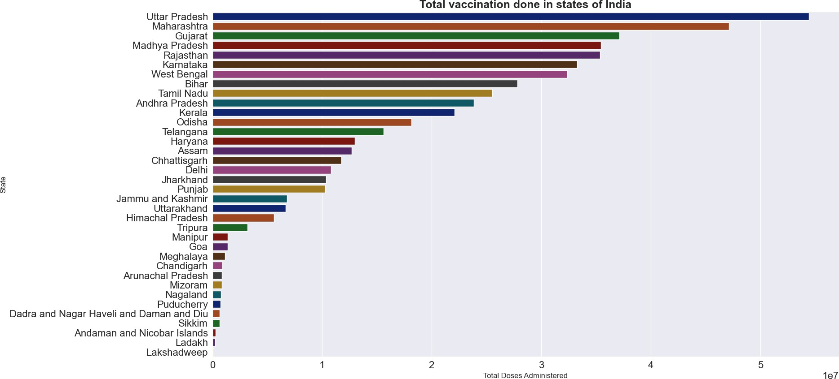

[30]:
population = pd.read_csv("population.csv") population.head(5)

[30]: |  | State | Till year 2021
 | 0 | Uttar Pradesh | 240000000
 | 1 | Maharashtra | 124000000
 | 2 | Bihar | 127000000
 | 3 | West Bengal | 100000000
 | 4 | Madhya Pradesh | 87000000
[31]:
total_vaccination = pd.merge(vaccination,population,on="State") total_vaccination.head(5)

[31]: State Total Doses Administered Till year 2021
 | 0 | Uttar Pradesh | 54447724.0 | 240000000
 | 1 | Maharashtra | 47153366.0 | 124000000
 | 2 | Gujarat | 37152375.0 | 70000000
 | 3 | Madhya Pradesh | 35456676.0 | 87000000
[36]: | 4 | Rajasthan | 35383662.0 | 81000000

plt.figure(figsize=(18,10)) plt.xticks(rotation=75)
plt.title("Percentage of people vaccinated as per population in India") vaccine_percent = total_vaccination["Total Doses Administered"] *100/
𝗌total_vaccination["Till year 2021"]
sns.barplot(x=total_vaccination.State, y=vaccine_percent,palette="dark");
C:\Users\avcoe\AppData\Local\Temp\ipykernel_18552\3799888914.py:5: FutureWarning:
Passing `palette` without assigning `hue` is deprecated and will be removed in v0.14.0. Assign the `x` variable to `hue` and set `legend=False` for the same effect.
sns.barplot(x=total_vaccination.State, y=vaccine_percent,palette="dark");

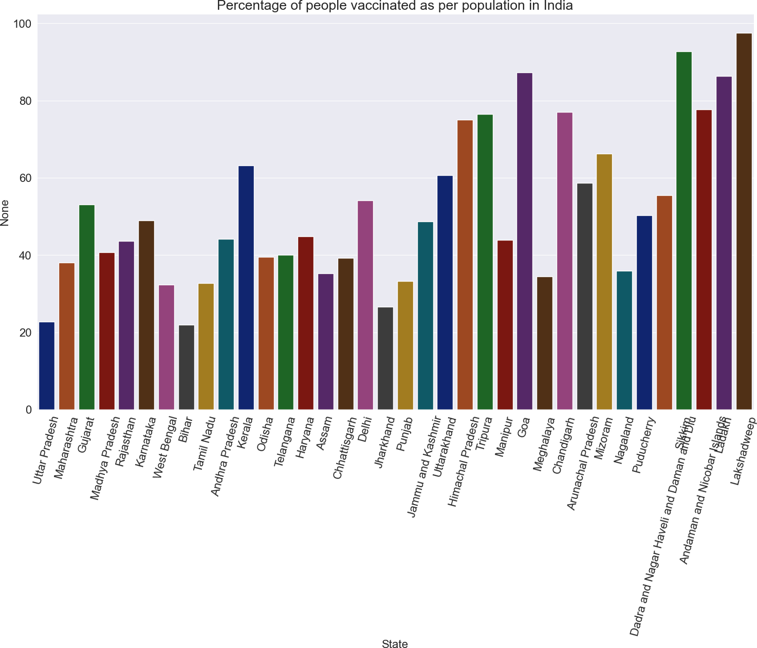

[37]:
male = vaccine_data.groupby("State")[["Male(Individuals Vaccinated)"]].max().
𝗌sum()
female = vaccine_data.groupby("State")[["Female(Individuals Vaccinated)"]].
𝗌max().sum()
others = vaccine_data.groupby("State")[["Transgender(Individuals Vaccinated)"]].
𝗌max().sum()

[42]:
print(male) print(female) print(others)

Male(Individuals Vaccinated) 0.0
dtype: float64
Female(Individuals Vaccinated) 0.0
dtype: float64
Transgender(Individuals Vaccinated) 0.0
dtype: float64

[45]:
import pandas as pd
df = pd.read_csv("covid_vaccine_statewise.csv")

[46]:
male = df["Male(Individuals Vaccinated)"].fillna(0).sum() female = df["Female(Individuals Vaccinated)"].fillna(0).sum()
others = df["Transgender(Individuals Vaccinated)"].fillna(0).sum()
print(male, female, others)

7138698858.0 6321628736.0 1979287.0
[62]:
import matplotlib.pyplot as plt
plt.figure(figsize=(8,8))
plt.pie(
[male, female, others], labels=["Male","Female","Others"], autopct="%0.2f%%",
startangle=90
)
plt.title("Vaccination based on Gender in India") plt.show()

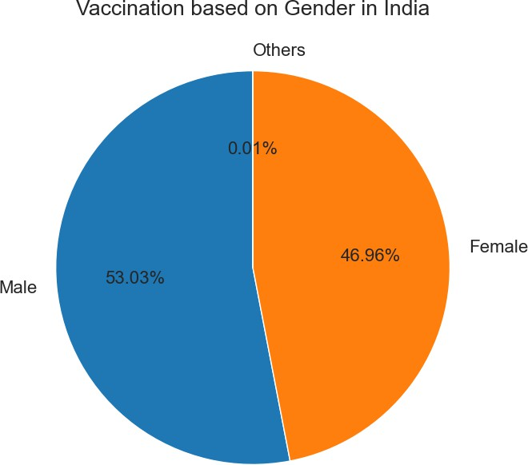

[63]:
doses = vaccine_data.groupby("State")[["First Dose Administered","Second Dose␣
𝗌Administered"]].max()

[64]:
import matplotlib.pyplot as plt import numpy as np

# Figure size FIRST
plt.figure(figsize=(18,10))
xpos = np.arange(len(doses.index))
# Bars
plt.bar(
xpos-0.2,

doses["First Dose Administered"]/1e7, width=0.4,
label="Dose 1"
)
plt.bar(
xpos+0.2,
doses["Second Dose Administered"]/1e7, width=0.4,
label="Dose 2"
)
# Labels after plotting
plt.xticks(xpos, doses.index, rotation=90, fontsize=10)
plt.xlabel("States", fontweight="bold", fontsize=12)
plt.ylabel("Number of doses in crores", fontweight="bold", fontsize=12)
plt.title(
"Dose 1 and Dose 2 vaccination coverage", fontweight="bold",
fontsize=18
)
plt.legend() plt.tight_layout() plt.show()
